Size-dependent demography, disturbance, and transition dynamics of Acropora palmata across the Caribbean
Adrian C. Stier^{1,2,}*, A. Raine Detmer¹, Karen L. Neely^{7,8}, Tali Vardi⁹, Darcy Bradley⁴, Aldo Croquer⁵, Rita I. Sellares-Blasco⁶, and Jameal F. Samhouri³
¹ Department of Ecology, Evolution, and Marine Biology, University of California, Santa Barbara, California, USA
² Marine Science Institute, University of California, Santa Barbara, CA 93106, USA
³ Conservation Biology Division, Northwest Fisheries Science Center, National Marine Fisheries Service, National Oceanic and Atmospheric Administration, Seattle, Washington, USA
⁴ California Oceans Program, The Nature Conservancy, Sacramento, California, USA
⁵ The Nature Conservancy, Caribbean Division, Punta Cana, Dominican Republic
⁶ Fundación Dominicana de Estudios Marinos (FUNDEMAR), Bayahibe, Dominican Republic
⁷ Halmos College of Natural Sciences and Oceanography, Nova Southeastern University, Dania Beach, Florida, USA
⁸ Florida Fish and Wildlife Research Institute, St. Petersburg and Marathon, Florida, USA
⁹ Scripps Institution of Oceanography, University of California San Diego, La Jolla, California, USA
* Correspondence: Adrian C. Stier
Corresponding author email: astier@ucsb.edu

Abstract
Restoration and conservation of endangered corals require understanding the demographic processes that maintain populations and replace lost colonies. For the reef-building elkhorn coral Acropora palmata, survival alone does not reveal whether colonies retain live tissue or persist in the largest size classes. We compiled longitudinal observations from 18 Caribbean studies and separated survival, growth, tissue loss, and movement among five size classes. Annual survival increased with colony size, but surviving colonies often lost tissue or moved into smaller classes. In a recruitment-free transition model that included fragmentation, persistence of the largest colonies contributed most to population growth; the deterministic $λ$ was 0.959, below replacement but close to it. Restoration records did not support a single survival rate for all colony sources: estimates differed among natural fragments, nursery outplants, re-cemented nursery outplants, and direct outplants. Simulated mortality matching the 2023 Florida heatwave further reduced effective $λ$ to 0.849 even when events recurred only once every 50 years. For programs seeking to maintain large living colonies, monitoring should follow live area and size-class transitions alongside survival. Reproductive recovery and restoration of reef habitat require additional measures of reproduction, recruitment, and skeletal structure.
Keywords: Caribbean coral reefs; demographic synthesis; elkhorn coral; meta-analysis; population dynamics; restoration

Introduction
The decline of endangered reef-building corals creates an immediate conservation problem: restoring colony abundance does not necessarily restore large living colonies or their reproductive contribution. Caribbean acroporid declines have reduced coral cover and the habitat once provided by Acropora palmata (Aronson and Precht 2001; Gardner et al. 2003). White-band disease, storms, predation, and chronic tissue loss continue to alter the abundance and condition of remaining colonies (Gladfelter 1982; Rogers and Muller 2012; Williams and Miller 2012). Restoration programs now propagate and outplant A. palmata, but assessing their contribution to population recovery requires knowing whether these colonies survive, grow, and retain live tissue long enough to replace large adults (Edmunds and Riegl 2020). Population rehabilitation and recovery of ecosystem structure and function require different measures of success (Croquer et al. 2026). The demographic rates needed to assess the first of these objectives remain scattered among studies and regions.
Colony size links individual performance to population persistence. Small corals can grow rapidly in proportional terms but experience high mortality, whereas large colonies can survive, reproduce, and produce fragments (Highsmith 1982; Hughes 1984; Hughes and Jackson 1985; Lirman 2000; Madin et al. 2014). However, survival does not ensure continued growth toward adult size. Storm damage, disease, and predation can remove live tissue from surviving colonies, and sufficient tissue loss moves a colony into a smaller size class (Lirman and Fong 1997; Madin et al. 2020). Partial mortality can also reduce reproductive output: A. palmata colonies with unhealed lesions produced smaller eggs than apparently healthy colonies, and the lesions did not regenerate over four months (Piñón-González and Banaszak 2018). Thus, two populations with similar survival could differ in their ability to maintain large colonies if survivors differ in growth and tissue loss. Size-structured models connect these processes by tracking both colony survival and movement among size classes.
Disturbance changes the conditions under which these demographic rates are measured. Storm frequency and intensity alter population trajectories in stage-structured simulations (Lirman 2003), while field monitoring and larval experiments show that disturbance can affect different life stages through different pathways (Randall and Szmant 2009; Rogers and Muller 2012). Disease outbreaks can also cluster within local populations, complicating comparisons among sites (Lentz et al. 2011). Excluding disturbed intervals would restrict a synthesis to the subset of conditions that remain after storms, disease, bleaching, and chronic pressures are removed. Yet pooling all intervals without retaining their exposure histories would obscure whether differences among studies reflect colony size or the conditions experienced during monitoring. The 2023 marine heatwave, which caused functional extinction of A. palmata in Florida (Manzello et al. 2025), makes this distinction consequential: rates estimated before the event cannot establish persistence under heatwaves of similar magnitude.
Colony source further complicates comparisons among restoration studies. Nursery outplants, colonies re-cemented after fragmentation, direct outplants, and natural fragments differ in initial size, handling, and environment (Forrester et al. 2012; Banister et al. 2024; Ramos Romero et al. 2025). Early survival and later outplant performance can also respond to different processes (Williams et al. 2008; Williams et al. 2023). Pooling these colonies as “restoration fragments” combines demographic records from different starting conditions and treatments. A pooled survival estimate may consequently describe the mixture of colony sources represented in the data more than the performance of any particular restoration practice. Comparing studies requires retaining colony source alongside size and disturbance history.
Demographic models have already informed restoration choices for Acropora cervicornis in Puerto Rico by evaluating how fragment size, fragmentation, and survival affect population trajectories (Mercado-Molina et al. 2015). The widely used size-structured model for A. palmata was parameterized from tagged colonies in the northern Florida Keys (Vardi et al. 2012), but the extent to which its rates represent colonies elsewhere in the Caribbean remains uncertain. Here, we combined individual colony records from seven studies with summaries from eleven additional studies to estimate size-dependent survival and growth. We then quantified tissue loss, movement to smaller size classes, and variation associated with disturbance history and colony source. Finally, we used a five-class transition model based on Vardi et al. (2012) to connect these rates to annual population change, retaining fragmentation and fixing sexual recruitment at zero. We expected that survival and growth would vary with colony size, that size–survival relationships would differ among disturbance categories, and that persistence of the largest colonies would contribute most to the model’s growth rate. This synthesis evaluates how the available demographic evidence informs the maintenance and replacement of large colonies, while identifying where source coverage limits that inference.

Materials and methods

Literature search and study selection
From June through December 2025, we searched repositories maintained by NOAA and the US Geological Survey, structured Google Scholar results, backward and forward citations from focal demographic studies, and data shared by restoration practitioners. In March 2026, we expanded the search through PubMed, Web of Science, Semantic Scholar/Elicit, targeted citation searches, and the project literature library. Search terms combined Acropora palmata or elkhorn coral with survival, mortality, growth, recruitment, restoration, and long-term monitoring. Additional individual colony records were obtained by direct data sharing in April 2026. The repository archives the search strings, screening decisions, and study-level exclusions.
We included studies that reported longitudinal observations of identified A. palmata colonies or fragments, survival or areal growth over a defined interval, and sufficient information to annualize survival or estimate a size-dependent vital rate. We excluded cross-sectional condition surveys, studies that reported only branch extension, laboratory micro-fragment experiments smaller than 1 cm², and overlapping analyses of the same tagged-colony datasets. Titles and abstracts were screened first, followed by full-text evaluation. A second reviewer independently evaluated a subset of expanded-search candidates; disagreements underwent a third review. Across all sources, we identified approximately 2,500 records, assessed 101 distinct study or data sources at full text or repository level, and excluded 83 with documented reasons; the most common reasons were a different species, overlap with an included dataset, and cross-sectional designs. The screening ledger contained 104 rows; we consolidated one duplicate Gladfelter record and three Vardi entries representing the same underlying study. When a source supplied an eligible parameter but another parameter was excluded, we counted the study once as included.
The final dataset comprised 18 studies. Seven supplied individual colony records: NOAA long-term monitoring of tagged colonies in the Florida Keys, Curaçao, and Navassa; Neely et al. (2022); Pausch et al. (2018); Kuffner et al. (2020); a USGS outplant experiment in the US Virgin Islands; FUNDEMAR nursery fragments in the Dominican Republic; and Mendoza Quiroz et al. (2023). Eleven supplied study-level summaries (Rogers et al. 1982; Bruckner and Bruckner 2001; Ortiz Prosper 2005; Garrison and Ward 2008; Williams and Miller 2010; Vardi 2011; Rogers and Muller 2012; Forrester et al. 2014; Maurer et al. 2022; Rosales et al. 2024; Ramos Romero et al. 2025). Seventeen of these studies, contributing 22 study-region effects, entered the survival synthesis. Mendoza Quiroz et al. (2023) contributed only to the size-dependent analyses (Online Resource 1, Table S1). Online Resource 1 summarizes the verified selection counts; early identification totals were approximate and could not support a fully enumerated PRISMA flow.

Data extraction and standardization
We classified records into two tiers. Tier 1 studies supplied individual colony identifiers, repeated sizes, and survival fates; these records supported analyses of survival, growth, shrinkage, and size-class transitions. Tier 2 studies supplied study-level survival proportions, sample sizes, and, where available, mean colony size. The raw survival file contained 7,842 interval records. We removed 480 duplicate records identified by study, colony identifier, survey year, and location, followed by 16 records with missing survival or missing or non-positive size, leaving 7,346 prepared records. The raw growth file contained 6,318 records; removing 423 duplicates left 5,895 prepared records. These counts describe colony intervals, which can include repeated observations of the same colony.
We standardized colony size as live planar tissue area in cm². For records containing perpendicular dimensions and live-tissue proportion, we calculated area as length × width × proportion live tissue, following the convention used in previous A. palmata size-structured matrix models (Vardi et al. 2012). For diameter-only records, we estimated area from a circular footprint. Where a study reported a single linear measure, we applied study-informed width-to-length ratios; records for which size could not be defensibly converted were retained for survival synthesis but not size-dependent analyses. We annualized non-annual survival as $S_{annual}=S_{observed}^{1/t}$, where $t$ is the monitoring interval in years. This transformation assumes a constant hazard within each interval and therefore does not represent seasonal mortality peaks. Mortality definitions also differed among studies, from loss of both tissue and skeleton in NOAA monitoring to loss of at least half of live tissue in Kuffner et al. (2020). We retained each study’s definition rather than imposing a common one, so part of the among-study variation reflects measurement rather than biology. Because demographic observations alone cannot identify the sexual versus clonal origin of colonies, genetic information would also be needed to evaluate the origins of colonies contributing to population persistence (Grober-Dunsmore et al. 2007).
We assigned colonies to five size classes: SC1, 0 < area ≤ 10 cm²; SC2, 10 < area ≤ 100 cm²; SC3, 100 < area ≤ 900 cm²; SC4, 900 < area ≤ 4,000 cm²; and SC5, area > 4,000 cm². We retained the 100, 900, and 4,000 cm² boundaries of the published A. palmata model to preserve comparability (Vardi et al. 2012), and divided its smallest class at 10 cm² to distinguish the smallest colonies. Vardi et al. linked the larger boundaries to branch development and increasing clonal and sexual reproductive potential. Our classes describe live-area ranges, not verified life stages or reproductive states: a small colony may be a recruit, a fragment, or a larger colony that lost tissue. We used shrinkage for a negative annual change in live tissue area within a colony that survived the interval, and retrogression for movement into a smaller size class. A colony could shrink without retrogressing, or retrogress after enough tissue loss to cross a class boundary. Stasis meant survival in the same size class, which could occur despite tissue loss.
We calculated relative growth rate as $RGR=G/A_{0}$, where $G$ is annual areal change (cm² yr⁻¹) and $A_{0}$ is initial colony area (cm²), giving RGR in yr⁻¹. We used live-tissue area and live-tissue change where available, with total-colony measurements as fallbacks. Negative RGR indicates a decrease in measured area; positive RGR indicates an increase.

Disturbance and restoration classification
We included disturbed intervals in the primary analyses to describe colonies under the conditions they experienced. We linked each interval to a Caribbean timeline of storms, disease, bleaching, cold events, and chronic pressures. The timeline distinguished intervals with no documented exposure, chronic or indirect pressure only, and an acute event. We removed the acute-event intervals in a sensitivity analysis; the absence of a documented event did not establish that an interval was undisturbed. An independent check verified the interval-to-event assignments (Online Resource 1, Table S2). We tested whether size–survival relationships differed among these categories using natural colonies only, excluding restoration handling and material from that comparison.
For restoration analyses, we used study metadata to classify records as natural fragments, nursery outplants, nursery outplants re-cemented after fragmentation, or outplanted colonies. We compared subtype-specific survival to assess how pooling distinct colony sources affected the broad “restoration fragment” estimate. Because studies differed in colony source and site, these comparisons did not estimate intervention effects.

Statistical analyses
We fitted binomial generalized additive models (GAMs) for annual survival and Gaussian GAMs for relative growth, using log-transformed colony size as the predictor. Fig. 2 shows fits to pooled observations without adjustment for study; mixed-effect models accounting for study tested sensitivity to pooling. Following the pre-specified threshold procedure of Detmer et al. (2025), we first compared each GAM with a linear model. We reported a threshold only if the GAM improved AICc by at least 2 units, then used derivatives of the fitted curve to locate it. We checked model fit and repeated the analyses with each study excluded in turn to assess how much the estimated threshold depended on study composition.
For the survival synthesis, we aggregated annualized survival proportions into study-region effects. For Tier 1 data, we estimated survival within groups sharing study, region, population type, and interval duration, annualized those proportions, and averaged them within effects using the number of interval records as weights. This synthesis used 7,176 of the prepared records: 52 Mendoza Quiroz records were outside the survival-synthesis study set, 24 Neely records lacked usable interval duration, and 94 NOAA restoration-fragment records were excluded from the natural-colony NOAA effects. Tier 2 effects contributed a further denominator of 1,431, giving 8,607 across 22 effects. Within the hand-extracted Tier 2 summaries, we used the maximum initial sample size within each effect rather than summing repeated census denominators, and weighted annualized survival by initial sample size. The total denominator therefore combines Tier 1 colony-interval records and Tier 2 effect-level sample sizes; it is not a count of unique colonies.
We transformed those proportions to log-odds effect sizes and applied a 0.5 continuity correction to zero cells. The primary random-effects model was a three-level REML model with study and within-study effect structure and t-based inference; an independent-effect model with Knapp–Hartung inference was a sensitivity analysis (Knapp and Hartung 2003; Viechtbauer 2010). We report pooled survival, 95% confidence intervals, prediction intervals, and heterogeneity statistics. We evaluated population type, colony size, year, and region as exploratory moderators because the number of effects was limited. We also performed leave-one-out, classification, and risk-of-bias sensitivity analyses. We assessed small-study effects with Egger-type regression tests on the independent-effect and three-level models and with trim-and-fill on the independent-effect model. Funnel-plot methods were designed for comparative effect sizes, so we treat these tests as diagnostics of asymmetry among single-proportion effects rather than as direct tests of publication bias.
We constructed a five-class Lefkovitch matrix to describe annual changes in the abundance of natural colonies. The matrix included survival, growth, movement to smaller classes, and fragment production; sexual recruitment was fixed at zero. Its dominant eigenvalue ($λ$) therefore described annual growth of this recruitment-free model, not growth of the full population. Four studies contributed survival rates and two contributed growth rates. NOAA records supplied most SC5 size-class survival observations, and Vardi (2011) supplied the only fragmentation estimates. We calculated matrix-cell elasticities: the proportional change in $λ$ expected from a small proportional change in each cell, with other cells held constant. To propagate sampling uncertainty, we resampled studies, then observations within sampled studies. We retained 2,000 valid bootstrap replicates; 132 imputed survival for at least one missing size class. The bootstrap did not propagate survival–growth covariance. We also excluded each of the four contributing studies in turn, refitting the same survival estimator and growth transitions. Excluding Vardi also removed its fragmentation estimates; missing survival classes used the full-data estimates.
To test whether independent survival and growth resampling affected uncertainty, we compared two additional 2,000-replicate bootstraps. Both retained two draws from the studies shared by survival and growth and two from survival-only studies; the coordinated version used the same shared-study draws for survival and growth. This comparison tested study-level coordination while holding the study mix fixed, but could not estimate temporal survival–growth covariance. We also replaced missing-class survival with a draw from its full-data bootstrap distribution, compared this with point imputation and discarding incomplete replicates, and removed Vardi’s survival and fragmentation contributions separately (Online Resource 1, Table S3).
We treated the 2023 Florida heatwave as an episodic, Florida-specific survival pulse rather than as a replacement for the chronic-regime matrix. We first used the A. palmata dose-response thresholds reported by Manzello et al. (2025) (ED50 = 7.8 degree-heating weeks [DHW], ED95 = 17.6 DHW) to define 8-, 12-, and 18-DHW sensitivity scenarios. We then added an observed-2023 Florida endpoint: 97.8–100% mortality, represented by a 0–2.2% heatwave-year survival multiplier. The deterministic projection used the midpoint of that range; because the published study reports bounds rather than a colony-level sampling distribution, Monte Carlo projections sampled uniformly across the reported range at each prescribed event. Each of 500 simulations per scenario retained the full-data matrix structure, scaled by one sampled bootstrap lambda for all 50 years; these simulations propagated parameter uncertainty, not environmental variation in annual transition rates. Heatwave pulses were applied after the annual matrix transition to all size classes, consistent with the reported absence of size refuge during the Florida event. We report the geometric mean of annual abundance ratios as effective lambda under recurrence intervals of 5, 10, 20, and 50 years, and the fraction of simulations in which total abundance fell below 10% of its initial value at year 50 (quasi-extinction). We prescribed these recurrence intervals to compare frequent and rare events; we did not estimate future return periods. The projections describe the recruitment-free subsystem under Florida-like mortality and cannot estimate Caribbean-wide thermal mortality or full population viability.
To test sensitivity to matrix structure and initial size composition, we projected all 2,000 complete bootstrap matrices and compared these with matrices scaled by the corresponding bootstrap lambdas. Each matrix remained fixed for 50 years, and heatwave mortality draws were identical across paired comparisons. The original starting population contained 100, 50, 30, 20, and 10 colonies in SC1–SC5; alternative starting proportions were 70, 15, 8, 5, and 2% (recruit-heavy), 2, 3, 5, 20, and 70% (adult-heavy), and the full-data matrix’s stable size distribution. These compositions were sensitivity assumptions, not estimates of Caribbean population structure (Online Resource 1, Table S4).

Reproducibility
We conducted analyses in R 4.5.2 under the project’s locked computational environment; the central workflow uses mgcv for generalized additive models, metafor for meta-analysis, and lme4 for mixed-effect diagnostic models. The public repository contains the data-processing and analysis scripts, figures, and tables, with links from each main-text result to its generating script and output (Data availability statement below). A versioned archival release will be deposited upon acceptance.

Results

Evidence spanned the Caribbean but remained geographically uneven
Demographic records covered 13 Caribbean regions, but the Florida Keys supplied 6,222 observations (84.7% of the 7,346 prepared individual-level survival records), more than all other regions combined (Fig. 1). Several regions contributed records from only a subset of size classes. Records of the largest colonies were concentrated in Florida, Curaçao, and Navassa, leaving their survival and transitions poorly documented elsewhere.

Survival and growth increased nonlinearly with colony size
Annual survival increased from roughly 60% below 10 cm² to above 90% beyond 4,000 cm², although colony size explained less than 10% of the deviance in individual fate (Fig. 2a). The survival GAM fit better than a linear model (ΔAICc = 17.9), with an estimated inflection near 7,498 cm²; that location varied widely when individual studies were excluded. Relative growth changed most sharply near 37 cm², whereas the threshold for the probability of positive growth occurred near 411 cm² (Online Resource 1, Fig. S1). Absolute-growth variance increased strongly with size, while relative growth described size dependence more effectively.
Study-level survival estimates by size class showed that the size effect was concentrated in the largest classes (Fig. 2c). Pooled survival was nearly flat from SC1 to SC3 (77.3%, 75.1%, and 76.6%) and then rose to 90.9% in SC4 and 94.7% in SC5, where every study estimate exceeded 82%. Among-study spread was widest in SC1–SC3, where individual estimates ranged from about 40% to 100% and where study context, disturbance history, and population type varied most strongly. Colony size alone did not account for the wide variation among studies.

Annual survival varied widely among Caribbean studies
The expanded synthesis estimated pooled annual survival at 78.7% (95% CI: 70.4–85.1%; 95% prediction interval: 37.4–95.8%) across 17 studies and 22 study-region effects (Fig. 3a). Tier 1 and Tier 2 effects were both annualized before aggregation. Heterogeneity was high (I² = 97.6%; $τ^{2}$ = 0.72, of which 0.29 was between studies and 0.44 within studies), so the pooled value summarizes the assembled evidence rather than a Caribbean-wide constant. No single study moved the independent-effect estimate by more than 2.6 percentage points in leave-one-out analyses, and restricting the synthesis to the 13 studies with the highest methodological-quality scores changed it by less than 1 point. Evidence for small-study asymmetry was mixed: the Egger-type test was not significant for the independent-effect model (p = 0.55) but was significant for the three-level model (p = 0.001), and trim-and-fill imputed three effects and lowered the independent-effect estimate from 80.1% to 77.3%.
Pooled survival was 85.4% for natural-colony effects (95% CI 72.9–92.7%, k = 10) and 74.5% for restoration-fragment effects (95% CI 63.9–82.9%, k = 12). Population type was not a supported moderator (p = 0.20), but this result did not establish equivalent survival. With 22 effects, the minimum detectable difference at 80% power was about 20 percentage points, larger than the observed 10.9-point difference. Regional variation remained substantial within population types (Fig. 3b). Even where the two types overlapped in colony size, study identity and sampling context could not be separated from population origin (Online Resource 1, Fig. S2).

Surviving colonies often shrank and moved into smaller size classes
Surviving colonies lost live tissue in 39.4% of records used for the transition analysis (Online Resource 1, Fig. S3). Shrinkage frequency increased from 18.2% in SC1 to 47.5% in SC5. Among SC2–SC5 colonies, the probabilities of moving to a smaller class were 15.2% in SC2, 16.8% in SC3, 17.2% in SC4, and 9.1% in SC5. Higher survival in large colonies therefore coexisted with frequent tissue loss and occasional movement out of the largest class.

Size–survival associations differed across exposure categories
Of 1,072 monitoring intervals, 95.1% overlapped a documented disturbance or chronic pressure (Online Resource 1, Table S2). Among 6,141 natural-colony survival records, only 353 came from intervals with no documented exposure, including 193 SC5 records. Size–survival relationships differed among the three exposure categories (likelihood-ratio test, p < 0.001; Online Resource 1, Fig. S4). Large colonies survived more often during intervals with acute events (SC5: 98.0%, n = 409; SC4: 90.4%, n = 250) than during intervals with no documented exposure (SC5: 83.9%, n = 193; SC4: 79.1%, n = 91). Survival in SC2 and SC3 differed by less than 6 percentage points among categories. The size-by-exposure interaction was weaker for positive growth (p = 0.010). Removing acute-event intervals from the individual-level synthesis (six studies) changed pooled survival only from 75.9% to 75.6%. These comparisons describe study intervals with different exposure histories; they do not isolate mortality caused by the events.

Restoration survival varied among colony-source subtypes
The subtype-coded dataset contained 5,079 records from five studies (Online Resource 1, Fig. S5): 3,968 natural fragments from one study, 1,012 nursery outplants from two studies, 53 re-cemented nursery outplants from one study, and 46 direct outplants from one study. Natural fragments had weighted survival of 87.1%, compared with 58.7% for nursery outplants, 81.1% for nursery outplants re-cemented after fragmentation, and 65.2% for outplanted colonies. Excluding natural fragments reduced mean survival across subtype-coded records from 81.2% to 60.0%. The subtype estimates describe highly unbalanced groups from different studies and do not isolate effects of colony source.

Largest-class stasis dominated conditional transition dynamics
The recruitment-free transition matrix estimated a deterministic lambda of 0.959 (95% bootstrap interval: 0.902–1.001; Fig. 4). In 97.1% of hierarchical-bootstrap replicates, lambda was below one. This resampling fraction characterizes uncertainty in the compiled transition rates; it is not a probability of real-world population decline. Stasis dominated the transition matrix, and SC5-to-SC5 stasis accounted for 59.8% of matrix-cell elasticity (95% bootstrap interval: 37.9–71.9%). Leave-one-study-out estimates of lambda ranged from 0.889 (excluding Vardi (2011), including its fragmentation estimates) to 0.977 (excluding Neely et al. (2022)). Excluding NOAA monitoring lowered lambda to 0.936. These exclusions used the same survival estimator and transition filters as the primary matrix. Removing fragmentation altogether lowered lambda to 0.892, so asexual fragment production, estimated from a single study, contributed about 0.07 to the deterministic growth rate. Within this conditional, recruitment-free subsystem, persistence of the largest colonies had more influence on lambda than marginal changes in any single early transition.
Coordinating the shared-study draws widened the uncertainty slightly: 95.6% of lambda estimates were below one (95% interval: 0.891–1.005), compared with 97.5% under independent resampling with the same study mix (Online Resource 1, Table S3). Lambda was below one in 96.9% of the 2,000 replicates under both point and distribution-based missing-class imputation. Removing Vardi’s survival data alone lowered lambda to 0.954, whereas removing its fragmentation estimates alone lowered it to 0.892. The combined exclusion effect therefore arose mainly from fragment production.

Florida-scale heatwaves reduced effective lambda
Adding heatwave mortality reduced projected abundance without changing the underlying chronic-regime matrix. Under the observed 2023 Florida endpoint, effective lambda was 0.355, 0.576, 0.768, and 0.849 when a Florida-like event recurred every 5, 10, 20, and 50 years, respectively (Online Resource 1, Fig. S6). In these primary simulations, every observed-endpoint scenario was below the quasi-extinction threshold at year 50 in all 500 simulations. Without heatwaves, 78.4% of the 500 primary simulations were below the year-50 threshold, and effective lambda was 0.935. This finite-horizon rate differed from the deterministic eigenvalue of 0.959 because it included bootstrap uncertainty and transient changes in size structure. The 18-DHW dose-response sensitivity scenario was less severe than the observed endpoint because its fitted mortality was 95.5%, rather than the 97.8–100% mortality reported from the Florida Keys and Dry Tortugas (Manzello et al. 2025). In these recruitment-free projections, recurrence of the observed Florida mortality drove abundance below the quasi-extinction threshold even at the longest return interval. The scenarios do not forecast recovery across the Caribbean.
Complete-matrix uncertainty gave similar baseline projections for the original size composition: effective lambda was 0.935 and 78.0% of simulations fell below 10% of initial abundance at year 50 (Online Resource 1, Table S4). In the paired comparison using all 2,000 bootstrap draws, 80.3% of lambda-only simulations were below the year-50 threshold. Initial size composition had a larger effect: with full matrices and no heatwaves, the fraction below the threshold ranged from 24.0% for adult-heavy populations to 90.6% for recruit-heavy populations. Under observed Florida mortality recurring every 50 years, 99.75–100% were below the threshold across the four starting compositions; shorter return intervals placed every simulation below it.

Discussion
Rehabilitating A. palmata populations requires both maintaining large living colonies and producing colonies that will replace them. Our synthesis suggests that these objectives are closely linked by tissue loss: large colonies survived more often, but survivors frequently shrank and sometimes moved into smaller size classes. Persistence in the largest class contributed most to population growth in the recruitment-free matrix. Consequently, colony survival alone can overstate progress toward maintaining large living colonies if survivors lose enough tissue to leave that class. These demographic outcomes do not, by themselves, demonstrate reproductive recovery or recovery of reef habitat (Croquer et al. 2026).

Colony size connects survival to persistence
The demographic contribution of a surviving colony depends on the size it retains. Size-structured theory captures this distinction by separating survival from growth and movement to smaller classes (Hughes 1984; Hughes and Jackson 1985). In our matrix, large-colony stasis had the greatest elasticity, agreeing with the northern Florida Keys model of Vardi et al. (2012) and with Lirman’s (2000) observations of persistence, reproduction, and fragment production in large A. palmata colonies. Agreement with Vardi is partly expected because Florida Keys monitoring also dominates our largest-size-class data. The synthesis adds evidence that remaining alive does not ensure remaining large: tissue loss occurred in 47.5% of SC5 growth records, and 9.1% of surviving colonies moved out of SC5. Disease and corallivore stress on large colonies in St. John (Grober-Dunsmore et al. 2006) provide a further reason to distinguish whole-colony mortality from partial loss of live tissue. Protecting a large colony’s demographic contribution therefore requires retaining its live area as well as preventing its death. Live-area loss need not imply an equivalent loss of physical habitat, however, because the standing skeleton may remain after tissue dies. Our area records do not measure skeletal persistence or three-dimensional complexity.
First fertility and widespread reproductive maturity are different demographic milestones. In Panama, Soong and Lang (1992) recorded a fertile A. palmata colony measuring 16 × 8 cm, but estimated a puberty size of 1,600 cm² from size-ranked observations of fertility. Their area estimate summed the living surface area of branches and the colony base, rather than the live planar area used here. These observations support increasing reproductive potential with size, but cannot assign fertility directly to our classes. Neither growth into SC5 nor retrogression out of it establishes a change in reproductive status.
Growth and survival changed over different size ranges, making a single size threshold an incomplete basis for choosing outplants. Relative growth changed most sharply near 37 cm², whereas survival increased across a much larger range of sizes. A size associated with rapid proportional growth need not confer high survival, and neither fitted relationship establishes the size at which an outplant will reach a large size. The survival inflection also shifted when individual studies were excluded, limiting its use as a planting rule. Initial-size trials should therefore follow cohorts through successive size classes and compare the proportion that reaches and remains in the largest size class. That comparison would connect a choice of planting size to large-colony replacement more directly than survival measured over one interval.

Disturbance and the limits of pooled rates
Demographic rates measured under one disturbance regime may fail to describe persistence under another. Storm-driven population simulations (Lirman 2003) illustrate why the frequency of mortality events matters in addition to demographic performance between events. In our observational comparison, large colonies survived more often during intervals flagged for acute disturbance, but exposure was confounded with study, site, and survey period. Intervals without a documented event were few and came from a narrow set of studies and years. The comparison therefore cannot establish that disturbance benefited colonies or estimate the mortality caused by an event. Manzello et al. (2025) provide a more direct measure of event mortality: 97.8–100% of A. palmata died in the Florida Keys and Dry Tortugas during the 2023 heatwave. Applying that mortality to our matrix further reduced effective $λ$ even when events recurred only once every 50 years. High survival before such an event offers little assurance that large adults will persist through its recurrence.
Geographic coverage and differences in measurement also limit the transfer of pooled rates to a particular restoration site. The annual-survival prediction interval spanned 37.4–95.8%, and Florida Keys studies supplied 84.7% of prepared individual-level survival records. Colonies outside Florida, especially the largest colonies, were poorly represented; studies also differed in mortality definitions and monitoring intervals. Coordinated resampling and alternative treatments of missing size classes retained an estimate close to replacement, although the coordinated interval (0.891–1.005) included both decline and growth. The separate Vardi exclusions showed that fragment production contributed more to the change in $λ$ than removal of its survival observations. Thus, uncertainty reflects both the demographic observations and which processes particular studies supplied. The pooled matrix provides a comparison for local monitoring, but its rates require evaluation against the colony sizes, disturbance history, and mortality definitions at the site where they will be used. Scaling from local colonies to connected populations would also require fecundity, fertilization, larval dispersal, settlement, and early survival. A spatially explicit metapopulation model could test whether recruitment from surviving source reefs offsets local losses, but our recruitment-free matrix cannot estimate that rescue or regional extinction risk.

Restoration should maintain and replace large living colonies
Comparing restoration practices requires separating the effect of a treatment from the colonies and sites selected for that treatment. Our subtype comparison could not make that separation. Natural fragments supplied most records and came from one study; removing them reduced record-weighted survival from 81.2% to 60.0%. The other sources differed in initial size, nursery history, attachment, substrate, and site. These differences matter because genotype, habitat, and size jointly shaped outplant performance in Pausch et al. (2018), while Kuffner et al. (2020) documented recovery through restoration at particular sites. Schill et al. (2021) used mapped depth, coral cover, algal cover, and rugosity to select A. cervicornis outplant sites in the Dominican Republic. Their approach illustrates the site information needed alongside colony demography, rather than a transferable survival rate for A. palmata. The subtype estimates consequently provide no basis for ranking colony sources across programs. For example, evaluating re-cementation would require comparing broken colonies with and without re-cementation at comparable sites, then measuring whether attachment changes survival, tissue retention, and subsequent growth.
Monitoring can make these treatment comparisons more informative by following the fate of the original cohort. Each cohort should retain records of colony source, initial live planar area, attachment treatment, site, and survey interval. Repeated surveys should record death and classify survivors as advancing, remaining in the same size class, or moving to a smaller class; live-area measurements would also identify tissue loss that does not cross a class boundary. Deaths and the fraction reaching and remaining in the largest size class should be reported relative to the original cohort, alongside growth and tissue loss among survivors. Reporting both would prevent high growth among a few survivors from obscuring losses from the cohort. First-year benchmarks for established Acropora cervicornis outplants (Schopmeyer et al. 2017) and the early bottlenecks reported during sexual propagation of A. palmata (Chamberland et al. 2015; Mendoza Quiroz et al. 2023) concern different species, origins, and stages. Their use in restoration comparisons requires preserving those distinctions and matching the follow-up interval.
Protection of large colonies and production of new colonies address different parts of the replacement process. The high elasticity of largest-class stasis identifies a transition to test with interventions that reduce death or tissue loss; it does not establish their effectiveness or their return per unit cost. Small outplants could supply future large colonies, but their contribution depends on survival and growth through the intervening classes. Trials of disease response, locally justified corallivore management, or stabilization after damage should therefore measure tissue retention in large colonies and size-class persistence, while trials of size at outplanting should measure the fraction of planted colonies that eventually enters the largest size class. Sexual propagation also involves processes outside our matrix. Red algae, macroalgae, and cyanobacteria can alter settlement or larval survival (Ritson-Williams et al. 2014; Ritson-Williams et al. 2020), so substrate and early-life-stage trials are needed to connect sexual recruitment to subsequent large-colony replacement. Our analysis cannot rank these interventions without estimates of treatment effects and costs.
By reporting large-colony attainment relative to the planted cohort and tissue retention among existing large colonies, restoration programs can identify where losses interrupt colony replacement (Madin et al. 2025). Croquer et al. (2026) define effective return more specifically as outplants surviving to become reproductive. Our size transitions identify progress toward large-colony attainment, but do not measure that return. Programs targeting reproductive recovery should also record reproductive condition or spawning and subsequent recruitment. Programs targeting habitat recovery need separate measurements of skeletal complexity and associated communities. A treatment that improves early survival but leaves few colonies reaching large sizes addresses a different limitation from one that prevents tissue loss in established large colonies.

Acknowledgements
We thank the NOAA Southeast Fisheries Science Center, the US Geological Survey, and FUNDEMAR for sharing monitoring data, and the authors of the published studies whose summaries made this synthesis possible.

Statements and Declarations

Funding
This work was supported by The Nature Conservancy.

Competing interests
The authors declare no competing interests.

Ethics approval and permits
Not applicable. This study synthesized existing observations and published study summaries and involved no new human-participant research, animal use, or field collection requiring ethical approval or permits.

Consent to participate
Not applicable.

Consent to publish
Not applicable.

Data availability
The data and code underlying this study are maintained at https://github.com/stier-lab/rse-2025-detmer-apalmata-rse-parameters. A versioned archival release will be deposited upon acceptance.

Author contributions
A.C.S. conceived the study and led manuscript development. A.R.D. led data curation and analyses, made the figures, and contributed to manuscript review. K.L.N. contributed Florida Keys data, data interpretation, and manuscript review. T.V. contributed the transition-matrix framework, fragmentation estimates, and interpretation. J.F.S., D.B., A.C., and R.I.S.-B. contributed domain expertise, data resources, and interpretation.

Online resources
Online Resource 1 (ESM_1.pdf). Concise supporting analyses for the Acropora palmata demographic synthesis: four supporting tables, including study coverage, disturbance overlap, matrix resampling, and projection sensitivities, and six supplementary figures. Extended diagnostics and source outputs remain available in the public repository.

Figure legends
Fig. 1 Study locations and size-class coverage for the Acropora palmata demographic synthesis. (a) Study locations across the Caribbean. Circles identify individual-level (Tier 1) studies and triangles summary-level (Tier 2) studies; regions with both are shown with both symbols. Symbol area is proportional to the number of observations, and labels give regional totals. Locations are regional centroids. (b) Availability of individual-level observations by size class and region; cell labels are sample sizes, and darker cells indicate more observations. Empty cells indicate no available observations. Size classes are SC1, 0–10 cm²; SC2, 10–100 cm²; SC3, 100–900 cm²; SC4, 900–4,000 cm²; and SC5, >4,000 cm². Each class includes its upper boundary and excludes its lower boundary; zero-area records were excluded.
Fig. 2 Size-dependent demographic rates for Acropora palmata. (a) Annual survival probability as a function of live tissue area for natural colonies. The line and shaded band are an unadjusted binomial generalized additive model (GAM) and its 95% confidence interval; points are binned observed proportions. Upper and lower rugs identify survival and mortality observations, respectively. (b) Relative growth rate (yr⁻¹) for natural colonies. The line and band are the unadjusted Gaussian GAM estimate and 95% confidence interval; pale points are individual observations, gold points are binned medians, and the dashed vertical line and band show the supported threshold and its cluster-bootstrap interval. (c) Study-level annual survival by size class. Colour indicates population type, shape identifies data tier, and point area is proportional to sample size; diamonds and error bars are pooled estimates and 95% confidence intervals. k gives the number of contributing effects.
Fig. 3 Caribbean-wide survival synthesis for Acropora palmata. (a) Random-effects annual-survival estimates from 17 studies contributing 22 effects. Points and horizontal lines are study estimates and 95% confidence intervals; point area is proportional to random-effects weight. Circles represent individual-level data and triangles summary-level data. Coloured diamonds are population-type pooled estimates, the dark diamond is the overall pooled estimate, the dashed line marks that estimate, and the shaded interval is its 95% prediction interval. (b) Regional study estimates and 95% confidence intervals. Colour identifies population type, point area is proportional to sample size, and dark diamonds identify regional pooled estimates where at least two effects were available. The dashed line marks overall pooled annual survival.
Fig. 4 Conditional transition dynamics for Acropora palmata. (a) Five-class, recruitment-free Lefkovitch transition matrix. Cells give annual matrix entries from size class at time t to size class at time t + 1; colour encodes entry magnitude. Entries combine survival and size-class movement with fragment production in the SC5 column, which consequently sums to more than one (Vardi 2011). (b) Elasticity decomposition by source size class. Stacked bars show stasis, growth, and retrogression; orange points show fragmentation elasticity, which is displayed separately because it is included in the retrogression entries rather than an additional transition class. (c) Distribution of lambda from 2,000 hierarchical-bootstrap replicates. Gray bars denote replicates with lambda < 1 and green bars replicates with lambda at least 1; the distribution characterizes uncertainty in the compiled transition rates, not the probability of real-world decline. The dashed line is the deterministic estimate and the solid line marks replacement. (d) Leave-one-study-out lambda estimates. The dashed and dotted lines mark the full-data estimate and replacement, respectively; orange identifies exclusion of the NOAA survey.

Figures
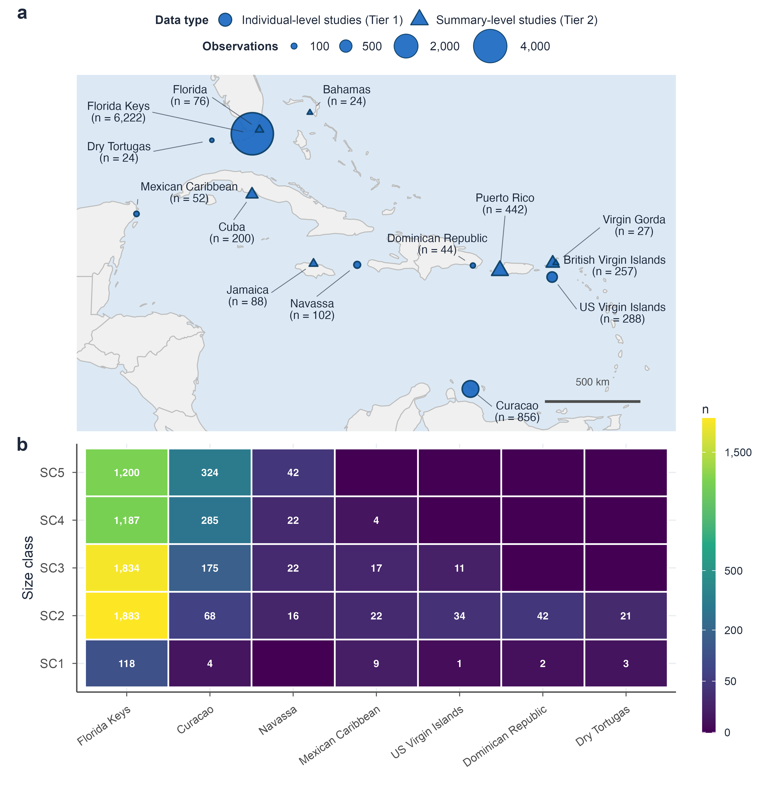
Figure 1. Study locations and size-class coverage for the Acropora palmata demographic synthesis.
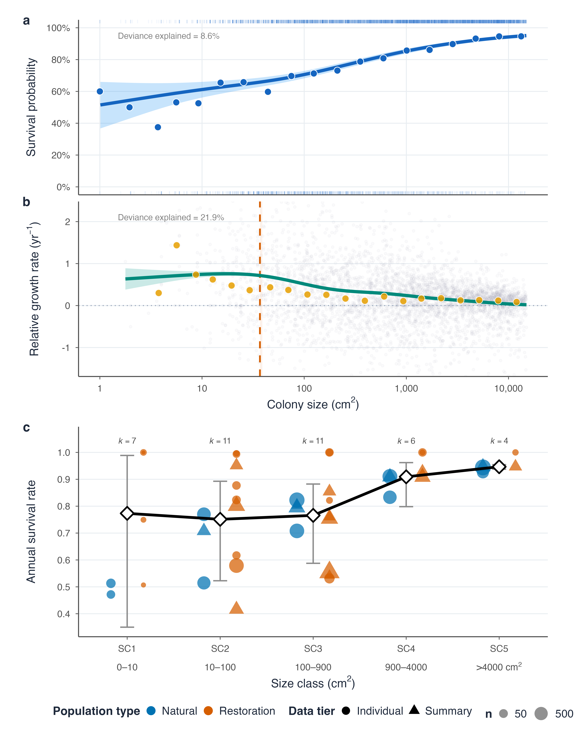
Figure 2. Size-dependent survival and growth rates for Acropora palmata.
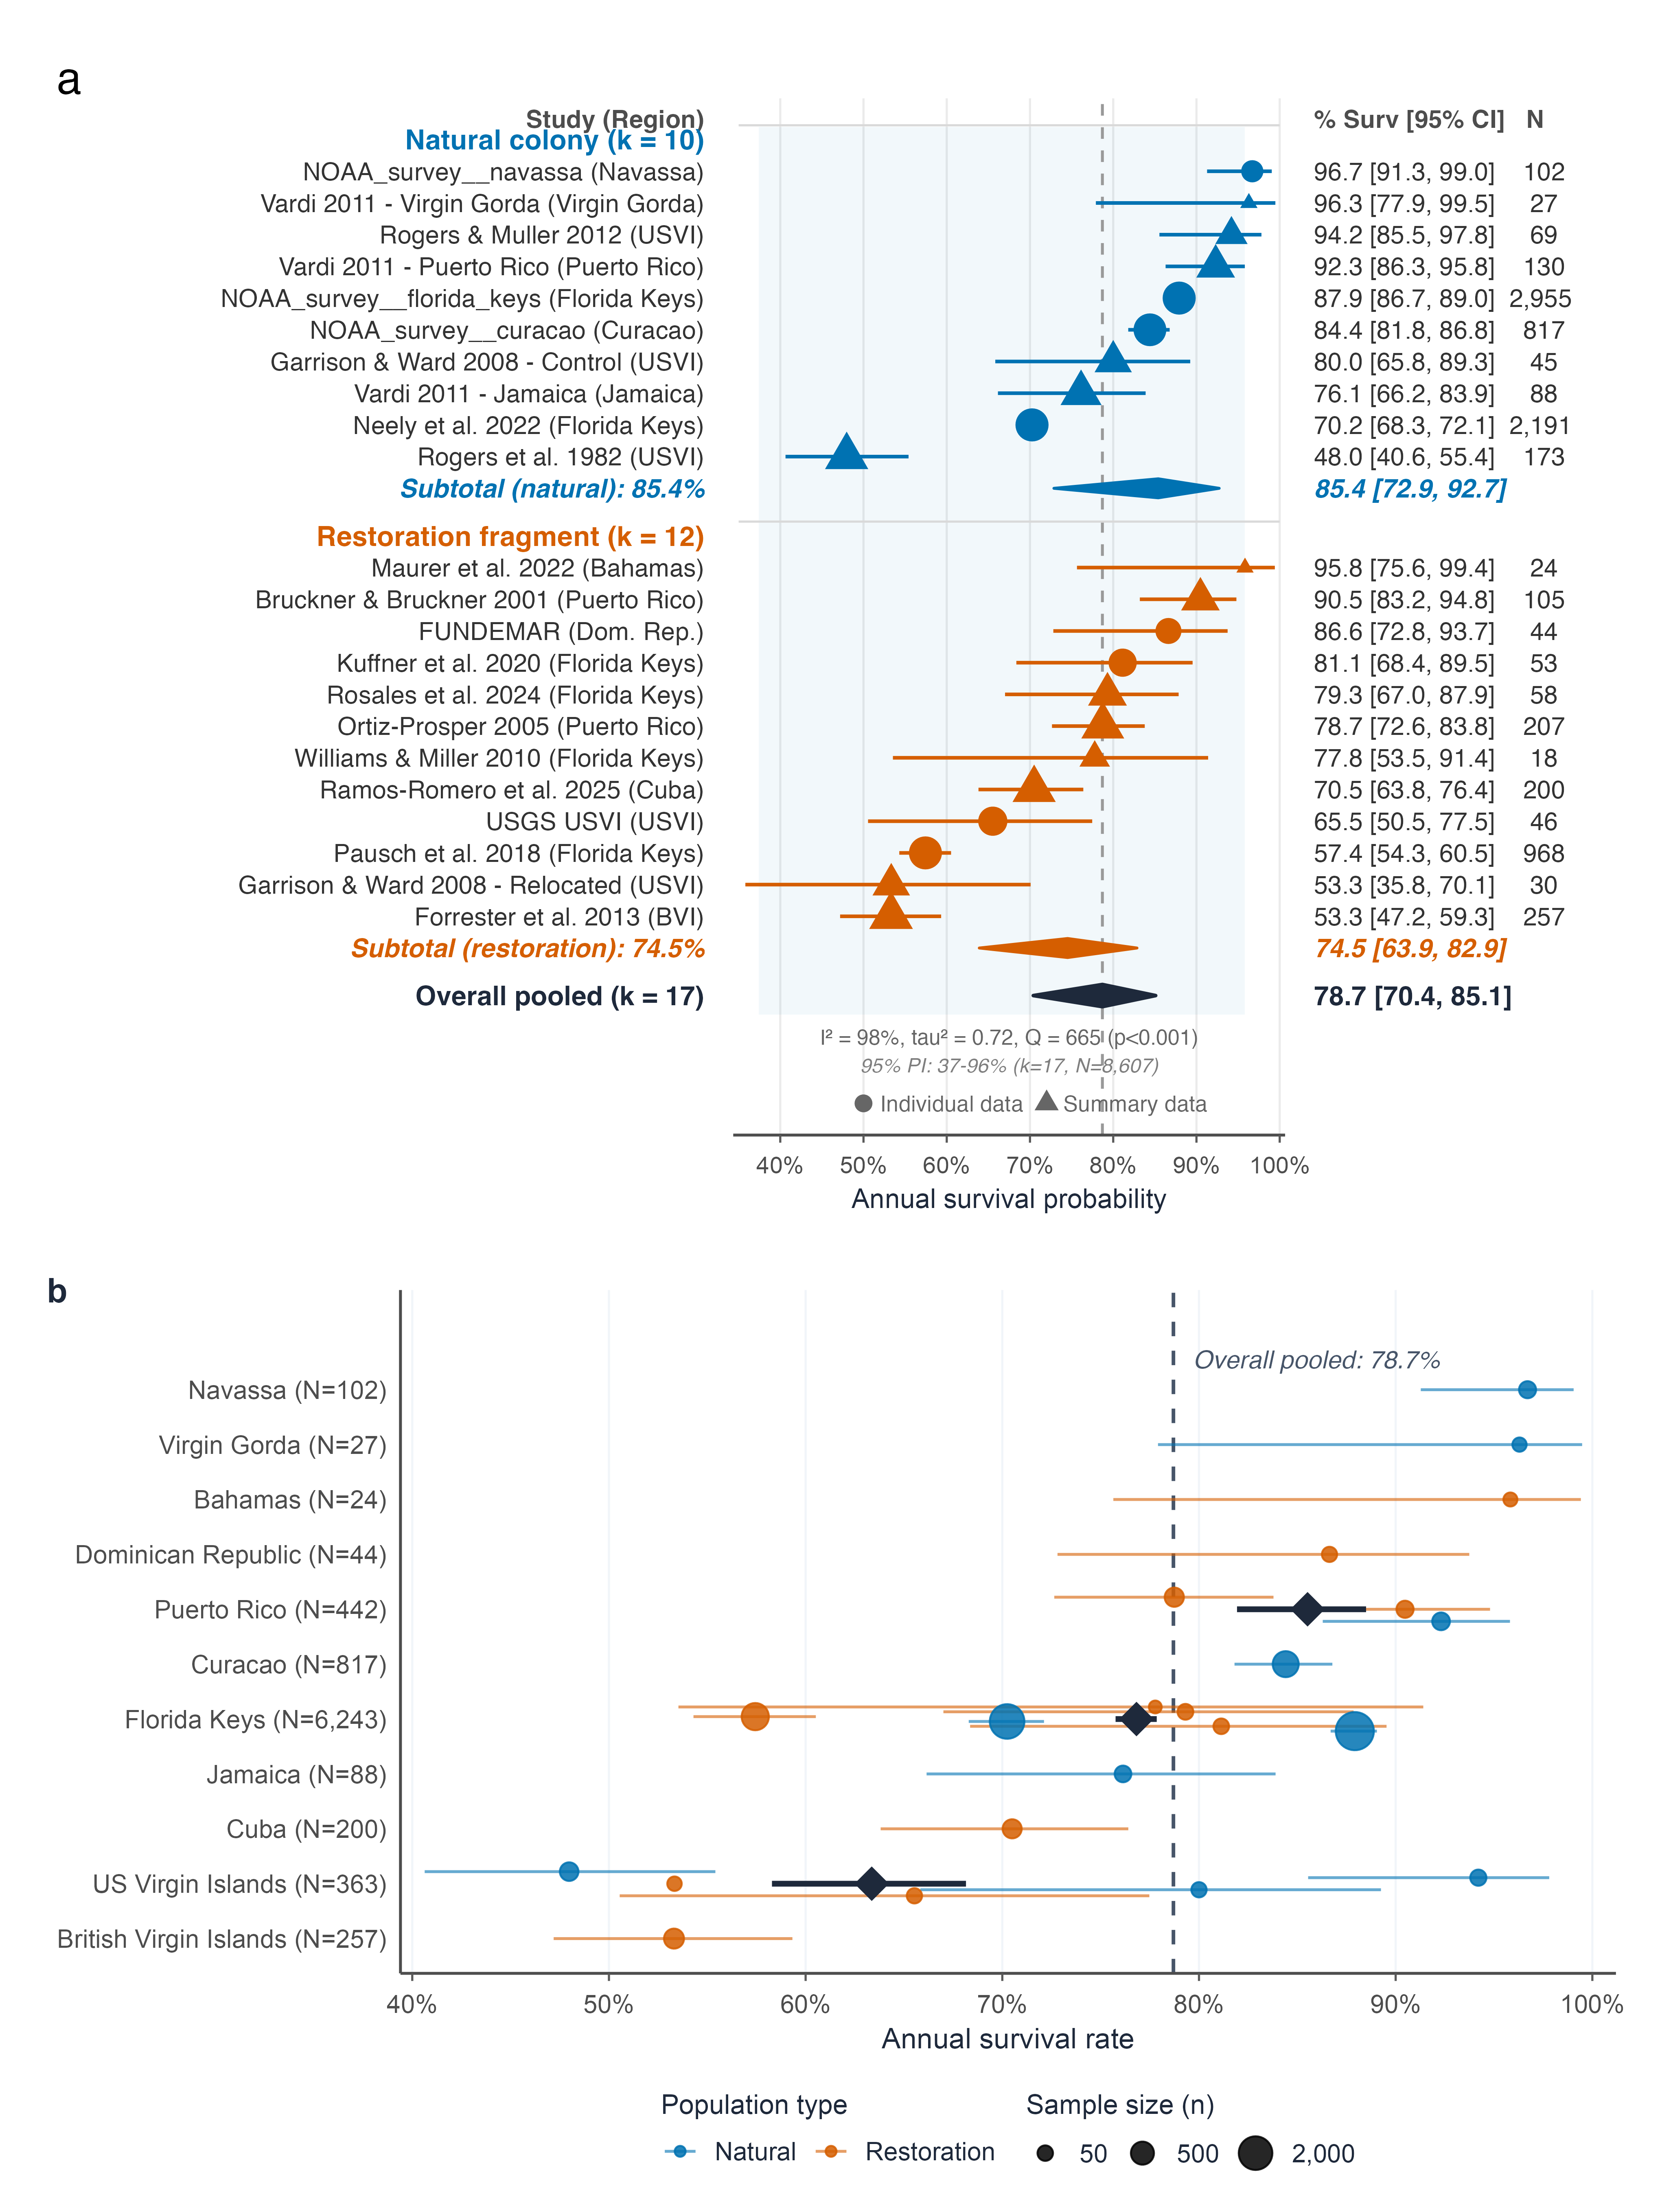
Figure 3. Caribbean-wide annual-survival synthesis for Acropora palmata.
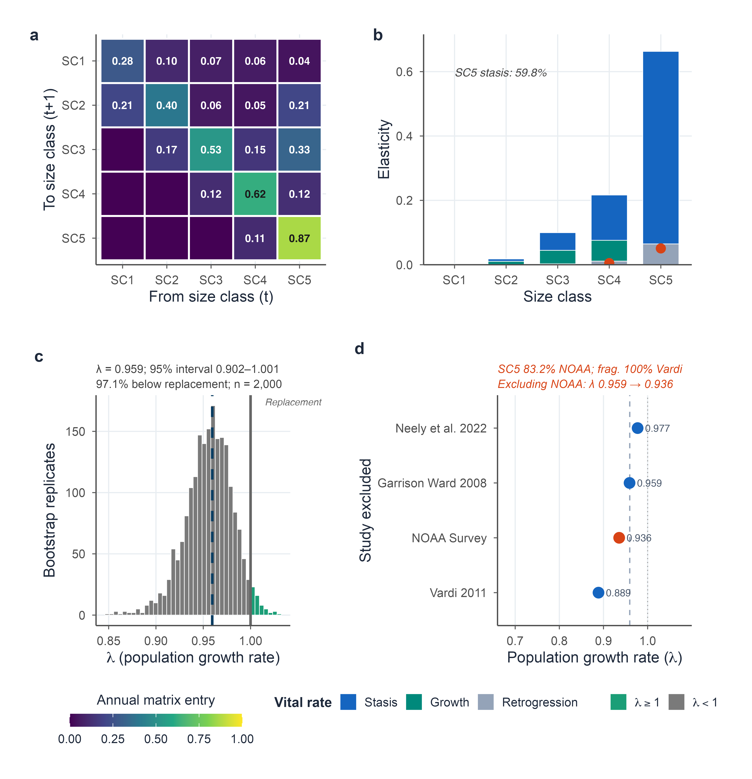
Figure 4. Conditional recruitment-free transition dynamics for Acropora palmata.

References
Aronson RB, Precht WF (2001) White-band disease and the changing face of Caribbean coral reefs. Hydrobiologia 460:25–38
Banister RB, Viehman TS, Schopmeyer S, van Woesik R (2024) Environmental predictors for the restoration of a critically endangered coral, Acropora palmata, along the Florida reef tract. PLoS ONE 19:e0296485. https://doi.org/10.1371/journal.pone.0296485
Bruckner AW, Bruckner RJ (2001) Condition of restored Acropora palmata fragments off Mona Island, Puerto Rico, 2 years after the Fortuna Reefer ship grounding. Coral Reefs 20:235–243. https://doi.org/10.1007/s003380100164
Chamberland VF, Vermeij MJA, Brittsan M, et al (2015) Restoration of critically endangered elkhorn coral (Acropora palmata) populations using larvae reared from wild-caught gametes. Global Ecology and Conservation 4:526–537. https://doi.org/10.1016/j.gecco.2015.10.005
Croquer A, Guendulain-García SD, Lefcheck JS, et al (2026) Towards a systematic framework to assess restoration success of interventions in coral reef ecosystems. PLoS One 21:e0331083. https://doi.org/10.1371/journal.pone.0331083
Detmer AR, Ward EJ, Hunsicker ME, et al (2025) Evaluating the robustness of generalized additive models as a tool for threshold detection in variable environments. Ecosphere 16:e70117. https://doi.org/10.1002/ecs2.70117
Edmunds PJ, Riegl B (2020) Urgent need for coral demography in a world where corals are disappearing. Marine Ecology Progress Series 635:233–242. https://doi.org/10.3354/meps13205
Forrester GE, Ferguson MA, O’Connell-Rodwell CE, Jarecki LL (2014) Long-term survival and colony growth of Acropora palmata fragments transplanted by volunteers for restoration. Aquatic Conservation: Marine and Freshwater Ecosystems 24:81–91. https://doi.org/10.1002/aqc.2374
Forrester GE, Maynard A, Schofield S, Taylor K (2012) Evaluating causes of transplant stress in fragments of Acropora palmata used for coral reef restoration. Bulletin of Marine Science 88:1099–1113. https://doi.org/10.5343/bms.2012.1016
Gardner TA, Côté IM, Gill JA, et al (2003) Long-term region-wide declines in Caribbean corals. Science 301:958–960. https://doi.org/10.1126/science.1086050
Garrison V, Ward G (2008) Storm-generated coral fragments – A viable source of transplants for reef rehabilitation. Biological Conservation 141:3089–3100. https://doi.org/10.1016/j.biocon.2008.09.020
Gladfelter WB (1982) White-band disease in Acropora palmata: Implications for the structure and growth of shallow reefs. Bulletin of Marine Science 32:639–643
Grober-Dunsmore R, Bonito V, Frazer TK (2006) Potential inhibitors to recovery of Acropora palmata populations in St. John, US Virgin Islands. Marine Ecology Progress Series 321:123–132. https://doi.org/10.3354/meps321123
Grober-Dunsmore R, Bonito V, Frazer TK (2007) Discernment of sexual recruits is not critical for assessing population recovery of Acropora palmata. Marine Ecology Progress Series 335:233–237. https://doi.org/10.3354/meps335233
Highsmith RC (1982) Reproduction by fragmentation in corals. Marine Ecology Progress Series 7:207–226
Hughes TP (1984) Population dynamics based on individual size rather than age: A general model with a reef coral example. The American Naturalist 123:778–795
Hughes TP, Jackson JBC (1985) Population dynamics and life histories of foliaceous corals. Ecological Monographs 55:141–166
Knapp G, Hartung J (2003) Improved tests for a random effects meta-regression with a single covariate. Statistics in Medicine 22:2693–2710. https://doi.org/10.1002/sim.1482
Kuffner IB, Stathakopoulos A, Toth LT, Bartlett LA (2020) Reestablishing a stepping-stone population of the threatened elkhorn coral Acropora palmata to aid regional recovery. Endangered Species Research 43:461–473. https://doi.org/10.3354/esr01083
Lentz JA, Blackburn JK, Curtis AJ (2011) Evaluating patterns of a white-band disease outbreak in Acropora palmata using spatial analysis: A comparison of transect and colony clustering. PLoS ONE 6:e21830. https://doi.org/10.1371/journal.pone.0021830
Lirman D (2000) Fragmentation in the branching coral Acropora palmata (Lamarck): Growth, survivorship, and reproduction of colonies and fragments. Journal of Experimental Marine Biology and Ecology 251:41–57
Lirman D (2003) A simulation model of the population dynamics of the branching coral Acropora palmata: Effects of storm intensity and frequency. Ecological Modelling 161:169–182. https://doi.org/10.1016/S0304-3800(02)00346-0
Lirman D, Fong P (1997) Patterns of damage to the branching coral Acropora palmata following Hurricane Andrew: Damage and survivorship of hurricane-generated asexual recruits. Journal of Coastal Research 13:67–72
Madin JS, Baird AH, Baskett ML, et al (2020) Partitioning colony size variation into growth and partial mortality. Biology Letters 16:20190727. https://doi.org/10.1098/rsbl.2019.0727
Madin JS, Baird AH, Dornelas M, Connolly SR (2014) Mechanical vulnerability explains size-dependent mortality of reef corals. Ecology Letters 17:1008–1015. https://doi.org/10.1111/ele.12306
Madin JS, Oliver T, McWilliam M, et al (2025) Demographic insights for coral restoration
Manzello DP, Cunning R, Karp RF, et al (2025) Heat-driven functional extinction of Caribbean Acropora corals from Florida’s Coral Reef. Science 390:361–366. https://doi.org/10.1126/science.adx7825
Maurer L, Puishys L, Ho NKP, et al (2022) Acropora cervicornis and Acropora palmata cultured on a low maintenance line nursery design in The Bahamas. PLoS ONE 17:e0267034. https://doi.org/10.1371/journal.pone.0267034
Mendoza Quiroz S, Beltrán-Torres AU, Grosso-Becerra MV, et al (2023) Long-term survival, growth, and reproduction of Acropora palmata sexual recruits outplanted onto Mexican Caribbean reefs. PeerJ 11:e15813. https://doi.org/10.7717/peerj.15813
Mercado-Molina AE, Ruiz-Diaz CP, Pérez ME, et al (2015) Demography of the threatened coral Acropora cervicornis: Implications for its management and conservation. Coral Reefs 34:1113–1124. https://doi.org/10.1007/s00338-015-1341-8
Neely KL, Macaulay KA, Lunz KS (2022) Population trajectory and stressors of Acropora palmata sites in the Florida Keys. Frontiers in Marine Science 9:978785. https://doi.org/10.3389/fmars.2022.978785
Ortiz Prosper AL (2005) Population dynamics of hurricane-generated fragments of elkhorn coral Acropora palmata (Lamarck, 1816). {PhD} dissertation, University of Puerto Rico, Mayagüez
Pausch RE, Williams DE, Miller MW (2018) Impacts of fragment genotype, habitat, and size on outplanted elkhorn coral success under thermal stress. Marine Ecology Progress Series 592:109–117. https://doi.org/10.3354/meps12488
Piñón-González VM, Banaszak AT (2018) Effects of partial mortality on growth, reproduction and total lipid content in the elkhorn coral Acropora palmata. Frontiers in Marine Science 5:396. https://doi.org/10.3389/fmars.2018.00396
Ramos Romero A, González-Díaz P, Aguilera Pérez G, Banaszak AT (2025) Does reef crest zone selection influence Acropora palmata (Lamarck, 1816) fragment survival and growth? PeerJ 13:e20303. https://doi.org/10.7717/peerj.20303
Randall CJ, Szmant AM (2009) Elevated temperature affects development, survivorship, and settlement of the elkhorn coral, Acropora palmata (Lamarck 1816). The Biological Bulletin 217:269–282. https://doi.org/10.1086/BBLv217n3p269
Ritson-Williams R, Arnold SN, Paul VJ (2020) The impact of macroalgae and cyanobacteria on larval survival and settlement of the scleractinian corals Acropora palmata, A. cervicornis and Pseudodiploria strigosa. Marine Biology 167:31. https://doi.org/10.1007/s00227-019-3639-5
Ritson-Williams R, Arnold SN, Paul VJ, Steneck RS (2014) Larval settlement preferences of Acropora palmata and Montastraea faveolata in response to diverse red algae. Coral Reefs 33:59–66. https://doi.org/10.1007/s00338-013-1113-2
Rogers CS, Muller EM (2012) Bleaching, disease and recovery in the threatened scleractinian coral Acropora palmata in St. John, US Virgin Islands: 2003–2010. Coral Reefs 31:807–819. https://doi.org/10.1007/s00338-012-0898-8
Rogers CS, Suchanek TH, Pecora FA (1982) Effects of Hurricanes David and Frederic (1979) on shallow Acropora palmata reef communities: St. Croix, U.S. Virgin Islands. Bulletin of Marine Science 32:532–548
Rosales SM, Young BD, Bright AJ, et al (2024) Reef site and habitat influence effectiveness of Acropora palmata restoration and its microbiome in the Florida Keys. Communications Earth & Environment 5:689. https://doi.org/10.1038/s43247-024-01816-7
Schill SR, Asner GP, McNulty VP, et al (2021) Site selection for coral reef restoration using airborne imaging spectroscopy. Front Mar Sci 8:698004. https://doi.org/10.3389/fmars.2021.698004
Schopmeyer SA, Lirman D, Bartels E, et al (2017) Regional restoration benchmarks for Acropora cervicornis. Coral Reefs 36:1047–1057. https://doi.org/10.1007/s00338-017-1596-3
Soong K, Lang JC (1992) Reproductive integration in reef corals. Biol Bull 183:418–431. https://doi.org/10.2307/1542018
Vardi T (2011) The threatened Atlantic elkhorn coral, Acropora palmata: Population dynamics and their policy implications. {PhD} dissertation, University of California, San Diego
Vardi T, Williams DE, Sandin SA (2012) Population dynamics of threatened elkhorn coral in the northern Florida Keys, USA. Endangered Species Research 19:157–169. https://doi.org/10.3354/esr00475
Viechtbauer W (2010) Conducting meta-analyses in R with the metafor package. Journal of Statistical Software 36:1–48. https://doi.org/10.18637/jss.v036.i03
Williams DE, Bright AJ, Williamson OM, et al (2023) Synchronous spawning of nursery-raised elkhorn coral (Acropora palmata) outplanted to reefs in the Florida Keys (United States). Frontiers in Marine Science 10:1180996. https://doi.org/10.3389/fmars.2023.1180996
Williams DE, Miller MW (2012) Attributing mortality among drivers of population decline in Acropora palmata in the Florida Keys (USA). Coral Reefs 31:369–382. https://doi.org/10.1007/s00338-011-0847-y
Williams DE, Miller MW (2010) Stabilization of fragments to enhance asexual recruitment in Acropora palmata, a threatened Caribbean coral. Restoration Ecology 18:446–451. https://doi.org/10.1111/j.1526-100X.2009.00579.x
Williams DE, Miller MW, Kramer KL (2008) Recruitment failure in Florida Keys Acropora palmata, a threatened Caribbean coral. Coral Reefs 27:697–705. https://doi.org/10.1007/s00338-008-0386-3

