Online Resource 1: Supporting analyses for size-dependent demography, disturbance, and transition dynamics of Acropora palmata across the Caribbean
Adrian C. Stier; A. Raine Detmer; Karen L. Neely; Tali Vardi; Darcy Bradley; Aldo Croquer; Sergio D. Guendulain-García; Maria F. Villalpando; Rita I. Sellares-Blasco; Jameal F. Samhouri
Journal: Coral Reefs
Corresponding author: Adrian C. Stier, Department of Ecology, Evolution, and Marine Biology and Marine Science Institute, University of California, Santa Barbara, CA 93106, USA.
Corresponding author email: astier@ucsb.edu.

Contents
- Eighteen studies supported the synthesis (Table S1)
- Regional screening windows overlapped most Tier 1 intervals (Tables S2 and S3)
- Survival and relative growth varied with size (Fig. S1)
- Study identity confounded population-origin comparisons (Fig. S2)
- Surviving colonies often lost tissue and retrogressed (Fig. S3)
- Size–survival associations varied among disturbance states (Fig. S4)
- Restoration estimates varied among colony-source subtypes (Fig. S5)
- Florida-scale heatwaves reduced recruitment-free projections (Fig. S6)
- Resampling choices changed uncertainty more than the central estimate (Table S4)
- Initial composition changed finite-horizon projections (Table S5)
Study selection. Consolidating duplicate and within-study entries reduced 104 screening-ledger rows to 101 distinct sources: 83 excluded and 18 included (seven individual-record studies and eleven summary studies). Seventeen studies supplied 22 survival-synthesis effects; Mendoza Quiroz et al. (2023) contributed only to size-dependent analyses. Approximately 2,500 records were identified, but inconsistent early screening totals prevent an exact PRISMA flow. The repository ledger retains all screening decisions.

1. Eighteen studies supported the synthesis
Table S1. Eighteen studies contributed data; seventeen entered the survival synthesis. Tier 1 studies supplied individual colony records; Tier 2 studies supplied study-level summaries. N is the effective annualized denominator in the survival synthesis after interval filtering and aggregation, summed across a study’s effects; survival is the N-weighted mean of annualized effect-level survival and is shown for orientation only (Fig. 3 gives random-effects estimates). Roles: S, survival synthesis; V, size-dependent vital-rate models; M, transition matrix (natural-colony survival and growth). Fragmentation in the matrix came only from Vardi (2011), whose summaries also entered the survival synthesis.
Study | T | Region(s) | Population type | Effects | N | Survival (%) | Roles
NOAA monitoring | 1 | Florida Keys, Curaçao, Navassa | Natural | 3 | 3,874 | 87.4 | S, V, M
Neely et al. (2022) | 1 | Florida Keys | Natural | 1 | 2,626 | 74.8 | S, V, M
Pausch et al. (2018) | 1 | Florida Keys | Restoration | 1 | 968 | 57.4 | S, V
Kuffner et al. (2020) | 1 | Florida Keys | Restoration | 1 | 53 | 81.1 | S, V
USGS outplant experiment (unpublished) | 1 | US Virgin Islands | Restoration | 1 | 46 | 65.5 | S, V
FUNDEMAR fragments (unpublished) | 1 | Dominican Republic | Nursery-held fragments | 1 | 44 | 86.6 | S, V
Mendoza Quiroz et al. (2023) | 1 | Mexican Caribbean | Sexual nursery and reef cohorts | – | – | – | V
Vardi (2011) | 2 | Jamaica, Puerto Rico, Virgin Gorda | Natural | 3 | 245 | 86.9 | S, M
Bruckner and Bruckner (2001) | 2 | Puerto Rico | Restoration | 1 | 105 | 90.5 | S
Ortiz Prosper (2005) | 2 | Puerto Rico | Restoration | 1 | 207 | 78.7 | S
Forrester et al. (2014) | 2 | British Virgin Islands | Restoration | 1 | 257 | 53.3 | S
Rosales et al. (2024) | 2 | Florida Keys | Restoration | 1 | 58 | 79.3 | S
Maurer et al. (2022) | 2 | Bahamas | Restoration | 1 | 24 | 95.8 | S
Williams and Miller (2010) | 2 | Florida Keys | Restoration | 1 | 18 | 77.8 | S
Garrison and Ward (2008) | 2 | US Virgin Islands | Natural and restoration | 2 | 75 | 69.3 | S, M
Rogers and Muller (2012) | 2 | US Virgin Islands | Natural | 1 | 69 | 94.2 | S
Ramos Romero et al. (2025) | 2 | Cuba | Restoration | 1 | 200 | 70.5 | S
Rogers et al. (1982) | 2 | US Virgin Islands | Natural | 1 | 173 | 48.0 | S
Total |  |  |  | 22 | 9,042
The total denominator comprises 7,611 Tier 1 colony-interval records and 1,431 from Tier 2 effect-level sample sizes; it is not a count of unique colonies. The full Tier 1 survival inventory contains 7,778 records, of which 52 Mendoza Quiroz records, 21 Neely records without verified interval duration, and 94 NOAA endpoint-selected fragment records did not enter these survival-synthesis effects.
Source-record checks. Main-text Methods define the area measurements and Neely live-area index. Twenty literal “live” entries establish survival with size unmeasured, not zero tissue; source interval identifiers preserve distinct survey rounds within calendar years. Collector verification removed all records for two colonies identified as another species and supplied one previously missing date. Of 2,647 Neely inventory records with measured starting size, 21 still lack a verified survey date and remain outside duration-based survival analyses. The other 2,626 contribute to the annual-survival effects. Known fates remain in the inventory; missing duration is never replaced by one year in survival cells. The repository’s source-correction and missing-duration audits retain colony IDs, worksheet rows and date-cell addresses. The shared extract omitted colony-type codes, so Neely records have unknown physical fragment status and retain natural population origin. They do not enter the fragment-only comparison without source-linked classification. Main-text Methods and Discussion describe metric differences, clonality and site-specific disturbance responses.
Reporting geography. Florida Keys in the study table and Fig. 1 combines Florida reef-tract records, including Dry Tortugas; original site and region labels remain in the data. The 85.5% Florida Keys share in the main text uses the original Florida Keys label, before combining the additional Dry Tortugas observations for display.
Size and reproductive status. Soong and Lang (1992) reported a smallest fertile A. palmata colony of 16 × 8 cm and an operational puberty size of 1,600 cm² in Panama. Puberty size was the size of the smallest colony in the first group of 20 consecutively size-ranked colonies with at least 90% fertility. Their area estimate summed the living surface area of branches and the colony base; fertility meant gonads in sampled tissue, not observed spawning. These measurements are not directly interchangeable with the area measurements and live-area index pooled here. We therefore did not assign fertility to a model class or treat retrogression as loss of reproductive capacity. Neither reproductive output nor three-dimensional habitat complexity was estimated.

2. Regional screening windows overlapped most Tier 1 intervals
Table S2. Eighteen author-assigned regional screening windows defined the disturbance comparison. The table lists every entry used by the matching algorithm. Years are inclusive analysis windows, not necessarily independently observed onset and end dates. Duration, biological mechanism, and analytical role are separate: an extended event can be assigned to the acute-event sensitivity. SCTLD means stony coral tissue loss disease. No entry establishes exposure or cause of death in a matched colony.
Event or contextual pressure | Matching region | Years | Duration; analytical role | Omitª | Supporting sources
Hurricane Hattie | Belize | 1961 | Acute; Acute-event screen | Yes | (Stoddart 1963)
Historical white-band disease (coral disease) | Caribbean-wide | 1978–1984 | Chronic; Chronic regime | No | (Gladfelter 1982; Aronson and Precht 2001)
First Diadema die-off (indirect herbivory loss) | Caribbean-wide | 1983–1984 | Acute; Acute-event screen | Yes | (Lessios et al. 1984)
Hurricane Andrew | Florida Keys | 1992 | Acute; Acute-event screen | Yes | (Fong and Lirman 1995; Lirman and Fong 1997)
Cuevones Grounding | Mexico | 1997 | Acute; Acute-event screen | Yes | (Victoria-Salazar et al. 2023)
Florida occupancy / water-quality context | Florida (Middle Keys) | 1999–2019 | Chronic; Chronic pressure | No | (Banister et al. 2024)
2005 Hurricane Season | Florida Keys | 2005 | Acute; Acute-event screen | Yes | (Williams and Miller 2012)
2005 Thermal Anomaly | USVI/Florida | 2005–2006 | Chronic; Acute-event screen | Yes | (Miller et al. 2009; Eakin et al. 2010)
Recurring corallivorous-snail pressure | Florida Keys | 2005–2010 | Chronic; Biotic pressure | No | (Miller 2001; Williams and Miller 2012)
Playa Baracoa monitoring / water-quality context | Cuba | 2005–2021 | Chronic; Chronic pressure | No | (Ramos et al. 2024)
2010 Cold-Water Event | Florida Keys | 2010 | Acute; Acute-event screen | Yes | (Lirman et al. 2011; Colella et al. 2012)
Recurring Sargassum pressure | Caribbean-wide | 2011–2025 | Annual; Chronic pressure | No | (Tussenbroek et al. 2017; Antonio-Martínez et al. 2020)
2014–2017 global bleaching period | Caribbean-wide | 2014–2017 | Chronic; Chronic regime | No | (Eakin et al. 2019)
Hurricane Irma | FL Keys/USVI | 2017 | Acute; Acute-event screen | Yes | (National Oceanic and Atmospheric Administration 2017b, 2018)
Noemi del Mar grounding (physical damage) | Puerto Rico | 2017 | Acute; Acute-event screen | Yes | (National Oceanic and Atmospheric Administration 2017a)
SCTLD in other corals (indirect framework loss) | Mexico | 2018–2025 | Chronic; Indirect framework | No | (Alvarez-Filip et al. 2022)
Second Diadema die-off (indirect herbivory loss) | USVI/Caribbean | 2022 | Acute; Acute-event screen | Yes | (Levitan et al. 2023)
2023 Marine Heatwave | Caribbean-wide | 2023 | Acute; Acute-event screen | Yes | (Birkart and Álvarez-Filip 2025; Manzello et al. 2025)
ª Omit means that a matched observation interval was excluded from the acute-event sensitivity only; all intervals remained in the primary analyses. An interval matching several entries was flagged if any had Yes. Otherwise a match meant context-only pressure, and no match meant no curated overlap.
How the windows were assigned. These are screening conventions rather than a complete Caribbean disturbance history. The 1978–1984 white-band period combines historical accounts. The 2011–2025 Sargassum and 2018–2025 SCTLD screens extend reported pressures beyond the years directly observed in their cited studies. The 1999–2019 Florida water-quality window follows occupancy-record coverage, and the 2005–2021 Cuban window follows monitoring coverage; neither identifies uninterrupted pollution at every reef. Sources support the event or pressure, not every chosen boundary or exclusion decision. Unsupported quantitative intensity and impact claims in the original working catalogue are not used as evidence here.
Geographic interpretation. The matcher combined Florida Keys, Dry Tortugas, and Middle Keys labels as Florida, and local Mexican entries as Mexican Caribbean. Thus the local Cuevones grounding and Middle Keys water-quality context can match observations elsewhere in their broad reporting regions. Caribbean-wide entries match every represented region. The 2023 references document named Florida and Puerto Morelos losses, not uniform mortality throughout the Caribbean. Diadema die-offs and SCTLD in other corals describe indirect community changes, not diagnosed disease in A. palmata. Table S3 reports overlap with these choices; the three states cannot identify a causal disturbance effect.
Table S3. Most monitoring windows matched the regional screening catalogue. The summary links 1,003 monitoring-window groups from seven Tier 1 studies to the 18 entries in Table S2; these are grouped windows, not individual colony intervals. Only 35 groups (3.5%) had no catalogue match. “Baseline exclusion” identifies the 289 groups flagged for removal in the acute-event sensitivity analysis; it does not mean that other groups were undisturbed. These proportions describe overlap with the selected catalogue, not the fraction of colonies experiencing a measured disturbance.
Study | Intervals | No overlap | One event | Two or more events | Baseline exclusion | Any overlap (%)
NOAA monitoring | 776 | 35 | 49 | 692 | 220 | 95.5
Neely et al. (2022) | 95 | 0 | 0 | 95 | 10 | 100.0
Pausch et al. (2018) | 70 | 0 | 0 | 70 | 46 | 100.0
USGS outplant experiment | 27 | 0 | 15 | 12 | 12 | 100.0
Kuffner et al. (2020) | 27 | 0 | 0 | 27 | 0 | 100.0
Mendoza Quiroz et al. (2023) | 7 | 0 | 0 | 7 | 0 | 100.0
FUNDEMAR fragments | 1 | 0 | 0 | 1 | 1 | 100.0
Total | 1,003 | 35 | 64 | 904 | 289 | 96.5
Matching rules. Region labels were standardized (for example, Florida Keys and Dry Tortugas to Florida); entries naming several regions were expanded at slashes. Caribbean-wide entries applied to every represented region. If the starting survey year was $y$ and duration in years was $t$, the matching endpoint year was $⌊y+max(t,1)−{10}^{−9}⌋$; missing or non-positive duration used one year for contextual matching only, never for annualizing survival. A match required inclusive calendar-year overlap and a matching region or Caribbean-wide entry. These rules can include a regionally documented pressure that was not measured at a particular reef.
Worked classifications. The 2005 thermal anomaly applied to Florida and the US Virgin Islands in 2005–2006: although its duration was labeled chronic, its analysis tier was acute-event and its exclusion flag was true. By contrast, Caribbean-wide 2014–2017 bleaching was chronic-regime context, with no baseline-exclusion flag; this does not mean bleaching was harmless. The 2018–2025 Mexican SCTLD entry described indirect loss of other framework species, not diagnosed SCTLD in A. palmata, and was not flagged for exclusion. White-band disease represented direct coral-disease history; Diadema die-offs represented indirect loss of herbivory. An interval with any true exclusion flag entered the acute category, one with overlap but no true flag entered context-only pressure, and one with no curated overlap entered no-curated-disturbance. Duration, biological mechanism, and analytical exclusion were separate fields.
The independent linkage check found no field mismatches; it verified execution of these rules, not individual exposure or cause of death. Table S2 gives the complete catalogue and its supporting sources. The repository retains the interval-by-entry assignments and diagnostics.

3. Survival and relative growth varied with size
Fig. S1. Relative growth changed curvature at small sizes, whereas positive-growth probability had no supported nonlinear threshold. (a) Survival against log colony area for natural colonies, excluding subannual intervals (n = 5,688); the generalized additive model (GAM) improved Akaike information criterion (AIC) over the linear model by 9.6 units (reporting gate: 2). (b) Probability of positive growth, for all colony sources (n = 5,049); the nonlinearity gate failed, so no threshold is marked. (c) Second derivative of the relative growth rate (RGR) GAM (n = 4,998); the dashed line marks the curvature minimum near 35 cm², not an outplant-size optimum. (d, e) Absolute areal growth rate (AGR, cm² yr⁻¹; n = 5,049) and RGR (yr⁻¹; n = 4,998) against colony size using their fitted records. (f) Within-bin standard deviations of AGR (cm² yr⁻¹) and RGR (yr⁻¹) on a logarithmic vertical axis (n = 5,886); lines join size-bin summaries and are directly labeled. The two growth measures have different units, so their standard deviations are not directly comparable in magnitude. Blue denotes survival or AGR; teal denotes positive growth or RGR. Points in a and b are binned proportions with approximate binomial 95% intervals; points in d and e are individual records. Solid curves are unadjusted GAM fits with pointwise 95% confidence ribbons; the dotted curve in a is the linear comparison. Growth responses use live-area change where available and total-area change otherwise; area includes the Neely index. Panel d and e axes display the central 98% of responses, while fits retain every fitted record. Primary growth fits exclude impossible values and proportional changes outside −50% to 200%; the variance display instead trims the extreme 0.5% tails and excludes high-variance Navassa records. The omitted lower-dimension positive-growth panel remains a repository diagnostic, not a second threshold estimate.
Fig. S1 (continued)
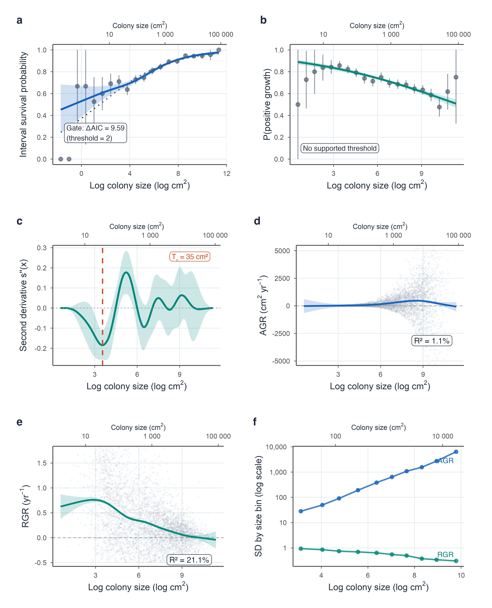

4. Study identity confounded population-origin comparisons
Fig. S2. Natural-colony and restoration-origin comparisons are confounded by study identity and a narrow shared size range. Each facet shows one Tier 1 study within the size range shared by natural and restoration records; restoration origin includes nursery-held material as well as outplants. (a) Observed survival and (b) relative growth rate (RGR, yr⁻¹) against initial area (cm²), including the Neely live-area index where available. Points are observations, coloured lines are study-specific binomial generalized linear model (a) or linear model (b) fits on log size, shaded bands are 95% confidence intervals, and labels give population type and sample size. For a study with all observed colonies surviving, the horizontal line marks the observed proportion; no survival slope or confidence band was estimated. The shared range (9–278 cm²) covers only a small part of the observed variation in colony area. Within it, survival slopes differed in sign among studies, so this comparison is descriptive rather than a causal estimate of restoration origin.
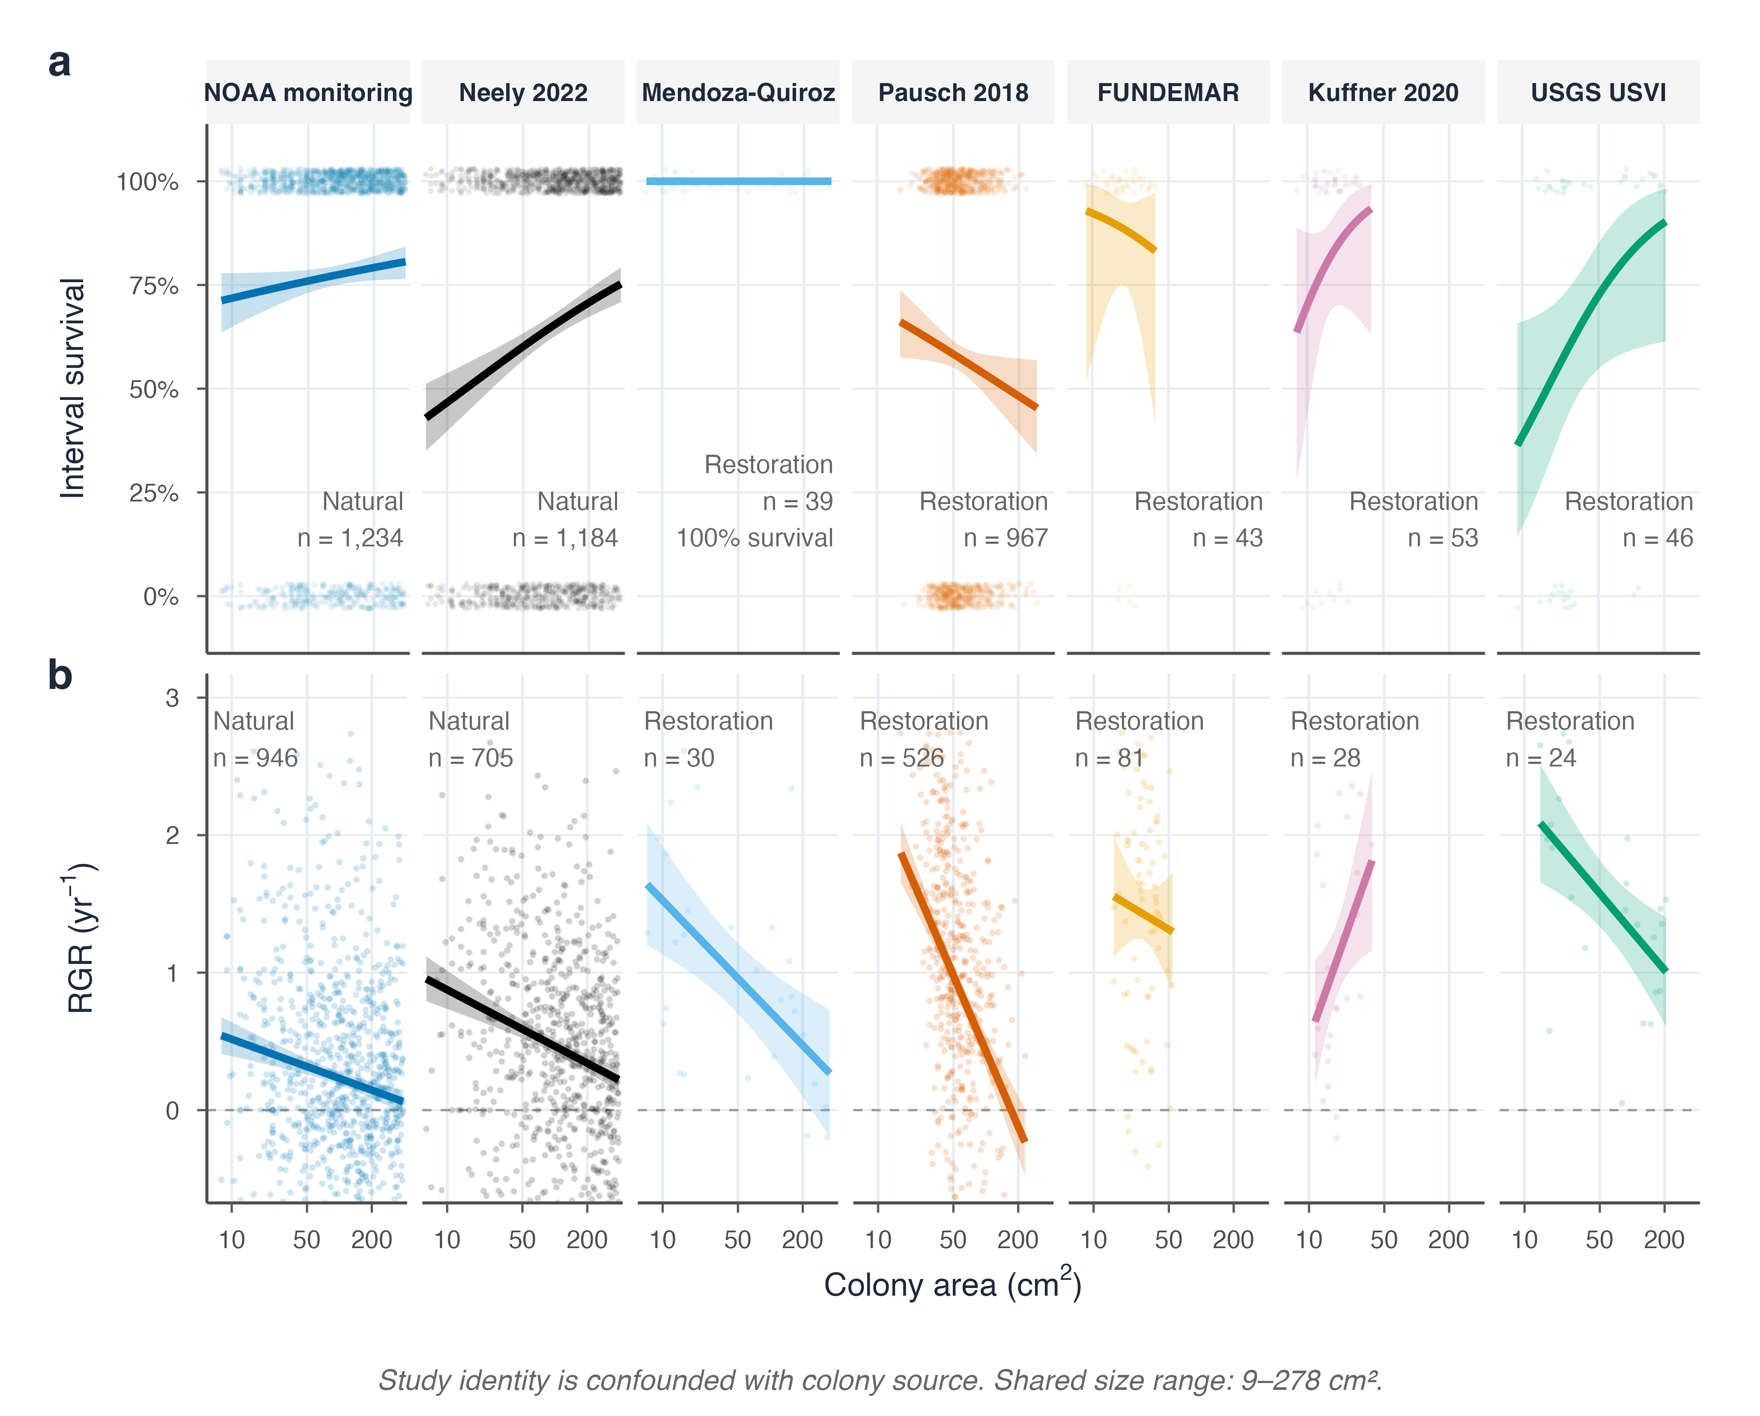

5. Surviving colonies often lost tissue and retrogressed
Fig. S3. Large colonies commonly survived while losing tissue, and every class above SC1 included transitions to smaller classes. Tissue loss means any negative annual change in live area; shrinkage, or retrogression, means a transition to a smaller size class, following Vardi et al. (2012). (a) Tissue-loss frequency among surviving colonies by size class, rising from 22.5% in SC1 to 44.4% in SC5. (b) Mean annual tissue loss among colonies with negative area change (cm² yr⁻¹). (c) Annualized transition probabilities: orange, movement to a larger class; gray, stasis; blue, retrogression. Labels give nonzero growth and retrogression percentages. SC5 has no larger destination class. (d) Tissue-loss frequency by natural-colony study; point colour gives mean tissue loss and point size the number of records. All panels use the transition matrix’s 4,791 natural-colony records from NOAA and Neely, with measured initial live area or live-area index (LAI), annual live-area change, and a positive observed live endpoint. Restoration records are excluded to keep this figure aligned with that natural-colony transition model; the separate descriptive restoration comparisons are in Fig. S5. Records were restricted to 0.5–1.5-year intervals, excluding impossible growth and the upper 1% of absolute live-area changes. Panel c projects one-year area from annualized change, with a 0.1 cm² floor, rather than observing every colony after exactly one year. SC1–SC5 starting counts were 40, 644, 1,416, 1,308, and 1,383.
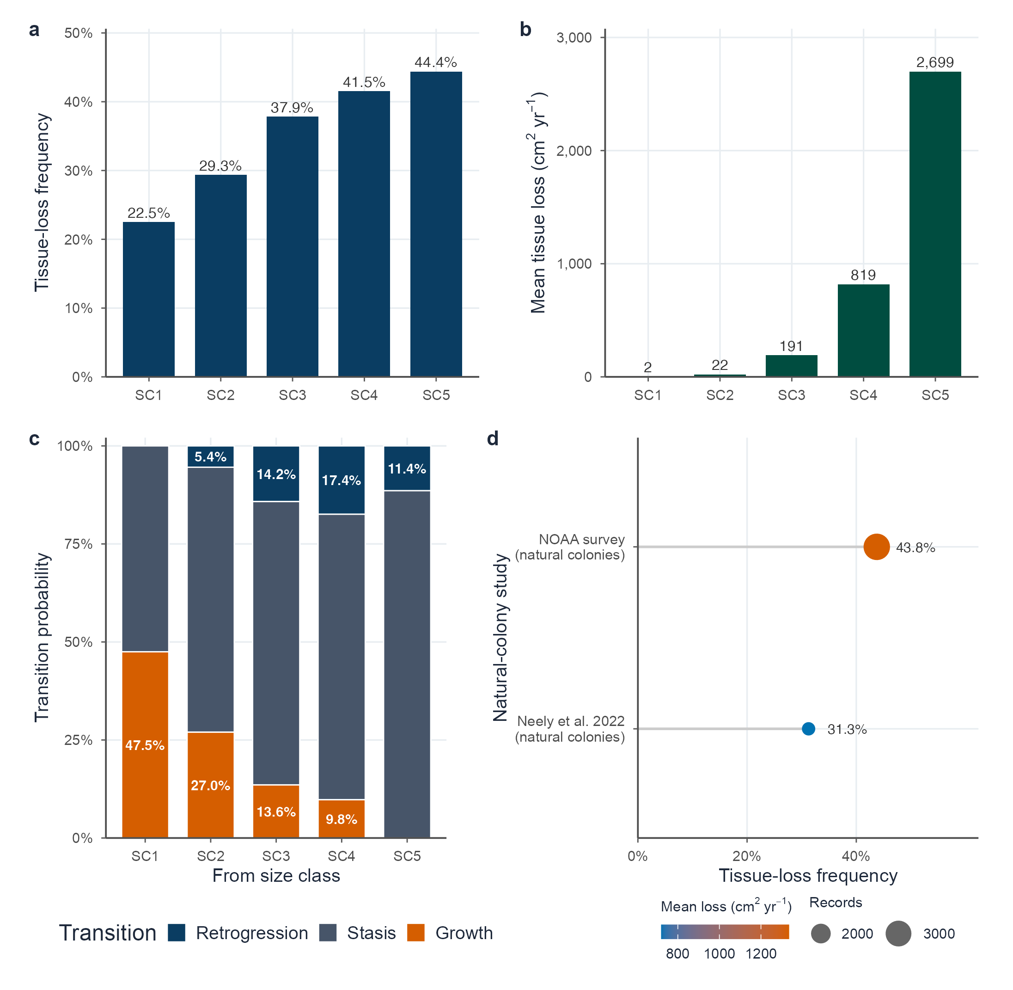

6. Size–survival associations varied among disturbance states
Fig. S4. Size associations differed among regional screening states, without identifying causal disturbance effects. Tiles show (a) observed interval survival (n = 6,500 natural-colony records) and (b) the proportion with positive reported areal growth (n = 5,441 natural-colony records), by starting size class and catalogue-overlap state. Labels give percentages and cell counts; blue encodes survival and orange positive growth, matching the outcome colors in Fig. S5. Both panels display percentages only for cells with at least five records. Gray “<5 obs.” tiles indicate sparse observations; white “No data” tiles indicate none. The no-curated-disturbance SC1 cell contains one survival record and no growth records. This display rule does not exclude records from the models or summary tables. The global size-by-state interaction had likelihood-ratio p = 0.001 for survival and p = 0.005 for positive growth; these are not pairwise tests of the displayed class-specific contrasts. Models included a study random intercept. The states follow the author-assigned windows in Table S2 and section 2, and remain confounded with study, site, and survey period. Growth uses live-area change where available and total-area change otherwise, unlike the strict live-area subset in Fig. S3.
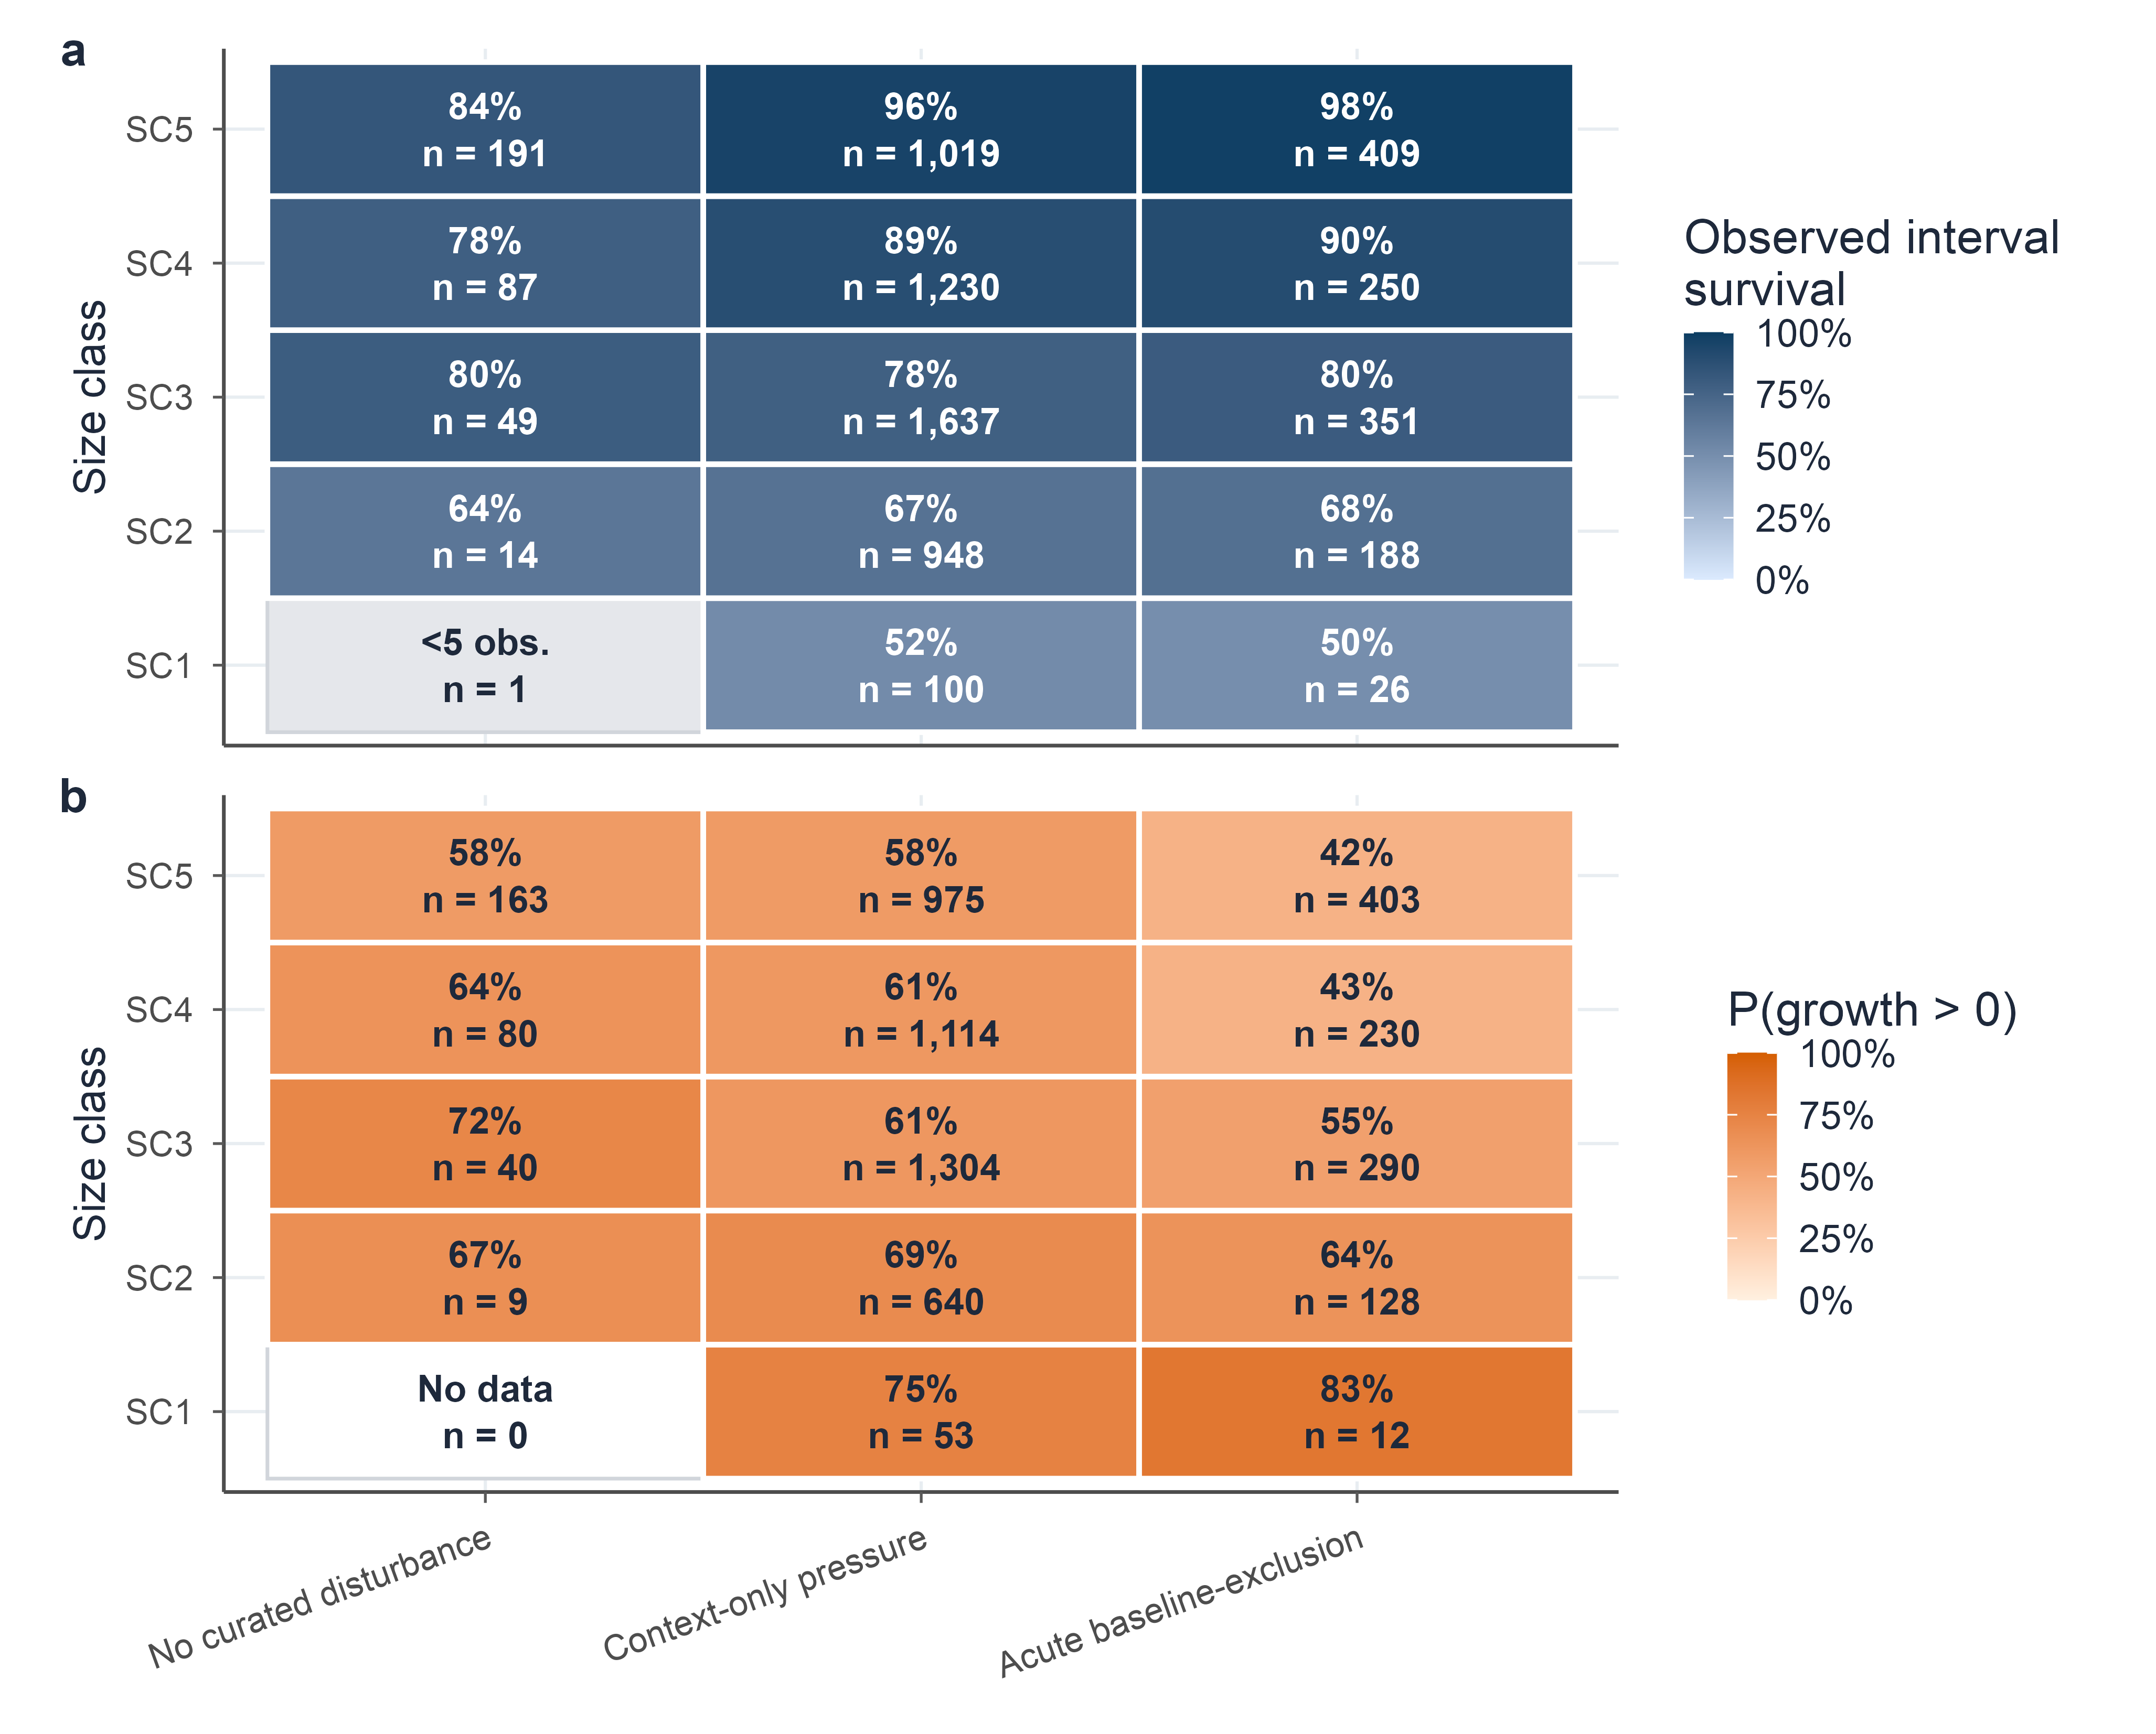

7. Restoration estimates varied among colony-source subtypes
Fig. S5. Seven propagation and observation groups define different descriptive comparisons. (a) Observed interval survival and (b) mean relative live-area growth (yr⁻¹). Open circles are study–region summaries with point area proportional to records; filled diamonds, offset above each row, are record-weighted group means, blue for survival and orange for growth. Neither panel shows uncertainty bars because the available studies cannot establish comparable between-program uncertainty. The survival inventory comprises 1,257 records from six studies, displayed in the same order in both panels: 94 naturally occurring fragments (NOAA), 968 nursery outplants (Pausch), 53 block-mounted nursery fragments (Kuffner), 46 reef outplants of unspecified origin (USGS), 44 nursery-held fragments (FUNDEMAR), 35 sexually propagated reef outplants (Mendoza Quiroz), and 17 sexually propagated nursery juveniles (Mendoza Quiroz). Kuffner’s nursery fragments were mounted on removable discs bolted to reef blocks, not reattached after post-planting breakage. NOAA fragment status was assigned among living endpoints, so its apparent 100% survival is withheld, not presented as cohort survival. Neely’s shared extract omitted colony-type codes, so its 2,647 inventory intervals retained unknown fragment status and natural population origin; none were assigned to a fragment subgroup. The remaining 1,163 records support descriptive interval-survival points; differing interval durations prevent reading these as standardized annual rates. Growth includes 857 records from four studies, requiring measured initial live area and annual live-area change, positive duration, and a positive observed endpoint, without total-area substitution. Kuffner and Mendoza Quiroz lack the required live-change field; unavailable growth is labeled, not zero. Propagation, study, site, handling, and sample size are unbalanced, so these summaries cannot rank restoration practices.
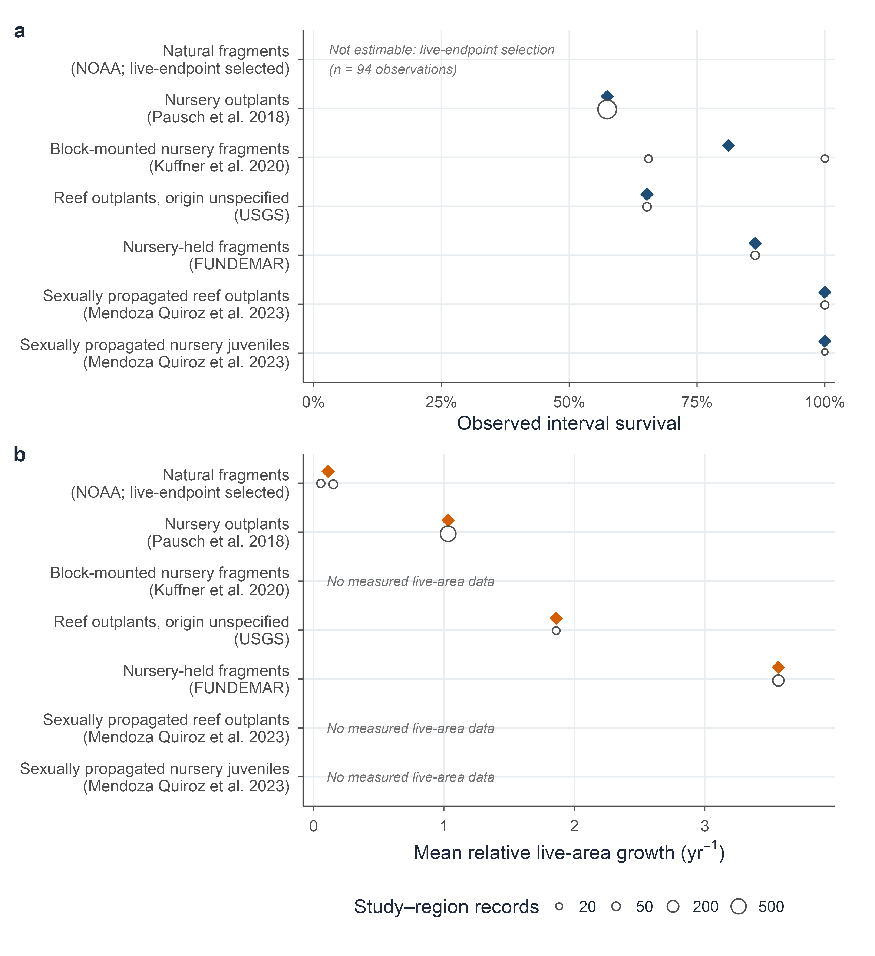

8. Florida-scale heatwaves reduced recruitment-free projections
Fig. S6. Recurrence of Florida-scale heatwave mortality drives effective lambda far below one in the recruitment-free transition subsystem. (a) Logistic mortality curve parameterized from the A. palmata DHW thresholds reported by Manzello et al. (2025) (ED50 = 7.8 DHW; ED95 = 17.6 DHW); the shaded range marks the 16–20 DHW exposure in the Florida Keys in 2023. (b) Median 50-year trajectories and 95% simulation intervals without heatwaves and for the observed 2023 Florida endpoint (97.8–100% mortality) at four return intervals; the dashed line marks the quasi-extinction threshold of 10% of initial abundance. (c) Effective lambda across dose-response and observed-endpoint scenarios; bars are geometric means of annual abundance ratios from simulations that scale the fixed matrix structure by one bootstrap lambda per replicate, and the dotted line is the unperturbed deterministic lambda (0.953). Each scenario used 500 simulations. Without heatwaves, effective lambda was 0.936 and 83.8% of simulations were below the quasi-extinction threshold at year 50; every observed-endpoint scenario was below that threshold at year 50 in all simulations. The 5-, 10-, 20-, and 50-year intervals span frequent to rare recurrence and are sensitivity values, not estimated return periods. The pooled reference includes monitoring through 2024, not a fitted pre-2023 counterfactual. These additional Florida-like pulses are stress tests, not historical reconstructions or Caribbean-wide forecasts.
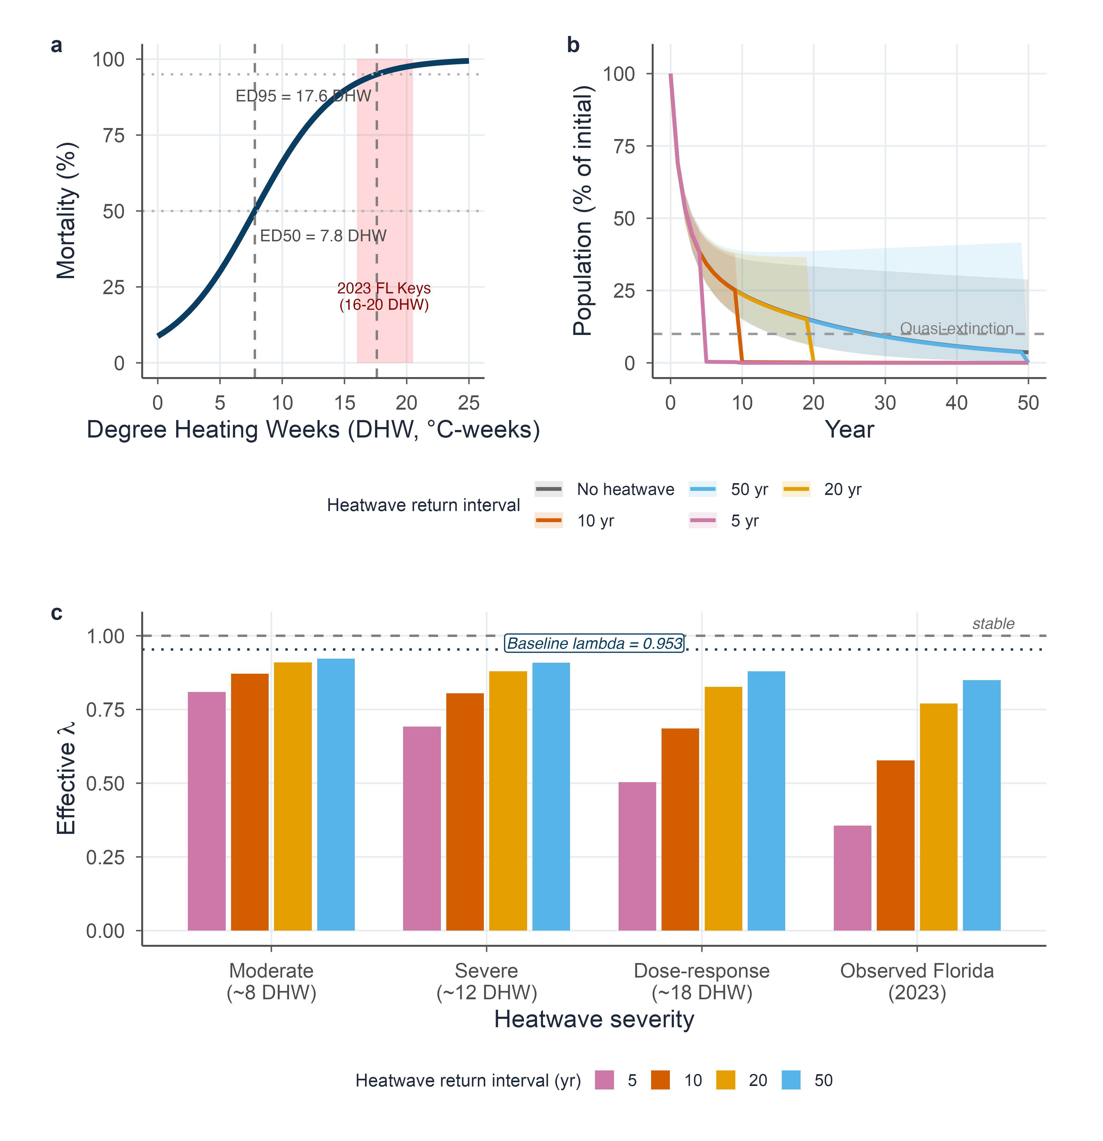

9. Resampling choices changed uncertainty more than the central estimate
Table S4. Alternative resampling choices left lambda predominantly below replacement. All analyses used the five-class recruitment-free matrix, annualized study-level survival pooling, near-annual natural-colony live-area transitions, and row-resampled annual fragmentation estimates. Transitions required both initial live area and annual live-area change; total-colony measurements were not substituted. Observed endpoints at or below zero were excluded from conditional growth, while deaths remained in the survival analysis. We projected one-year area by adding annual live-area change to initial live area and applying a 0.1 cm² floor. Intervals are 2.5th–97.5th bootstrap percentiles; the final column is the percentage of lambda estimates below one, not a probability of decline in a real population. n is the number of retained replicates. Analyses used R 4.5.2 and the project’s locked package versions.
Resampling and missing-class treatment | n | Replicates imputed | 95% interval | Below one (%)
Primary independent, point imputation | 2,000 | 124 | 0.913–1.000 | 97.4
Primary independent, discard incomplete | 1,876 | 0 | 0.912–1.000 | 97.5
Independent sensitivity, point imputation | 2,000 | 135 | 0.913–0.999 | 97.6
Independent sensitivity, distribution imputation | 2,000 | 135 | 0.913–0.999 | 97.6
Fixed study mix, independent | 2,000 | 0 | 0.914–0.999 | 97.6
Fixed study mix, coordinated | 2,000 | 0 | 0.921–0.989 | 99.3
The primary bootstrap drew four survival studies and two growth studies independently, then resampled survival cells and colony growth records within each selected study. The independent sensitivity used a separate seed; within each replicate, point imputation and distribution imputation used identical survival, growth, and fragmentation draws. For a missing survival class, distribution imputation replaced its full-data point estimate with a survival draw from that class’s full-data bootstrap distribution. This propagated conditional sampling uncertainty, but did not supply evidence from an unobserved population.
For the fixed-study-mix comparison, both versions sampled two study instances from the two shared survival–growth studies and two from the survival-only studies. Growth used either a separate draw from the shared studies or the same draw as survival. Holding this mix fixed distinguished study-level coordination from changes in source coverage; it did not estimate within-colony or year-to-year survival–growth covariance. Each sensitivity retained 2,000 replicates, using seed 20261007.
Vardi (2011) contributed survival data and the only fragmentation estimates, but no paired individual growth records to this matrix. With growth held unchanged and missing survival classes filled by the full-data estimates, lambda was 0.953 with all data, 0.951 when only Vardi’s survival data were removed, 0.889 when only its fragmentation estimates were removed, and 0.888 when both were removed. The combined exclusion therefore mainly reflected loss of fragmentation.
SC5-to-SC5 stasis accounted for 51.5% of matrix-cell elasticity (95% bootstrap interval: 38.8–64.7%). This means persistence in the largest live-area class strongly influenced the modeled rate; it does not estimate an intervention’s effect. The primary independent-bootstrap interval extended slightly beyond replacement (upper limit 1.0001 before three-decimal rounding). The separate imputation-sensitivity upper limit was 0.9990, just below replacement.

10. Initial composition changed finite-horizon projections
Table S5. Initial size composition affected the 50-year abundance threshold more than the choice of matrix-uncertainty representation. Each row used all 2,000 valid bootstrap draws. Full-matrix simulations retained one complete bootstrap matrix for 50 years; lambda-only simulations retained the full-data matrix scaled by the corresponding bootstrap lambda. Effective lambda is exp[mean(log(N50 / N0))/50], where Nt is total abundance at year t. The two percentage columns give fractions below 10% of initial abundance at year 50 without heatwaves and with observed Florida mortality recurring every 50 years. These are conditional simulation fractions, not full population-viability probabilities.
Initial composition | Uncertainty | Baseline effective lambda | Below threshold, no heatwave (%) | Below threshold, 50-year heatwave (%)
Original | Lambda-only | 0.936 | 82.5 | 100.00
Original | Full matrix | 0.936 | 80.7 | 100.00
Small-colony-heavy | Lambda-only | 0.925 | 92.1 | 100.00
Small-colony-heavy | Full matrix | 0.925 | 90.8 | 100.00
Large-colony-heavy | Lambda-only | 0.972 | 22.0 | 99.90
Large-colony-heavy | Full matrix | 0.971 | 23.2 | 99.85
Stable | Lambda-only | 0.955 | 50.6 | 100.00
Stable | Full matrix | 0.955 | 51.4 | 100.00
The original SC1–SC5 starting abundances were 100, 50, 30, 20, and 10 colonies. Small-colony-heavy proportions were 70, 15, 8, 5, and 2%; large-colony-heavy proportions were their exact reverse, 2, 5, 8, 15, and 70%. The stable composition was the full-data matrix’s dominant right eigenvector normalized to sum to one. All compositions were normalized to the same initial abundance. These assumptions bracket contrasting size structures, not measured regional compositions or verified ages or maturity states.
Heatwave pulses followed the annual matrix transition and multiplied all classes by survival drawn uniformly from 0–2.2%, the reported bounds for the 2023 Florida endpoint (Manzello et al. 2025). The same pulse draws were used across matrix methods and initial compositions, with seed 20261007 plus the scenario index. Full-matrix projections for the original composition gave effective lambdas of 0.358, 0.578, 0.772, and 0.850 for 5-, 10-, 20-, and 50-year recurrence, respectively. At least 99.85% of simulations were below the endpoint threshold at 5-, 10-, 20-, and 50-year recurrence across all starting compositions and both uncertainty methods; the only fractions below 100% occurred with the large-colony-heavy composition at 50-year recurrence. Threshold attainment at any earlier time was recorded separately from the year-50 endpoint; the two measures agreed for baseline and observed-Florida scenarios, but not for every dose-response scenario. There was no sexual recruitment, immigration, density dependence, or environmental variation in annual matrix transitions.

References
Alvarez-Filip L, González-Barrios FJ, Pérez-Cervantes E, Molina-Hernández A, Estrada-Saldívar N (2022) Stony coral tissue loss disease decimated Caribbean coral populations and reshaped reef functionality. Communications Biology 5:440. https://doi.org/10.1038/s42003-022-03398-6
Antonio-Martínez F, Henaut Y, Vega-Zepeda A, Cerón-Flores AI, Raigoza-Figueras R, Cetz-Navarro NP, Espinoza-Avalos J (2020) Leachate effects of pelagic Sargassum spp. On larval swimming behavior of the coral Acropora palmata. Scientific Reports 10:3910. https://doi.org/10.1038/s41598-020-60864-z
Aronson RB, Precht WF (2001) White-band disease and the changing face of Caribbean coral reefs. Hydrobiologia 460:25–38
Banister RB, Viehman TS, Schopmeyer S, van Woesik R (2024) Environmental predictors for the restoration of a critically endangered coral, Acropora palmata, along the Florida reef tract. PLoS ONE 19:e0296485. https://doi.org/10.1371/journal.pone.0296485
Birkart LV, Álvarez-Filip L (2025) 2023 global heatwave causes mass mortality of a keystone coral on shallow western Atlantic reefs. iScience 28:113722. https://doi.org/10.1016/j.isci.2025.113722
Bruckner AW, Bruckner RJ (2001) Condition of restored Acropora palmata fragments off Mona Island, Puerto Rico, 2 years after the Fortuna Reefer ship grounding. Coral Reefs 20:235–243. https://doi.org/10.1007/s003380100164
Colella MA, Ruzicka RR, Kidney JA, Morrison JM, Brinkhuis VB (2012) Cold-water event of January 2010 results in catastrophic benthic mortality on patch reefs in the Florida Keys. Coral Reefs 31:621–632. https://doi.org/10.1007/s00338-012-0880-5
Eakin CM, Morgan JA, Heron SF, Smith TB, Liu G, Alvarez-Filip L, Baca B, Bartels E, Bastidas C, Bouchon C, Brandt M, Bruckner AW, Bunkley-Williams L, Cameron A, Causey BD, Chiappone M, Christensen TRL, Crabbe MJC, Day O, Guardia E de la, Díaz-Pulido G, DiResta D, Gil-Agudelo DL, Gilliam DS, Ginsburg RN, Gore S, Guzmán HM, Hendee JC, Hernández-Delgado EA, Husain E, Jeffrey CFG, Jones RJ, Jordán-Dahlgren E, Kaufman LS, Kline DI, Kramer PA, Lang JC, Lirman D, Mallela J, Manfrino C, Maréchal J-P, Marks K, Mihaly J, Miller WJ, Mueller EM, Muller EM, Orozco Toro CA, Oxenford HA, Ponce-Taylor D, Quinn N, Ritchie KB, Rodríguez S, Ramírez AR, Romano S, Samhouri JF, Sánchez JA, Schmahl GP, Shank BV, Skirving WJ, Steiner SCC, Villamizar E, Walsh SM, Walter C, Weil E, Williams EH, Roberson KW, Yusuf Y (2010) Caribbean corals in crisis: Record thermal stress, bleaching, and mortality in 2005. PLoS ONE 5:e13969. https://doi.org/10.1371/journal.pone.0013969
Eakin CM, Sweatman HPA, Brainard RE (2019) The 2014–2017 global-scale coral bleaching event: Insights and impacts. Coral Reefs 38:539–545. https://doi.org/10.1007/s00338-019-01844-2
Fong P, Lirman D (1995) Hurricanes cause population expansion of the branching coral Acropora palmata (Scleractinia): Wound healing and growth patterns of asexual recruits. Marine Ecology 16:317–335. https://doi.org/10.1111/j.1439-0485.1995.tb00415.x
Forrester GE, Ferguson MA, O’Connell-Rodwell CE, Jarecki LL (2014) Long-term survival and colony growth of Acropora palmata fragments transplanted by volunteers for restoration. Aquatic Conservation: Marine and Freshwater Ecosystems 24:81–91. https://doi.org/10.1002/aqc.2374
Garrison V, Ward G (2008) Storm-generated coral fragments – A viable source of transplants for reef rehabilitation. Biological Conservation 141:3089–3100. https://doi.org/10.1016/j.biocon.2008.09.020
Gladfelter WB (1982) White-band disease in Acropora palmata: Implications for the structure and growth of shallow reefs. Bulletin of Marine Science 32:639–643
Kuffner IB, Stathakopoulos A, Toth LT, Bartlett LA (2020) Reestablishing a stepping-stone population of the threatened elkhorn coral Acropora palmata to aid regional recovery. Endangered Species Research 43:461–473. https://doi.org/10.3354/esr01083
Lessios HA, Robertson DR, Cubit JD (1984) Spread of Diadema mass mortality through the Caribbean. Science 226:335–337. https://doi.org/10.1126/science.226.4672.335
Levitan DR, Best RM, Edmunds PJ (2023) Sea urchin mass mortalities 40 y apart further threaten Caribbean coral reefs. Proceedings of the National Academy of Sciences 120:e2218901120. https://doi.org/10.1073/pnas.2218901120
Lirman D, Fong P (1997) Patterns of damage to the branching coral Acropora palmata following Hurricane Andrew: Damage and survivorship of hurricane-generated asexual recruits. Journal of Coastal Research 13:67–72
Lirman D, Schopmeyer S, Manzello D, Gramer LJ, Precht WF, Muller-Karger F, Banks K, Barnes B, Bartels E, Bourque A, Byrne J, Donahue S, Duquesnel J, Fisher L, Gilliam D, Hendee J, Johnson M, Maxwell K, McDevitt E, Monty J, Rueda D, Ruzicka R, Thanner S (2011) Severe 2010 cold-water event caused unprecedented mortality to corals of the Florida Reef Tract and reversed previous survivorship patterns. PLoS ONE 6:e23047. https://doi.org/10.1371/journal.pone.0023047
Manzello DP, Cunning R, Karp RF, Baker AC, Bartels E, Bonhag R, Borreil A, Bourque A, Brown KT, Bruckner AW, Corbett B, D’Alessandro M, Dahlgren C, Dilworth J, Geiger E, Gilliam DS, Gomez M, Hanson G, Harrell C, Hesley D, Huebner LK, Kenkel CD, Koch HR, Kuehl J, Kuffner IB, Ladd MC, Lee S, Lesneski KC, Lewan A, Lirman D, Liu G, Matsuda SB, Montoya-Maya PH, Moore J, Muller EM, Nedimyer K, Parkinson JE, Ruzicka R, Spadaro J, Spady BL, Stein J, Unsworth JD, Walter C, Wen ADE, Williams DE, Williams SD, Williamson OM (2025) Heat-driven functional extinction of Caribbean Acropora corals from Florida’s Coral Reef. Science 390:361–366. https://doi.org/10.1126/science.adx7825
Maurer L, Puishys L, Ho NKP, Dahlgren C, Kamerman TY, Martin S, Stamper MA (2022) Acropora cervicornis and Acropora palmata cultured on a low maintenance line nursery design in The Bahamas. PLoS ONE 17:e0267034. https://doi.org/10.1371/journal.pone.0267034
Mendoza Quiroz S, Beltrán-Torres AU, Grosso-Becerra MV, Muñoz Villareal D, Tecalco Rentería R, Banaszak AT (2023) Long-term survival, growth, and reproduction of Acropora palmata sexual recruits outplanted onto Mexican Caribbean reefs. PeerJ 11:e15813. https://doi.org/10.7717/peerj.15813
Miller J, Muller E, Rogers C, Waara R, Atkinson A, Whelan KRT, Patterson M, Witcher B (2009) Coral disease following massive bleaching in 2005 causes 60% decline in coral cover on reefs in the US Virgin Islands. Coral Reefs 28:925–937. https://doi.org/10.1007/s00338-009-0531-7
Miller MW (2001) Corallivorous snail removal: Evaluation of impact on Acropora palmata. Coral Reefs 19:293–295. https://doi.org/10.1007/PL00006963
National Oceanic and Atmospheric Administration (2017a) Boat injures corals: Local partners and NOAA respond in Puerto Rico
National Oceanic and Atmospheric Administration (2017b) Hurricane Irma: NOS fiscal year 2017 year in review
National Oceanic and Atmospheric Administration (2018) NOAA and partners assess reef, aid recovery following Hurricane Irma
Neely KL, Macaulay KA, Lunz KS (2022) Population trajectory and stressors of Acropora palmata sites in the Florida Keys. Frontiers in Marine Science 9:978785. https://doi.org/10.3389/fmars.2022.978785
Ortiz Prosper AL (2005) Population dynamics of hurricane-generated fragments of elkhorn coral Acropora palmata (Lamarck, 1816). PhD dissertation, University of Puerto Rico, Mayagüez
Pausch RE, Williams DE, Miller MW (2018) Impacts of fragment genotype, habitat, and size on outplanted elkhorn coral success under thermal stress. Marine Ecology Progress Series 592:109–117. https://doi.org/10.3354/meps12488
Ramos A, González-Díaz P, Banaszak AT, Perera O, Hernandez Delgado F, Delfín de León S, Vicente Castro P, Aguilera Pérez GC, Duran A (2024) Seventeen-year study reveals fluctuations in key ecological indicators on two reef crests in Cuba. PeerJ 12:e16705. https://doi.org/10.7717/peerj.16705
Ramos Romero A, González-Díaz P, Aguilera Pérez G, Banaszak AT (2025) Does reef crest zone selection influence Acropora palmata (Lamarck, 1816) fragment survival and growth? PeerJ 13:e20303. https://doi.org/10.7717/peerj.20303
Rogers CS, Muller EM (2012) Bleaching, disease and recovery in the threatened scleractinian coral Acropora palmata in St. John, US Virgin Islands: 2003–2010. Coral Reefs 31:807–819. https://doi.org/10.1007/s00338-012-0898-8
Rogers CS, Suchanek TH, Pecora FA (1982) Effects of Hurricanes David and Frederic (1979) on shallow Acropora palmata reef communities: St. Croix, U.S. Virgin Islands. Bulletin of Marine Science 32:532–548
Rosales SM, Young BD, Bright AJ, Montes E, Zhang J-Z, Traylor-Knowles N, Williams DE (2024) Reef site and habitat influence effectiveness of Acropora palmata restoration and its microbiome in the Florida Keys. Communications Earth & Environment 5:689. https://doi.org/10.1038/s43247-024-01816-7
Soong K, Lang JC (1992) Reproductive integration in reef corals. Biol Bull 183:418–431. https://doi.org/10.2307/1542018
Stoddart DR (1963) Effects of Hurricane Hattie on the British Honduras reefs and cays, October 30-31, 1961. Atoll Research Bulletin 95:1–142. https://doi.org/10.5479/si.00775630.95.1
Tussenbroek BI van, Hernández Arana HA, Rodríguez-Martínez RE, Espinoza-Avalos J, Canizales-Flores HM, González-Godoy CE, Barba-Santos MG, Vega-Zepeda A, Collado-Vides L (2017) Severe impacts of brown tides caused by Sargassum spp. on near-shore Caribbean seagrass communities. Marine Pollution Bulletin 122:272–281. https://doi.org/10.1016/j.marpolbul.2017.06.057
Vardi T (2011) The threatened Atlantic elkhorn coral, Acropora palmata: Population dynamics and their policy implications. PhD dissertation, University of California, San Diego
Vardi T, Williams DE, Sandin SA (2012) Population dynamics of threatened elkhorn coral in the northern Florida Keys, USA. Endangered Species Research 19:157–169. https://doi.org/10.3354/esr00475
Victoria-Salazar I, González EJ, Meave JA, Ruiz-Zárate M-Á, Hernández-Arana HA (2023) Stories told by corals, algae, and sea-urchins in a Mesoamerican coral reef: Degradation trumps succession. PeerJ 11:e14680. https://doi.org/10.7717/peerj.14680
Williams DE, Miller MW (2010) Stabilization of fragments to enhance asexual recruitment in Acropora palmata, a threatened Caribbean coral. Restoration Ecology 18:446–451. https://doi.org/10.1111/j.1526-100X.2009.00579.x
Williams DE, Miller MW (2012) Attributing mortality among drivers of population decline in Acropora palmata in the Florida Keys (USA). Coral Reefs 31:369–382. https://doi.org/10.1007/s00338-011-0847-y

