Online Resource 1: Supporting analyses for size-dependent demography, disturbance, and transition dynamics of Acropora palmata across the Caribbean
Adrian C. Stier; A. Raine Detmer; Jameal F. Samhouri; Darcy Bradley; Aldo Croquer; Rita I. Sellares-Blasco
Journal: Coral Reefs
Corresponding author: Adrian C. Stier, Department of Ecology, Evolution, and Marine Biology and Marine Science Institute, University of California, Santa Barbara, CA 93106, USA.
Corresponding author email: astier@ucsb.edu.

Contents
- Studies contributing to the synthesis (Table S1)
- Study-window disturbance summary (Table S2)
- Growth-size diagnostics (Fig. S1)
- Population origin is confounded with study identity (Fig. S2)
- Shrinkage and retrogression (Fig. S3)
- Disturbance and size-dependent survival (Fig. S4)
- Restoration subtype sensitivity (Fig. S5)
- Florida-scale heatwave scenarios (Fig. S6)

1. Studies contributing to the synthesis
Table S1. Eighteen studies contributed data; seventeen entered the survival synthesis. Tier 1 studies supplied individual colony records; Tier 2 studies supplied study-level summaries. N is the effective annualized denominator in the survival synthesis after interval filtering and aggregation, summed across a study’s effects; survival is the N-weighted mean of annualized effect-level survival and is shown for orientation only (Fig. 3 gives random-effects estimates). Roles: S, survival synthesis; V, size-dependent vital-rate models; M, transition matrix (natural-colony survival and growth). Fragmentation in the matrix came only from Vardi (2011), whose summaries also entered the survival synthesis.
Study | T | Region(s) | Population type | Effects | N | Survival (%) | Roles
NOAA monitoring | 1 | Florida Keys, Curaçao, Navassa | Natural | 3 | 3,874 | 87.4 | S, V, M
Neely et al. (2022) | 1 | Florida Keys | Natural | 1 | 2,191 | 70.2 | S, V, M
Pausch et al. (2018) | 1 | Florida Keys | Restoration | 1 | 968 | 57.4 | S, V
Kuffner et al. (2020) | 1 | Florida Keys | Restoration | 1 | 53 | 81.1 | S, V
USGS outplant experiment (unpublished) | 1 | US Virgin Islands | Restoration | 1 | 46 | 65.5 | S, V
FUNDEMAR fragments (unpublished) | 1 | Dominican Republic | Restoration | 1 | 44 | 86.6 | S, V
Mendoza Quiroz et al. (2023) | 1 | Mexican Caribbean | Restoration (sexual outplants) | – | – | – | V
Vardi (2011) | 2 | Jamaica, Puerto Rico, Virgin Gorda | Natural | 3 | 245 | 86.9 | S, M
Bruckner and Bruckner (2001) | 2 | Puerto Rico | Restoration | 1 | 105 | 90.5 | S
Ortiz Prosper (2005) | 2 | Puerto Rico | Restoration | 1 | 207 | 78.7 | S
Forrester et al. (2014) | 2 | British Virgin Islands | Restoration | 1 | 257 | 53.3 | S
Rosales et al. (2024) | 2 | Florida Keys | Restoration | 1 | 58 | 79.3 | S
Maurer et al. (2022) | 2 | Bahamas | Restoration | 1 | 24 | 95.8 | S
Williams and Miller (2010) | 2 | Florida Keys | Restoration | 1 | 18 | 77.8 | S
Garrison and Ward (2008) | 2 | US Virgin Islands | Natural and restoration | 2 | 75 | 69.3 | S
Rogers and Muller (2012) | 2 | US Virgin Islands | Natural | 1 | 69 | 94.2 | S
Ramos Romero et al. (2025) | 2 | Cuba | Restoration | 1 | 200 | 70.5 | S
Rogers et al. (1982) | 2 | US Virgin Islands | Natural | 1 | 173 | 48.0 | S
Total |  |  |  | 22 | 8,607

2. Study-window disturbance summary
Table S2. Curated disturbance overlap was pervasive across the demographic records. The study-window summary links 1,072 prepared survival intervals from the seven Tier 1 studies to the curated disturbance timeline. Only 53 intervals (4.9%) overlapped no curated event. “Baseline exclusion” identifies the 297 intervals removed only in the acute-event sensitivity analysis; it does not mean that other intervals were undisturbed.
Study | Intervals | No overlap | One event | Two or more events | Baseline exclusion | Any overlap (%)
NOAA monitoring | 842 | 50 | 59 | 733 | 228 | 94.1
Neely et al. (2022) | 98 | 3 | 0 | 95 | 10 | 96.9
Pausch et al. (2018) | 70 | 0 | 0 | 70 | 46 | 100.0
USGS outplant experiment | 27 | 0 | 15 | 12 | 12 | 100.0
Kuffner et al. (2020) | 27 | 0 | 0 | 27 | 0 | 100.0
Mendoza Quiroz et al. (2023) | 7 | 0 | 0 | 7 | 0 | 100.0
FUNDEMAR fragments | 1 | 0 | 0 | 1 | 1 | 100.0
Total | 1,072 | 53 | 74 | 945 | 297 | 95.1
The linkage produced zero field mismatches. Full disturbance chronology, interval-level assignments, and extended diagnostics are available in the project repository.

3. Growth-size diagnostics
Fig. S1. Survival and growth change with colony size at different points in ontogeny. (a) Annual survival against log live planar area; the label gives the improvement of the GAM over a linear model (ΔAICc = 17.9; the pre-specified gate for reporting a threshold was 2). (b) Probability of positive growth; the dashed line marks the supported threshold (411 cm²). (c) Second derivative of the relative-growth-rate GAM; the dashed line marks the steepest change in curvature (37 cm²). (d, e) Absolute growth rate (AGR, cm² yr⁻¹) and relative growth rate (RGR, yr⁻¹) against colony size. (f) Probability of positive growth fitted with a lower-dimension smooth (k = 3), which captures the broad U-shaped trend but not the dome detected in panel b. (g) Standard deviation of AGR and RGR within size bins on a log scale: AGR variance rose by more than two orders of magnitude across the size range, whereas RGR variance declined. Points are binned observations, lines are GAM fits, and ribbons or error bars are 95% confidence intervals. Analyses exclude the upper and lower 0.5% of relative-growth values to limit leverage by extreme proportional changes and exclude high-variance Navassa records.
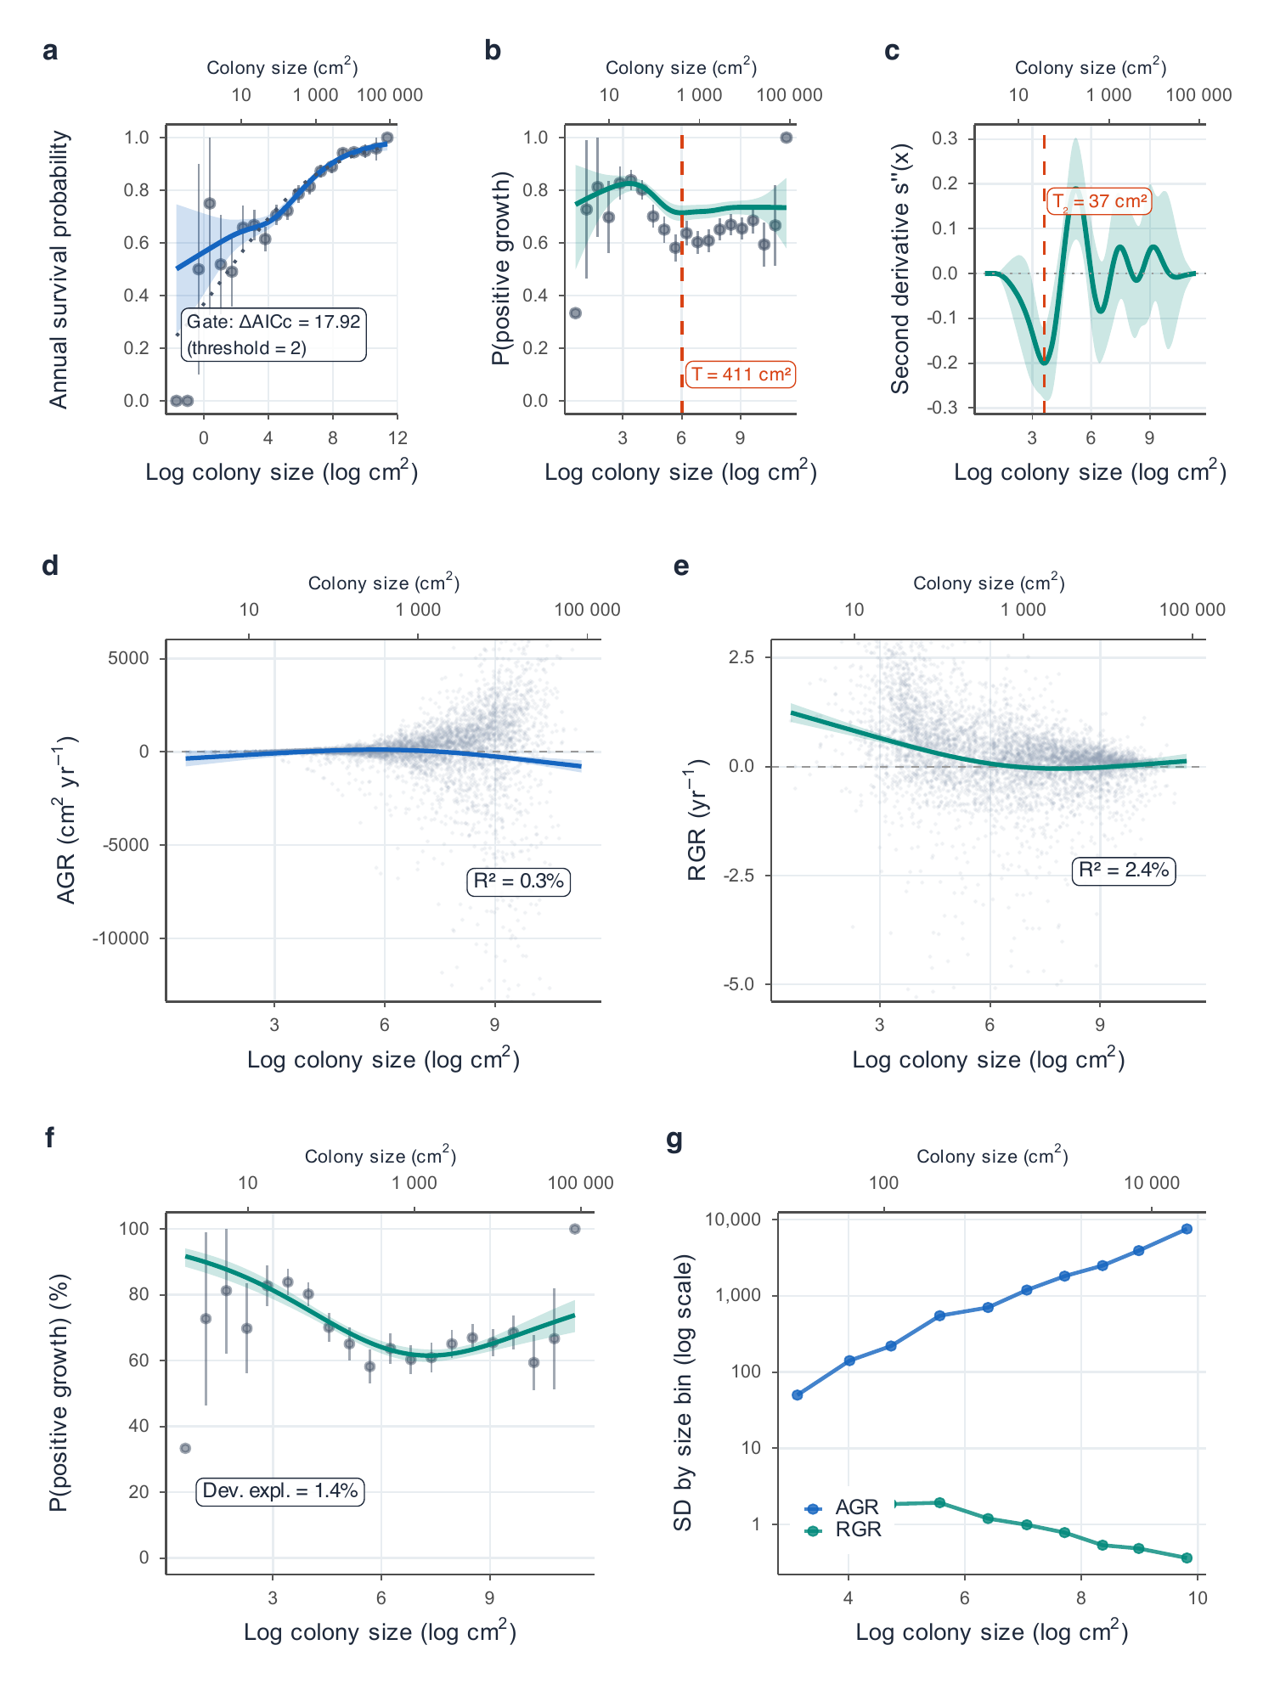

4. Population origin and study identity
Fig. S2. Natural-colony and restoration-fragment comparisons are confounded by study identity and a narrow shared size range. Each facet shows one Tier 1 study within the size range shared by natural and restoration records. (a) Annual survival and (b) relative growth rate (yr⁻¹) against initial live tissue area (cm²). Points are observations, coloured lines are study-specific binomial GLM (a) or linear model (b) fits on log size, shaded bands are 95% confidence intervals, and labels give population type and sample size. The shared range (11–202 cm²) is small relative to the full 1–15,000 cm² range, and within it survival slopes differed in sign among studies, so this comparison is descriptive rather than a causal estimate of restoration origin.
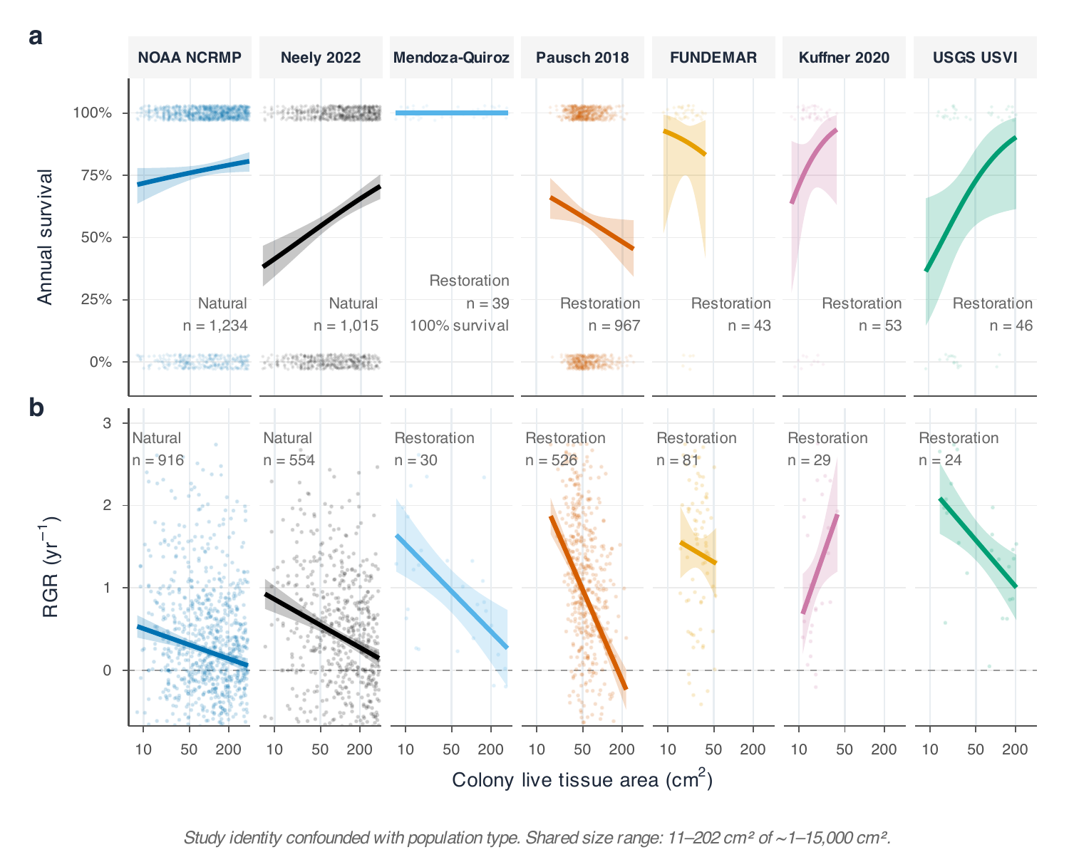

5. Shrinkage and retrogression
Fig. S3. Large colonies commonly survived while losing tissue, and every non-recruit class moved backward through the size structure. (a) Shrinkage frequency among surviving colonies by size class, rising from 18.2% in SC1 to 47.5% in SC5. (b) Mean annual tissue loss among shrinking colonies (cm² yr⁻¹). (c) Observed annual transition probabilities (growth, stasis, retrogression) by initial size class; labels give retrogression probabilities. (d) Shrinkage frequency by study; point colour gives mean tissue loss and point size the number of records. The analysis uses matrix-compatible records of surviving colonies with paired size observations.
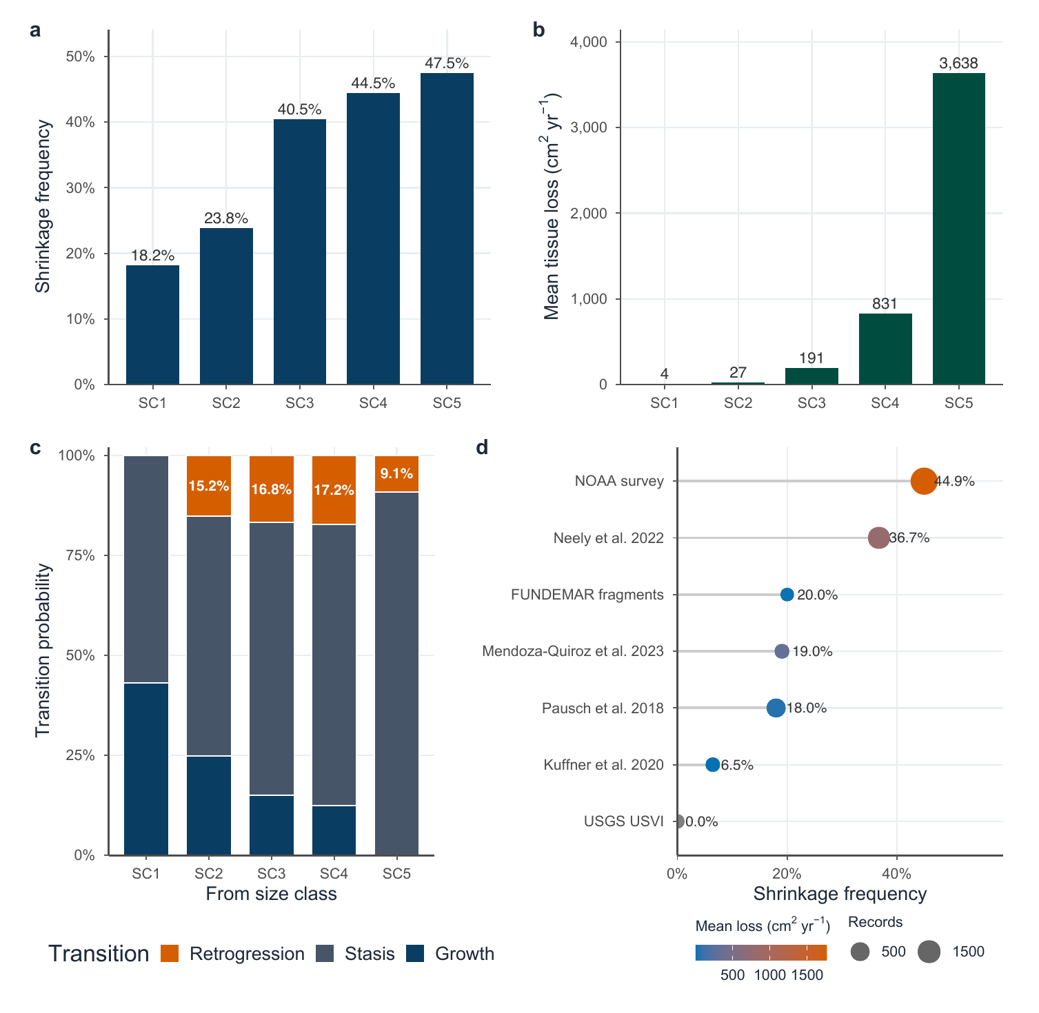

6. Disturbance and size-dependent survival
Fig. S4. The relationship between size and survival differed among curated disturbance states, but not as a simple disturbance penalty. Tiles give observed (a) annual survival and (b) probability of positive growth by size class and disturbance state for natural colonies (n = 6,141 survival records). Tile labels are percentages. The size-by-state interaction was supported for survival (likelihood-ratio test, p < 0.001) and weaker for positive growth (p = 0.010). Large colonies survived better in intervals flagged for acute events (SC5, 98.0%, n = 409) than in intervals with no curated event (SC5, 83.9%, n = 193). The no-disturbance category contained only 353 records, including a single SC1 colony, so its SC1 tile is not interpretable. Disturbance states are observational and confounded with study, site, and survey period.
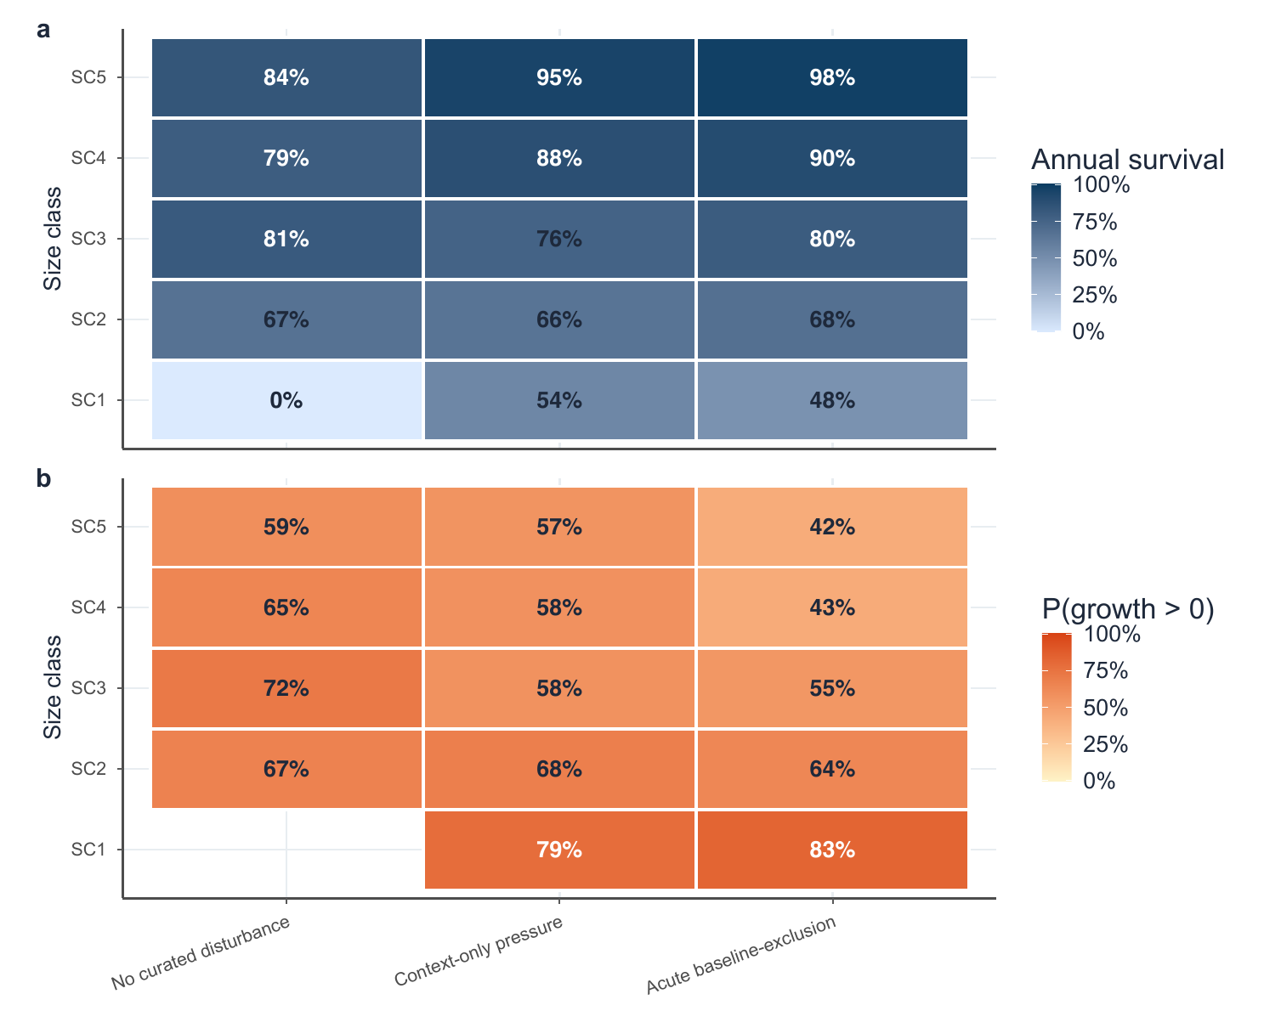

7. Restoration subtype sensitivity
Fig. S5. Apparent restoration performance depends on the biological material grouped under that label. (a) Annual survival and (b) mean relative growth rate (yr⁻¹) for naturally occurring fragments (3,968 records, one study), nursery outplants (1,012 records, two studies), nursery outplants re-cemented after fragmentation (53 records, one study), and outplanted colonies (46 records, one study). Open circles are study summaries, with symbol size proportional to records; filled diamonds are record-weighted subtype means, and horizontal lines span the study summaries. These contrasts are descriptive because subtype, study, site, handling, and sample size are not independently balanced.
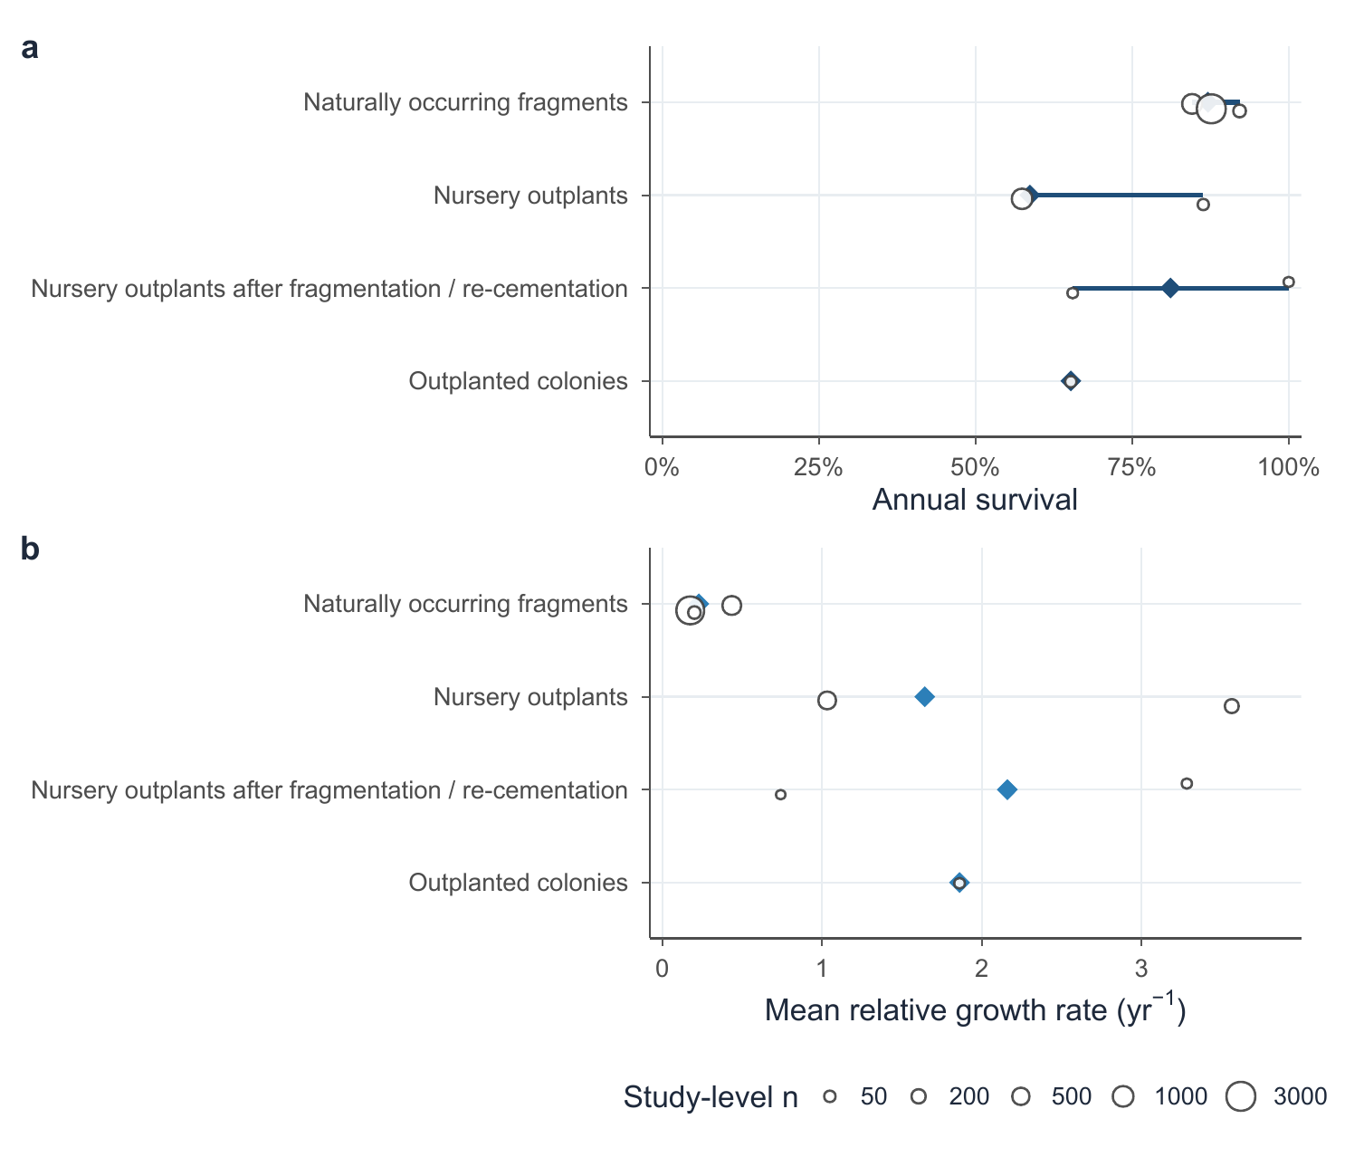

8. Florida-scale heatwave scenarios
Fig. S6. Recurrence of Florida-scale heatwave mortality drives effective lambda far below one in the recruitment-free transition subsystem. (a) Logistic mortality curve parameterized from the A. palmata DHW thresholds reported by Manzello et al. (2025) (ED50 = 7.8 DHW; ED95 = 17.6 DHW); the shaded range marks the 16–20 DHW exposure in the Florida Keys in 2023. (b) Median 50-year trajectories and 95% simulation intervals without heatwaves and for the observed 2023 Florida endpoint (97.8–100% mortality) at four return intervals; the dashed line marks the quasi-extinction threshold of 10% of initial abundance. (c) Effective lambda across dose-response and observed-endpoint scenarios; bars are geometric means from the bootstrap-based simulations, and the dotted line is the unperturbed deterministic lambda (0.961). Without heatwaves, the simulations had an effective lambda of 0.933 and a 70.8% probability of quasi-extinction within 50 years; every observed-endpoint scenario reached quasi-extinction in all simulations. The 5-, 10-, 20-, and 50-year intervals span frequent to rare recurrence and are sensitivity values, not estimated return periods. These are Florida-like event stress tests, not Caribbean-wide forecasts.
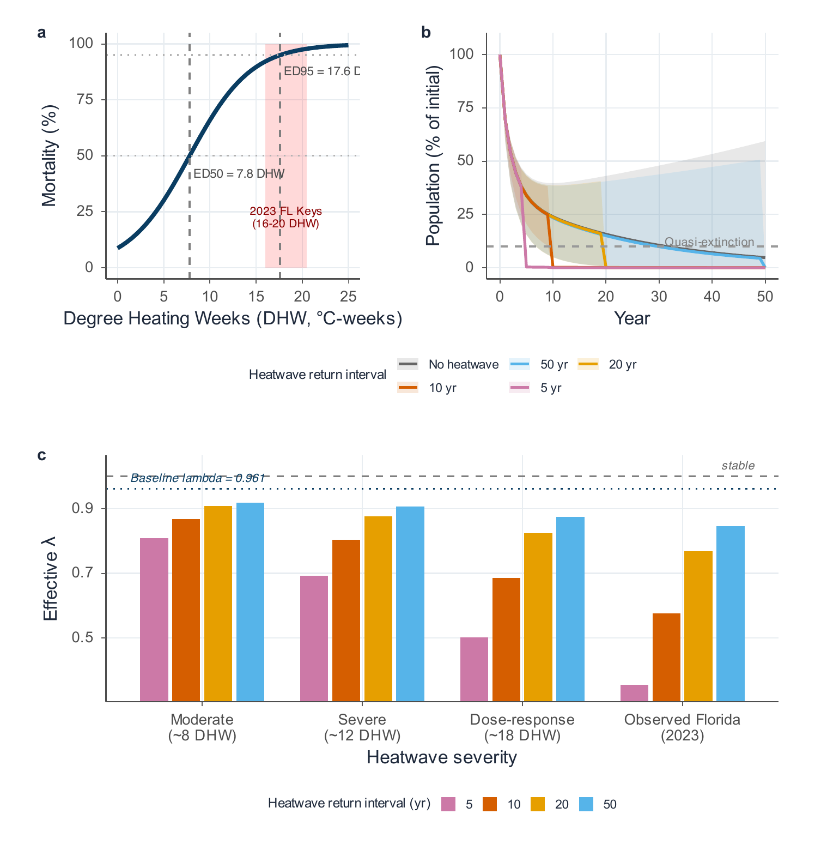

References
Bruckner, A. W., and R. J. Bruckner. 2001. “Condition of Restored Acropora palmata Fragments Off Mona Island, Puerto Rico, 2 Years After the Fortuna Reefer Ship Grounding.” Coral Reefs 20: 235–43. https://doi.org/10.1007/s003380100164.
Forrester, Graham E., Megan A. Ferguson, Caitlin E. O’Connell-Rodwell, and Lianna L. Jarecki. 2014. “Long-Term Survival and Colony Growth of Acropora palmata Fragments Transplanted by Volunteers for Restoration.” Aquatic Conservation: Marine and Freshwater Ecosystems 24: 81–91. https://doi.org/10.1002/aqc.2374.
Garrison, Virginia, and Greg Ward. 2008. “Storm-Generated Coral Fragments – A Viable Source of Transplants for Reef Rehabilitation.” Biological Conservation 141: 3089–100. https://doi.org/10.1016/j.biocon.2008.09.020.
Kuffner, Ilsa B., Anastasios Stathakopoulos, Lauren T. Toth, and Lucy A. Bartlett. 2020. “Reestablishing a Stepping-Stone Population of the Threatened Elkhorn Coral Acropora palmata to Aid Regional Recovery.” Endangered Species Research 43: 461–73. https://doi.org/10.3354/esr01083.
Manzello, Derek P., Ross Cunning, Richard F. Karp, et al. 2025. “Heat-Driven Functional Extinction of Caribbean Acropora Corals from Florida’s Coral Reef.” Science 390 (6771): 361–66. https://doi.org/10.1126/science.adx7825.
Maurer, Leah, Lauren Puishys, Nancy Kim Pham Ho, et al. 2022. “Acropora cervicornis and Acropora palmata Cultured on a Low Maintenance Line Nursery Design in The Bahamas.” PLoS ONE 17 (4): e0267034. https://doi.org/10.1371/journal.pone.0267034.
Mendoza Quiroz, Sandra, Aurora Urania Beltrán-Torres, Maria Victoria Grosso-Becerra, Daniela Muñoz Villareal, Raúl Tecalco Rentería, and Anastazia T. Banaszak. 2023. “Long-Term Survival, Growth, and Reproduction of Acropora palmata Sexual Recruits Outplanted onto Mexican Caribbean Reefs.” PeerJ 11: e15813. https://doi.org/10.7717/peerj.15813.
Neely, Karen L., Kevin A. Macaulay, and Kate S. Lunz. 2022. “Population Trajectory and Stressors of Acropora palmata Sites in the Florida Keys.” Frontiers in Marine Science 9: 978785. https://doi.org/10.3389/fmars.2022.978785.
Ortiz Prosper, Antonio L. 2005. “Population Dynamics of Hurricane-Generated Fragments of Elkhorn Coral Acropora palmata (Lamarck, 1816).” {PhD} dissertation, University of Puerto Rico, Mayagüez.
Pausch, Rachel E., Dana E. Williams, and Margaret W. Miller. 2018. “Impacts of Fragment Genotype, Habitat, and Size on Outplanted Elkhorn Coral Success Under Thermal Stress.” Marine Ecology Progress Series 592: 109–17. https://doi.org/10.3354/meps12488.
Ramos Romero, Amanda, Patricia González-Díaz, Gabriela Aguilera Pérez, and Anastazia T. Banaszak. 2025. “Does Reef Crest Zone Selection Influence Acropora palmata (Lamarck, 1816) Fragment Survival and Growth?” PeerJ 13: e20303. https://doi.org/10.7717/peerj.20303.
Rogers, C. S., and E. M. Muller. 2012. “Bleaching, Disease and Recovery in the Threatened Scleractinian Coral Acropora palmata in St. John, US Virgin Islands: 2003–2010.” Coral Reefs 31: 807–19. https://doi.org/10.1007/s00338-012-0898-8.
Rogers, Caroline S., Thomas H. Suchanek, and Frank A. Pecora. 1982. “Effects of Hurricanes David and Frederic (1979) on Shallow Acropora palmata Reef Communities: St. Croix, U.S. Virgin Islands.” Bulletin of Marine Science 32 (2): 532–48.
Rosales, Stephanie M., Benjamin D. Young, Allan J. Bright, et al. 2024. “Reef Site and Habitat Influence Effectiveness of Acropora palmata Restoration and Its Microbiome in the Florida Keys.” Communications Earth & Environment 5: 689. https://doi.org/10.1038/s43247-024-01816-7.
Vardi, Tali. 2011. “The Threatened Atlantic Elkhorn Coral, Acropora palmata: Population Dynamics and Their Policy Implications.” {PhD} dissertation, University of California, San Diego.
Williams, Dana E., and Margaret W. Miller. 2010. “Stabilization of Fragments to Enhance Asexual Recruitment in Acropora palmata, a Threatened Caribbean Coral.” Restoration Ecology 18 (S2): 446–51. https://doi.org/10.1111/j.1526-100X.2009.00579.x.

