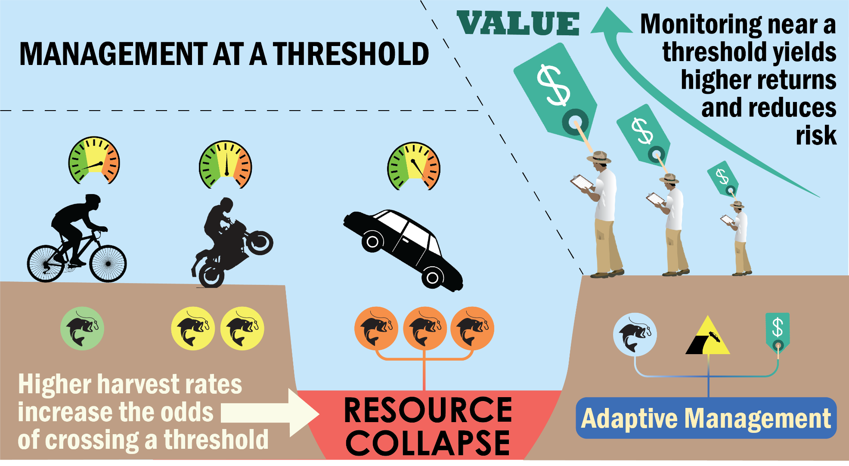
Effective decision-making in a system with an environmental, ecological, or management threshold can be extremely difficult, but is extremely important to avoid detrimental collapses of natural resources. This diagram illustrates how managers must incorporate information about resource harvest intensity, the costs and benefits of monitoring, and distance from a threshold in order to design and implement successful and economically sound management protocols.

Message Box: Monitoring strategies to avoid resource tipping points
What are the problems/conflicts/issues involved (Problems?)
In environmental management, a major question is how much monitoring is needed to maximize delivery of ecosystem goods and services while minimizing risk of species or ecosystem collapse?
Why does this information matter to my listener (So What?)
Because monitoring is often expensive, and these expenses/risk tend to be born by a different agent than those paying for monitoring (i.e. a moral hazard), monitoring investment is often contentious. Yet monitoring investment can also help managers avoide crossing management or biological tipping points. Therefore, natural resource managers require discrete management principles that maximize harvest yields while minimizing monitoring costs and the risk of collapse.
What are some of the possible solutions to this problem (Solutions?)
We propose three management principles to maximize services and minimize risk of collapse:
- Used adaptive monitoring such that monitoring investment is based on the value of information. monitoring investment often is a product of funding availability, technology, personnel logistics, and perceptions of risk among managers and resource users. We suggest managers take a precautionary and adaptive approach by investing in monitoring based on its value. In particular, managers should invest heavily in monitoring when a system is close to a management or biological threshold.

- Stay within a predefined safe operating space: Numerous combinations of resource harvest rates and monitoring precision can be defined as “safe”, for a given level of assumed risk of collapse. By defining this safe space, managers can work with stakeholders to identify ideal management solutions given available resources while acknowledging the clear trade off between monitoring precision and harvest rates.

- Share risk to among stakeholders and minimize moral hazards: The payment system for natural resource monitoring can be a ‘moral hazard’, where one organization (e.g. industry) is involved in a risky activity (harvest) but is protected against risk by another party that incurs the monitoring cost (e.g. government). We suggest lower precision monitoring combined with shared risk among multiple parties can help resolve such moral hazards
What are the potential benefits of resolving this problem (Benefits?)
Embracing these three principles will promote investment in monitoring when it is most valuable, thereby reducing the probability of collapse, promoting sustainable harvest and conservation of natural resources, and increasing food security.

