Title: “The value of information”: Adaptive Monitoring and the Trade Off Between Monitoring Costs and Precision in Ecosystem Assessment

Abstract: Research and monitoring are a critical but expensive component of sustainable natural resources exploitation. Here we argue that a more adaptive and flexible monitoring program that foregoes optimization of extractive ecosystem services (e.g. maximizing fisheries or lumber yield) in exchange for simplified monitoring system that seeks to ensure that the natural-human system is in a safe operating zone, and uses indicators of potential ecosystem tipping points to prompt more extensive and expensive monitoring. We demonstrate how the value of information depends on tipping points where ecosystem services are degraded by destabilizing feedbacks. We contrast the performance of three alternative approaches – one that applies precautionary buffers to reduce the likelihood of state-change, another that uses intensive monitoring to precisely estimate proximity of the ecosystem to a critical threshold and uses that to optimize management, to an adaptive monitoring and less-ambitious set of management goals that seeks to stay in a “safe operating zone” across ecological, social and economic dimensions. A comprehensive understanding of how ecosystem characteristics dictate the trade off between precision in ecosystem state estimates and the costs of overexploitation is utilitarian for agencies and managers with finite resources.

Approach: We use a closed-loop management strategy evaluation model that includes a process model with a tipping point below which populations exhibit destabilizing dynamics at low densities (i.e. an allee effect). The model allows flexibility in 1) strength of resource extraction, 2) the level of resource extraction, 3) the strength of the Allee effect, and 4) the management strategy used to avoid a tipping point. We use this model to answer the following three questions:

Q1: How does the probability of a system crossing a tipping point shift with a) certainty about ecosystem state (i.e. monitoring investment) and b) levels of resource extraction

Q2: How does the return on monitoring investment to better estimate ecosystem state scale with proximity to a tipping point?

Q3: What are the benefits of adaptive monitoring relative to precautionary buffers and intensive monitoring as approaches to avoid tipping points?

Figure 1: Description of the model configuration demonstrating: A) variation in the strength of the tipping point for continuous time version of the allee effect model. B) the scaling relationship between the coefficient of variation (CV) and the degree to which the sampled biomass differs from the true biomass. C) The harvest control rule – a hockey stick function. D) Some example output describing how biomass, estimated biomass (dashed line), and Yield vary for low and high CV. – Not included here, but potentially useful are a) the production function for yield to profit and b) the cost function for monitoring (i.e. how much does CV decrease with increasing investment in monitoring).

Q1: How does the probability of a system crossing a tipping point shift with a) certainty about ecosystem state (i.e. monitoring investment) and b) levels of resource extraction

H1: Ecosystems are more likely to cross tipping points when managers have less certainty about resource availability and under higher levels of resource extraction.

Figure 2: Twenty-year simulations across a range of monitoring investment (CV of true biomass) and maximum harvest rate (percentage of Fmsy - pFmsy). Summarizing across 10,000 model iterations. We calculated three attributes of the system for a given combination of monitoring investment and maximum harvest rate: (1) the mean probability of crossing a tipping point over 20 years, where crossing a tipping points leads to population collapse. (2) the mean net present value, which is the cumulative yield adjusted with a discount rate. (3) The maximum allowable CV needed to avoid a tipping point under four different risk scenarios (1%, 5%, 10%, and 20%).
On the left side you can see that the probability of crossing a tipping point increases as monitoring accuracy decreases and the harvest rate increases. You can see this with the heatmap and also with the graph below it with slices for a few different pFmsy’s. On the top right hand side you can see that the maximum CV needed to avoid a 20%, 10%, 5% or 1% chance of a tipping point. Thus, as our intuition suggested, you need a higher accuracy of harvesting to avoid a low probability of a tipping point. We can overlay this to demonstrate how the CV necessary to avoid a collapse relates to the net present value, which exhibits a hump shaped relationship with harvest rate (bottom right)

Q2: How does the return on monitoring investment vary with proximity to a tipping point?

H2: We hypothesized that monitoring accuracy will be increasingly beneficial as the system approaches a tipping point, because it will allow harvest to occur and avoid future profit losses by avoiding population collapse.

Figure 3. Using a similar simulation as described in the above figure 2, we estimated the return on (monitoring) investment at different distances from the tipping point. We calculated return on investment as the difference (or ratio) in net present value from simulations with high monitoring effort (NPVCV=0.1) relative to simulations with low monitoring effort (NPVCV=0.5), and estimated this “value” for a range of extraction intensities (pFmsy). The logic here is that populations that start at low biomass will exhibit a greater return on investment because they will be less likely to crash and more likely to open the resource to extraction and make money. Plotted here is the relationship between starting biomass and return on investment for the ratio (left column) and difference (right column). I expected to see a bump in value of information as we approached the biomass limit in the model (B=30 dotted line) as well as at the critical value for the allee model (B=10 dashed line). But, we’re not seeing a bump at the biomass limit, and we only see an increase in the relative benefit of monitoring (ratio plot) as we approach the collapse.
A couple of thoughts about what’s going on: Are we fishing hard enough? Are there funky things going on with the first few time steps and we need a burn in? Should we run the simulation for longer? Are we using the wrong proximity of the tipping point and b.lim to see the two peaks in value? I was initially a little concerned with this approach because it's not exactly following the value for a single time series as the harvest goes further and closer to a tipping point, and measuring how value changes within a series, but from chatting with Phil, I think we can perhaps justify this as exploring systems with different fishing histories. For example you can get the equilibrium population to be low if you crank up fishing. However, for the current parameter set (which we could change), the effects of fishing don’t knock down the equilibrium population that close to the allee threshold (10), until fishing is quite strong. So maybe we need to pump fishing up or production down? I don’t think it’s about running the series out (similar plots

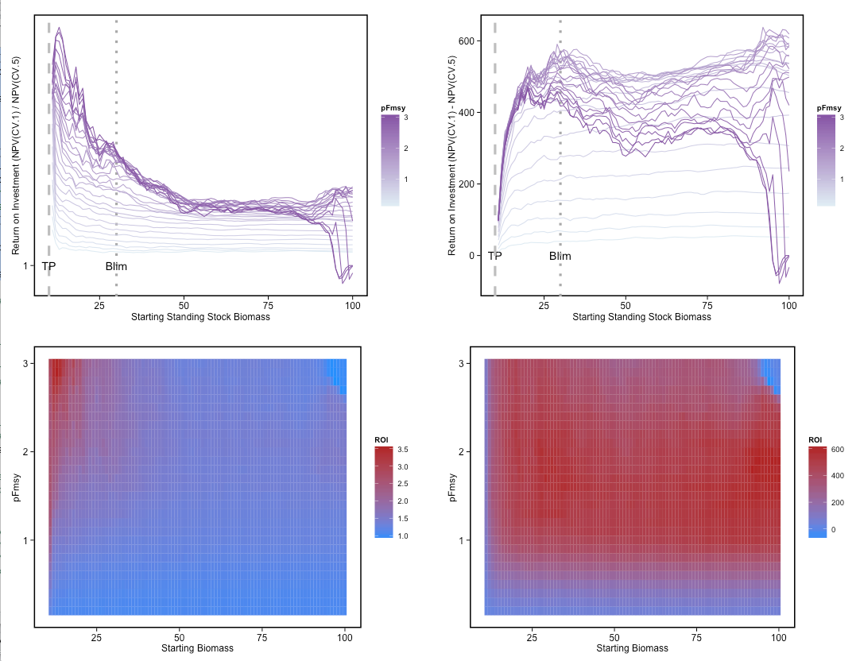

Q3: What are the benefits of adaptive monitoring relative to precautionary buffers and intensive monitoring as approaches to avoid tipping points?

H3: We hypothesize that adaptive monitoring that increases in intensity as an ecosystem approaches a critical threshold will be less costly than intensive monitoring but this will depend on institutional inertia and flexibility of resources and personnel.

Here we use “rule 2” where monitoring is high below some threshold (b.crit) and then declines when fishing stops below blim. You can see that with low fishing pressure, the profit (npv-monitoring cost) is lower with adaptive monitoring, but that when fishing is higher, people willing to take some risk of tipping, might chooses the adaptive monitoring approach because its more lucrative.

Things to do next

- What is the best rule for adaptive monitoring? Implement rule 3 of the adaptive monitoring, where monitoring window goes down to the tipping point threshold not the biomass limit threshold for fishing
- What is the trade off between risk of collapse and profit? create a surface to show how an increase in the probability of tipping and the cost of monitoring (i.e. the scaling exponent in the inverse relationship between CV of monitoring an cost), can present a trade off when you think about the profit to the fishery as NPV – monitoring cost. Do this for a couple of different fishing pressure values and maybe for more than one rule.
- What is the risk of fishing near the tipping point? Simulate the importance of the proximity of the tipping point to the Biomass limit for fishing. E.g. for a given (or couple of fishing pressures), draw figure 3 (ROI versus SSB) for different tipping point proximity to the biomass limit. Or heat map of SSB versus delta of tipping point and blim and plot the ROI?
- How many management strategies do we want to contrast? In the initial abstract we distinguished between adaptive and precautionary buffer, but I’m struggling to understand how to do this contrast. Maybe one that has a more continuous ramp up of monitoring effort as the system approaches a known threshold rather than the buffer, which is more of a hockey stick function between proximity to state and ramping up monitoring?

