Program Features:

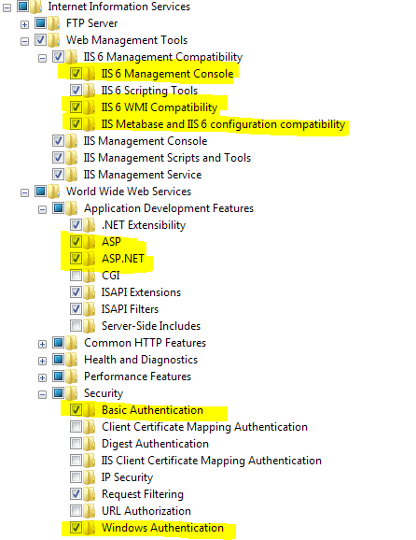

Create new application pool:

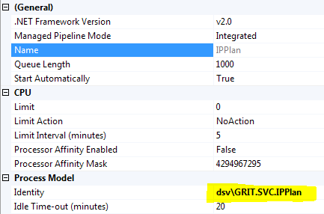

Add new Application:



Configure Application, and select the new Application Pool



Configure authentication:

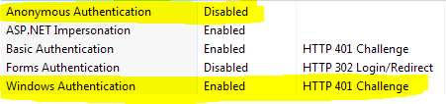

<system.web>

…  
 <authentication mode="Windows" />

<identity impersonate="false" />  
 ...  
</system.web>

Configure authentication:

<connectionStrings>

<add name="DSVAsset" connectionString="Data Source=[server]\[instance];Initial Catalog=[Database];Persist Security Info=True;Trusted_Connection=Yes" providerName="System.Data.SqlClient" />

</connectionStrings>