## REPORT

|  |  |
| --- | --- |
| **Project ID:** | R-161 |
| **Project:** | Assessment of adverse reactions when one type of Gadolinium agent is substituted for another agent in MRI |
| **Investigator(s):** | Dr. Joo Cho |
| **BCL Consultant(s):** | Spiro Stilianoudakis |
| **Date:** | 12/21/2018 |

## Introduction

Magnetic resonance imaging (MRI) is a medical imaging technique used in radiology to form pictures of the anatomy and the physiological processes of the body in both health and disease. In order to improve the visibility of internal body structures, radiologists incorporate the use of MRI contrast agents. The most commonly used compounds for contrast enhancement are gadolinium-based. However, recent associations have been found between the use of certain gadolinium-based contrast agents and the incidence of nephrogenic systemic fibrosis (NSF). Nephrogenic systemic fibrosis (NSF) is a rare syndrome characterized by allergic-like reactions that involve fibrosis of skin, joints, eyes, and internal organs. Because of this, many healthcare institutions are beginning to consider changing the type of gadolinium-based contrast agent they use for their general patient population.

Changing contrast agents in an attempt to reduce incidence of NSF could have unintended consequences. Risk of allergic-like reactions have been shown to vary among different gadolinium-based contrast agents, and it is unclear if a change in contrast will contribute to an increase in incidence. Likewise, transient increases in the detection of adverse events are common when introducing a new agent. This is known as a Weber effect, and the number of events tend to peak during the second year after a new agent is introduced.

Between the years of 2005 and 2018, an abrupt change in the primary use of one type of gadolinium-based contrast agent (Magnevist) was made in favor for another (Gadavist). This offered an opportunity to study the differences in events of allergic-like reactions that occurred during the change. Therefore, the purpose of this study was to evaluate the effect of abruptly changing gadolinium-based contrast agents on the number of allergic-like reactions. Similarly, we aimed to assess whether or not there was a definitive Weber effect in the three years after the switch occurred.

## Methods

All 63,282 intravenous administrations of gadolinium based contrast agents between the dates of January 1, 2005 and March 22, 2018 were identified by means of a query of electronic billing records at the [insert name of hospital]. The length of this retrospective study was chosen primarily to assess the trend in allergic-like reaction rates prior to the switch, while also including a 3-year period after the switch to account for any Weber effect. The following list of gadolinium-based contrast agents were used in the study: Magnevist, Dotarem, Prohance, Ablavar, Eovist, and Gadavist. A large portion of contrast agents prior to the switch were not accurately recorded at the time of administration and labeled as “Unknown”. This group was combined with the other lesser used agents including Dotarem, Prohance, Ablavar, and Eovist and labeled as “Other” in downstream analyses. Prior to the switch, Magnevist was the primary contrast agent used. On March 22, 2015 an abrupt switch to Gadavist was made.

Allergic-like reactions were classified as mild, moderate, or severe. Mild allergic-like reactions were characterized by signs of itchiness of the throat and presence of hives. Moderate allergic-like reactions were characterized by tightness of the face and/or throat. Lastly, severe allergic-like reactions were characterized by difficulty breathing, followed by the occurrence of anaphylactic shock. Demographic characteristics were obtained and reported at time of injection including age group and sex. The age groups were defined as < 9 months, 9 – 18 months, and > 18 months.

Rates of allergic-like reactions were compared between different contrast agents using Chi-Squared Tests or Fisher’s Exact Tests (with odds ratios (OR) and 95% confidence intervals (CI)) where appropriate. Stratified analyses in the form of a Cochran-Mantel-Haenszel Test was used to assess the relationship between age groups and incidents of allergic-like reactions, while accounting for sex. A post-hoc Woolf’s Test was used to assess whether the odds ratios across the sex strata were indeed statistically similar or not. Further Chi-Square tests were used to compare the different contrast agents (Gadavist, Magnevist, and Other) with the rate of allergic-like reactions. Additionally, we compared two-year intervals in the study using Fisher’s Exact Tests to determine significant changes in allergic-like reaction rates and a possible instance of a Weber Effect. A p-value of 0.05 or less was considered to represent a significant difference for all hypothesis tests. All statistical analyses were performed in R version 3.4.2.

## Results

A total of 63,282 contrast injections between the dates of January 2005 and March 2018 were considered in the study. There were 25 allergic-like reactions that occurred for an overall rate of 0.040%. Of the reactions, 16 were classified as “mild” (64%; signs of itchiness of the throat and hives), 8 as “moderate” (32%; tightness of the face and/or throat), and 1 as “severe” (4%; difficulty breathing, followed by anaphylactic shock). The majority of known injections were Magnevist (31%) and Gadavist (26%). A large portion of injections were labeled as “Unknown”. They were combined with other less frequent contrast agents and labeled as “Other” in Table 1. Throughout the study, Magnevist injections resulted in 12 reactions (48%), while Gadavist injections resulted in 11 reactions (44%). The brand of contrast agent was not found to be significantly associated with the type of reaction reaction (p=0.654).

Most Magnevist agents were given prior to the 2015 switch (99%), while all Gadavist agents were given after the 2015 switch (100%). From Table 2, we see that there were 45,795 (72%) injections that occurred prior to the primary switch of contrast agents in 2015. During this time 13 allergic-like reactions occurred among the patients for a reaction rate of 0.028%. There were 17487 injections that occurred after the switch, 12 of which resulted in allergic-like reactions (0.069%).

Figure 1 demonstrates the aggregate number of injections according to bi-yearly intervals for each of the three types of contrast agents considered in the study. We see that prior to the 1st half of 2010, all of the contrast agents used were considered “Other”. Within this interval, the entirety of these injections were not accurately recorded, and labeled as “Unknown” at the time. In the intervals between the 1st half of 2011 to the 1st half of 2015 (where the switching of agents occurred), most injects were Magnevist. Following, the 1st half of 2015, the majority of contrast agents were Gadavist.

Table 3 summarizes the number of allergic-like reactions and injections of the different contrast agents by age, while stratified by sex during the study period. Although not statistically significant, when compared to males, females were found to have slightly higher rates of allergic-like reactions for all contrast agents, 0.050 compared to 0.029 respectively (OR = 1.72; 95% CI (0.76, 3.90)). However, it was found that age was indeed significantly associated with reaction rate, with patients younger than 9 months of age least likely to have an allergic-like reaction (0.010% (2/20395); p = 0.002). The results from the Cochran-Mantel-Haenszel Test suggested that there was significant relationship between age and reaction, regardless of sex (p = 0.003). The results from the post-hoc Woolf’s test confirmed that the odds ratios were indeed statistically similar across the strata of sex (p = 0.796).

Comparisons of the overall rates of allergic-like reactions between each type of contrast are summarized in Table 4. When compared to contrast agents classified as “Other”, both Gadavist and Magnevist contrasts were associated with significantly higher rates of allergic-like reactions (OR = 9.33 and 8.41 respectively). There was not a significant difference in the rates of allergic-like reactions between Gadavist and Magnevist contrast agents, however.

The rates of allergic-like reactions during two-year intervals beginning in the 2nd quarter of 2005 until the 1st quarter of 2018 are presented in Table 5. It was found that the rate of reactions during the 8 quarters from the 2nd quarter of 2011 to the 1st quarter of 2013 were significantly higher than all other intervals (OR = 2.49 (1.07, 5.77); p = 0.028). The two-year interval immediately after the switch from Magnevist to Gadavist agents also exhibited slightly higher rates of reactions, although not statistically significant (OR = 1.97 (0.85, 4.57); p = 0.107). Figure 2 demonstrates the changing reaction rates during bi-quarterly intervals throughout the study. The distinct peak between the 2nd quarter of 2010 and the 1st quarter of 2012 is clearly present. Additionally, there were two smaller peaks in reaction rates after the 1st quarter of 2015, where the switch occurred.

## Tables & Figures

|  |  |  |  |  |  |  |
| --- | --- | --- | --- | --- | --- | --- |
|  |  |  | **Type of Allergic-like Reaction** | | |  |
| **Contrast Agent** | **No. of Injections (N=63282)** | **All Reactions (N=25)** | **Mild (N=16)** | **Moderate (N=8)** | **Severe (N=1)** | **P-Value** |
| Gadavist | 16204 (26%) | 11 (44%) | 7 (44%) | 3 (38%) | 1 (100%) | 0.654 |
| Magnevist | 19615 (31%) | 12 (48%) | 7 (44%) | 5 (62%) | 0 (0%) |  |
| Other | 27463 (43%) | 2 (8%) | 2 (12%) | 0 (0%) | 0 (0%) |  |

**Table 1.** Rates and severity of allergic-like reactions resulting from intravenous injections of various contrast agents from January 1, 2005 to March 22, 2018.

|  |  |  |  |  |  |
| --- | --- | --- | --- | --- | --- |
|  |  |  | **Contrast Agent** | | |
| **Timing of Injection** | **No. of Injections (N=63282)** | **Allergic-Like Reactions (N=25)** | **Gadavist (N=16204)** | **Magnevist (N=19615)** | **Other (N=27463)** |
| Before Switch | 45795 (72%) | 13 (0.028%) | 0 (0%) | 19393 (99%) | 26402 (96%) |
| After Switch | 17487 (28%) | 12 (0.069%) | 16204 (100%) | 222 (1%) | 1061 (4%) |

**Table 2.** Rates of allergic-like reactions before and after the switching of contrast agents to primarily Gadavist injections. The switch occurred on March 22, 2015.

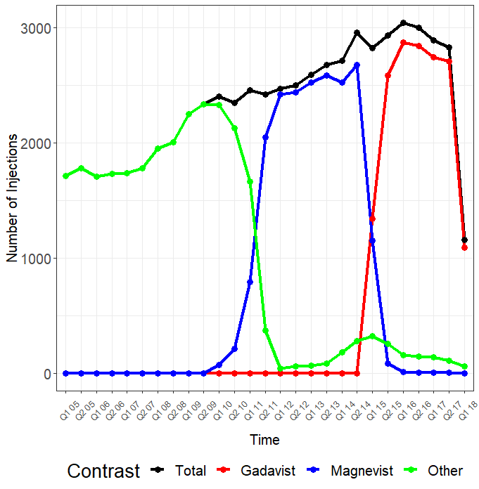

**Figure 1.** A graph illustrating the total number of intravenous administrations of contrast agents at specific bi-yearly intervals from January 2005 to March 2018. Each quarter represents a 6-month interval.

|  |  |  |  |  |
| --- | --- | --- | --- | --- |
|  | **Contrast Agent** | | |  |
| **Sex and Age Group** | **Gadavist (N=16204)** | **Magnevist (N=19615)** | **Other (N=27463)** | **All Agents (N=63282)** |
| **Female Patients** | |  |  |  |
| < 9 months | 0 (0/2447) | 0.036 (1/2796) | 0 (0/4500) | 0.010 (1/9743) |
| 9 - 18 months | 0.090 (4/4432) | 0.091 (5/5461) | 0 (0/7373) | 0.052 (9/17266) |
| > 18 months | 0.248 (3/1211) | 0.174 (3/1726) | 0 (0/2190) | 0.117 (6/5127) |
| All Ages | 0.087 (7/8090) | 0.090 (9/9983) | 0 (0/14063) | 0.050 (16/32136) |
| **Male Patients** | |  |  |  |
| < 9 months | 0.036 (1/2773) | 0 (0/3251) | 0 (0/4628) | 0.009 (1/10652) |
| 9 - 18 month | 0.048 (2/4181) | 0.020 (1/4939) | 0.028 (2/7052) | 0.031 (5/16172) |
| > 18 months | 0.086 (1/1160) | 0.138 (2/1442) | 0 (0/1720) | 0.069 (3/4322) |
| All Ages | 0.049 (4/8114) | 0.031 (3/9632) | 0.015 (2/13400) | 0.029 (9/31146) |
| **Both Sexes** | |  |  |  |
| < 9 months | 0.019 (1/5220) | 0.017 (1/6047) | 0 (0/9128) | 0.010 (2/20395) |
| 9 - 18 months | 0.070 (6/8613) | 0.058 (6/10400) | 0.014 (2/14425) | 0.042 (14/33438) |
| > 18 months | 0.169 (4/2371) | 0.158 (5/3168) | 0 (0/3910) | 0.095 (9/9449) |
| **All Ages and Sexes** | 0.068 (11/16204) | 0.061 (12/19615) | 0.007 (2/27463) | 0.040 (25/63282) |

**Table 3.** Allergic-like reaction rates across different contrast agents for a variety of age groups and sex combinations. Rates are represented as percents followed by the respective ratio.

|  |  |  |  |  |
| --- | --- | --- | --- | --- |
| **Contrast Agent** | **Reaction Rate** | **Gadavist** | **Magnevist** | **Other** |
| Gadavist | 0.068 (11/16204) | -- | 1.11 (0.49, 2.52) [0.803] | 9.33 (2.07, 42.09) [< 0.001] |
| Magnevist | 0.061 (12/19615) |  | -- | 8.41 (1.88, 37.56) [< 0.001] |
| Other | 0.007 (2/27463) |  |  | -- |

**Table 4.** Chi-Square Statistics comparing rates of allergic-like reactions between each contrast agent. Tests of association are represented by odds ratios, 95% confidence intervals, and p-values.

|  |  |  |  |
| --- | --- | --- | --- |
| **Time Period** | **Overall Reaction Rate** | **OR (95% CI)** | **P Value** |
| 2005 Q2 - 2007 Q1 | 0.014 (1/6959) | 0.33 (0.04, 2.46) | 0.256 |
| 2007 Q2 - 2009 Q1 | 0.025 (2/7760) | 0.61 (0.14, 2.60) | 0.502 |
| 2009 Q2 - 2011 Q1 | 0.021 (2/9407) | 0.49 (0.12, 2.08) | 0.323 |
| 2011 Q2 - 2013 Q1 | 0.081 (8/9929 | 2.49 (1.07, 5.77) | 0.028 |
| 2013 Q2 - 2015 Q1 | 0 (0/10899) | -- | -- |
| 2015 Q2 - 2017 Q1 | 0.066 (8/12032) | 1.97 (0.85, 4.57) | 0.107 |
| 2017 Q2 - 2018 Q1 | 0.073 (4/5443) | 1.99 (0.68, 5.81) | 0.197 |

**Table 5.** Chi-Square Statistics comparing rates of allergic-like reactions between each two-year interval starting in March of 2005. Rates are represented by percents and ratios. Tests of association are represented by odds ratios, 95% confidence intervals, and p-values.

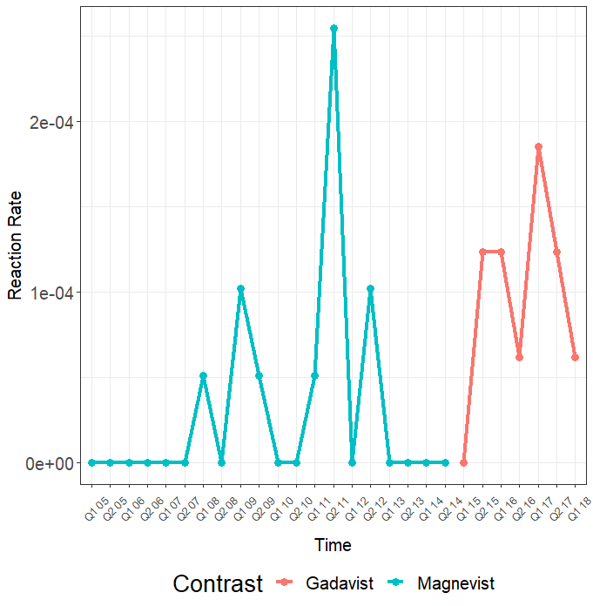

**Figure 2.** A graph illustrating the rates of allergic-like reactions according to bi-yearly intervals. Each quarter represents a 6-month interval.