A total of 63,282 contrast injections between the dates of January 2005 and March 2018 were considered in the study. There were 25 allergic-like reactions that occured (14 mild; 7 moderate; 1 severe) for an overall rate of 0.040%. Of the reactions, 16 were classified as “mild” (64%; signs of itchiness of the throat and hives), 8 as “moderate” (32%; tightness of the face and/or throat), and 1 as “severe” (4%; difficulty breathing, followed by anaphylactic shock). The majority of known injections were Magnevist (31%) and Gadavist (26%). A large portion of injections were labeled as “Unknown”. They were combined with other less frequent contrast agents and labeled as “Other” in Table 1. Throughout the study, Magnevist injections resulted in 12 reactions (48%), while Gadavist injections resulted in 11 reactions (44%). The brand of contrast agent was not found to be significantly associated with the type of reaction reaction (p=0.654).

Most Magnevist agents were given prior to the 2015 switch (99%), while all Gadavist agents were given after the 2015 switch (100%). From Table 2, we see that there were 45,795 (72%) injections that occurred prior to the primary switch of contrast agents in 2015. During this time 13 allergic-like reactions occurred among the patients for a reaction rate of 0.028%. There were 17487 injections that occurred after the switch, 12 of which resulted in allergic-like reactions (0.069%).

Figure 1 demonstrates the aggregate number of injections according to bi-yearly intervals for each of the three types of contrast agents considered in the study. We see that prior to the 1st half of 2010, all of the contrast agents used were considered “Other”. Within this interval, the entirety of these injections were not accurately recorded, and labeled as “Unknown” at the time. In the intervals between the 1st half of 2011 to the 1st half of 2015 (where the switching of agents occurred), most injects were Magnevist. Following, the 1st half of 2015, the majority of contrast agents were Gadavist.

Table 3 summarizes the number of allergic-like reactions and injections of the different contrast agents by age and sex during the study period. When compared to males, females were found to have slightly higher rates of allergic-like reactions for all contrast agents (OR = 1.72; 95% CI (0.76, 3.90)). However, it was found that age was significantly associated with reaction rate, with patients younger than 9 months of age least likely to have an allergic-like reaction (0.010% (2/20395); p = 0.002).

Comparisons of the overall rates of allergic-like reactions between each type of contrast are summarized in Table 4. When compared to contrast agents classified as “Other”, both Gadavist and Magnevist contrasts were associated with significantly higher rates of allergic-like reactions (OR = 9.33 and 8.41 respectively). There was not a significant difference in the rates of allergic-like reactions between Gadavist and Magnevist contrast agents, however.

The rates of allergic-like reactions during two-year intervals beginning in the 2nd quarter of 2005 until the 1st quarter of 2018 are presented in Table 5. It was found that the rate of reactions during the 8 quarters from the 2nd quarter of 2011 to the 1st quarter of 2013 were significantly higher than all other intervals (OR = 2.49 (1.07, 5.77); p = 0.028). The two-year interval immediately after the switch from Magnevist to Gadavist agents also exhibited slightly higher rates of reactions, although not statistically significant (OR = 1.97 (0.85, 4.57); p = 0.107). Figure 2 demonstrates the changing reaction rates during bi-quarterly intervals throughout the study. The distinct peak between the 2nd quarter of 2010 and the 1st quarter of 2012 is clearly present. Additionally, there were two smaller peaks in reaction rates after the 1st quarter of 2015, where the switch occurred.

|  |  |  |  |  |  |  |
| --- | --- | --- | --- | --- | --- | --- |
|  |  |  | **Type of Allergic-like Reaction** | | |  |
| **Contrast Agent** | **No. of Injections (N=63282)** | **All Reactions (N=25)** | **Mild (N=16)** | **Moderate (N=8)** | **Severe (N=1)** | **P-Value** |
| Gadavist | 16204 (26%) | 11 (44%) | 7 (44%) | 3 (38%) | 1 (100%) | 0.654 |
| Magnevist | 19615 (31%) | 12 (48%) | 7 (44%) | 5 (63%) | 0 (0%) |  |
| Other | 27463 (43%) | 2 (8%) | 2 (12%) | 0 (0%) | 0 (0%) |  |

**Table 1.** Rates and severity of allergic-like reactions resulting from intravenous injections of various contrast agents from January 1, 2005 to March 22, 2018.

|  |  |  |  |  |  |
| --- | --- | --- | --- | --- | --- |
|  |  |  | **Contrast Agent** | | |
| **Timing of Injections** | **No. of Injections (N=63282)** | **Allergic-Like Reactions (N=25)** | **Gadavist (N=16204)** | **Magnevist (N=19615)** | **Other (N=27463)** |
| Before Switch | 45795 (72%) | 13 (0.028%) | 0 (0%) | 19393 (99%) | 26402 (96%) |
| After Switch | 17487 (28%) | 12 (0.069%) | 16204 (100%) | 222 (1%) | 1061 (4%) |

**Table 2.** Rates of allergic-like reactions before and after the switching of contrast agents to primarily Gadavist injections. The switch occurred on March 22, 2015.

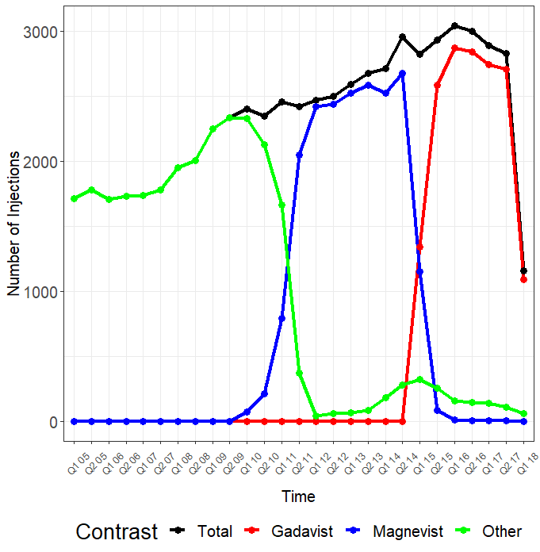

**Figure 1.** A graph illustrating the total number of intravenous administrations of contrast agents at specific bi-yearly intervals from January 2005 to March 2018. Each quarter represents a 6-month interval.

|  |  |  |  |  |
| --- | --- | --- | --- | --- |
|  | **Contrast Agent** | | |  |
| **Sex and Age Group** | **Gadavist (N=16204)** | **Magnevist (N=19615)** | **Other (N=27463)** | **All Agents (N=63282)** |
| **Female Patients** | |  |  |  |
| < 9 months | 0 (0/2447) | 0.036 (1/2796) | 0 (0/4500) | 0.010 (1/9743) |
| 9 - 18 months | 0.090 (4/4432) | 0.091 (5/5461) | 0 (0/7373) | 0.052 (9/17266) |
| > 18 months | 0.248 (3/1211) | 0.174 (3/1726) | 0 (0/2190) | 0.117 (6/5127) |
| All Ages | 0.087 (7/8090) | 0.090 (9/9983) | 0 (0/14063) | 0.050 (16/32136) |
| **Male Patients** | |  |  |  |
| < 9 months | 0.036 (1/2773) | 0 (0/3251) | 0 (0/4628) | 0.009 (1/10652) |
| 9 - 18 month | 0.048 (2/4181) | 0.020 (1/4939) | 0.028 (2/7052) | 0.031 (5/16172) |
| > 18 months | 0.086 (1/1160) | 0.138 (2/1442) | 0 (0/1720) | 0.069 (3/4322) |
| All Ages | 0.049 (4/8114) | 0.031 (3/9632) | 0.015 (2/13400) | 0.029 (9/31146) |
| **Both Sexes** | |  |  |  |
| < 9 months | 0.019 (1/5220) | 0.017 (1/6047) | 0 (0/9128) | 0.010 (2/20395) |
| 9 - 18 months | 0.070 (6/8613) | 0.058 (6/10400) | 0.014 (2/14425) | 0.042 (14/33438) |
| > 18 months | 0.169 (4/2371) | 0.158 (5/3168) | 0 (0/3910) | 0.095 (9/9449) |
| **All Ages and Sexes** | 0.068 (11/16204) | 0.061 (12/19615) | 0.007 (2/27463) | 0.040 (25/63282) |

**Table 3.** Allergic-like reaction rates across different contrast agents for a variety of age groups and sex combinations. Rates are represented as percents followed by the respective ratio.

|  |  |  |  |  |
| --- | --- | --- | --- | --- |
| **Contrast Agent** | **Reaction Rate** | **Gadavist** | **Magnevist** | **Other** |
| Gadavist | 0.068 (11/16204) | -- | 1.11 (0.49, 2.52) [0.803] | 9.33 (2.07, 42.09) [< 0.001] |
| Magnevist | 0.061 (12/19615) |  | -- | 8.41 (1.88, 37.56) [< 0.001] |
| Other | 0.007 (2/27463) |  |  | -- |

**Table 4.** Chi-Square Statistics comparing rates of allergic-like reactions between each contrast agent. Tests of association are represented by odds ratios, 95% confidence intervals, and p-values.

|  |  |  |  |
| --- | --- | --- | --- |
| Time Period | Overall Reaction Rate | OR (95% CI) | P Value |
| 2005 Q2 - 2007 Q1 | 0.014 (1/6959) | 0.33 (0.04, 2.46) | 0.256 |
| 2007 Q2 - 2009 Q1 | 0.025 (2/7760) | 0.61 (0.14, 2.60) | 0.502 |
| 2009 Q2 - 2011 Q1 | 0.021 (2/9407) | 0.49 (0.12, 2.08) | 0.323 |
| 2011 Q2 - 2013 Q1 | 0.081 (8/9929 | 2.49 (1.07, 5.77) | 0.028 |
| 2013 Q2 - 2015 Q1 | 0 (0/10899) | -- | -- |
| 2015 Q2 - 2017 Q1 | 0.066 (8/12032) | 1.97 (0.85, 4.57) | 0.107 |
| 2017 Q2 - 2018 Q1 | 0.073 (4/5443) | 1.99 (0.68, 5.81) | 0.197 |

**Table 5.** Chi-Square Statistics comparing rates of allergic-like reactions between each two-year interval starting in March of 2005. Rates are represented by percents and ratios. Tests of association are represented by odds ratios, 95% confidence intervals, and p-values.

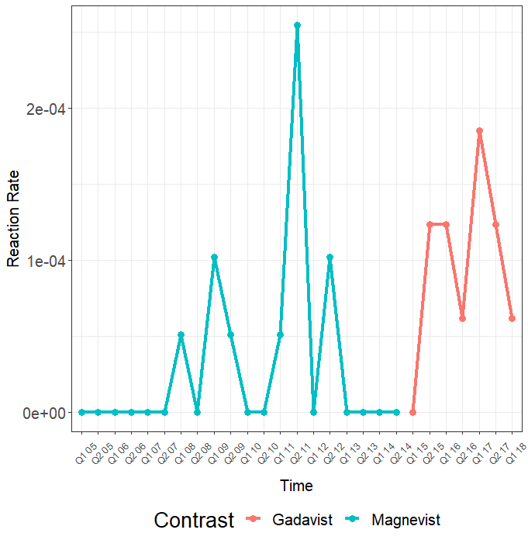

**Figure 2.** A graph illustrating the rates of allergic-like reactions according to bi-yearly intervals. Each quarter represents a 6-month interval.