**Keppra Study Report R-168**

1. **Compare the baseline demographics between each group to see if there are any differences (Columns B - J).**

|  |  |  |  |
| --- | --- | --- | --- |
| **Variable** | **Behavioral Event** | | **P-Value** |
| **No (n=512)** | **Yes (n=453)** |
| **Age at Admission (SD)** | 59.41 (18.49) | 60.87 (18.63) | 0.221 |
| **Ethnicity (%)** |  |  | 0.486 |
| Black or African American | 233 (45.5) | 191 (42.2) |  |
| Other | 20 ( 3.9) | 23 ( 5.1) |  |
| Unknown | 9 ( 1.8) | 5 ( 1.1) |  |
| White | 250 (48.8) | 234 (51.7) |  |
| **Gender (%)** |  |  | >0.999 |
| Male | 267 (52.1) | 237 (52.3) |  |
| Female | 245 (47.9) | 216 (47.7) |  |
| **Diagnosis (%)** |  |  | 0.418 |
| Cerebral infarction | 141 (27.5) | 111 (24.5) |  |
| Intracerebral hemorrhage | 155 (30.3) | 147 (32.5) |  |
| Subarachnoid hemorrhage | 78 (15.2) | 59 (13.0) |  |
| Traumatic intracranial injury | 138 (27.0) | 136 (30.0) |  |
| **GCS (SD)** | 11.16 (4.36) | 11.11 (4.32) | 0.848 |
| **Discharge Disposition (%)** |  |  | <0.001 |
| Discharged to Rehab Unit/Facility | 77 (15.0) | 108 (23.8) |  |
| Discharged to SNF | 72 (14.1) | 130 (28.7) |  |
| Expired | 110 (21.5) | 50 (11.0) |  |
| Home | 213 (41.6) | 109 (24.1) |  |
| Hospice | 14 ( 2.7) | 33 ( 7.3) |  |
| Other | 26 ( 5.1) | 23 ( 5.1) |  |
| log(**Length of Stay at Hospital**) (SD) | 2.04 (1.02) | 2.56 (0.90) | <0.001 |
| log(**Length of Stay in ICU**) (SD) | 1.55 (1.10) | 1.99 (1.03) | <0.001 |
| log(**Keppra Dose**) (SD) | 1.94 (1.01) | 2.32 (0.92) | <0.001 |
| **Length of Stay at Hospital (IQR)** | 8.11 (3.80-16.60) | 13.91 (7.01-23.61) | <0.001 |
| **Length of Stay in ICU (IQR)** | 4.40 (2.00-11.10) | 7.60 (3.60-16.10) | <0.001 |
| **Keppra Dose (IQR)** | 8.00 (3.00-14.00) | 12.00 (6.00-17.00) | <0.001 |

Notes:

* For Age, GCS, log(Length of Stay at Hospital), log(Length of Stay in ICU), and log(Keppra Dose) means and standard deviations are provided. P-values from Student’s t-tests are provided to assess statistical difference between behavioral event.
* For ethnicity, gender, diagnosis, and discharge disposition counts and frequencies are provided. P-values from chi-square tests are provided to assess statistical difference between behavioral event.
* For Length of Stay at Hospital, Length of Stay in ICU, and Keppra Dose medians and IQRs are provided. P-values from Wilcoxon rank sum tests are provided to assess statistical difference between behavioral event.

1. **In the patients with a behavioral event we would like to determine the incidence of each (columns K, L, O, Q, and R)**

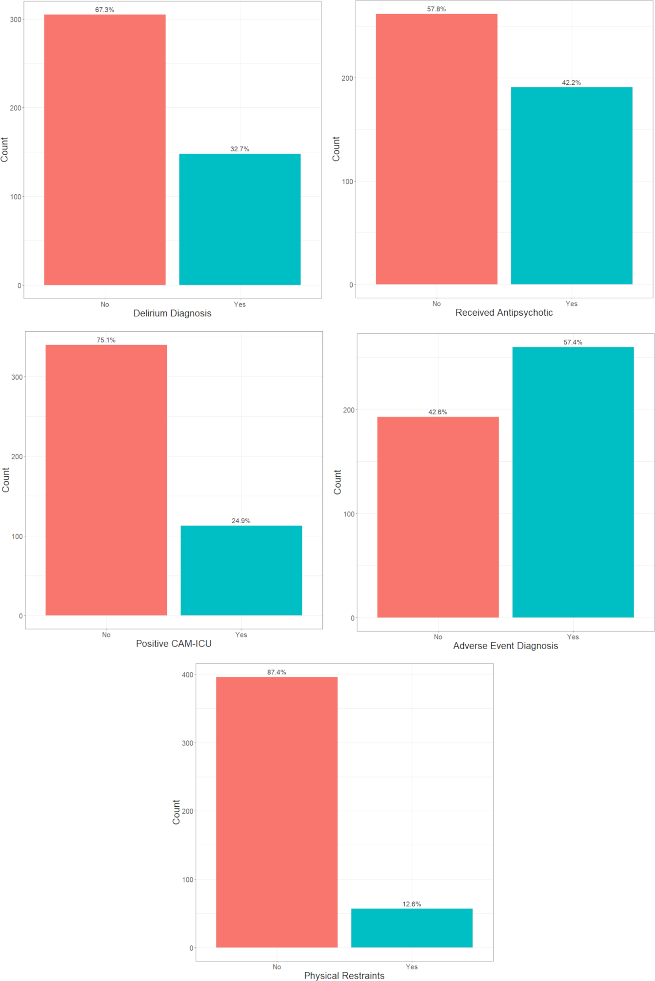

1. The percent with multiple (yes in 2 or more columns)

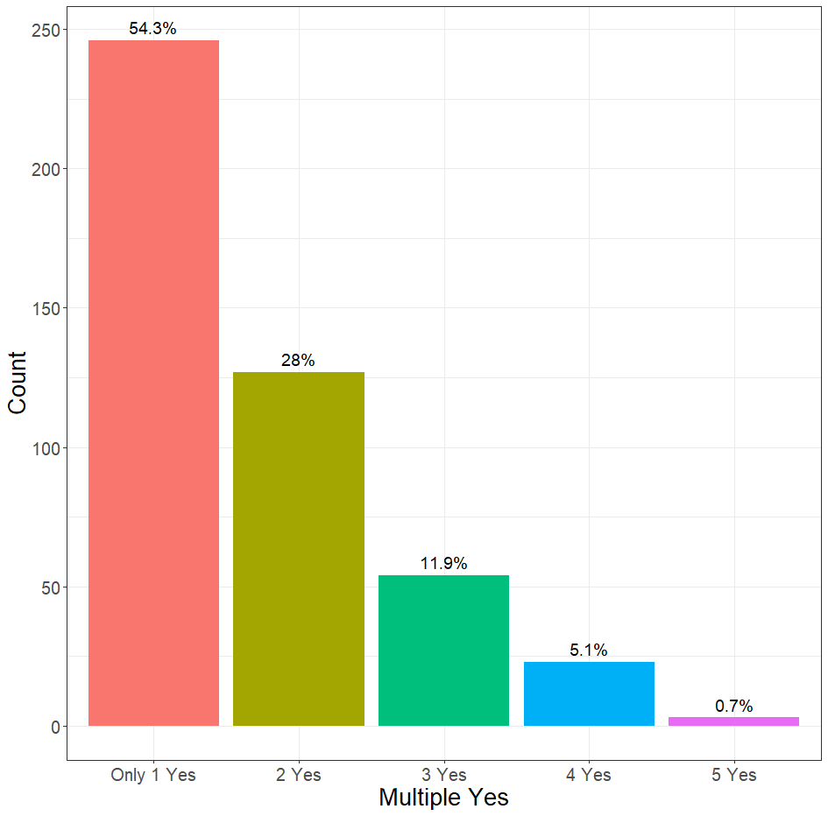

1. **In patients with a "yes" in column L, we would like to determine the most frequently administered drug (column M)**

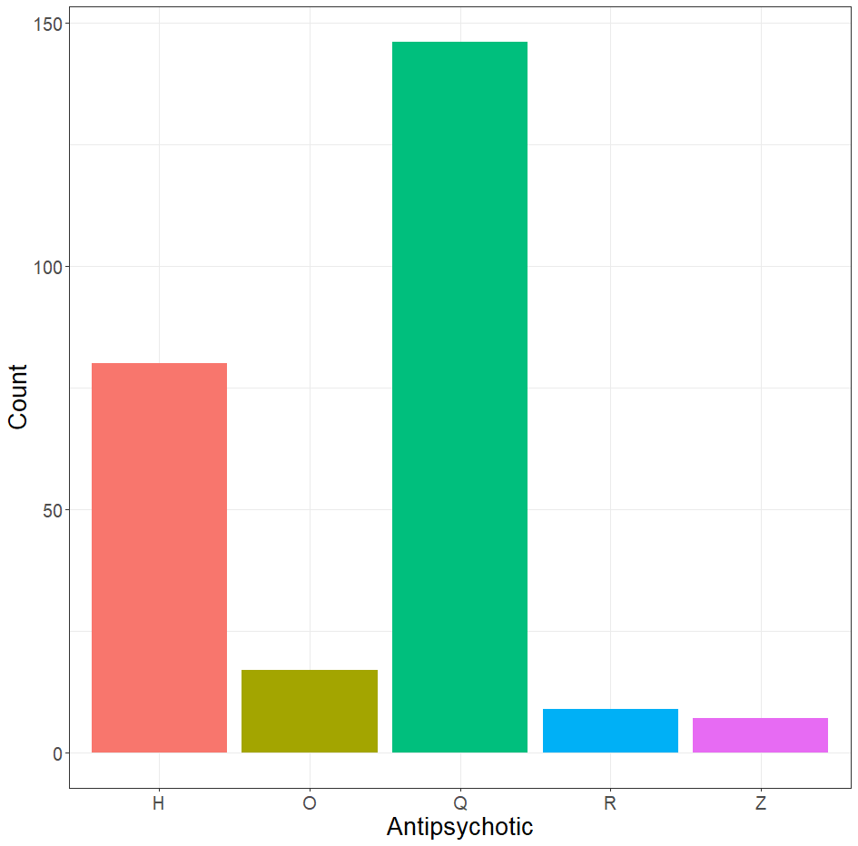

Notes:

* Could not find specific drug names associated with each letter in the data that was provided.

1. Lastly, in patients with a "yes" in column L or O, determining the average time to occurrence (columns N or P respectively) for each, as well as the overall average time, including the shorter duration in patients that have a "yes" in both columns L and O.

For these two time to event variables there are missing times. These correspond to patients that never received an antipsychotic (or positive CAM respectively). To calculate an unbiased median “survival time” we need one of two bits of information that will allow us to fill in values for these patients. They are as follows:

1. A maximum follow up time

OR

1. Two dates: an initial date (i.e. date of admission) and a date of last follow up