**Keppra Study Report R-168**

**Update Table**

|  |  |  |  |
| --- | --- | --- | --- |
| **Variable** | **Behavioral Event** | | **P-Value** |
| **No (n=512)** | **Yes (n=453)** |
| **Age at Admission (SD)** | 59.41 (18.49) | 60.87 (18.63) | 0.221 |
| **Ethnicity (%)** |  |  | 0.486 |
| Black or African American | 233 (45.5) | 191 (42.2) |  |
| Other | 20 ( 3.9) | 23 ( 5.1) |  |
| Unknown | 9 ( 1.8) | 5 ( 1.1) |  |
| White | 250 (48.8) | 234 (51.7) |  |
| **Gender (%)** |  |  | >0.999 |
| Male | 267 (52.1) | 237 (52.3) |  |
| Female | 245 (47.9) | 216 (47.7) |  |
| **Diagnosis (%)** |  |  | 0.418 |
| Cerebral infarction | 141 (27.5) | 111 (24.5) |  |
| Intracerebral hemorrhage | 155 (30.3) | 147 (32.5) |  |
| Subarachnoid hemorrhage | 78 (15.2) | 59 (13.0) |  |
| Traumatic intracranial injury | 138 (27.0) | 136 (30.0) |  |
| **GCS (IQR)** | 14.00 (7-15) | 13.00 (7-15) | 0.825 |
| **Discharge Disposition (%)** |  |  | <0.001 |
| Discharged to Rehab Unit/Facility | 77 (15.0) | 108 (23.8) |  |
| Discharged to SNF | 72 (14.1) | 130 (28.7) |  |
| Expired | 110 (21.5) | 50 (11.0) |  |
| Home | 213 (41.6) | 109 (24.1) |  |
| Hospice | 14 ( 2.7) | 33 ( 7.3) |  |
| Other | 26 ( 5.1) | 23 ( 5.1) |  |
| log(**Length of Stay at Hospital**) (SD) | 2.04 (1.02) | 2.56 (0.90) | <0.001 |
| log(**Length of Stay in ICU**) (SD) | 1.55 (1.10) | 1.99 (1.03) | <0.001 |
| log(**Total** **Keppra Dose**) (SD) | 0.96 (0.41) | 1.14 (0.39) | <0.001 |
| Log(**Keppra Duration**) (SD) | 0.73 (0.36) | 0.90 (0.36) | <0.001 |
| **Length of Stay at Hospital (IQR)** | 12.33 (3.80-16.60) | 13.91 (7.01-23.61) | <0.001 |
| **Length of Stay in ICU (IQR)** | 4.4 (2.00-11.10) | 7.6 (3.6-16.1) | <0.001 |
| **Total Keppra Dose (IQR)** | 11.0 (5.0-15.0) | 14.0 (10.0-21.0) | <0.001 |
| **Keppra Duration (IQR)** | 5.10 (2.22-7.0) | 6.59 (4.53-10.49) | <0.001 |
| **Rass < 3 (%)** |  |  | 0.002 |
| Yes | 229 (44.7) | 248 (54.7) |  |
| No |  |  |  |
| **Median Keppra Dose (%)** |  |  |  |
| 250 | 9 ( 1.8) | 7 ( 1.5) |  |
| 500 | 330 (64.5) | 278 (61.4) |  |
| 750 | 72 (14.1) | 76 (16.8) |  |
| 1000 | 72 (14.1) | 60 (13.2) |  |
| 1250 | 0 ( 0.0) | 2 ( 0.4) |  |
| 1500 | 22 ( 4.3) | 20 ( 4.4) |  |
| 1750 | 0 ( 0.0) | 1 ( 0.2) |  |
| 2000 | 4 ( 0.8) | 9 ( 2.0) |  |
| 3000 | 1 ( 0.2) | 0 ( 0.0) |  |
| Missing | 2 ( 0.4) | 0 ( 0.0) |  |
| **Received Benzos (%)** |  |  | < 0.001 |
| Yes | 175 (34.2) | 216 (47.7) |  |
| No | 337 (65.8) | 237 (52.3) |  |
| **CIWA Orders (%)** |  |  | < 0.001 |
| Yes | 50 (9.8) | 119 (26.3) |  |
| No | 462 (90.2) | 334 (73.7) |  |
| **Pain Scores (%)** |  |  | 0.236 |
| 0-3 | 360 (70.3) | 335 (74) |  |
| 4-10 | 152 (29.7) | 118 (26.0) |  |
| **Received IV opioid (%)** |  |  | 0.361 |
| Yes | 391 (76.4) | 358 (79.0) |  |
| No | 121 (23.6) | 95 (21.0) |  |
| **AED received while on Keppra (%)** |  |  | 0.002 |
| Yes | 56 (10.9) | 83 (18.3) |  |
| No | 456 (89.1) | 370 (81.7) |  |

**Time to Event Analysis:**

* **Patients that experienced a behavioral event (excluding missing):**
* Median time to antipsychotic administration (IQR): 2.15 (1.15-5.38)
* Median time to positive CAM (IQR): 2.04 (0.62-4.42)
* Median time to first occurance (N=50) (IQR): 1.5 (0.62-3.90)
* **Patients that experienced a behavioral event (including missing):**
* Estimated median time to antipsychotic administration (95% CI): 11.74 (7.53-16.35)

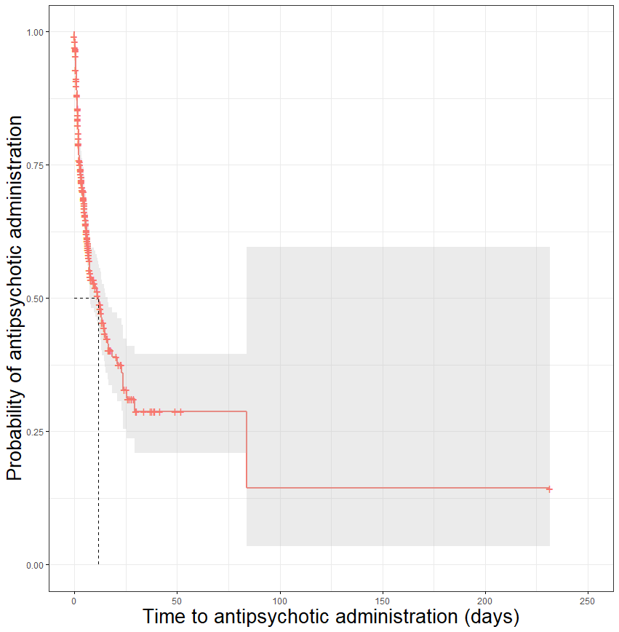

* Estimated median time to positive CAM (95% CI): NA

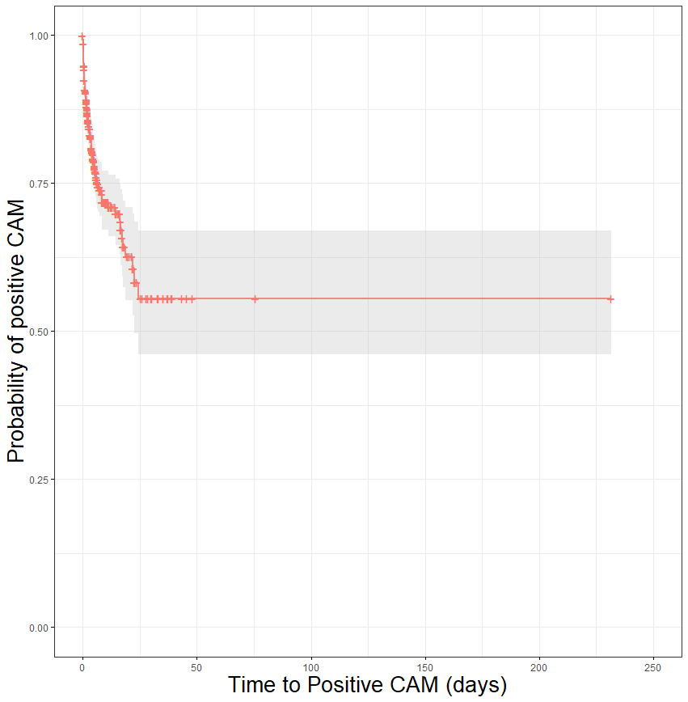

* Estimated median time to first occurance (all patients) (95% CI): 5.33 (4.39-6.44)

