**Keppra Study Report R-168**

1. **Inclusion of all patient demographics of surviving patients.**

|  |  |  |  |
| --- | --- | --- | --- |
|  | Stratified by Behavioral Event | | P-Value |
| Variable | No (N=402) | Yes (N=403) |  |
| Age (mean (SD)) | 58.07 (18.51) | 60.29 (18.72) | 0.091 |
| Ethnicity (%) |  |  | 0.42 |
| White | 198 (49.3) | 206 (51.1) |  |
| Black or African American | 183 (45.5) | 172 (42.7) |  |
| Other | 15 ( 3.7) | 22 ( 5.5) |  |
| Unknown | 6 ( 1.5) | 3 ( 0.7) |  |
| Gender (%) |  |  | 0.971 |
| Male | 210 (52.2) | 209 (51.9) |  |
| Female | 192 (47.8) | 194 (48.1) |  |
| Diagnosis (%) |  |  | 0.087 |
| CEREBRAL INFARCTION | 115 (28.6) | 99 (24.6) |  |
| INTRACEREBRAL HEMORRHAGE | 121 (30.1) | 128 (31.8) |  |
| SUBARACHNOID HEMORRHAGE | 69 (17.2) | 53 (13.2) |  |
| Traumatic intracranial injury | 97 (24.1) | 123 (30.5) |  |
| GCS (mean (SD)) | 11.78 (4.00) | 11.40 (4.17) | 0.192 |
| Discharge.Disposition (%) |  |  | <0.001 |
| Disch to Rehab Unit/Facility | 77 (19.2) | 108 (26.8) |  |
| Disch to SNF | 72 (17.9) | 130 (32.3) |  |
| Home | 213 (53.0) | 109 (27.0) |  |
| Hospice | 14 ( 3.5) | 33 ( 8.2) |  |
| Other | 26 ( 6.5) | 23 ( 5.7) |  |
| Length of Stay Hospital (mean (SD)) | 13.64 (14.53) | 20.53 (30.39) | <0.001 |
| Length of Stay ICU (mean (SD)) | 9.00 (11.12) | 13.26 (27.12) | 0.004 |
| Total Keppra Doses (mean (SD)) | 14.44 (13.34) | 20.00 (21.22) | <0.001 |
| Keppra Duration (mean (SD)) | 7.08 (7.89) | 10.52 (15.77) | <0.001 |
| log Length of Stay Hospital (mean (SD)) | 0.96 (0.40) | 1.13 (0.37) | <0.001 |
| log Length of Stay ICU (mean (SD)) | 0.71 (0.46) | 0.88 (0.44) | <0.001 |
| log Total Keppra Doses (mean (SD)) | 1.01 (0.37) | 1.14 (0.38) | <0.001 |
| log Keppra Duration (mean (SD)) | 0.77 (0.34) | 0.90 (0.35) | <0.001 |
| Rass less than -3 (%) |  |  | <0.001 |
| Yes | 123 (30.6) | 202 (50.1) |  |
| No | 279 (69.4) | 201 (49.9) |  |
| Median Keppra Dose (%) |  |  | NaN |
| 250 | 7 ( 1.7) | 5 ( 1.2) |  |
| 500 | 264 (65.7) | 249 (61.8) |  |
| 750 | 55 (13.7) | 70 (17.4) |  |
| 1000 | 53 (13.2) | 52 (12.9) |  |
| 1250 | 0 ( 0.0) | 1 ( 0.2) |  |
| 1500 | 19 ( 4.7) | 18 ( 4.5) |  |
| 1750 | 0 ( 0.0) | 1 ( 0.2) |  |
| 2000 | 4 ( 1.0) | 7 ( 1.7) |  |
| 3000 | 0 ( 0.0) | 0 ( 0.0) |  |
| Received Benzo (%) |  |  | 0.001 |
| Yes | 143 (35.6) | 191 (47.4) |  |
| No | 259 (64.4) | 212 (52.6) |  |
| CIWA Orders (%) |  |  | <0.001 |
| Yes | 45 (11.2) | 115 (28.5) |  |
| No | 357 (88.8) | 288 (71.5) |  |
| Pain Scores (%) |  |  | 0.009 |
| 0-3 | 144 (35.8) | 109 (27.0) |  |
| 4-10 | 258 (64.2) | 294 (73.0) |  |
| Received IV opioid (%) |  |  | 0.244 |
| Yes | 295 (73.4) | 311 (77.2) |  |
| No | 107 (27.6) | 92 (22.8) |  |
| AED Received while on Keppra (%) |  |  | 0.003 |
| Yes | 45 (11.2) | 76 (18.9) |  |
| No | 357 (88.8) | 327 (91.1) |  |
| Times RASS less neg3 (mean (SD)) | 34.87 (60.06) | 20.70 (27.96) | 0.004 |
| Times RASS evaluated (mean (SD)) | 124.21 (95.44) | 155.24 (125.77) | 0.019 |
| Percent RASS less neg3 (mean (SD)) | 23.42 (26.07) | 15.88 (23.38) | 0.007 |

1. **Possibility of enlarging or adding X-axis break for time to event curves.**

Need more clarification on this

1. **Is it possible to adjust for the confounding variables and look at the different lengths of stay for each group (behavioral event vs no behavioral event) using a regression analysis?**

Multiple linear regression analysis modelling the mean change in length of stay (hospital/ICU) between patients that had a behavioral event and those that did, after adjusting for RASS, Benzo status, pain score, opioid status, concurrent AED status, and Keppra dose

* Hospital length of stay:

|  |  |  |  |
| --- | --- | --- | --- |
| Parameter | Estimate | Std. Error | P-Value |
| Intercept | 0.516 | 0.03 | < 0.0001 |
| Behavioral Event (Yes) | 0.175 | 0.024 | < 0.0001 |
| Rass < -3 (Yes) | 0.089 | 0.027 | 0.0011 |
| Received Benzo (Yes) | 0.159 | 0.025 | < 0.0001 |
| Pain Scores (4-10) | 0.012 | 0.028 | 0.6578 |
| Received IV opioid (Yes) | 0.319 | 0.03 | < 0.0001 |
| Concurrent AED (Yes) | 0.127 | 0.035 | 0.0003 |
| Median Keppra Dose cat (>500 mg) | 0.039 | 0.025 | 0.122 |

* ICU length of stay

|  |  |  |  |
| --- | --- | --- | --- |
| Parameter | Estimate | Std. Error | P-Value |
| Intercept | 0.244 | 0.033 | < 0.0001 |
| Behavioral Event (Yes) | 0.125 | 0.026 | < 0.0001 |
| Rass < -3 (Yes) | 0.16 | 0.029 | < 0.0001 |
| Received Benzo (Yes) | 0.221 | 0.027 | < 0.0001 |
| Pain Scores (4-10) | 0.015 | 0.03 | 0.6128 |
| Received IV opioid (Yes) | 0.339 | 0.033 | < 0.0001 |
| Concurrent AED (Yes) | 0.094 | 0.037 | 0.0118 |
| Median Keppra Dose cat (>500 mg) | 0.023 | 0.027 | 0.385 |

Notes:

* The above analyses models the log of the length of stay (given the skewness; lack of normality) using the following regression equation:

log(yi) = β0 + β1X1 + β2X2 + … + εi

* The interpretation for behavioral event is a follows:
* The difference in the expected geometric means of the log of hospital length of stay between patients with a behavioral event and those without is 0.175, while adjusting for all other covariates.
* The natural way to interpret log transformed outcomes is to use exponentiate:
* Patients with a behavioral event had a 13% (exp(0.125)=1.133) increase in the geometric mean of hospital length of stays, while adjusting for all other covariates.
* The interpretation for ICU length of stay is similar.

1. **Since there is a link between CIWA orders and benzo use, removing CIWA orders as a confounding variable**

Multiple Logistic Regression Parameter Estimates:

|  |  |  |  |
| --- | --- | --- | --- |
| **Potential Confounder** | **Estimate** | **Std. Error** | **P-Value** |
| Intercept | -0.486 | 0.160 | 0.0024 |
| Rass < -3 (Yes) | 0.304 | 0.147 | 0.0390 |
| Received Benzo (Yes) | 0.463 | 0.137 | 0.0007 |
| Pain Score (4-10) | -0.092 | 0.153 | 0.5448 |
| Received IV opioid (Yes) | -0.046 | 0.168 | 0.7812 |
| Concurrent AED (Yes) | 0.485 | 0.191 | 0.0114 |
| Median Keppra Dose (>500) | 0.051 | 0.139 | 0.7117 |

Odds Ratios:

|  |  |
| --- | --- |
| **Potential Confounder** | **Odds Ratio (95% CI)** |
| Intercept | 0.615 (0.447, 0.841) |
| Rass < -3 (Yes) | 1.355 (1.016, 1.810) |
| Received Benzo (Yes) | 1.589 (1.213, 2.083) |
| Pain Score (4-10) | 0.911 (0.674, 1.231) |
| Received IV opioid (Yes) | 0.954 (0.685, 1.329) |
| Concurrent AED (Yes) | 1.624 (1.117, 2.374) |
| Median Keppra Dose (>500) | 1.053 (0.801, 1.383) |

1. **Is it possible to incorporate the confounding variables in the time to event curves?**

Time to antipsychotic administration:

* Cox Proportional Hazard Ratio Estimates:

|  |  |  |  |
| --- | --- | --- | --- |
| Parameter | HR | Lower 95% CI | Lower 95% CI |
| Rass < -3 (Yes) | 0.797 | 0.572 | 1.109 |
| Received Benzo (Yes) | 1.362 | 1.01 | 1.838 |
| Pain Score (4-10) | 0.992 | 0.709 | 1.388 |
| Received IV opioid (Yes) | 0.695 | 0.476 | 1.017 |
| Concurrent AED (Yes) | 1.296 | 0.922 | 1.82 |
| Median Keppra Dose (>500) | 0.929 | 0.689 | 1.252 |

Time to positive CAM:

* Cox Proportional Hazard Ratio Estimates:

|  |  |  |  |  |
| --- | --- | --- | --- | --- |
| Parameter | HR | Lower 95% CI | Lower 95% CI | P-Value |
| Rass < -3 (Yes) | 2.495 | 1.519 | 4.098 | 0.0003 |
| Received Benzo (Yes) | 0.87 | 0.594 | 1.275 | 0.4778 |
| Pain Score (4-10) | 0.847 | 0.524 | 1.369 | 0.4981 |
| Received IV opioid (Yes) | 0.521 | 0.303 | 0.895 | 0.0182 |
| Concurrent AED (Yes) | 0.788 | 0.485 | 1.279 | 0.3357 |
| Median Keppra Dose (>500) | 1.087 | 0.741 | 1.593 | 0.6690 |

Notes: The cox proportional hazards model evaluates the effect of multiple variables on the time to event (antipsychotic administration/positive CAM). In other words, it allows us to examine how specified factors influence the rate of a particular event happening (e.g., infection, death) at a particular point in time. We measure this using the hazard ratio (HR).

* The interpretation for RASS is a follows:

There is a significant relationship between RASS < -3 and higher risk of being administered an antipsychotic. Specifically, having RASS < -3 increases the risk of being administered an antipsychotic by a factor of 2.5 (or 150%), while holding all other covariates constant.

* Similar interpretations can be made about the other HRs and about time to positive CAM

1. **We would like to determine if there is a difference between the groups regarding the frequency of a RASS score of </= -3**

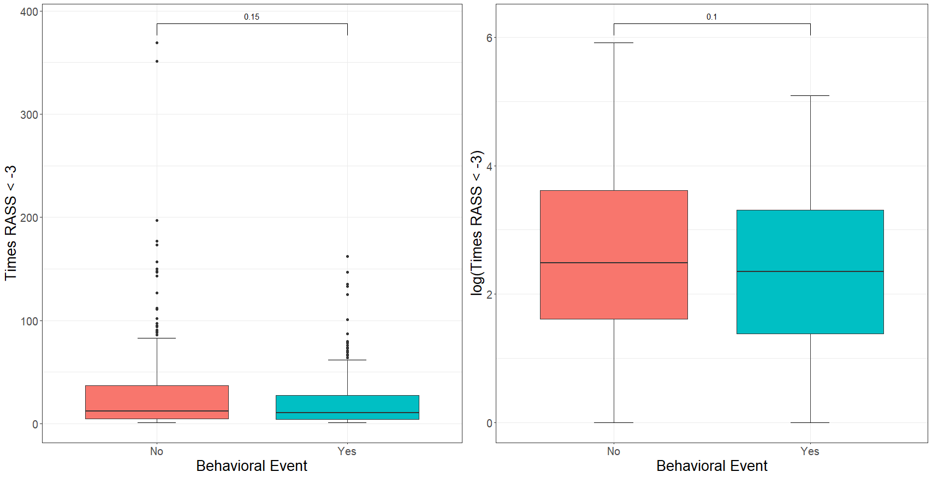

Notes: The difference in the number of times RASS was less than -3 (or log transformed) was deemed not to be significantly different between patients that had a behavioral event and those that did not using a Wilcoxon rank sum test, p=0.15 (p=0.10 log transformed student’s t test).

* Some things to consider here:

1. Patients with missing Times_RASS_less_neg3 were removed.
2. Should these actually be coded as 0 instead of missing?