## REPORT

|  |  |
| --- | --- |
| **Project ID:** | R -96 |
| **Project:** | Longitudinal Assessment of the relationship of Age on Quality of life and Uncertainty in Patients Undergoing Intracranial Radiation Therapy |
| **Investigator(s):** | Yasamin Sharifzadeh-Moghaddam |
| **BCL Consultant(s):** | Spiro Stilianoudakis |
| **Date:** | 01/26/2017 |

## Introduction

From the time of diagnosis, a variety of treatment modalities, including radiation therapy, are employed to patients diagnosed with intracranial malignancies with the hopes of controlling disease and prolonging life. However, unwanted side effects of therapy can significantly impact patients’ quality of life (QoL) and their uncertainty toward the future. Understanding QoL and patient uncertainty in clinical oncology is an important endeavor, and a variety of methods have been employed to characterize each. A factor affecting each of these metrics is a patient’s age. We hypothesize that older patients are more likely to be at peace with their diagnosis and subsequent treatment, and thus will have lower uncertainty and higher QoL scores. Therefore, we aim to investigate the relationship of age on QoL and uncertainty for patients with intracranial malignancies and determine if these relationships changes with time.

## Methods

**Patient Population**

This was a prospective longitudinal study consisting of patients who were recruited through the UCSD Department of Radiation Oncology and scheduled to undergo radiation treatment as part of the standard of care for intracranial malignancies. These malignancies included cerebral metastases, high- or low-grade gliomas, meningiomas, pituitary adenomas, vestibular schwannomas, etc. Patients were offered the opportunity to participate at the initial radiation oncology consultation. After consent was obtained, patients completed a combined questionnaire (generated from the EORTC QLQ-C15-PAL, BN-20 module, and limited additional items) prior to receipt of radiation therapy in the clinic. Following the completion of radiation therapy, patients were again asked to complete the questionnaire at each follow up visit, which was to be at 1, 3, and 6-months post-treatment. After the initial baseline completion, patients were allowed to complete the questionnaire either at home or at the clinic.

The inclusion criteria of the study included: age $>$ 18 years, life expectancy $>$ 3 months, ECOG performance status $≤$ 3 or Karnofsky performance status $>$ 50, and a plan on the patient's part to receive intracranial radiation therapy. All patients had to be fluent in either English or Spanish to participate. Patients were not excluded on the basis of gender or ethnicity. If patients were determined to have mental capacity to answer questions, but did not have the capacity to write, they were allowed to designate a proxy to transcribe their responses.

Quality of Life was initially assessed by patient response to 1 of the questions on the questionnaire. The question was on a 1 to 7 scale. Uncertainty was calculated using 4 separate questions, each on a 1 to 4 scale. Each of these metrics were then transformed into a 0-100 scale. In addition to obtaining data from patient questionnaires, patient age, Karnofsky Performance Scale (KPS) Index, gender, whether the patient had prior resection, and if it was deemed that the patient had been responding to treatment were also obtained.

**Study Design and Analysis**

Due to insufficient sample size, only baseline, 1-month, and 3-month time points were considered for the analysis. Patient dropout between each of the three time points was evaluated and it was found that the majority of dropout occurred between baseline to 1-month timepoints. To determine if the dropout between these two time points was random, two groups were created. One group consisted of patients that only had completed the questionnaire at baseline, and the other included patients with any sort of follow-up data (either 1 month or 1 month and 3 month). Student’s t-tests and Pearson Chi-Square tests were performed on the baseline measurements of the two groups in order to evaluate if dropout from baseline to 1-month had an effect in biasing the sample.

LOESS plots of age on QoL and uncertainty were performed to determine if a nonlinear relationship existed. Two separate mixed effects models were performed to predict the QoL and uncertainty scores using age as the sole variable. Unstructured covariance structures were used for each model. All statistical analyses were performed in R version 3.4.2 at a significance level of 0.05.

## Results

There were 107 patients included in the analyses. Table 1 presents the patients in two mutually exclusive groups with respect to the completion status of the questionnaire. The groups were compared across the different patient characteristics. It was concluded that the two groups were not different and, therefore, any drop out was attributed to randomness.

**Table 1.** Results of statistical tests used to determine if patients in one of two groups based on dropout are different across other variables.

|  |  |  |  |  |
| --- | --- | --- | --- | --- |
| **Variable** | **Total (n=107)** | **Baseline Only (n = 48)** | **Any Follow-Up (n = 59)** | **P-Value** |
| **QoL Score (sd)** | 60.0 (23.3) | 57.1 (24.2) | 62.1 (22.5) | 0.273 |
| **Uncertainty Score (sd)** | 37.8 (26.7) | 33.3 (24.4) | 41.4 (28.2) | 0.117 |
| **Age (sd)** | 56.9 (14.5) | 57.7 (13.6) | 56.2 (15.3) | 0.579 |
| **KPS (sd)** | 86.0 (12.7) | 84.9 (13.2) | 86.9 (12.4) | 0.412 |
| **Gender (%)** |  |  |  | 0.351 |
| **Male** | 65 (61) | 32 (67) | 33 (55) |  |
| **Female** | 42 (39) | 16 (33) | 26 (44) |  |
| **Prior Resection (%)** |  |  |  | 0.333 |
| **No** | 58 (54) | 29 (60) | 29 (49) |  |
| **Yes** | 49 (46) | 19 (40) | 30 (51) |  |
| **Cancer Still Affecting (%)** |  |  |  | 0.855 |
| **No** | 48 (45) | 22 (46) | 26 (44) |  |
| **Yes** | 59 (55) | 26 (54) | 33 (56) |  |

Loess plots were used to asses the form of the relationship between age and QoL, as well as age and uncertainty, to determine if any transformations needed to be included in the subsequent models. Figure 1 depicts the loess plots, separated by timing of the questionnaire. In either case, the points appear scattered in a cloud, with no real relationship between age and QoL or age and uncertainty across time.

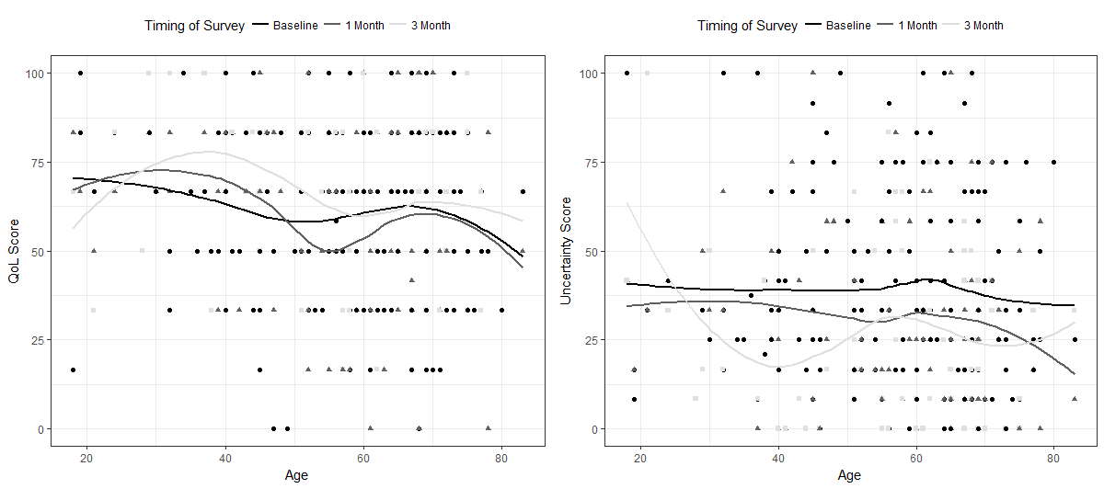

**Figure 1.** Loess plots of Age vs QoL and Age vs Uncertainty separated by when the patient filled out the questionnaire.

For the model of QoL vs age, the age by time interaction estimate was found to be -0.14 and not significant, with a p-value of 0.143. Therefore, it was concluded that, given the data, the relationship of age and QoL did not change over time. For the model of age vs uncertainty, the age by time interaction was also found not to be significant, with an estimate of -0.02 and a p-value of 0.857. Likewise, it was concluded that, given the data, the relationship of age and uncertainty did not change over time either.

## Discussion

After thorough exploration into the relationship of patient age and QoL, as well as uncertainty, it was concluded that no such relationship existed. Furthermore, there was no significant change in the relationship between patient age and each of QoL and uncertainty scores. A possible limitation of the study was the small number of time points that were available in the data.

Acknowledgement

"Services in support of the research project were generated by the VCU Massey Cancer Center Biostatistics Shared Resource, supported, in part, with funding from NIH-NCI Cancer Center Support Grant P30 CA016059."