**Color Acuity Project Report**

**Exploratory Data Analysis:**

* Age

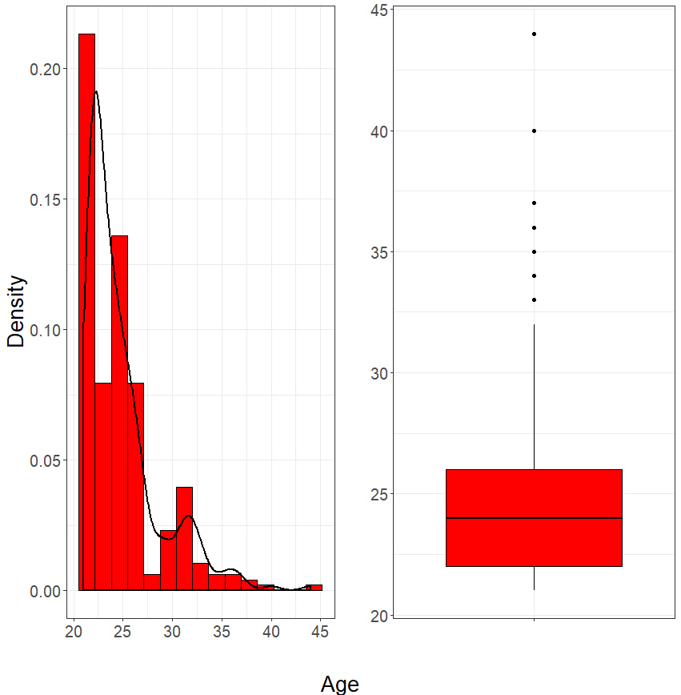

* Sex

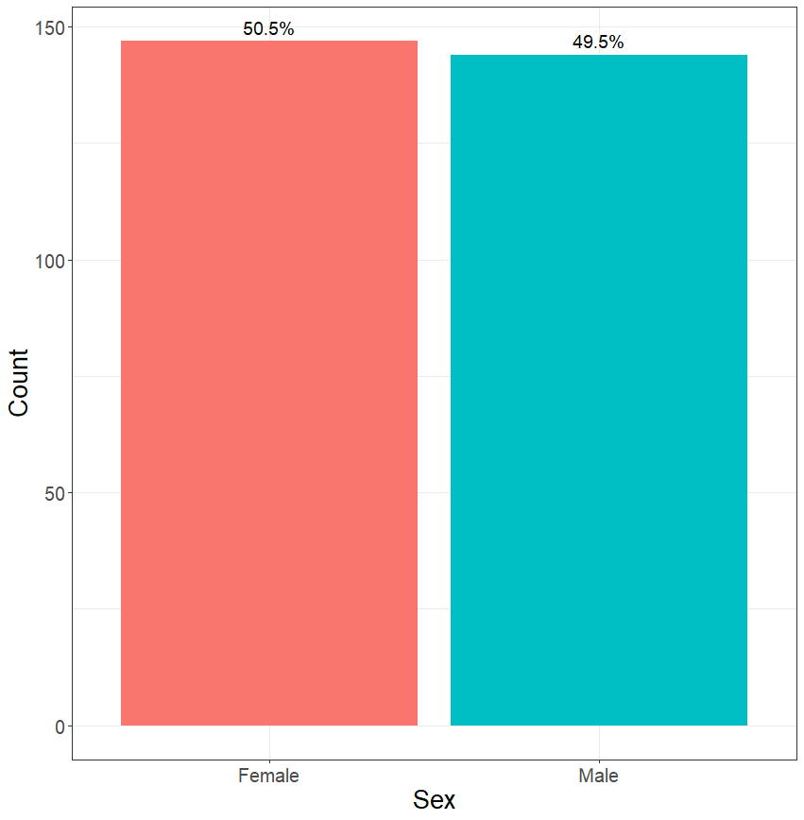

* PAT

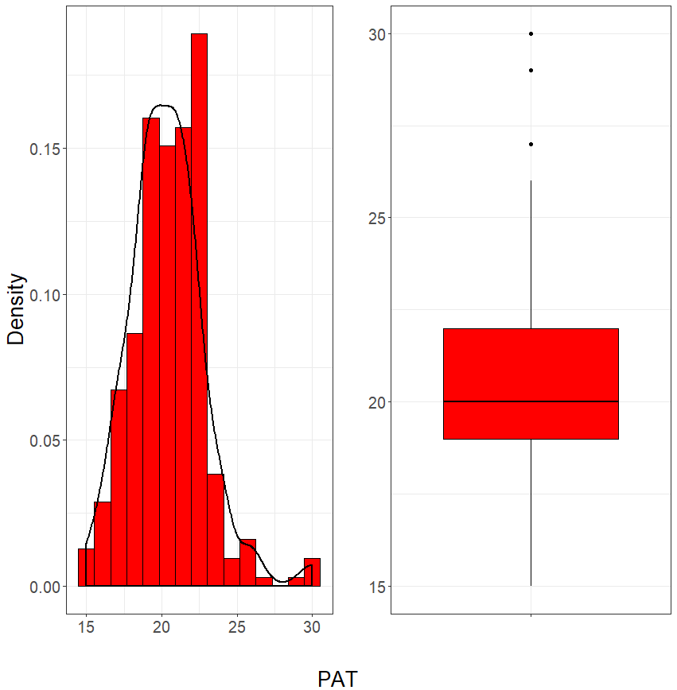

* Ethnicity

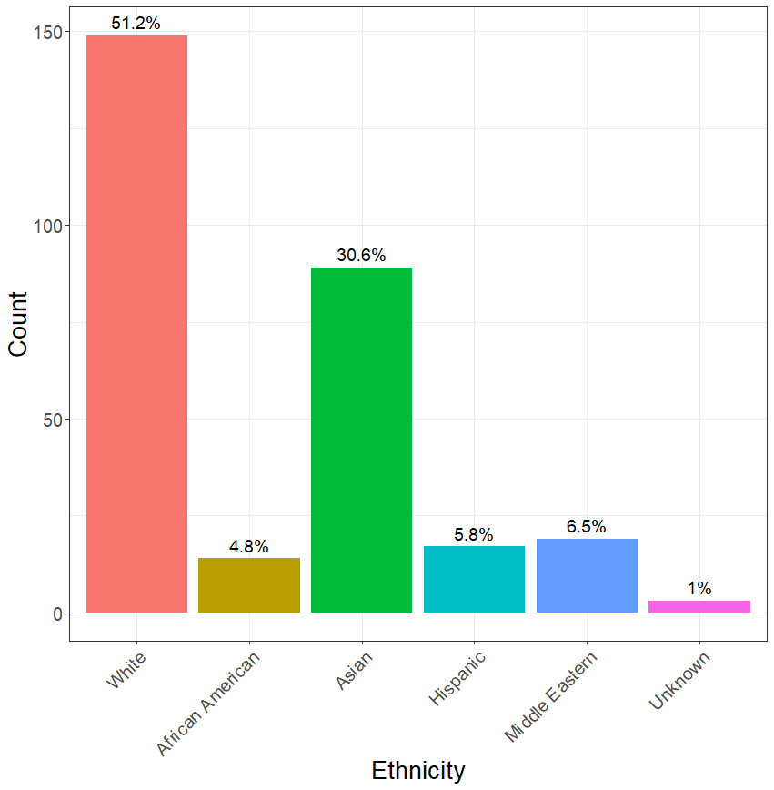

* TES

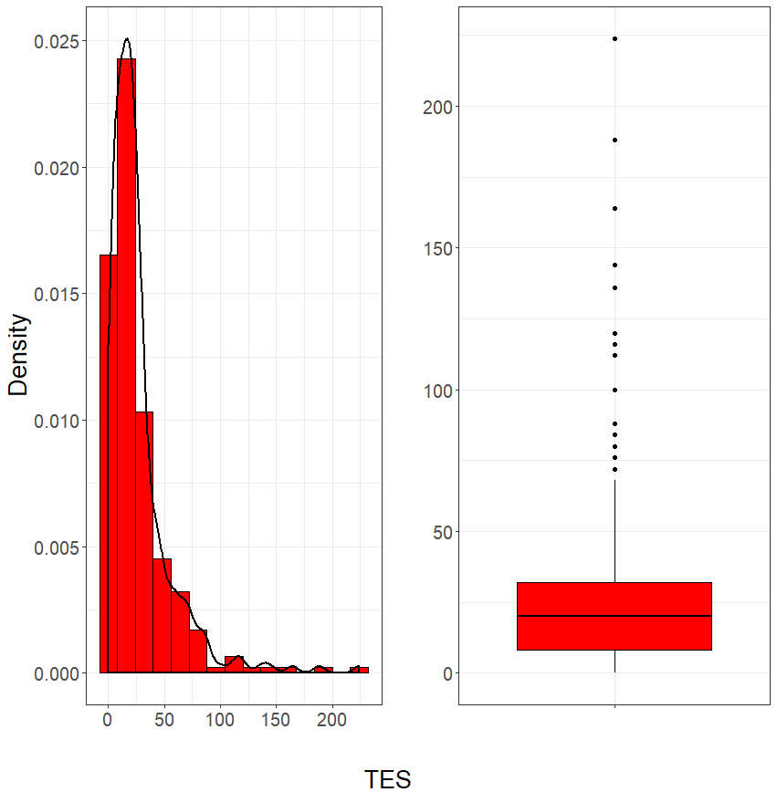

* Time to completion of test

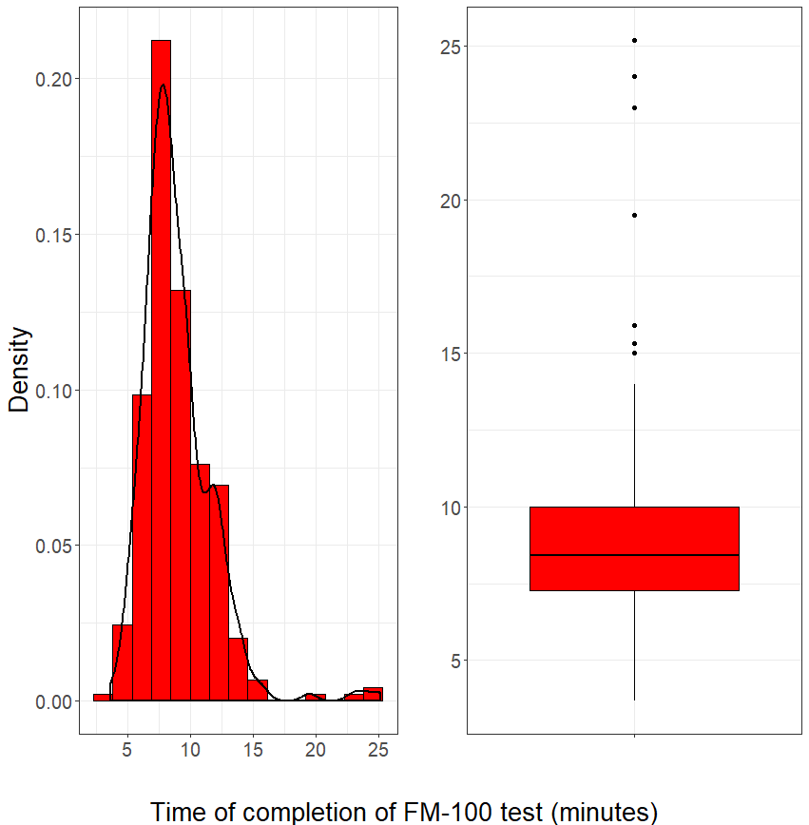

* Color Acuity Score

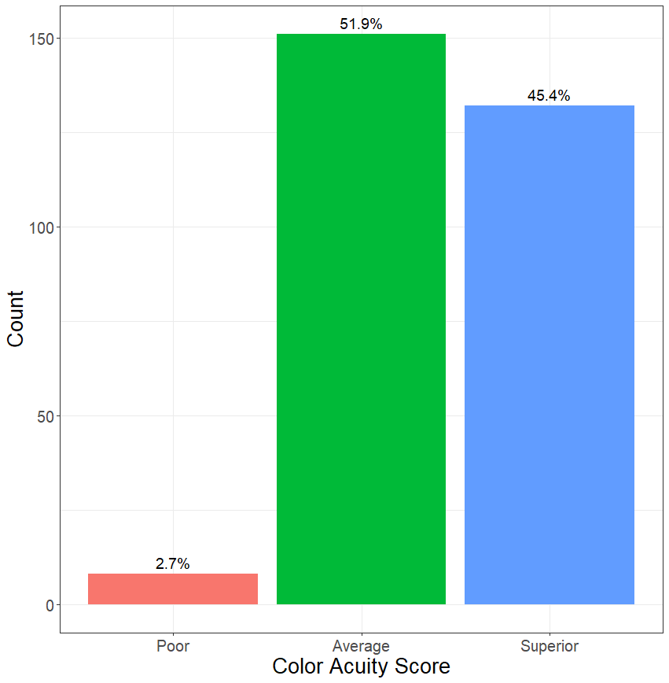

**Data Analysis:**

1. Is there a difference in sex regarding PAT or TES score?

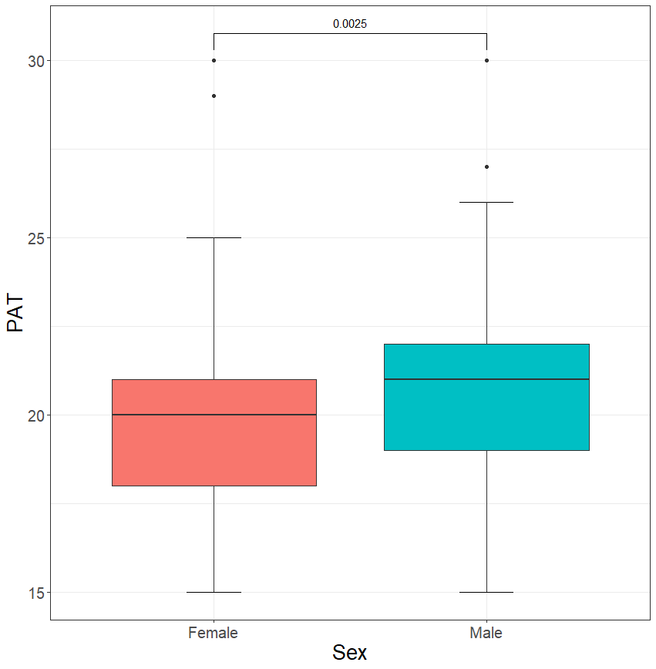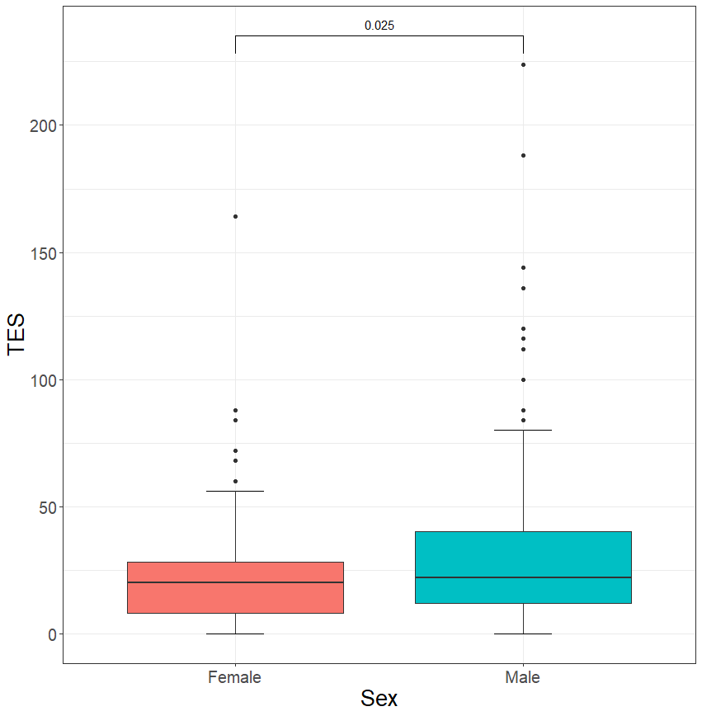

The p-values from the statistical tests indicate that PAT and TES scores are significantly different between males and females. A two-sample Student’s t-test was performed for PAT score (p=0.0025), while a two-sample nonparametric Wilcoxon Rank-Sum test was performed for TES score to account for nonnormality (p=0.025).

1. Is there a difference in ethnicity regarding PAT or TES score?

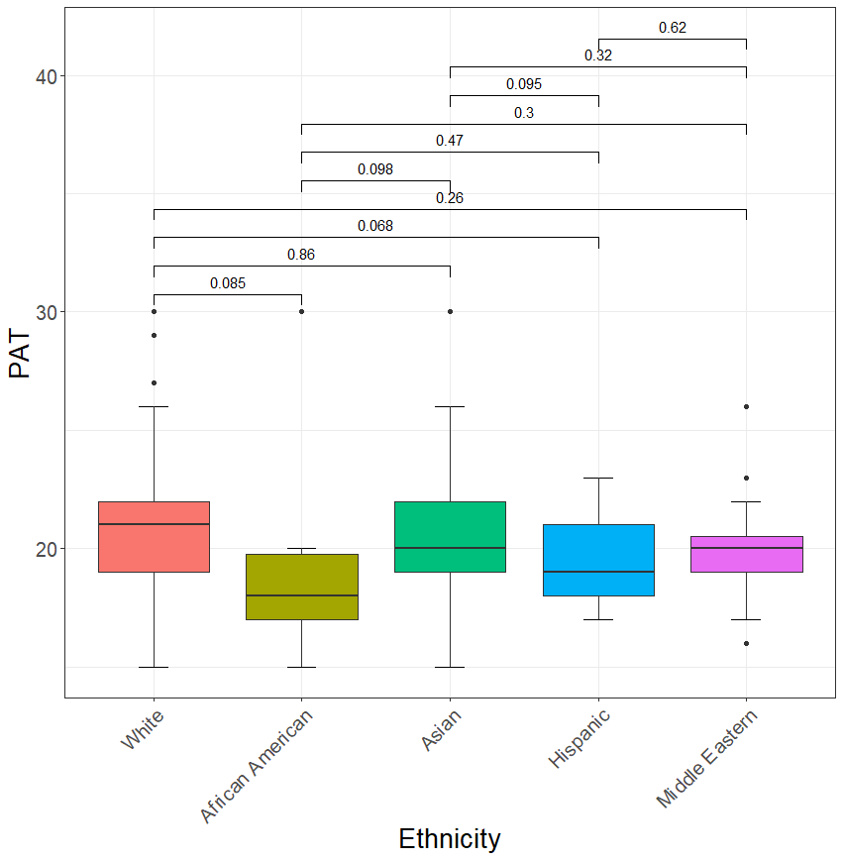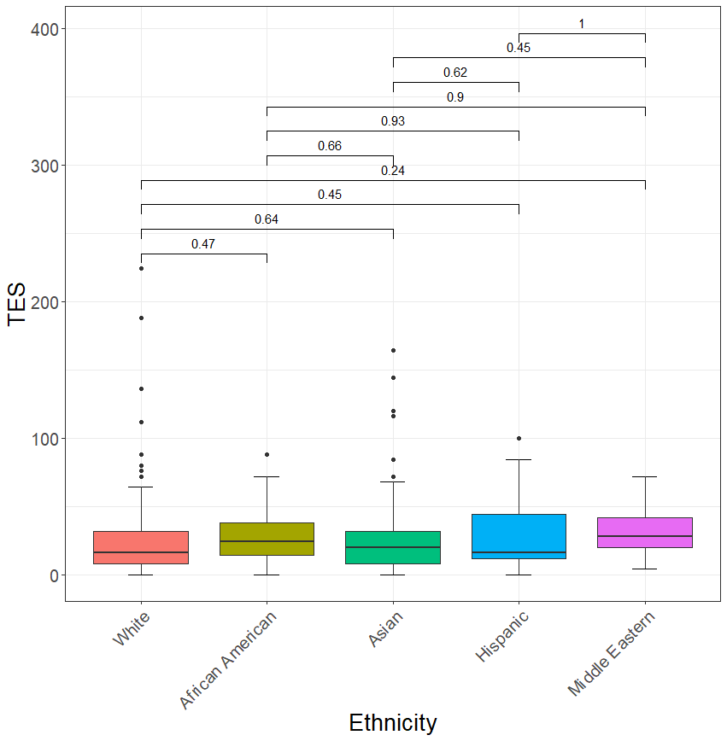

Pairwise statistical tests were performed between each ethnicity category. P-values derived from Student’s t-tests for PAT and Wilcoxon Rank-Sum tests for TES are proved above each pairwise test.

1. Does higher PAT correlate with lower TES (better performance on FM-100)?

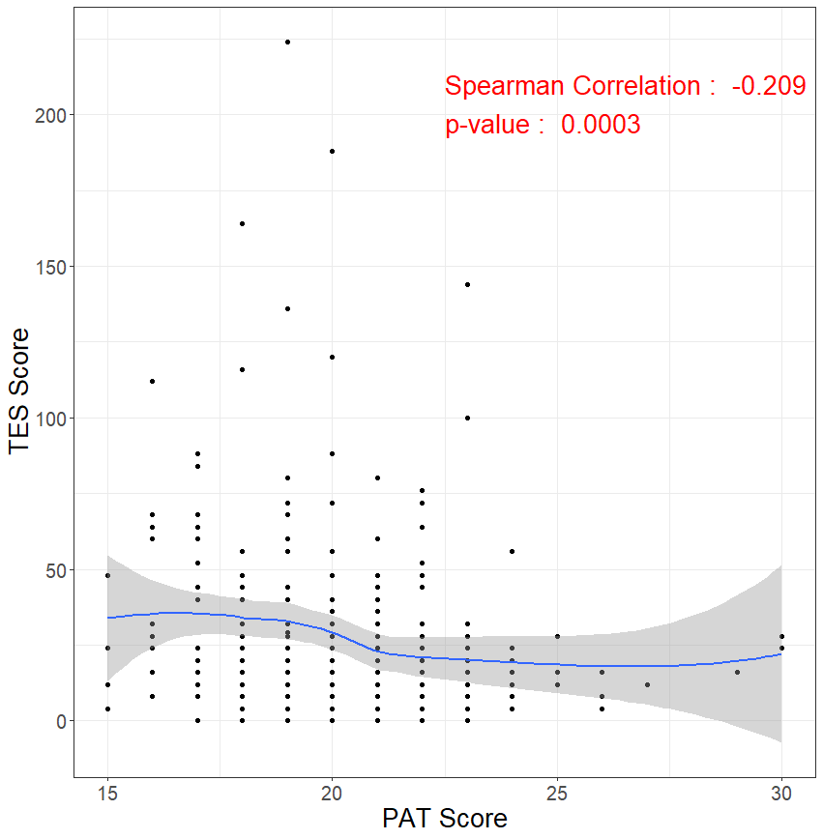

The Spearman Rank correlation coefficient suggests a strong negative relationship between PAT score and TES score, indicating that higher PAT scores correlate with lower TES scores (p=0.0003). The loess curve (blue line), followed by its 95% confidence band (grey region), shows the general trend of the relationship.

1. Does time of completion correlate with better performance?

* Using continuous performance (TES score)

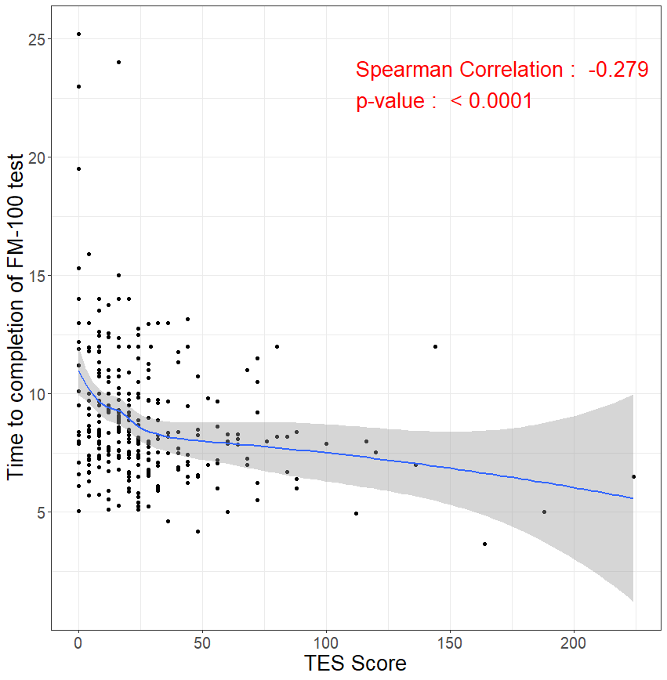

The Spearman Rank correlation coefficient suggests a strong negative relationship between TES score and time of completed test, indicating that higher TES scores (worse scores) correlate with lower times of completion (p<0.0001). The loess curve (blue line), followed by its 95% confidence band (grey region), shows the general trend of the relationship.

* Using categorical performance (Color Acuity)

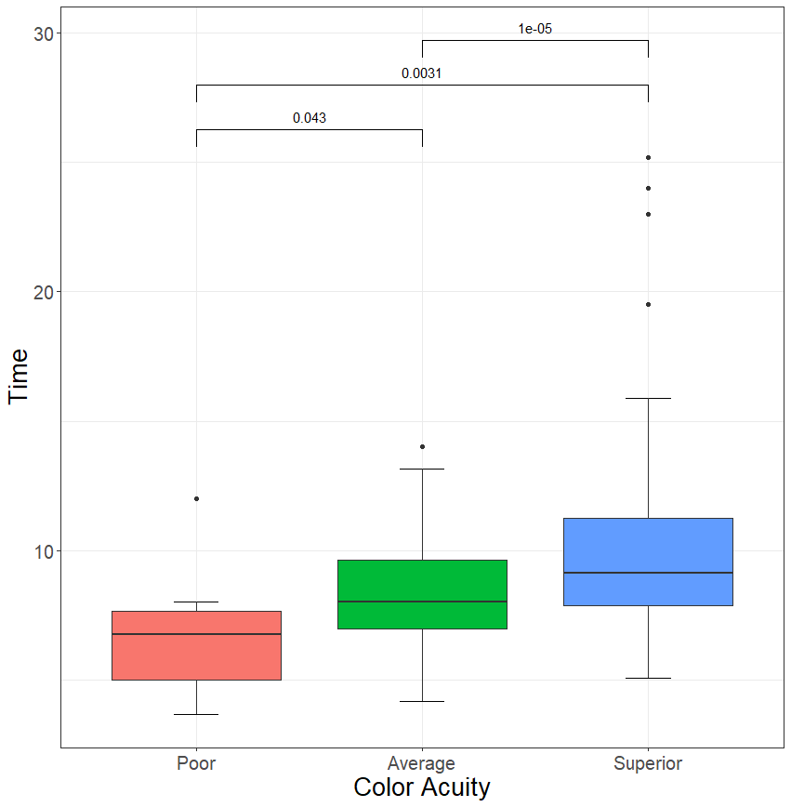

Pairwise statistical tests using Wilcoxon Rank-Sum tests were performed between each color acuity category. Each pairwise difference was found to be significantly different. The overall trend confirms what was seen in the continuous case above. That is, worse color acuity was associated with shorter time to completion of the Farnsworth-Munsell-100 Hue test.