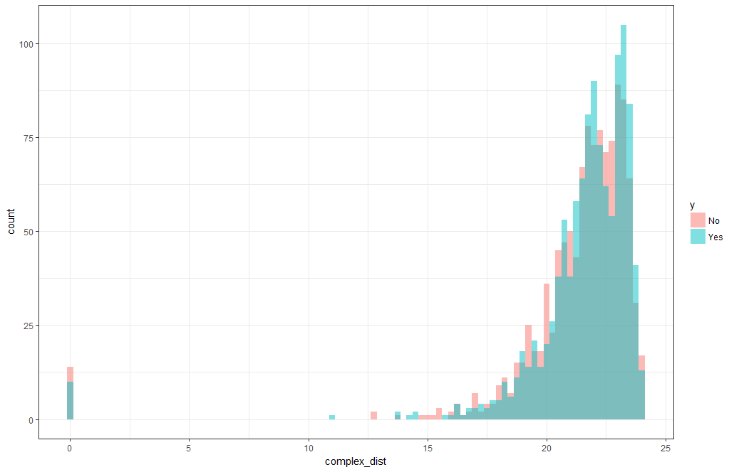 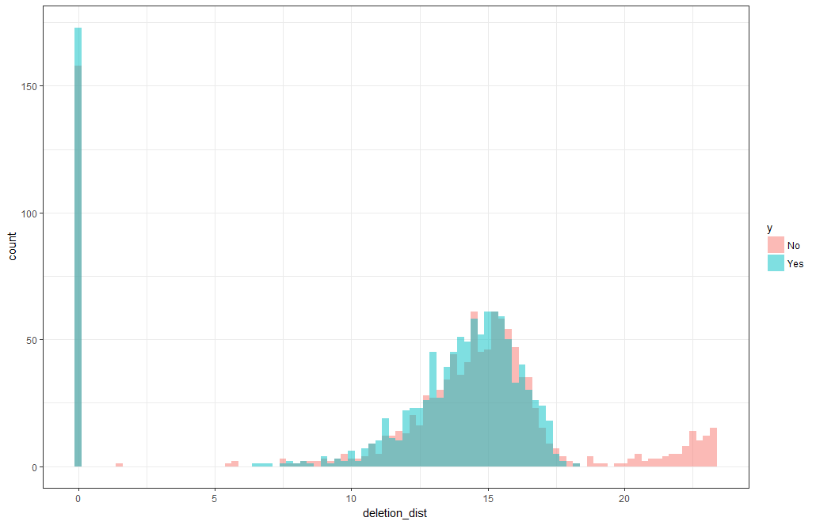

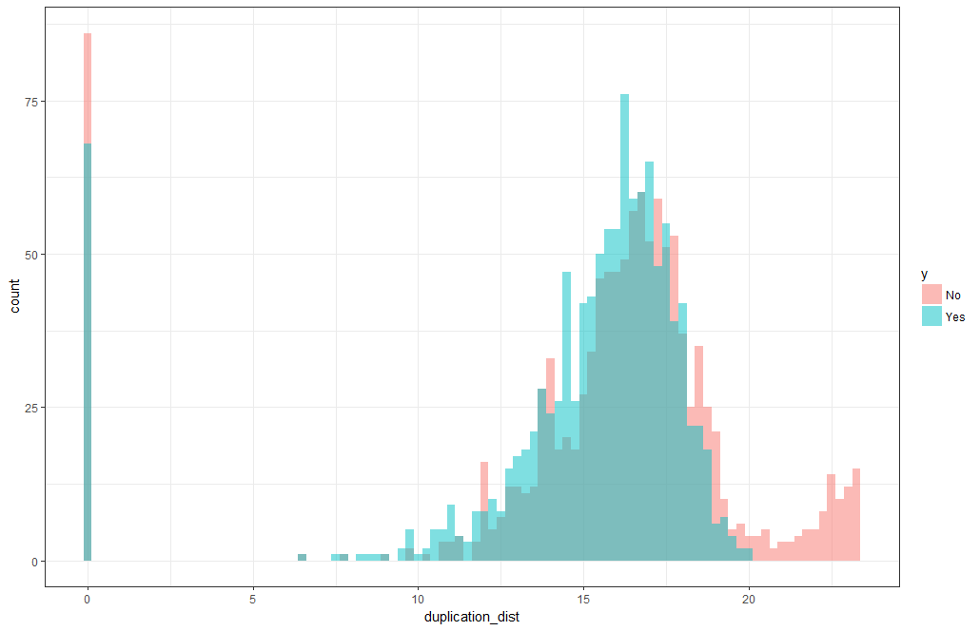 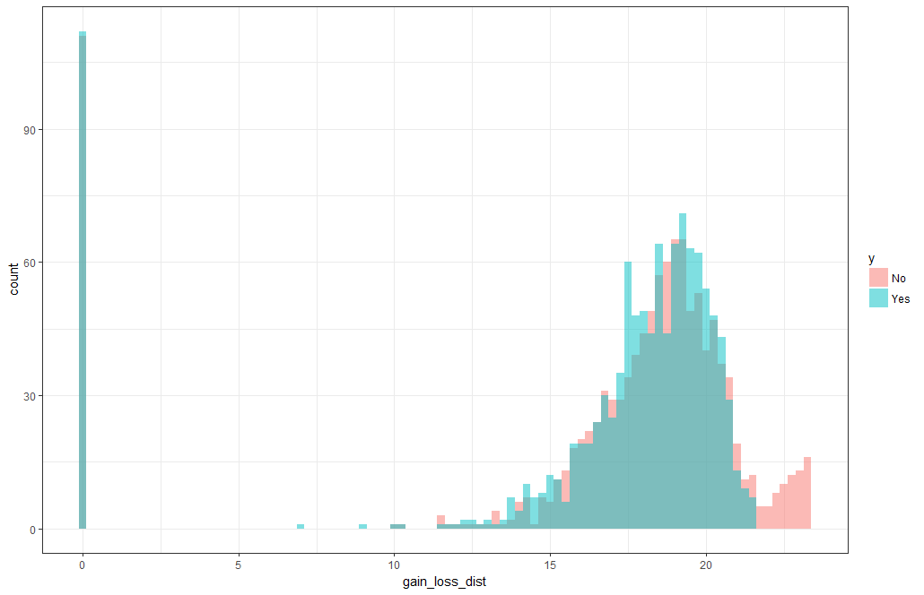

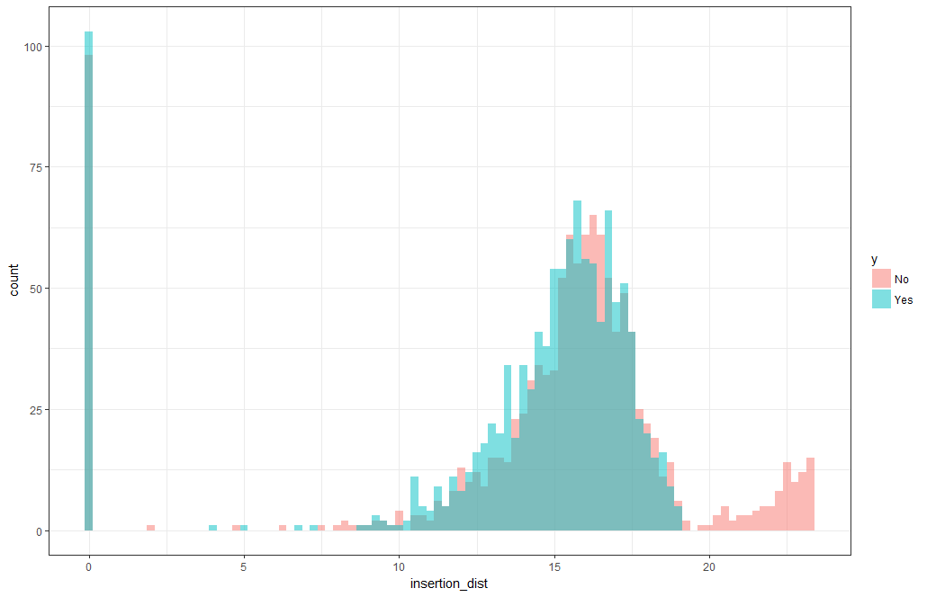 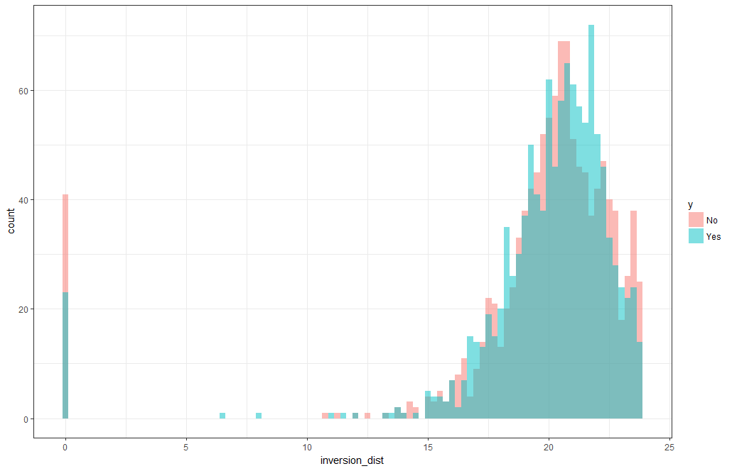

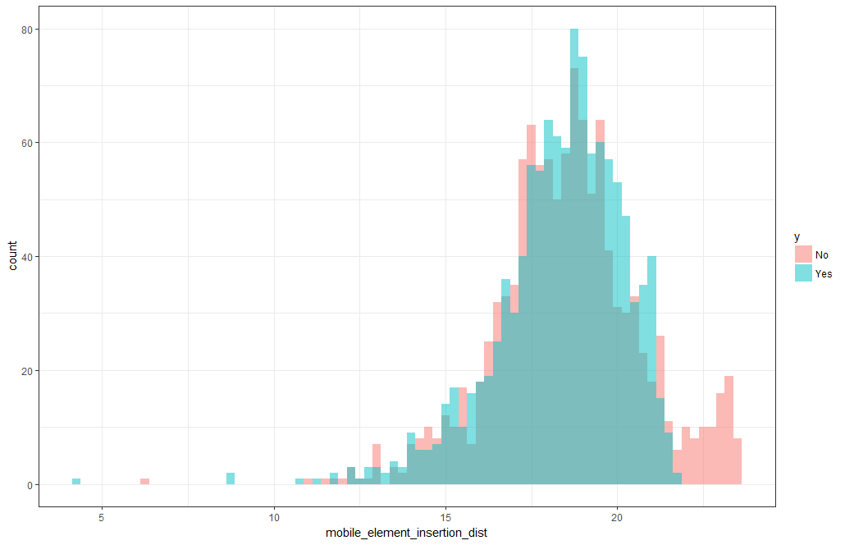 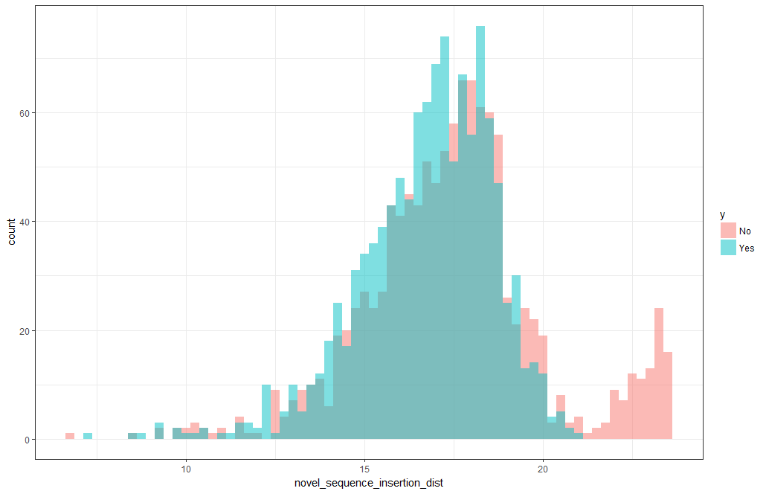

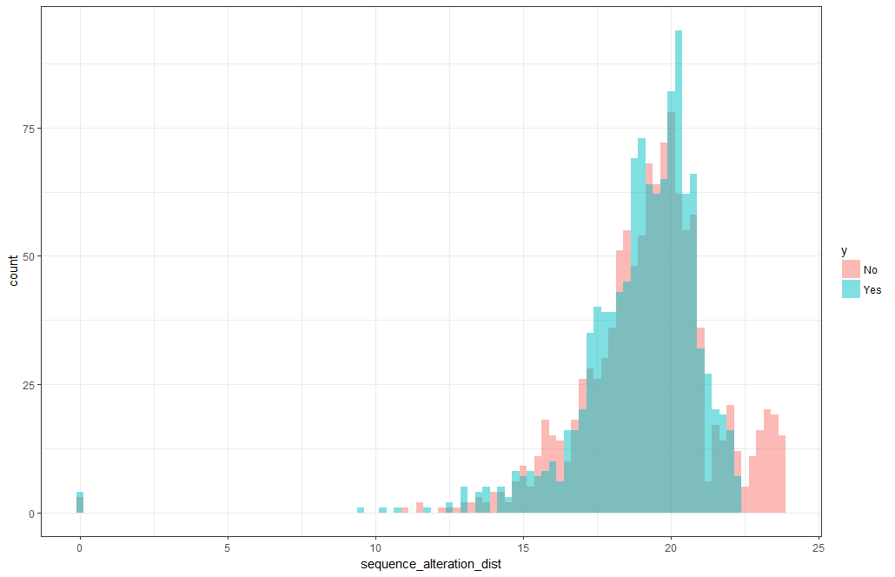 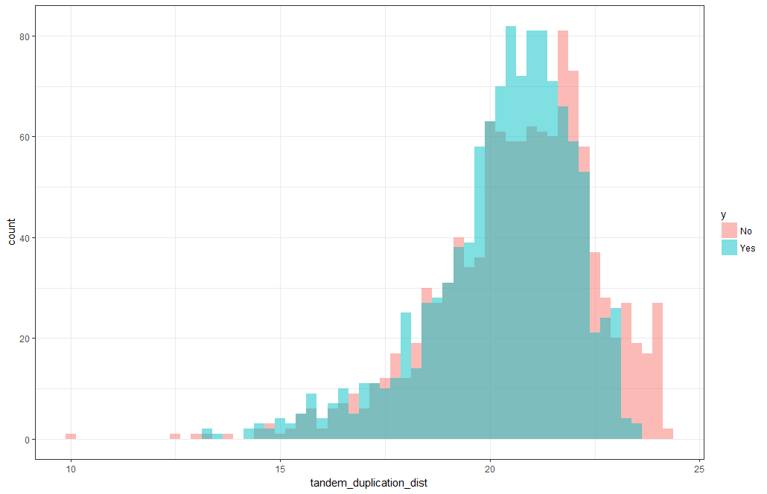

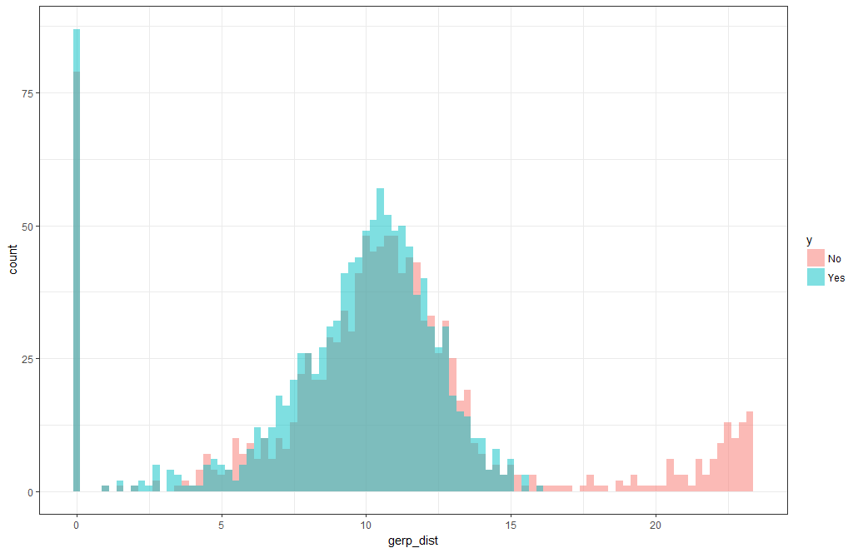 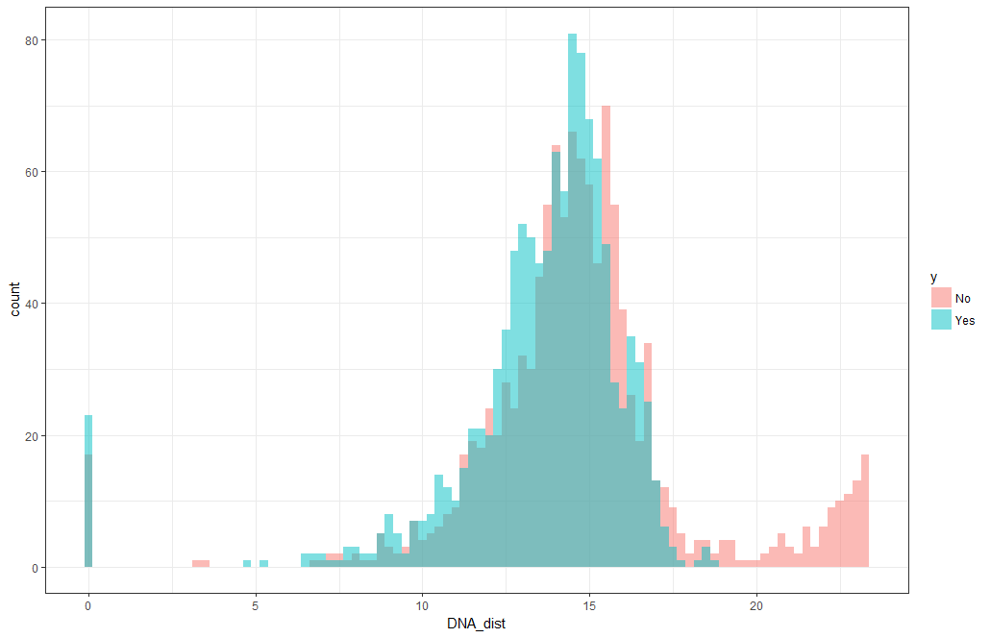

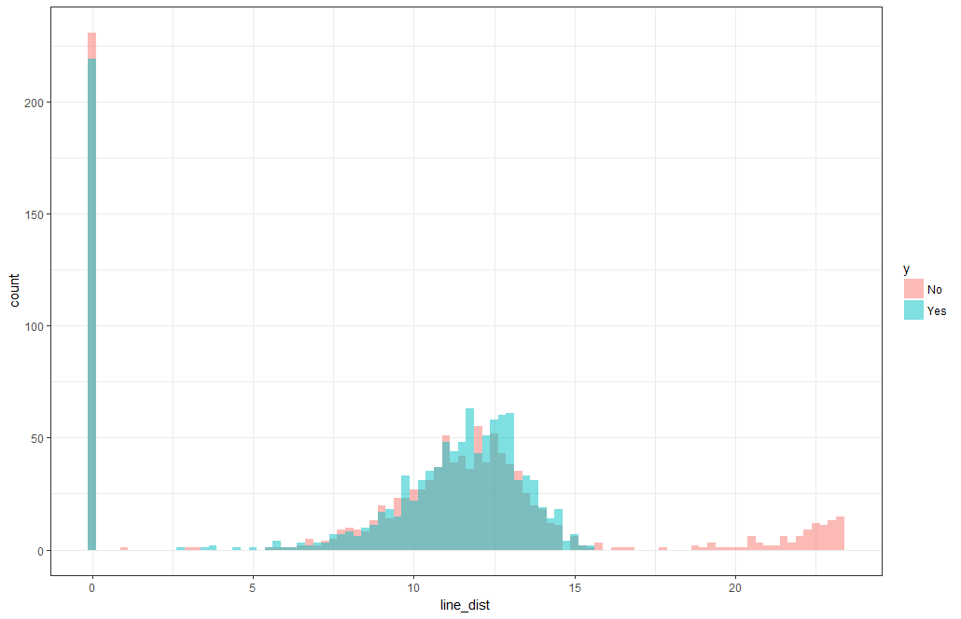 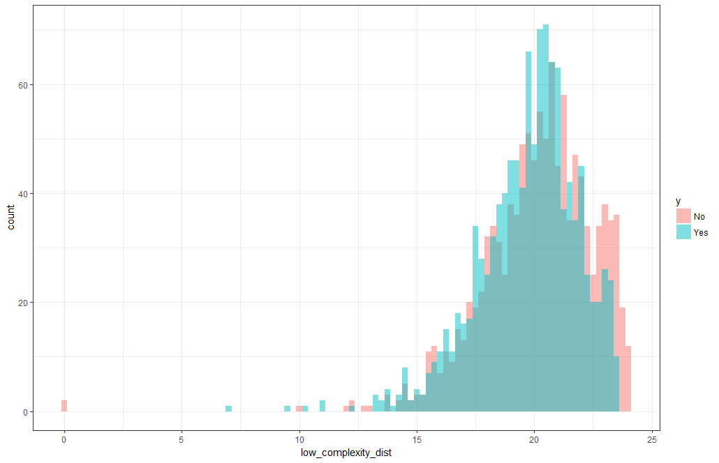

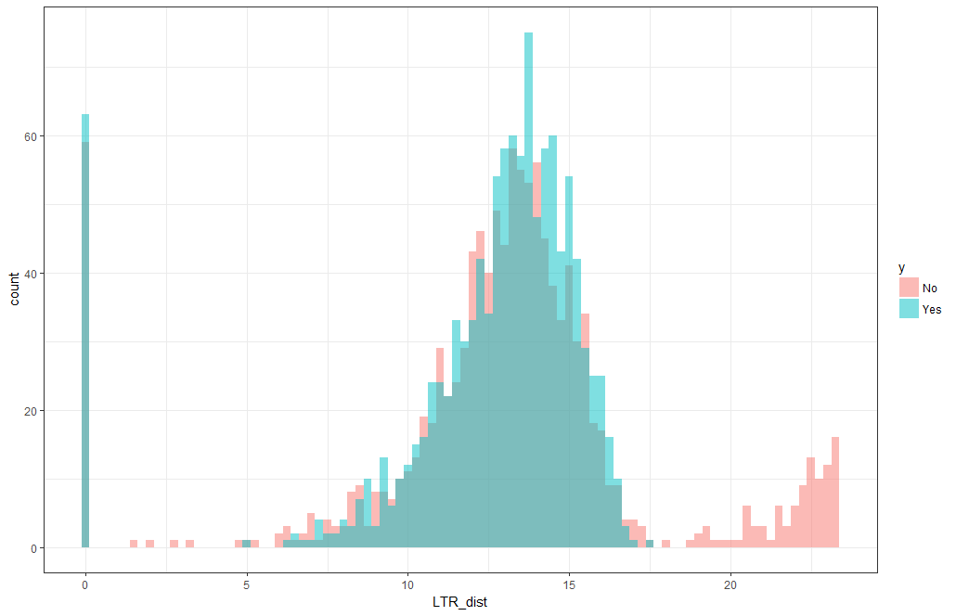 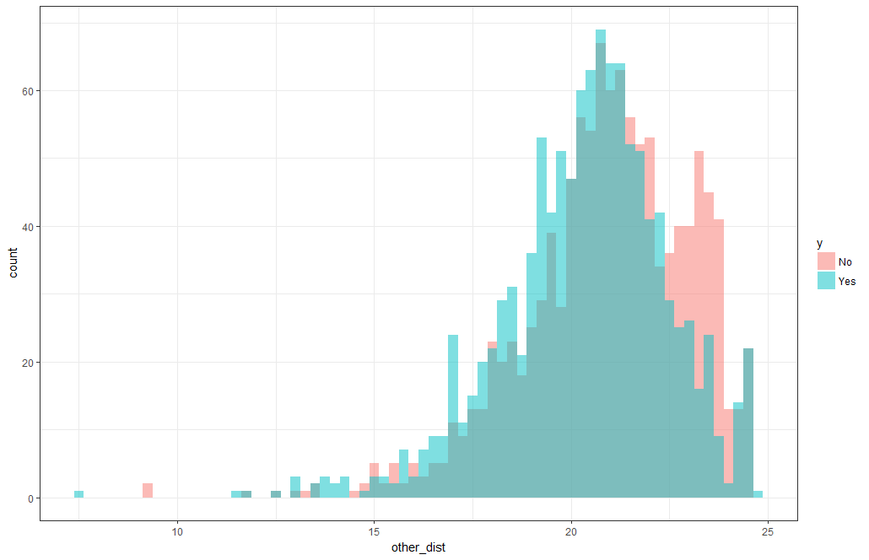

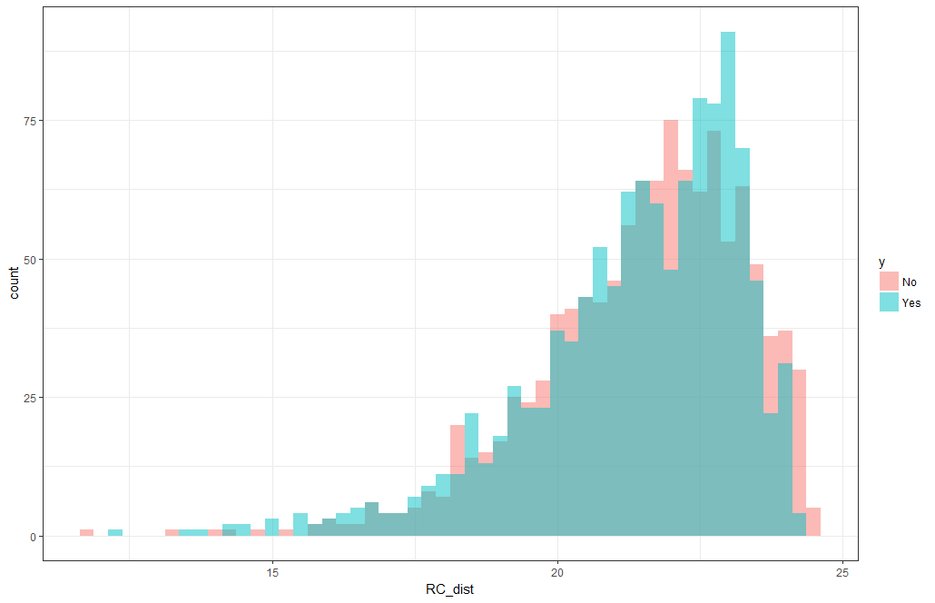 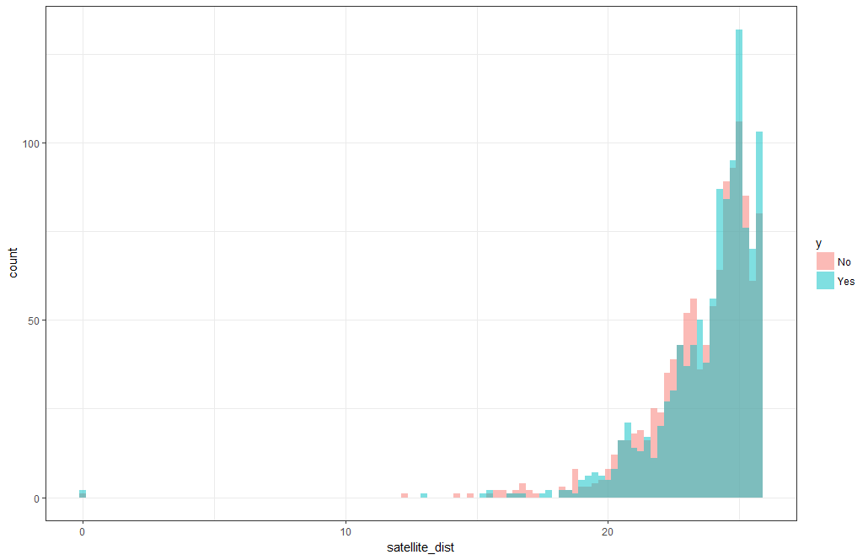

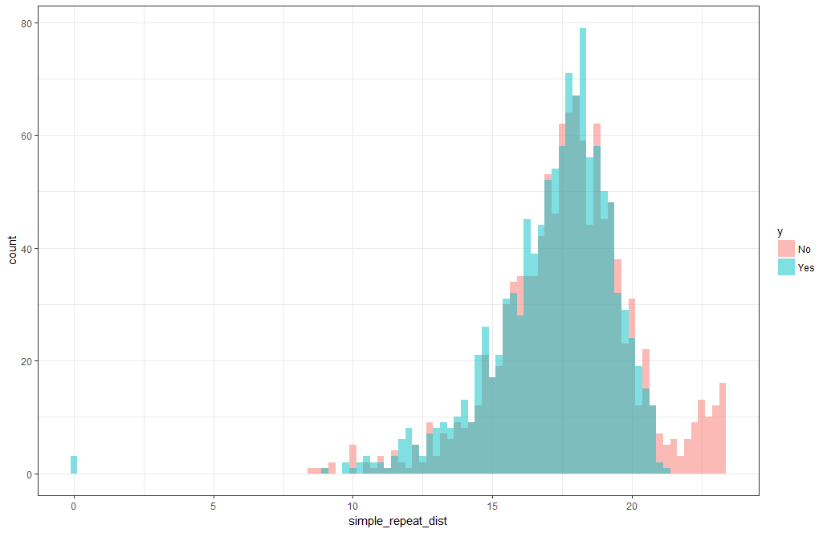 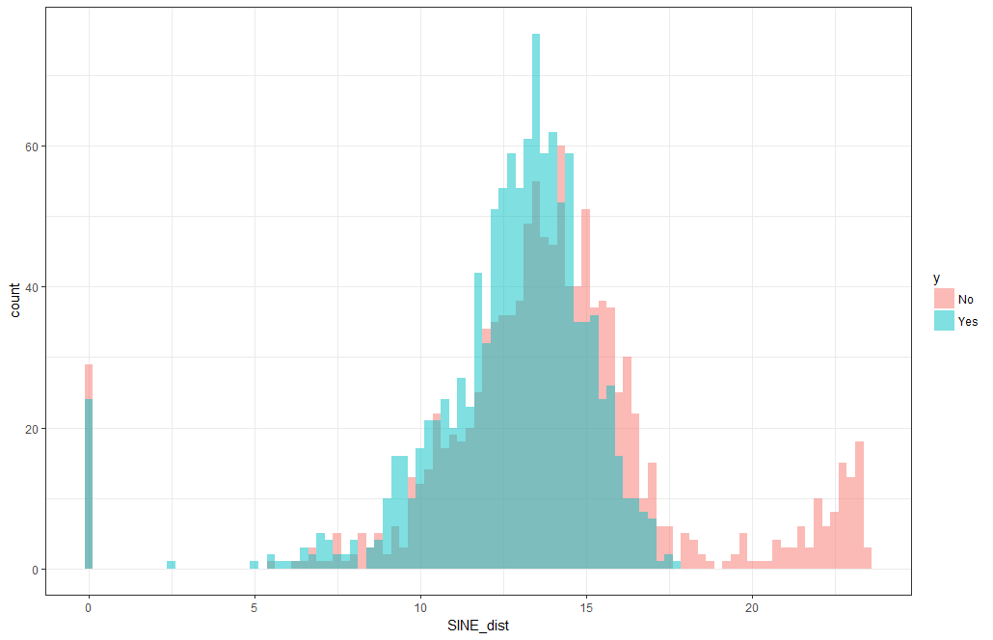

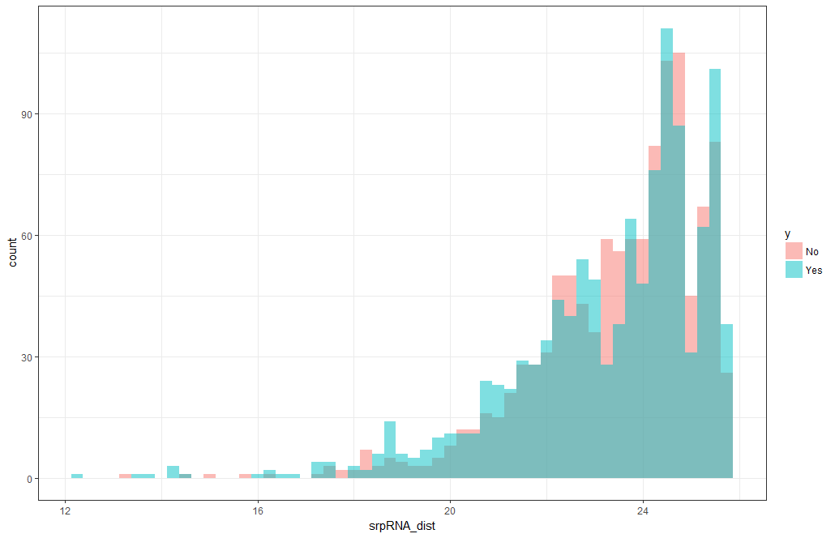 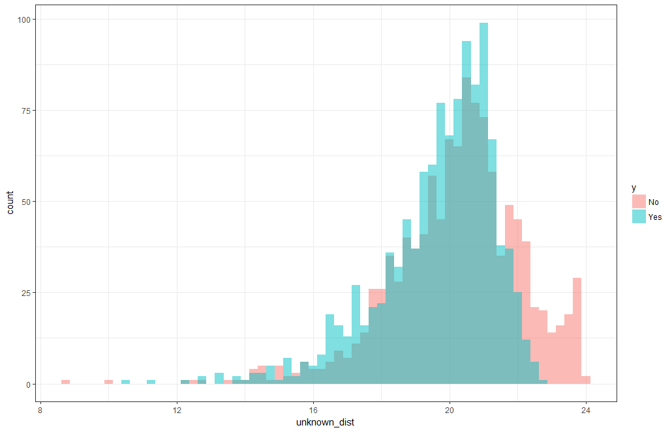

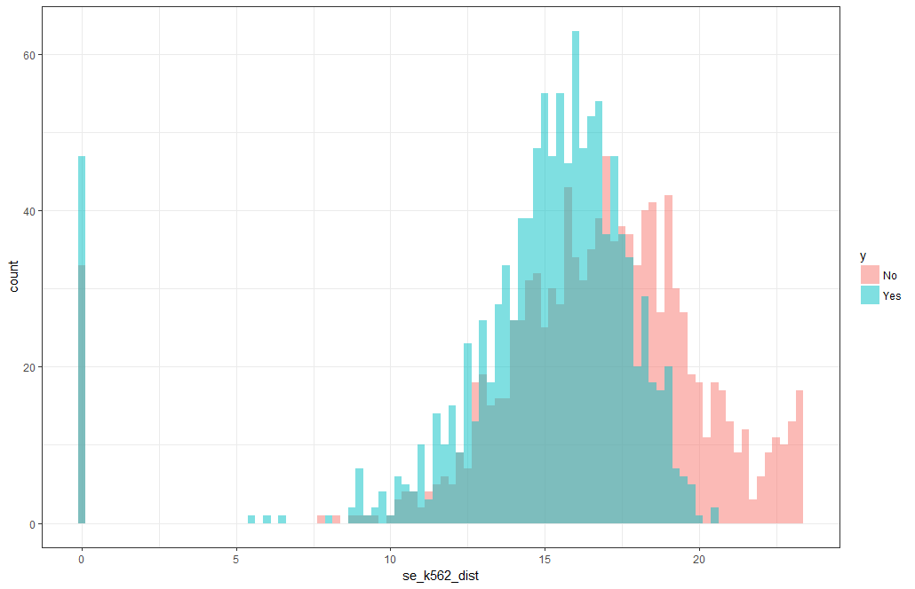 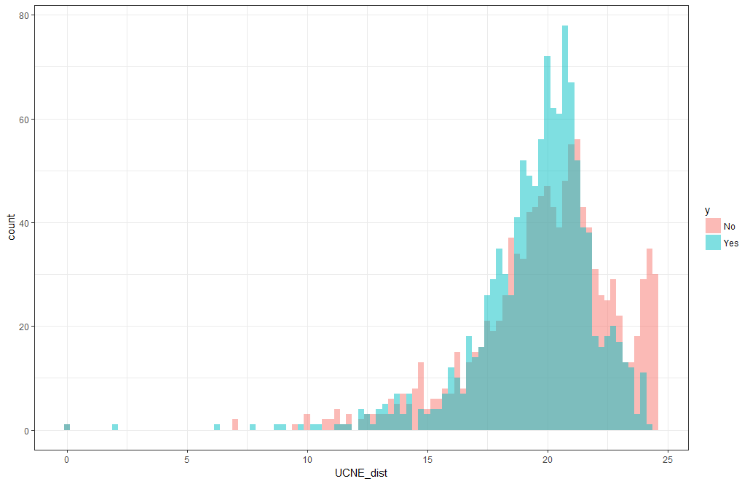

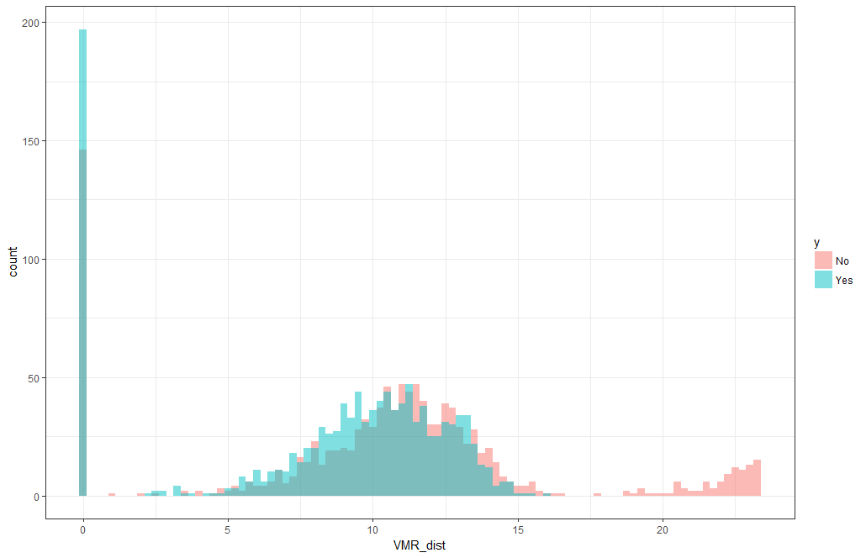 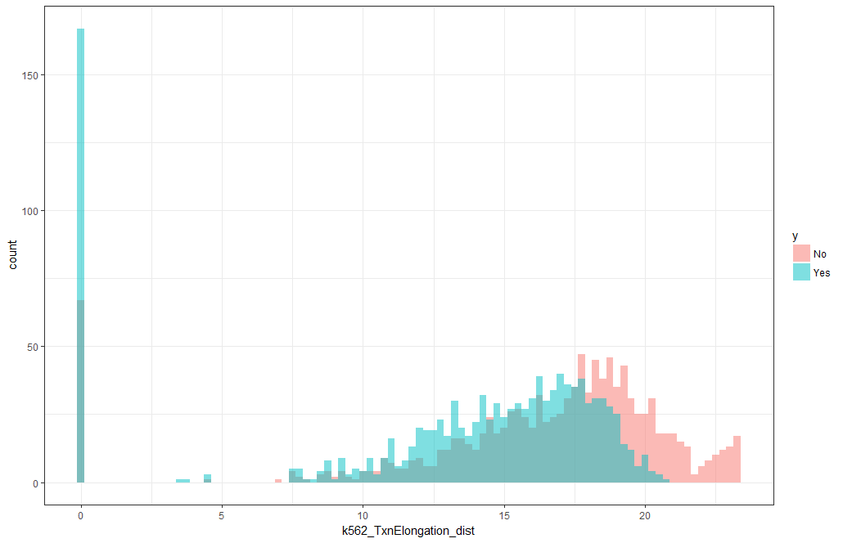

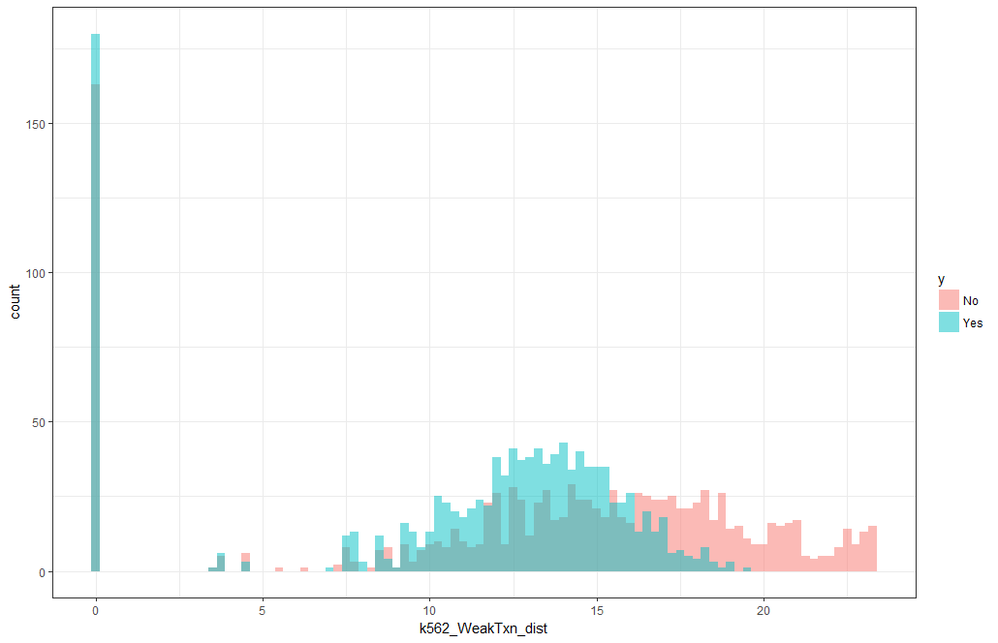 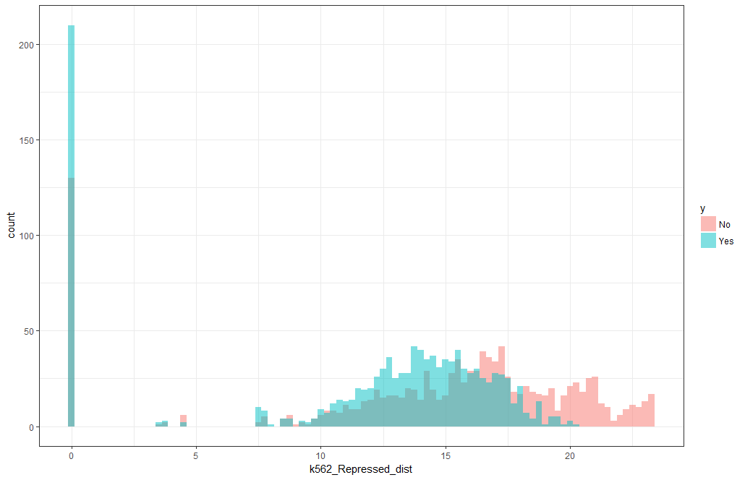

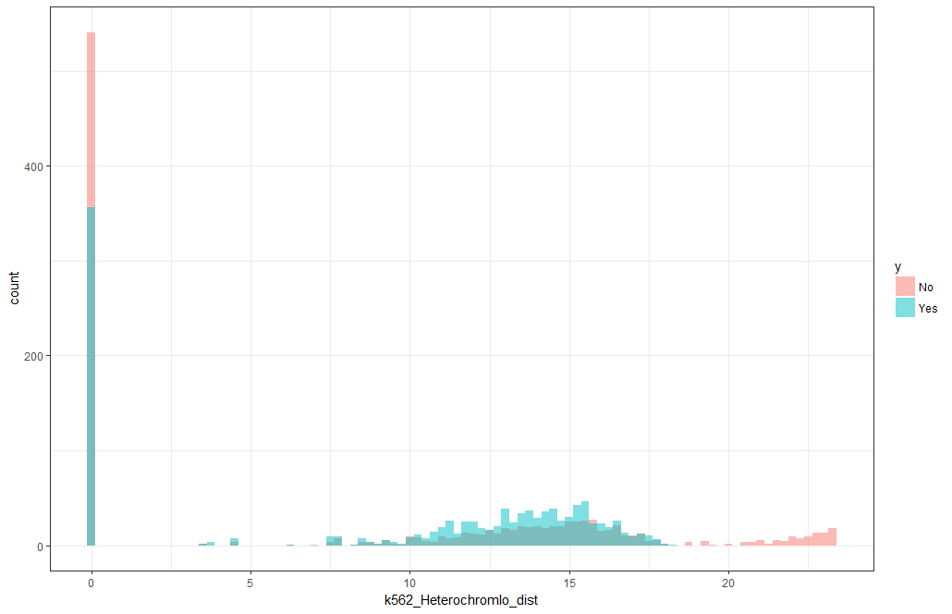 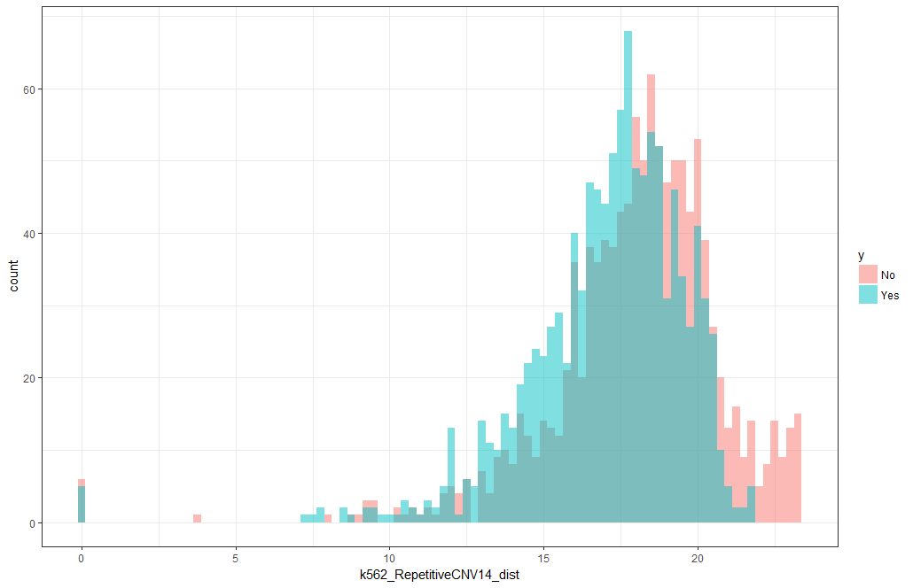

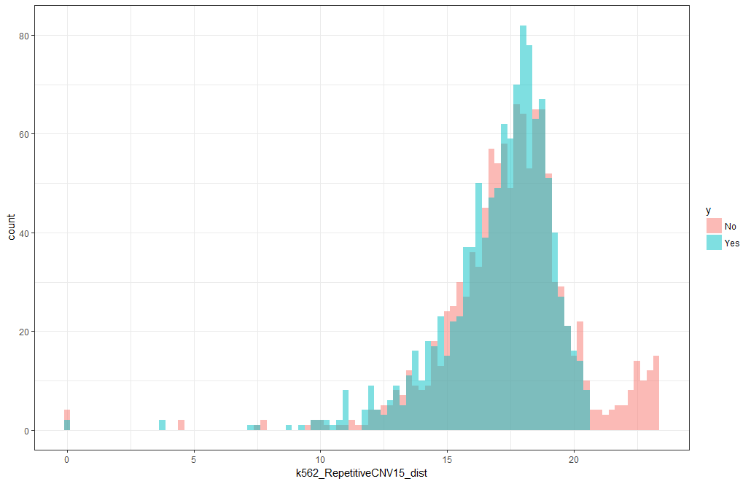 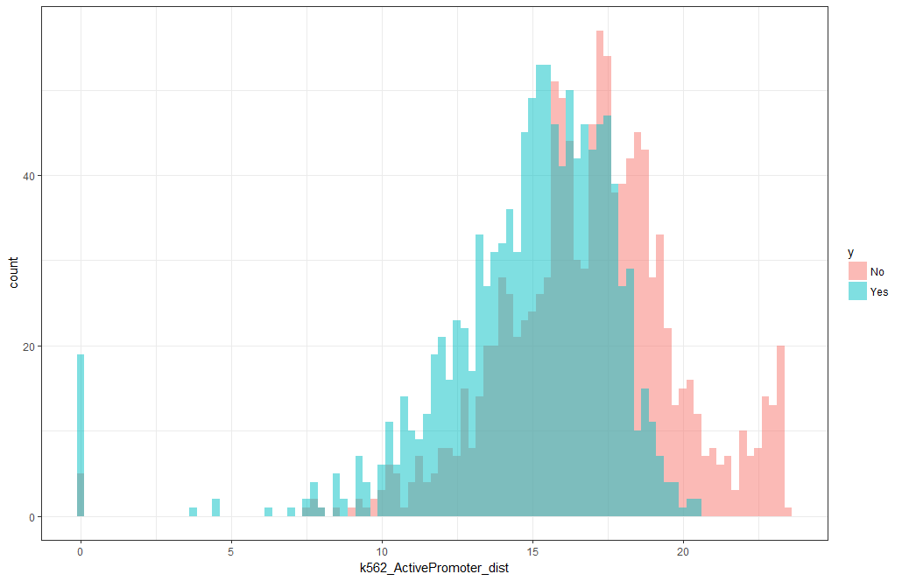

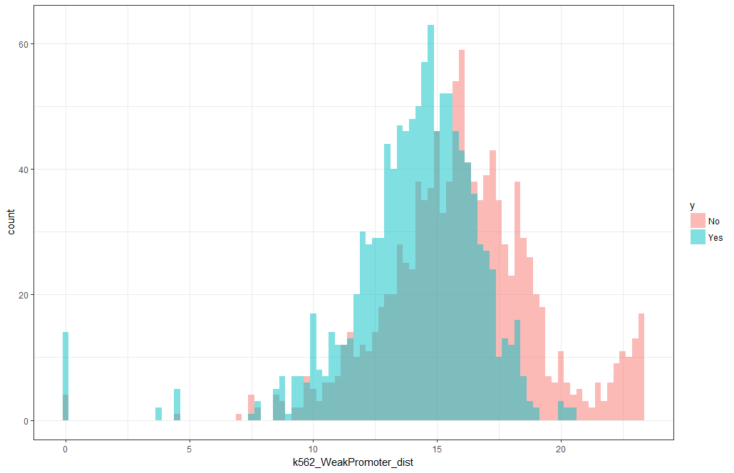 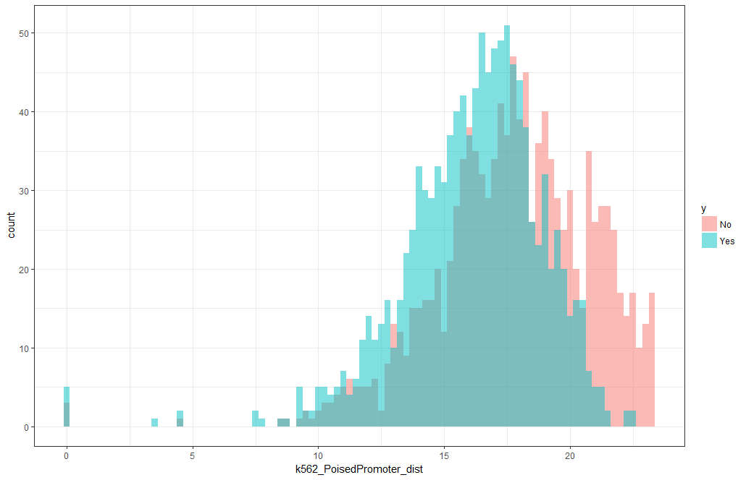

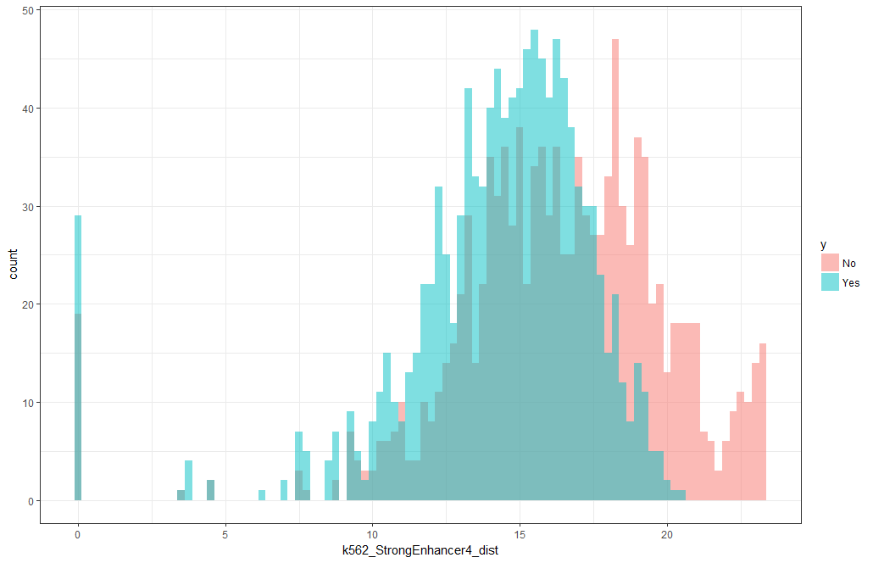 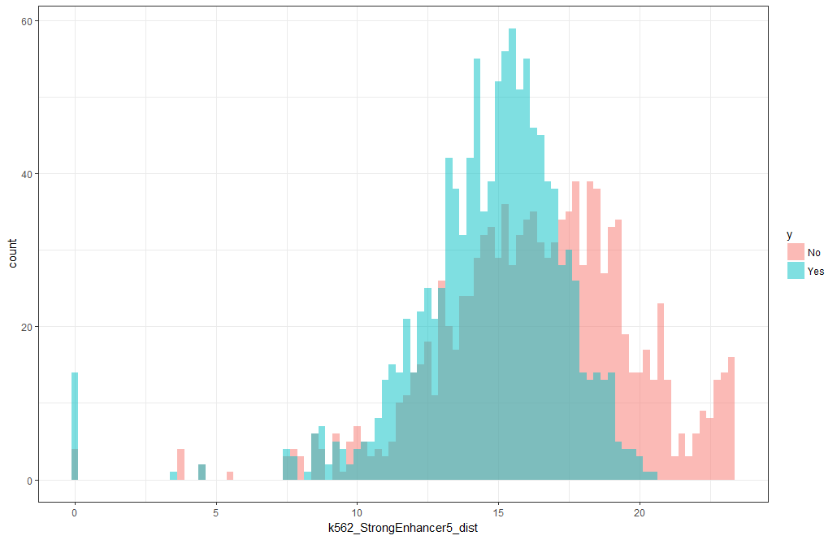

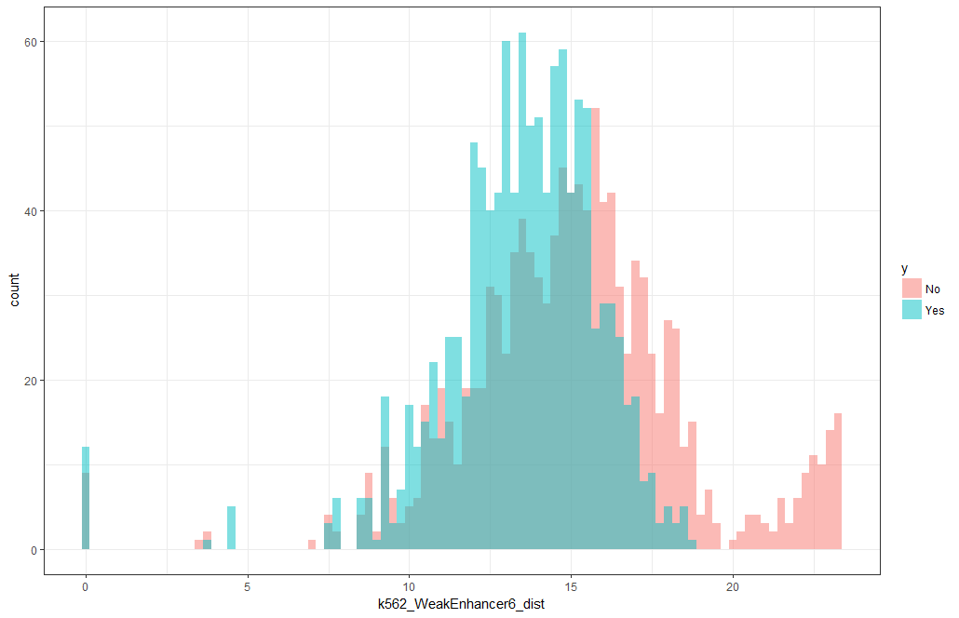 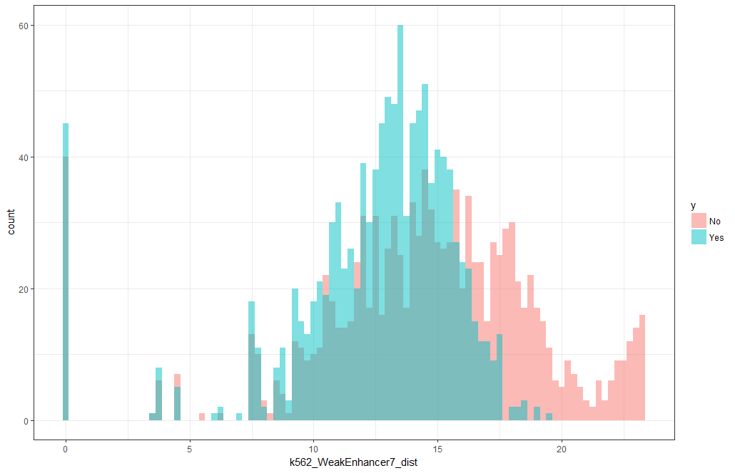

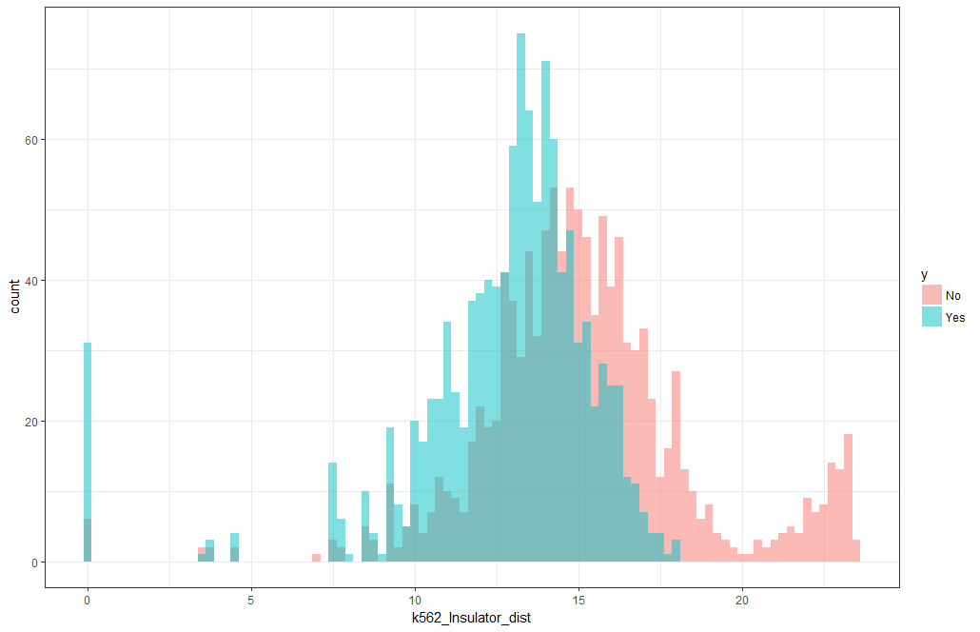 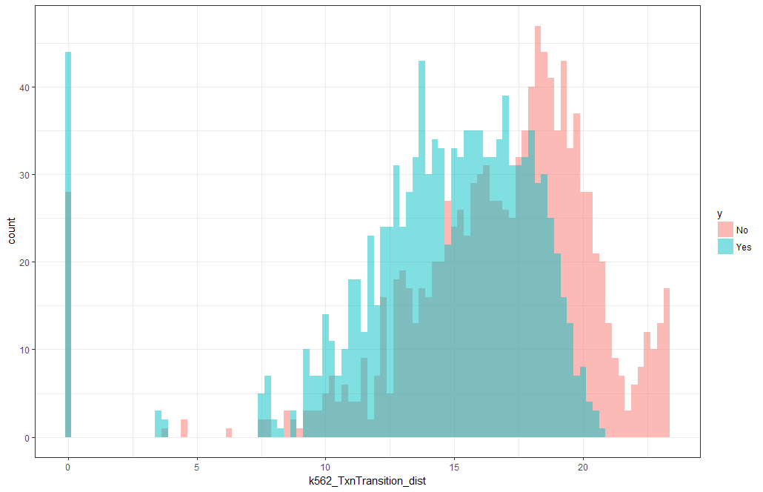

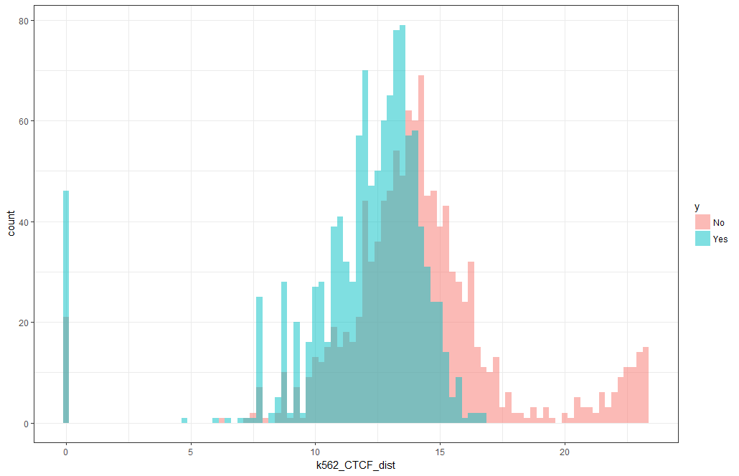 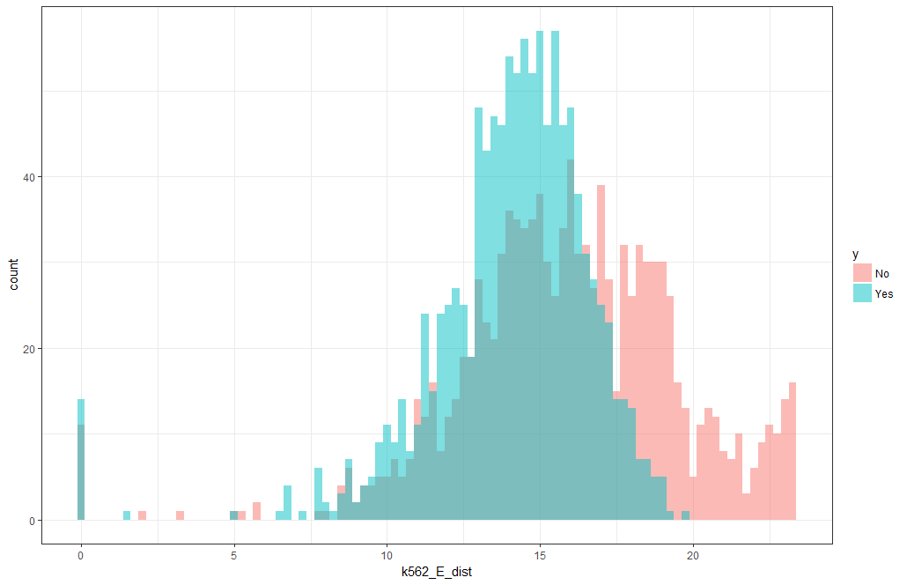

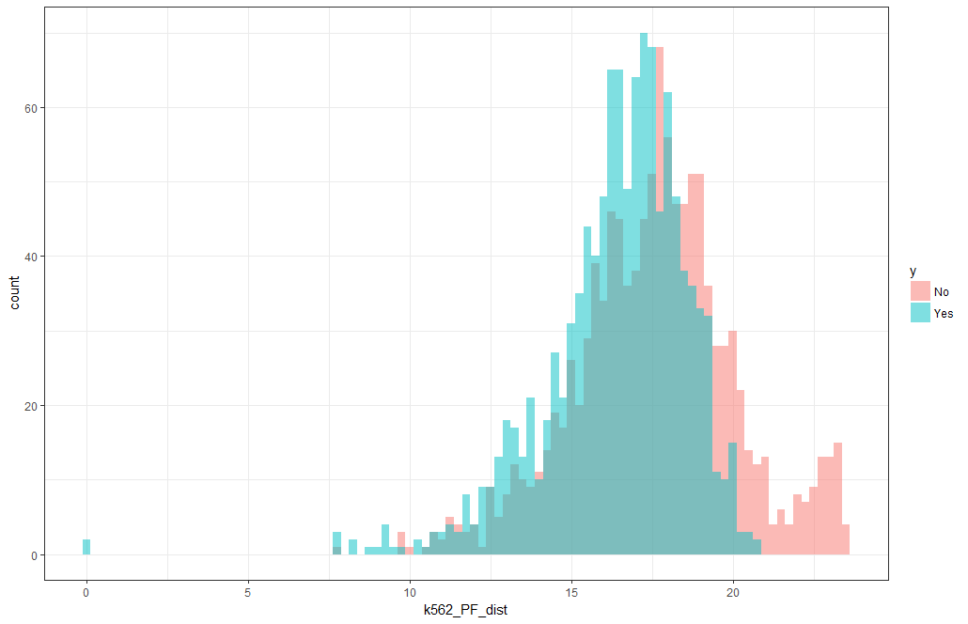 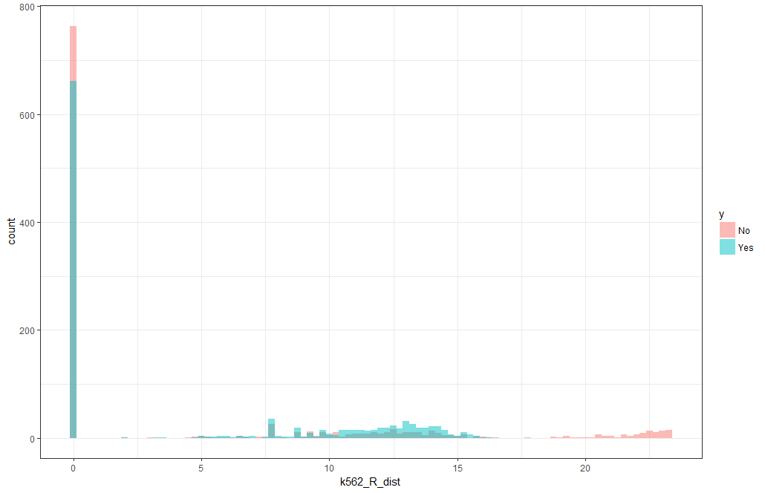

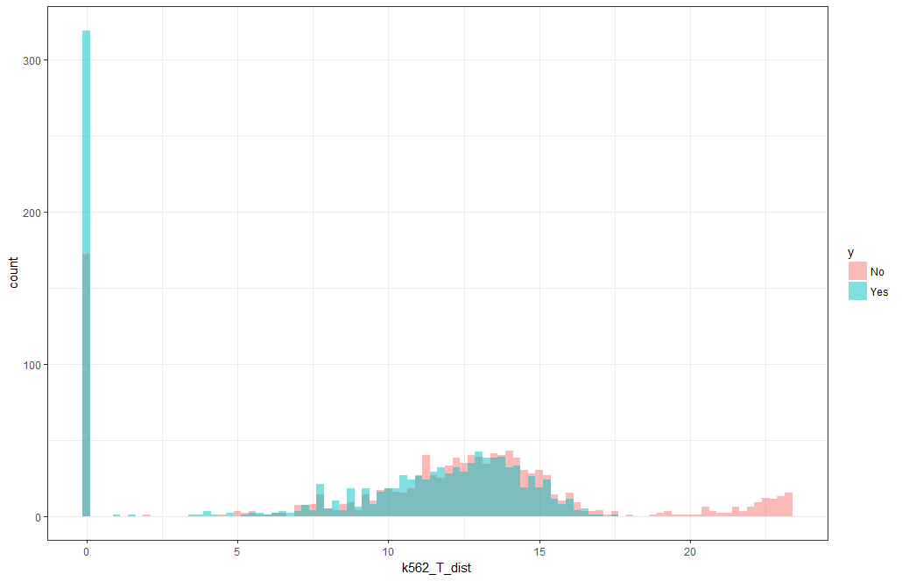 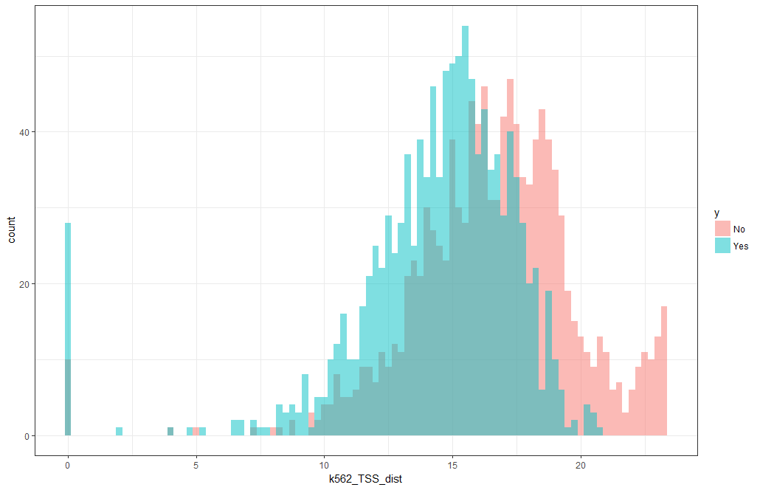

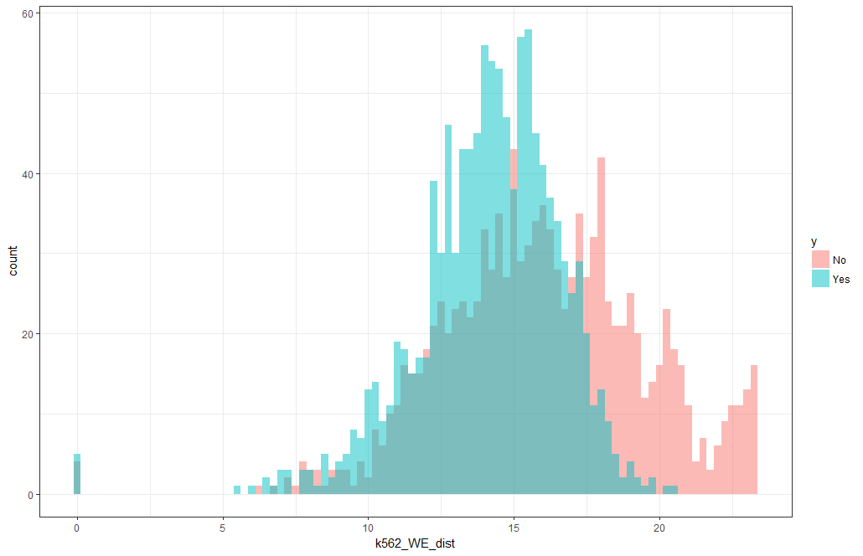

|  |  |  |  |  |  |  |  |
| --- | --- | --- | --- | --- | --- | --- | --- |
|  | **Mean** | | **Median** | | **Range** | |  |
| **Feature** | **No** | **Yes** | **No** | **Yes** | **No** | **Yes** | **P Value** |
| Insulator | 15.13 | 12.74 | 14.91 | 13.29 | 23.41 | 18.12 | < 0.0001 |
| CTCF | 14.07 | 11.84 | 13.93 | 12.53 | 23.33 | 16.83 | < 0.0001 |
| TSS | 16.57 | 14.36 | 16.76 | 14.93 | 23.36 | 20.63 | < 0.0001 |
| ActivePromoter | 16.89 | 14.85 | 17.1 | 15.36 | 23.4 | 20.46 | < 0.0001 |
| TxnTransition | 16.69 | 14.41 | 17.49 | 15.08 | 23.36 | 20.63 | < 0.0001 |
| TxnElongation | 16.21 | 13.07 | 17.48 | 15.04 | 23.36 | 20.65 | < 0.0001 |
| WeakPromoter | 16.01 | 14.09 | 16 | 14.44 | 23.34 | 20.56 | < 0.0001 |
| StrongEnhancer4 | 16.34 | 14.25 | 16.57 | 14.83 | 23.33 | 20.51 | < 0.0001 |
| Repressed | 14.55 | 11.62 | 16.02 | 13.71 | 23.34 | 20.26 | < 0.0001 |
| E | 15.93 | 14.04 | 15.95 | 14.39 | 23.33 | 19.63 | < 0.0001 |
| WE | 16.05 | 14.13 | 16 | 14.36 | 23.33 | 20.5 | < 0.0001 |
| se_k562 | 16.55 | 14.78 | 16.94 | 15.53 | 23.35 | 20.57 | < 0.0001 |
| PoisedPromoter | 17.76 | 16.14 | 17.88 | 16.44 | 23.34 | 22.5 | < 0.0001 |
| StrongEnhancer5 | 16.38 | 14.66 | 16.56 | 15.05 | 23.34 | 20.51 | < 0.0001 |
| WeakEnhancer7 | 14.51 | 12.51 | 14.81 | 13.2 | 23.34 | 19.44 | < 0.0001 |
| WeakTxn | 13.43 | 11.07 | 14.76 | 12.77 | 23.32 | 19.58 | < 0.0001 |
| WeakEnhancer6 | 15.07 | 13.46 | 15.1 | 13.71 | 23.33 | 18.71 | < 0.0001 |
| PF | 17.58 | 16.41 | 17.71 | 16.76 | 15.63 | 20.73 | < 0.0001 |
| T | 11.37 | 8.67 | 12.53 | 11.04 | 23.33 | 17.58 | < 0.0001 |
| RepetitiveCNV14 | 18 | 17.05 | 18.33 | 17.45 | 23.32 | 21.87 | < 0.0001 |
| SINE | 13.98 | 12.68 | 13.95 | 13.19 | 23.42 | 17.85 | < 0.0001 |
| VMR | 10.42 | 8.51 | 10.94 | 9.78 | 23.33 | 16.08 | < 0.0001 |
| DNA | 14.67 | 13.58 | 14.59 | 14.12 | 23.34 | 18.63 | < 0.0001 |
| other | 20.92 | 20.34 | 21.08 | 20.57 | 15.4 | 17.15 | < 0.0001 |
| unknown | 20.2 | 19.65 | 20.42 | 20.02 | 15.09 | 12.02 | < 0.0001 |
| duplication | 15.43 | 14.8 | 16.46 | 15.96 | 23.32 | 19.95 | < 0.0001 |
| novel_sequence_insertion | 17.46 | 16.76 | 17.5 | 17.01 | 16.8 | 13.58 | < 0.0001 |
| Gerp | 10.62 | 9.29 | 10.56 | 10.11 | 23.33 | 15.94 | < 0.0001 |
| insertion | 14.73 | 13.94 | 15.83 | 15.4 | 23.32 | 19.05 | < 0.0001 |
| low_complexity | 20.18 | 19.74 | 20.42 | 20.07 | 24.02 | 16.53 | < 0.0001 |
| tandem_duplication | 20.66 | 20.32 | 20.88 | 20.61 | 14.25 | 10.26 | < 0.0001 |
| UCNE | 19.94 | 19.57 | 20.31 | 19.98 | 24.54 | 24.14 | < 0.0001 |
| deletion | 13 | 12.12 | 14.53 | 14.13 | 23.32 | 18.26 | < 0.0001 |
| simple_repeat | 17.71 | 17.18 | 17.8 | 17.61 | 14.74 | 21.15 | < 0.0001 |
| RepetitiveCNV15 | 17.47 | 17.02 | 17.67 | 17.5 | 23.32 | 20.6 | 0.000254 |
| Heterochromlo | 7.97 | 9.3 | 9.26 | 12.29 | 23.36 | 18.2 | 0.000742 |
| R | 4.6 | 4.83 | 0 | 0 | 23.33 | 16.33 | 0.002998 |
| gain_loss | 16.85 | 16.51 | 18.58 | 18.38 | 23.34 | 21.54 | 0.004544 |
| satellite | 23.6 | 23.8 | 24.16 | 24.35 | 25.85 | 25.84 | 0.004945 |
| complex | 21.35 | 21.58 | 21.89 | 22.01 | 24 | 23.98 | 0.012721 |
| sequence_alteration | 19.23 | 18.98 | 19.45 | 19.33 | 23.73 | 22.29 | 0.056373 |
| LTR | 13.02 | 12.42 | 13.3 | 13.28 | 23.34 | 17.53 | 0.156816 |
| Line | 10.02 | 9.32 | 11.19 | 11.23 | 23.33 | 15.6 | 0.206309 |
| RC | 21.51 | 21.38 | 21.8 | 21.74 | 12.55 | 11.93 | 0.247015 |
| srpRNA | 23.47 | 23.29 | 23.89 | 23.82 | 12.47 | 13.53 | 0.254127 |
| mobile_element_insertion | 18.53 | 18.33 | 18.56 | 18.6 | 17.21 | 17.52 | 0.46554 |
| inversion | 19.65 | 19.91 | 20.48 | 20.55 | 23.81 | 23.8 | 0.932093 |

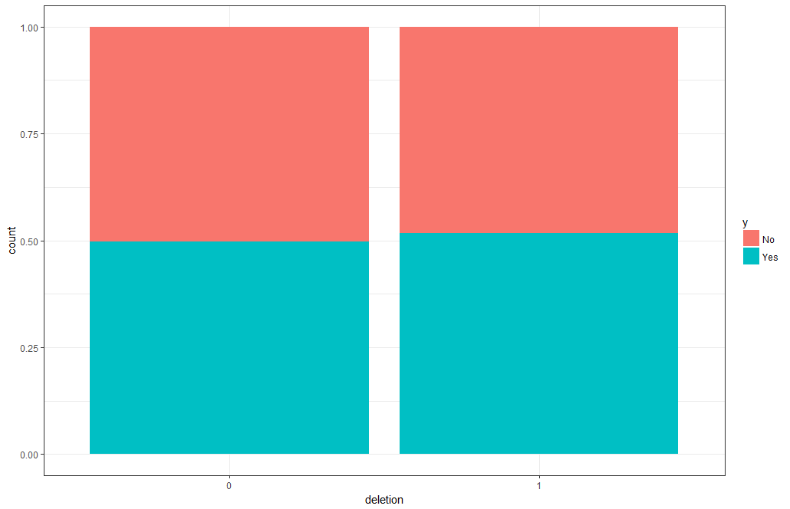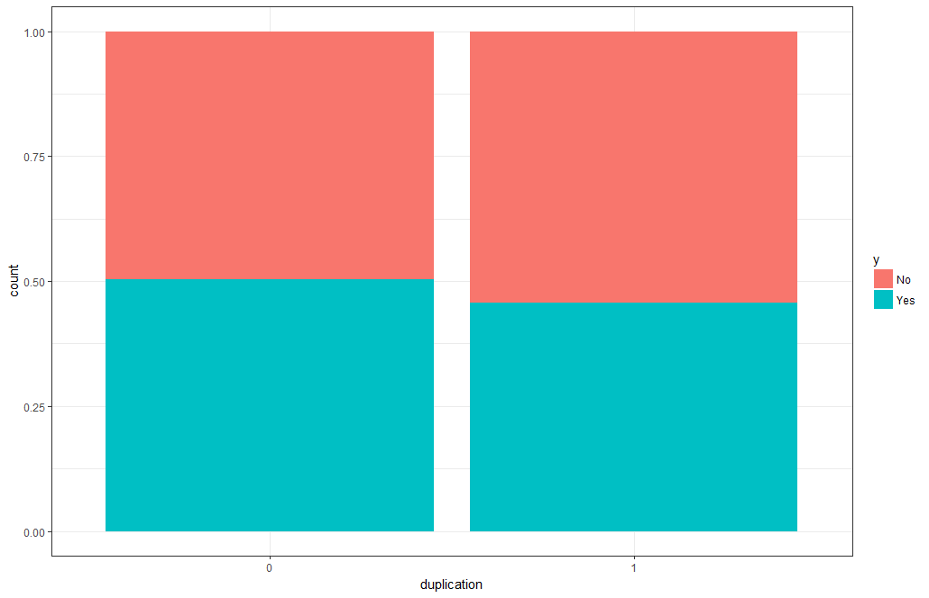

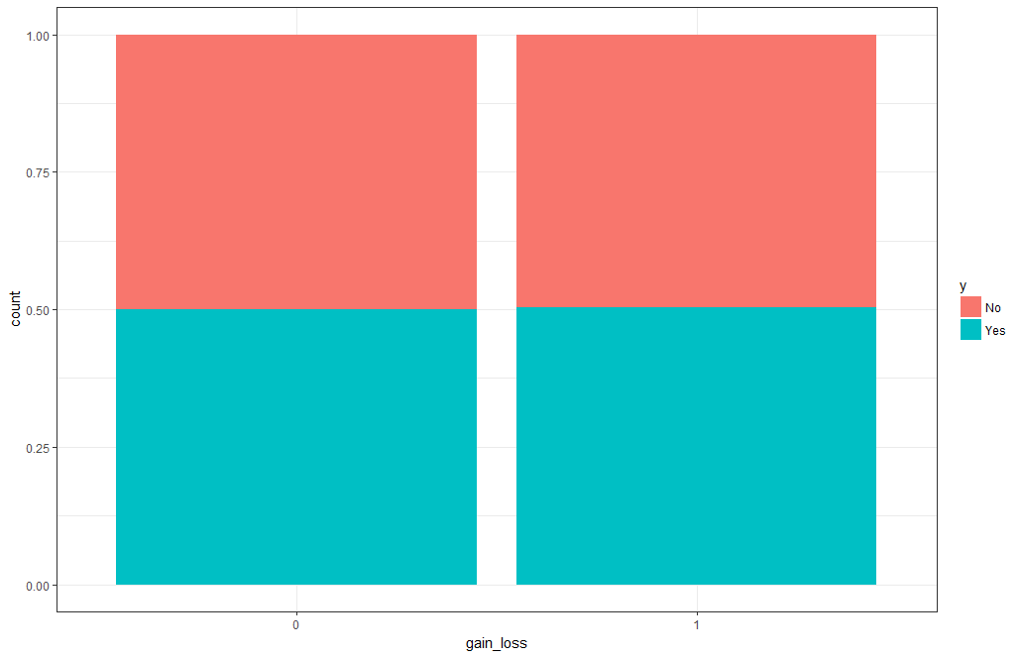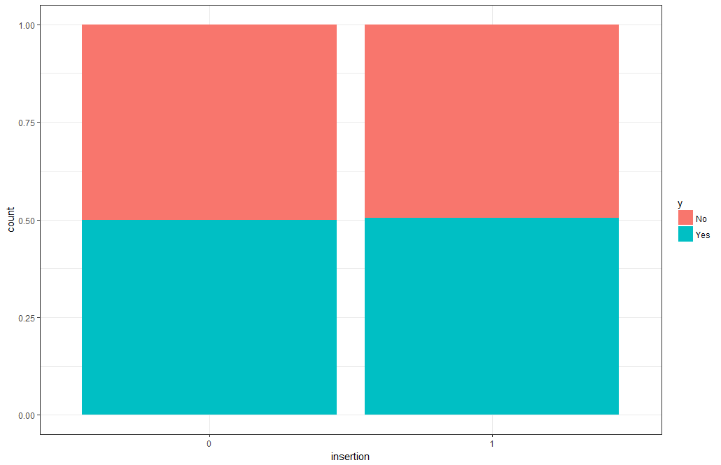

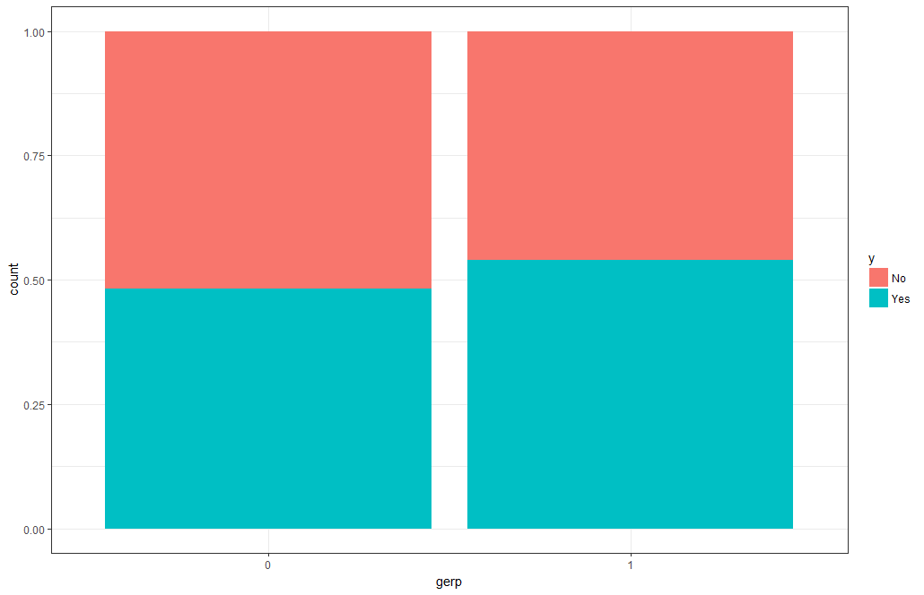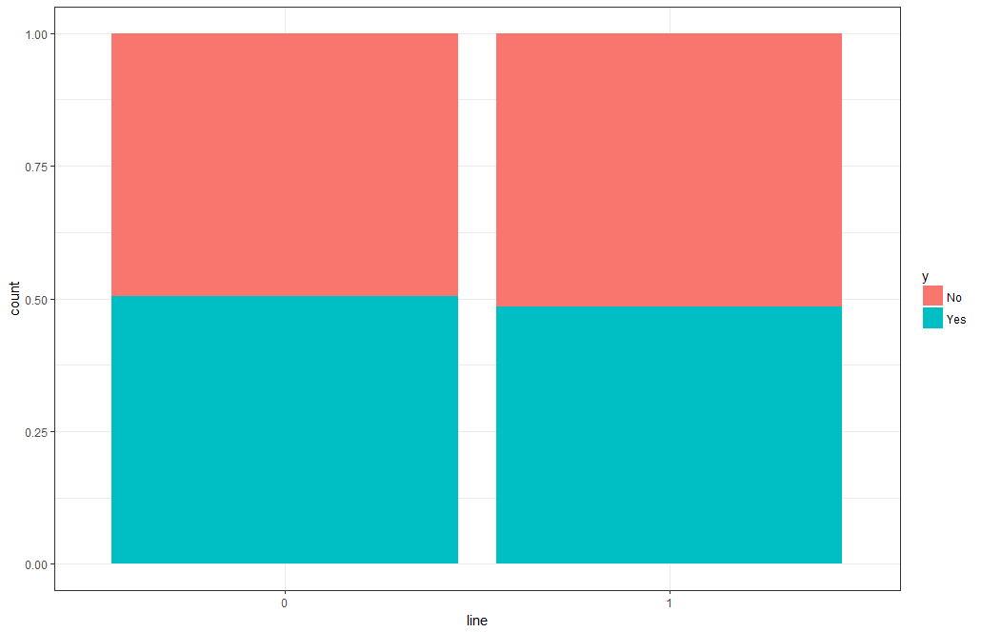

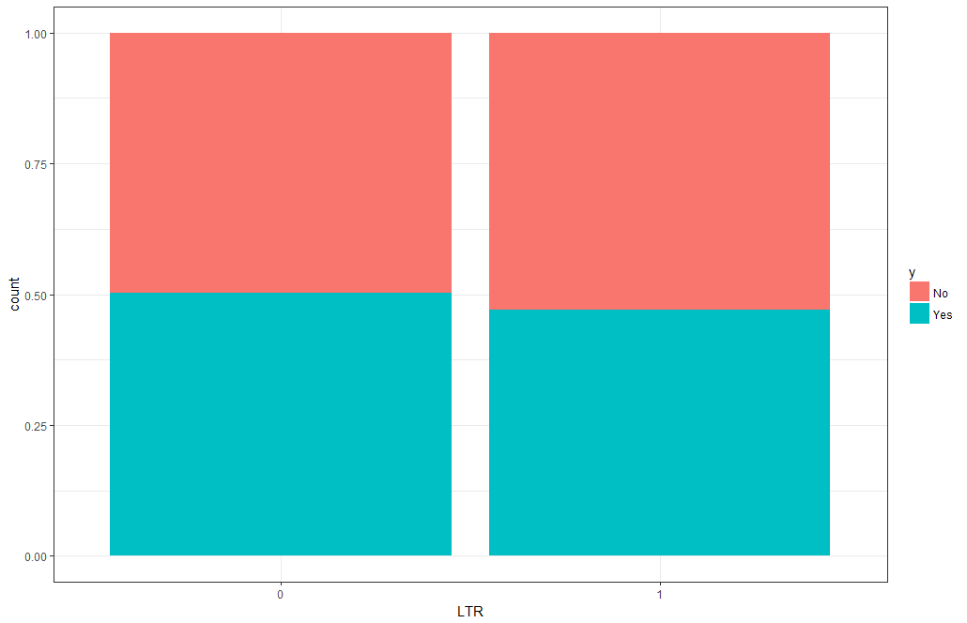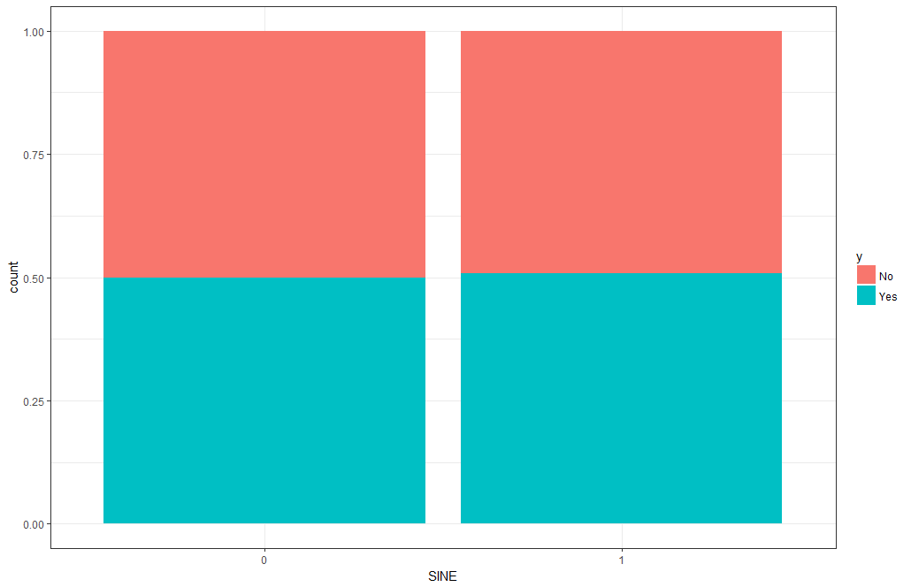

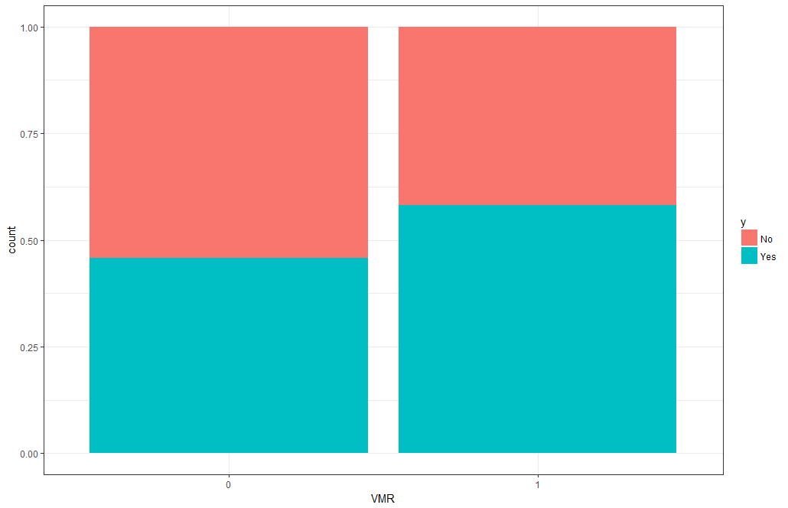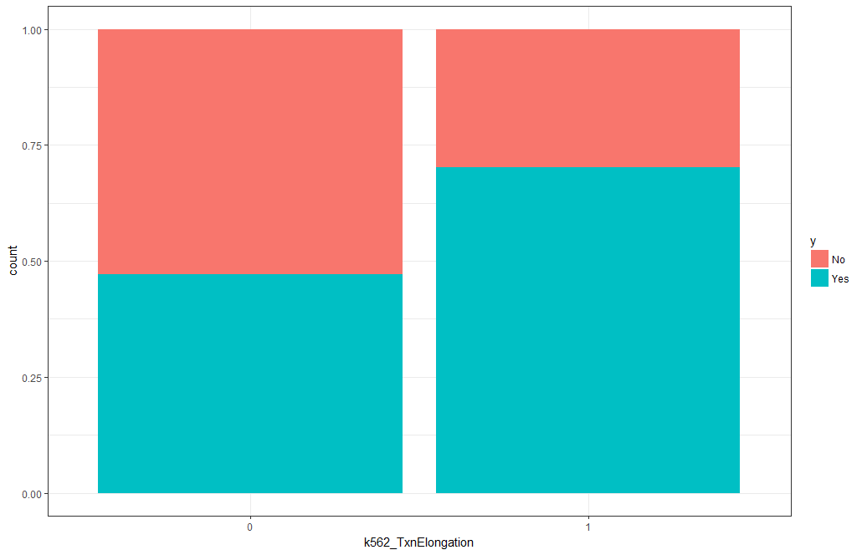

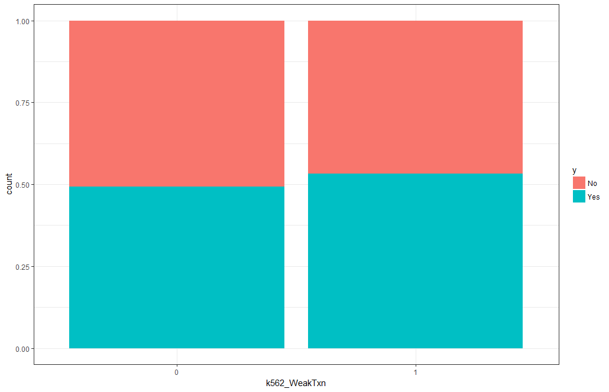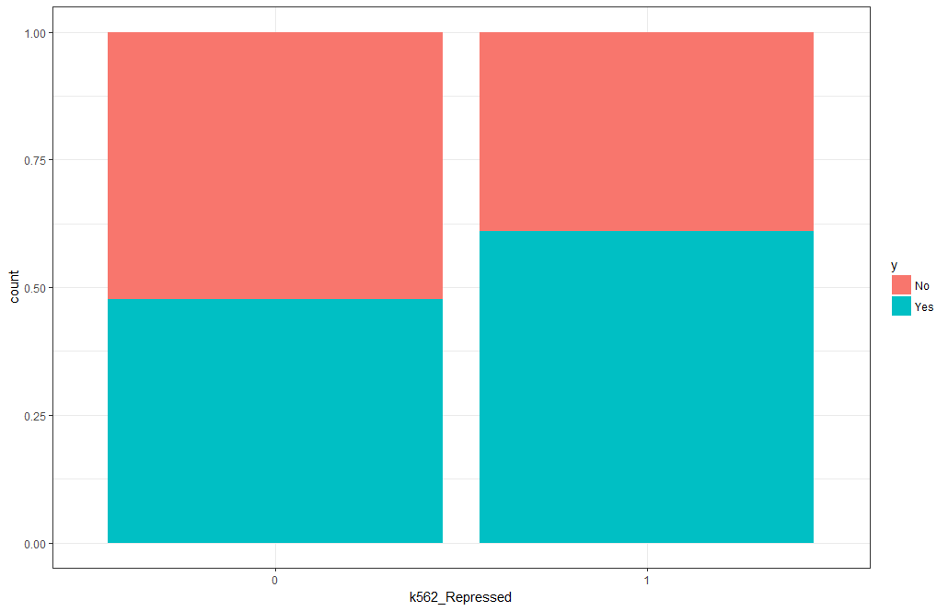

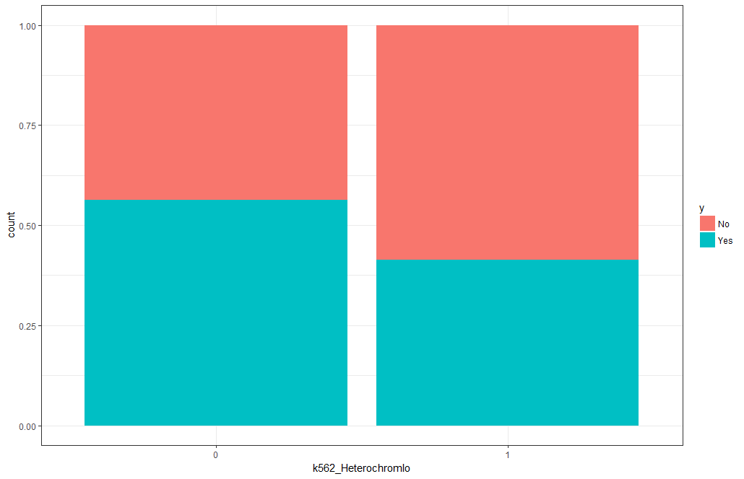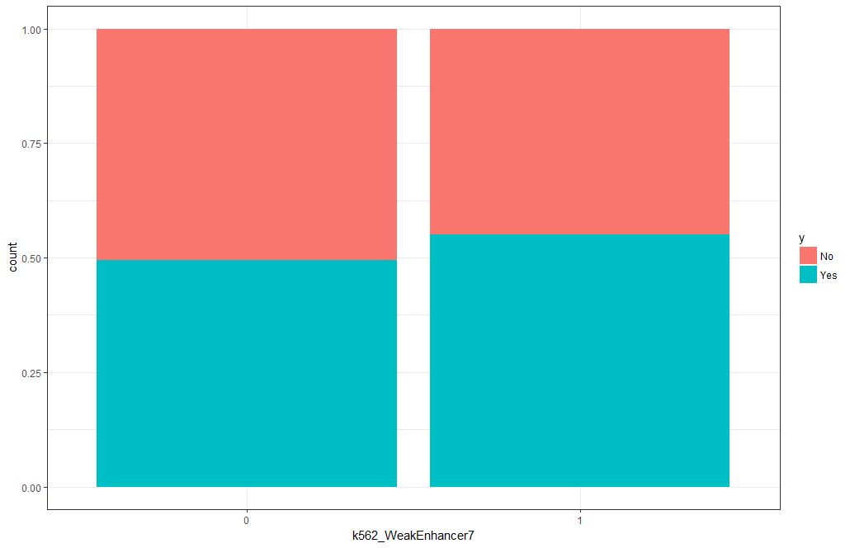

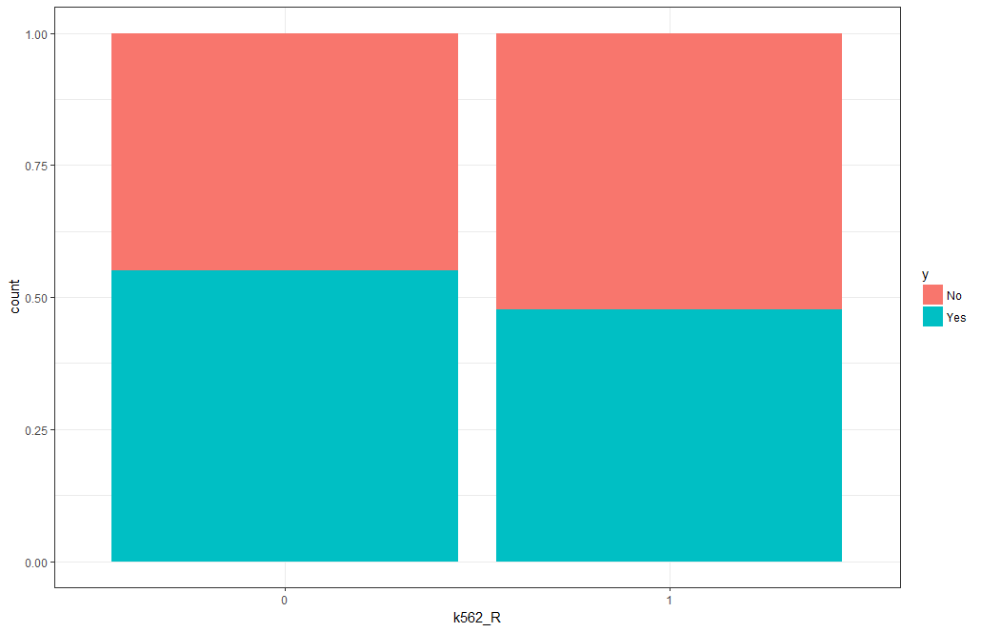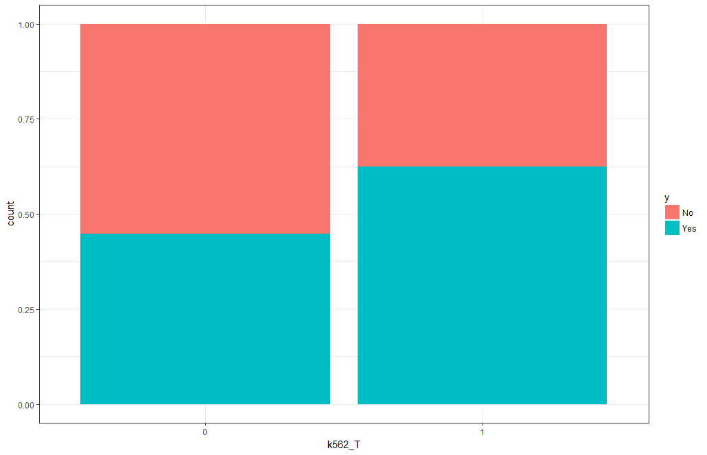

|  |  |  |  |  |
| --- | --- | --- | --- | --- |
|  |  | **TAD Boundary** | |  |
| **Feature** | **Level** | **No** | **Yes** | **P Value** |
| **T** | No | 58 | 22 | < 0.0001 |
|  | Yes | 42 | 77 |  |
| **TxnElongation** | No | 54 | 77 | < 0.0001 |
|  | Yes | 46 | 22 |  |
| **Heterochromlo** | No | 72 | 58 | < 0.0001 |
|  | Yes | 28 | 42 |  |
| **VMR** | No | 37 | 52 | < 0.0001 |
|  | Yes | 63 | 48 |  |
| **Repressed** | No | 88 | 79 | < 0.0001 |
|  | Yes | 12 | 21 |  |
| **R** | No | 72 | 61 | 0.0014 |
|  | Yes | 28 | 39 |  |
| **Gerp** | No | 25 | 35 | 0.0123 |
|  | Yes | 75 | 65 |  |
| **WeakTxn** | No | 95 | 90 | 0.1375 |
|  | Yes | 5 | 10 |  |
| **WeakEnhancer7** | No | 71 | 62 | 0.1448 |
|  | Yes | 29 | 38 |  |
| **duplication** | No | 93 | 88 | 0.2892 |
|  | Yes | 7 | 12 |  |
| **LTR** | No | 92 | 89 | 0.3897 |
|  | Yes | 8 | 11 |  |
| **line** | No | 95 | 93 | 0.4201 |
|  | Yes | 5 | 7 |  |
| **deletion** | No | 93 | 95 | 0.5265 |
|  | Yes | 7 | 5 |  |
| **SINE** | No | 89 | 91 | 0.9252 |
|  | Yes | 11 | 9 |  |
| **insertion** | No | 84 | 85 | 0.9429 |
|  | Yes | 16 | 15 |  |
| **Gain_loss** | No | 91 | 92 | 0.9438 |
|  | Yes | 9 | 8 |  |