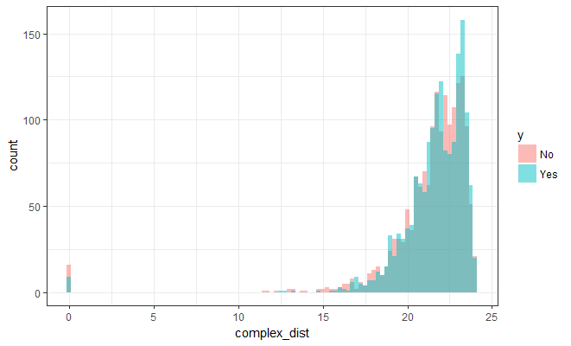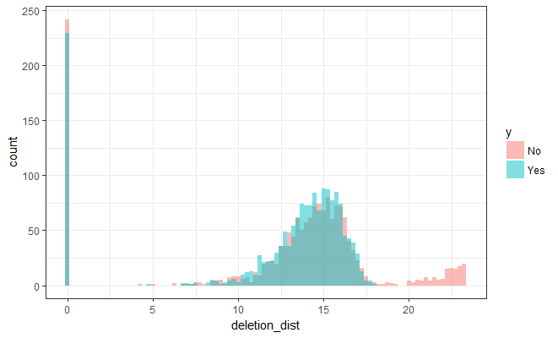

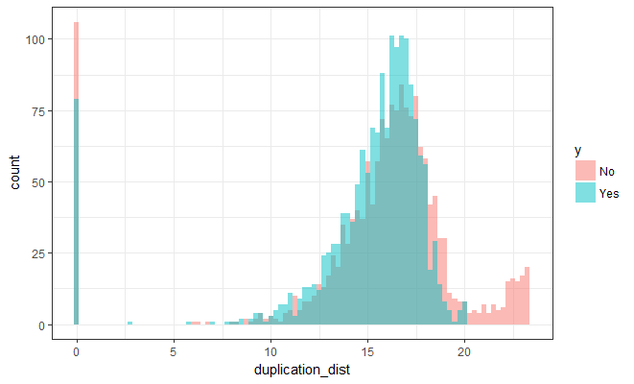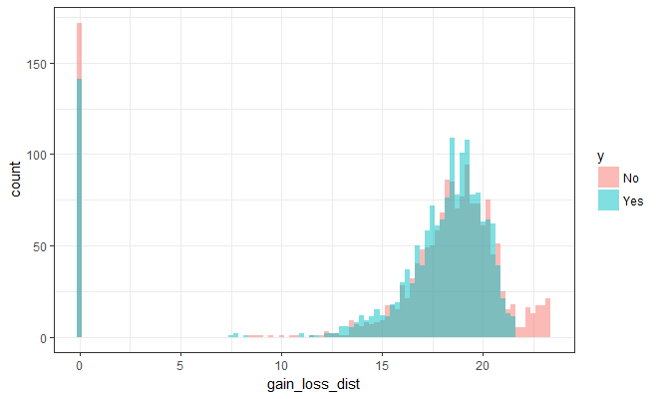

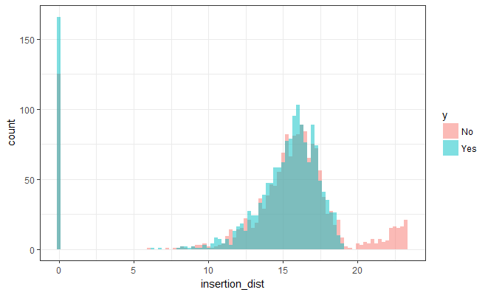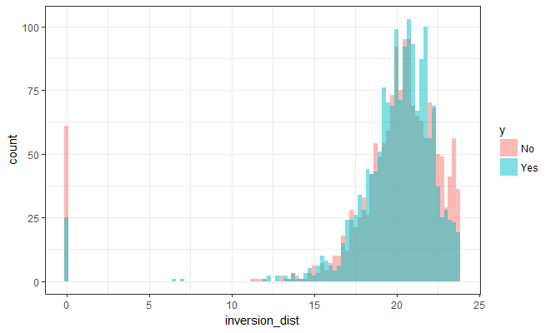

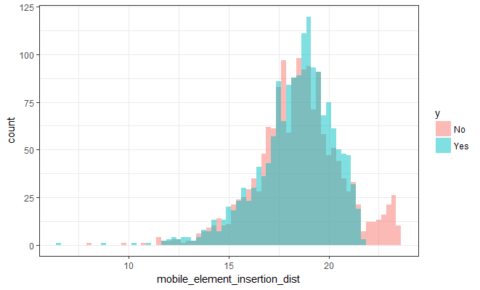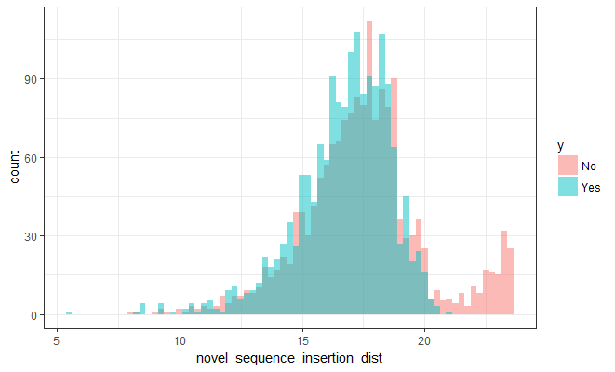

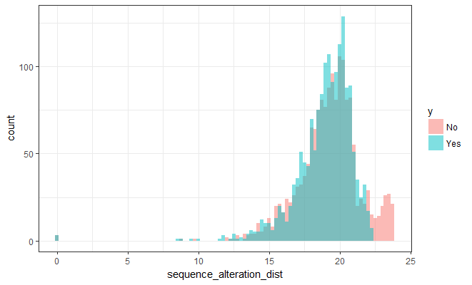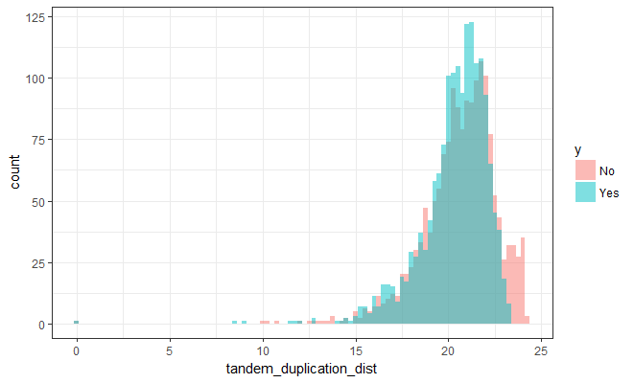

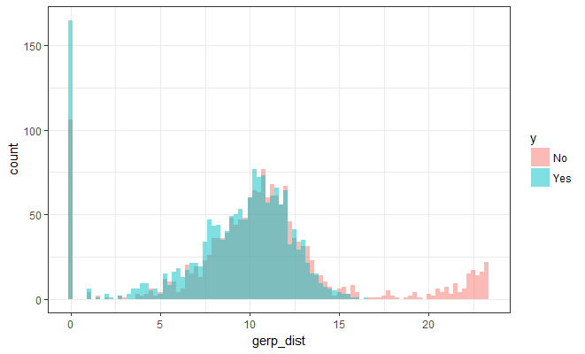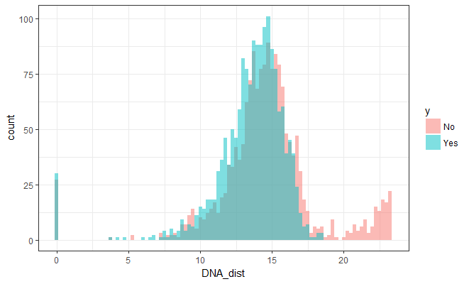

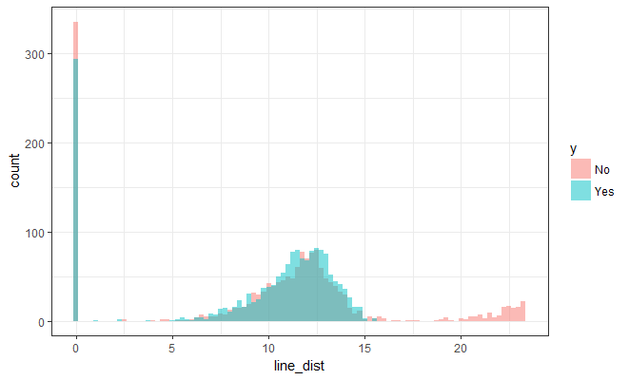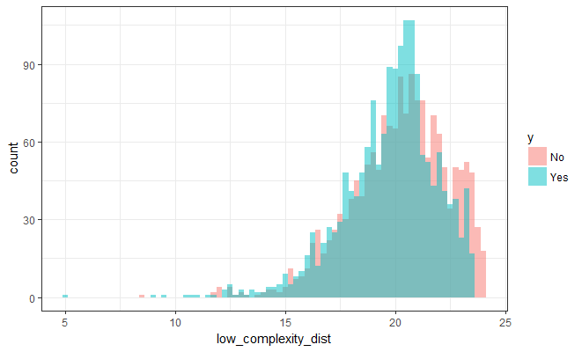

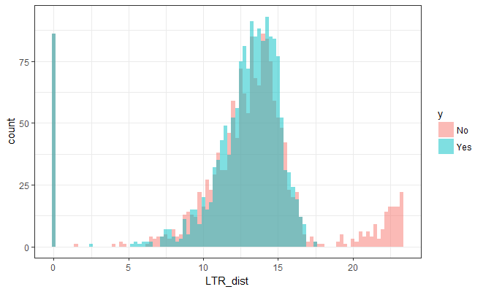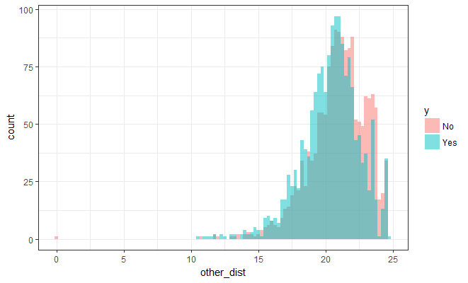

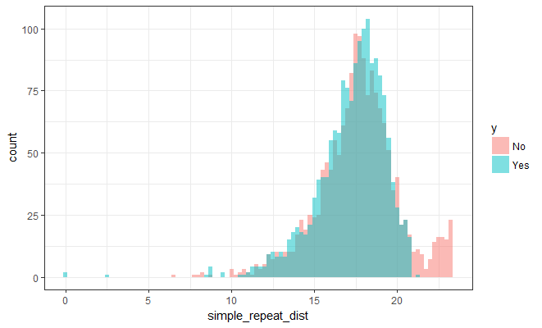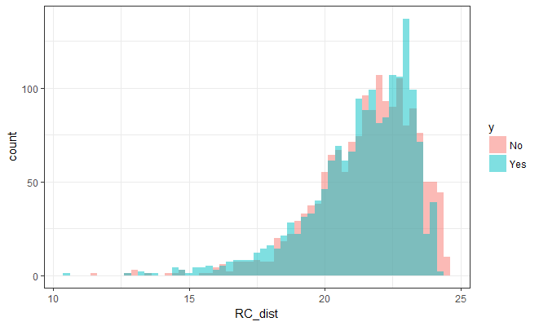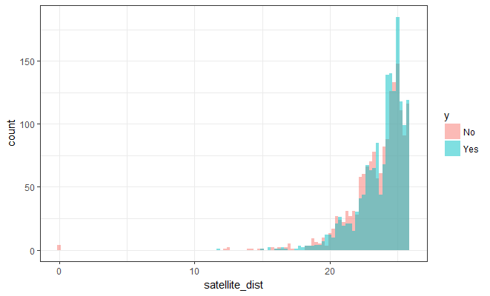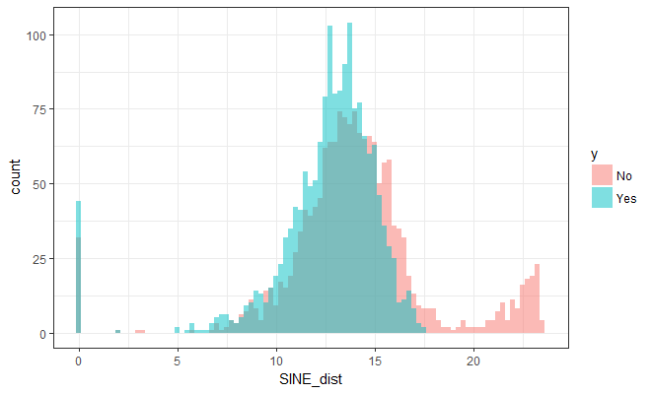

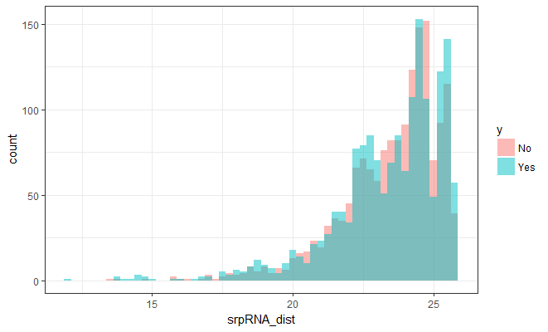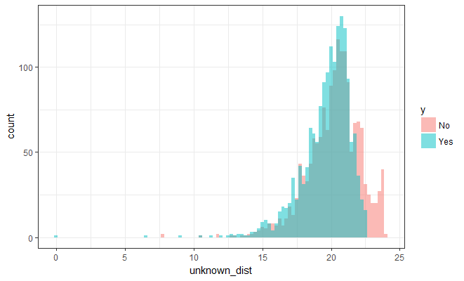

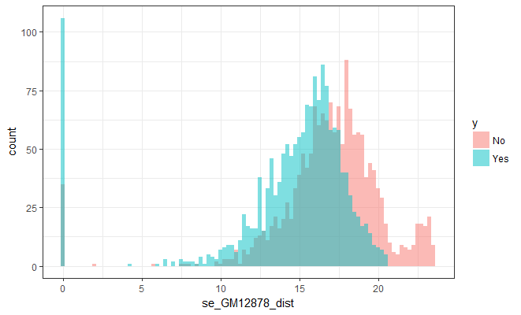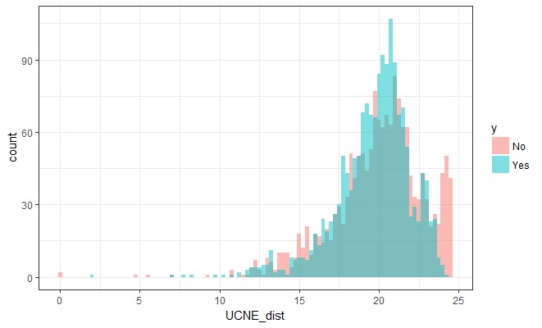

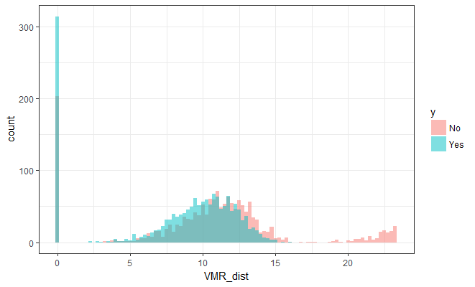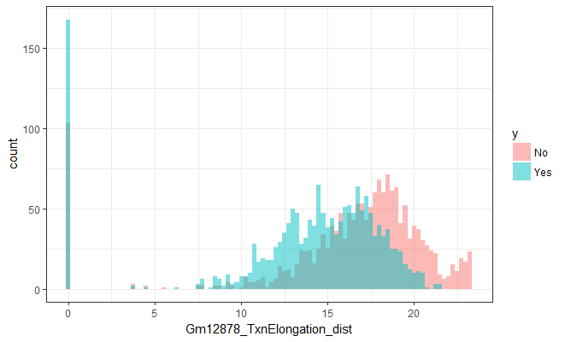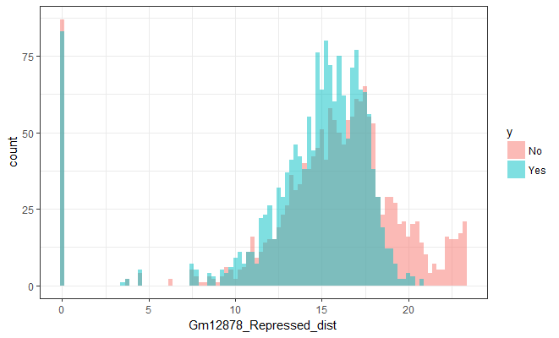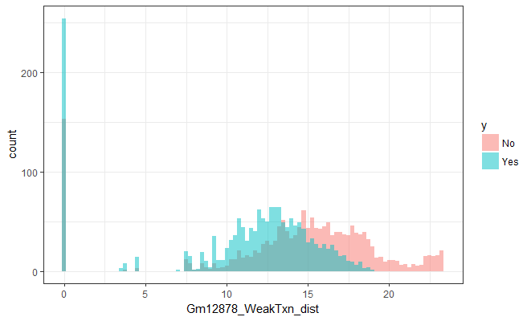  
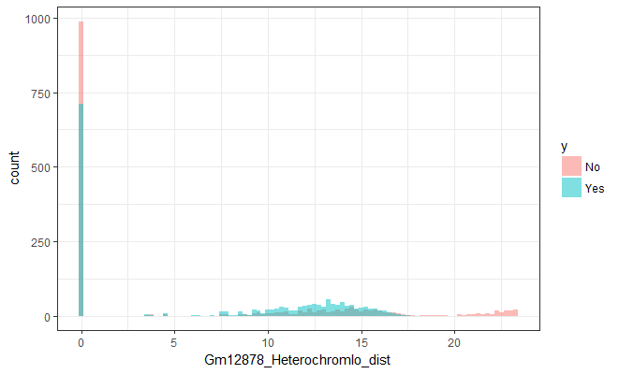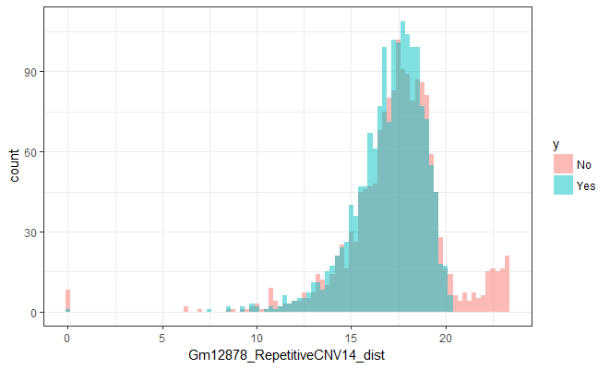

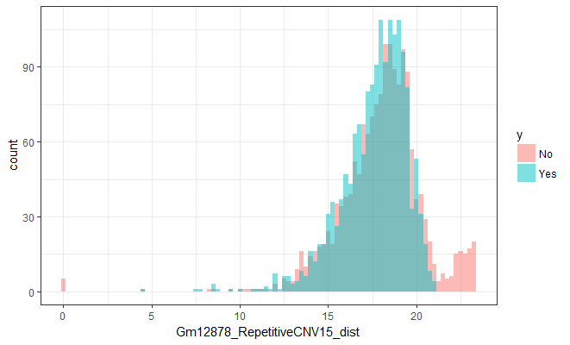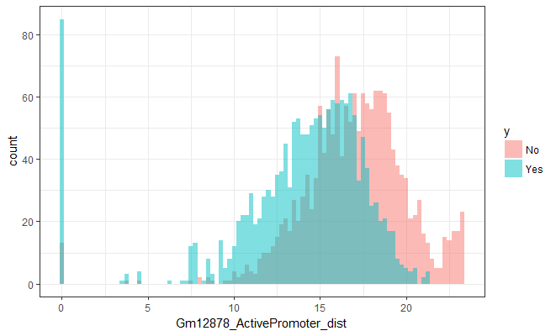

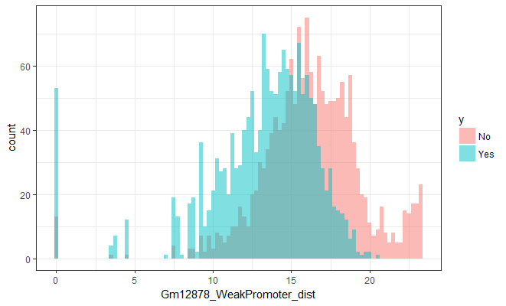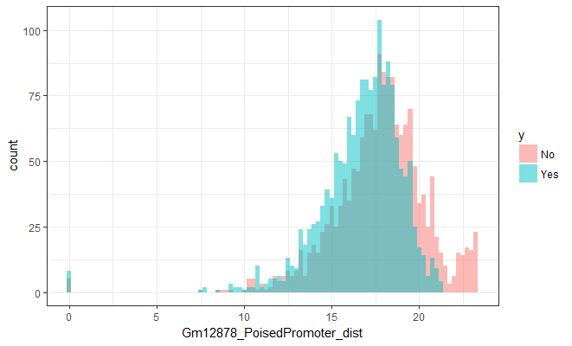

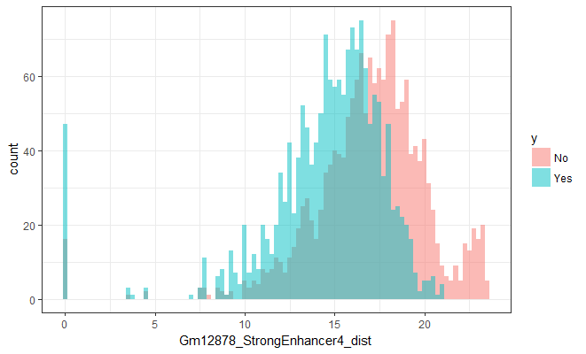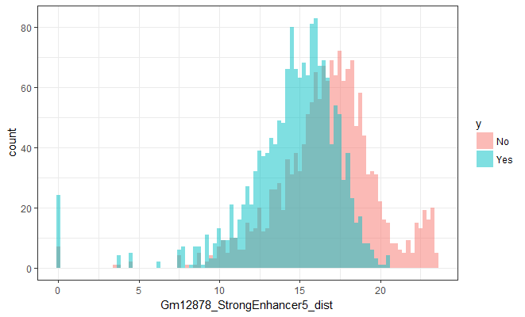

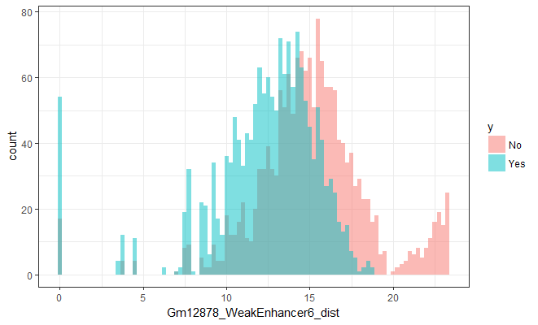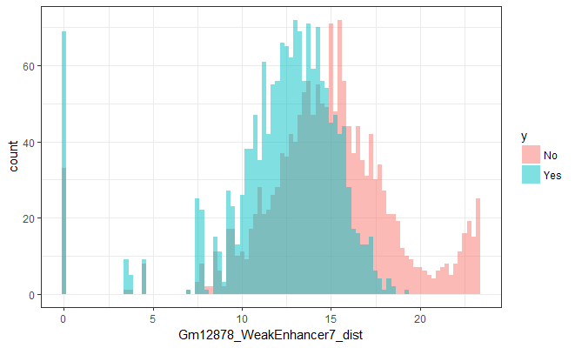

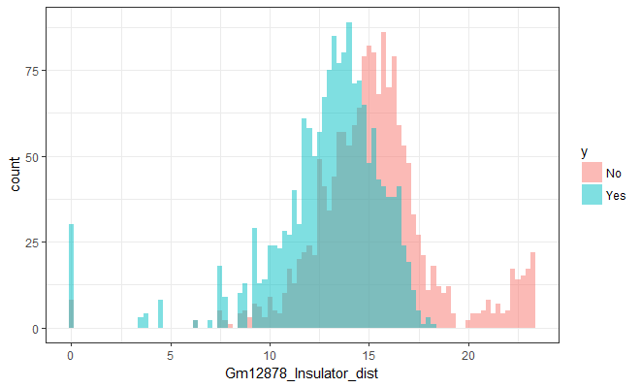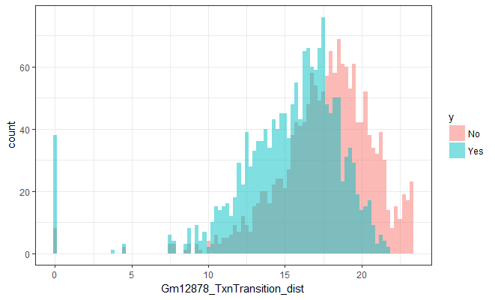

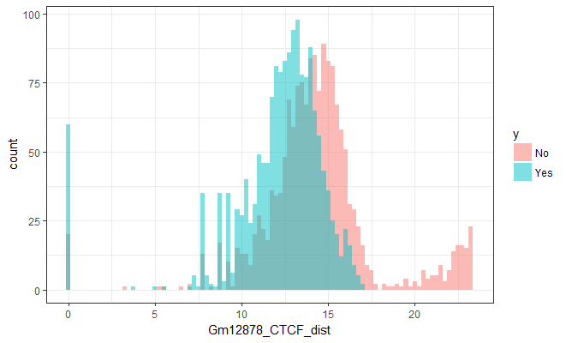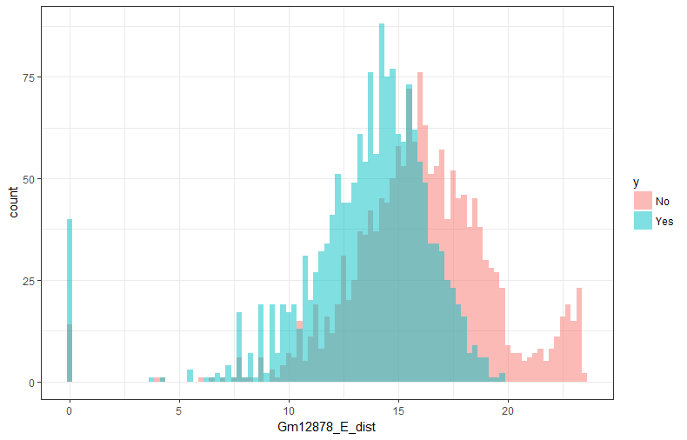

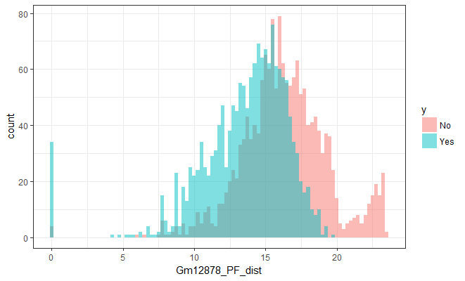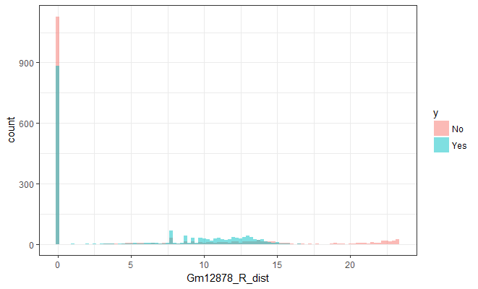

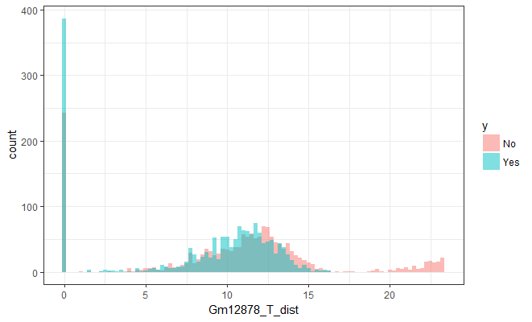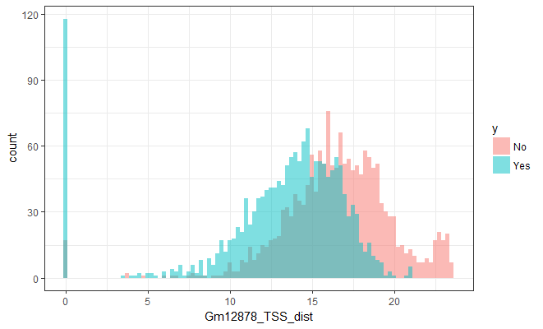

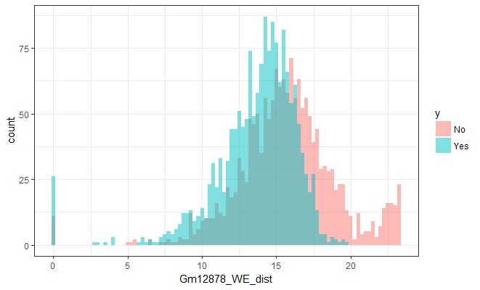

|  |  |  |  |  |  |  |  |
| --- | --- | --- | --- | --- | --- | --- | --- |
|  | **Mean** | | **Median** | | **Range** | |  |
| **Feature** | **No** | **Yes** | **No** | **Yes** | **No** | **Yes** | **P Value** |
| **TSS** | 16.54 | 13.04 | 16.67 | 14.04 | 23.42 | 21.09 | < 0.0001 |
| **WeakPromoter** | 16.24 | 13.19 | 16.22 | 13.83 | 23.37 | 20.47 | < 0.0001 |
| **ActivePromoter** | 16.98 | 13.89 | 17.13 | 14.74 | 23.37 | 21.36 | < 0.0001 |
| **PF** | 16.3 | 13.57 | 16.18 | 14.2 | 23.38 | 19.73 | < 0.0001 |
| **WeakEnhancer6** | 15.09 | 12.3 | 15.04 | 12.89 | 23.37 | 18.83 | < 0.0001 |
| **WeakTxn** | 14.21 | 10.8 | 15.18 | 12.34 | 23.33 | 18.95 | < 0.0001 |
| **E** | 16.02 | 13.54 | 16.03 | 14.12 | 23.38 | 19.8 | < 0.0001 |
| **Insulator** | 15.23 | 12.98 | 15.14 | 13.42 | 23.33 | 18.19 | < 0.0001 |
| **StrongEnhancer4** | 16.94 | 14.55 | 17.23 | 15.18 | 23.4 | 21 | < 0.0001 |
| **CTCF** | 14.3 | 12.07 | 14.21 | 12.64 | 23.35 | 16.94 | < 0.0001 |
| **StrongEnhancer5** | 16.7 | 14.57 | 16.96 | 15.01 | 23.4 | 20.56 | < 0.0001 |
| **SE** | 16.91 | 14.4 | 17.26 | 15.54 | 23.44 | 20.56 | < 0.0001 |
| **TxnElongation** | 16.35 | 13.61 | 17.5 | 14.82 | 23.37 | 21.46 | < 0.0001 |
| **TxnTransition** | 17.64 | 15.32 | 18.02 | 16 | 23.37 | 21.73 | < 0.0001 |
| **WeakEnhancer7** | 14.76 | 12.22 | 14.85 | 12.85 | 23.37 | 19.36 | < 0.0001 |
| **WE** | 15.7 | 13.63 | 15.7 | 14.2 | 23.34 | 19.8 | < 0.0001 |
| **VMR** | 10.48 | 8.18 | 10.93 | 9.61 | 23.33 | 16.08 | < 0.0001 |
| **PoisedPromoter** | 17.76 | 16.72 | 17.94 | 17.08 | 23.35 | 21.29 | < 0.0001 |
| **SINE** | 14.04 | 12.59 | 13.89 | 13.08 | 23.41 | 17.58 | < 0.0001 |
| **T** | 10.41 | 8.19 | 11.26 | 10.11 | 23.33 | 16.24 | < 0.0001 |
| **DNA** | 14.59 | 13.49 | 14.6 | 13.94 | 23.35 | 18.61 | < 0.0001 |
| **Repressed** | 15.42 | 14.34 | 16.12 | 15.27 | 23.33 | 20.74 | < 0.0001 |
| **GERP** | 10.68 | 8.86 | 10.62 | 9.86 | 23.33 | 16.56 | < 0.0001 |
| **unknown** | 20.2 | 19.65 | 20.42 | 20.01 | 16.1 | 22.62 | < 0.0001 |
| **other** | 20.92 | 20.36 | 21.11 | 20.58 | 24.62 | 14.19 | < 0.0001 |
| **Novel sequence insertion** | 17.45 | 16.73 | 17.47 | 17 | 15.73 | 15.57 | < 0.0001 |
| **duplication** | 15.48 | 14.92 | 16.38 | 15.92 | 23.32 | 20.02 | < 0.0001 |
| **R** | 4.33 | 4.95 | 0 | 0 | 23.33 | 16.39 | < 0.0001 |
| **Low complexity** | 20.2 | 19.77 | 20.41 | 20.1 | 15.42 | 18.46 | < 0.0001 |
| **Insertion** | 14.86 | 13.9 | 15.8 | 15.53 | 23.32 | 19.05 | < 0.0001 |
| **RepetitiveCNV14** | 17.4 | 17.03 | 17.58 | 17.35 | 23.33 | 20.31 | < 0.0001 |
| **Heterochromlo** | 5.93 | 7.08 | 0 | 9.6 | 23.33 | 17.51 | < 0.0001 |
| **Tandem duplication** | 20.62 | 20.33 | 20.88 | 20.63 | 24.15 | 23.33 | < 0.0001 |
| **RepetitiveCNV15** | 17.98 | 17.62 | 18.23 | 17.95 | 23.32 | 16.48 | < 0.0001 |
| **UCNE** | 19.97 | 19.65 | 20.29 | 20.04 | 24.54 | 22.14 | < 0.0001 |
| **Deletion** | 12.8 | 12.24 | 14.43 | 14.11 | 23.32 | 17.92 | < 0.0001 |
| **Simple repeat** | 17.65 | 17.25 | 17.74 | 17.61 | 16.96 | 21.26 | 0.0002 |
| **Sequence alteration** | 19.24 | 18.94 | 19.44 | 19.29 | 23.73 | 22.29 | 0.0010 |
| **Satellite** | 23.55 | 23.82 | 24.12 | 24.32 | 25.84 | 13.97 | 0.0023 |
| **Gain loss** | 16.69 | 16.68 | 18.52 | 18.4 | 23.33 | 21.56 | 0.0024 |
| **LTR** | 13.05 | 12.43 | 13.36 | 13.27 | 23.33 | 17.57 | 0.0157 |
| **RC** | 21.53 | 21.35 | 21.82 | 21.7 | 12.92 | 13.6 | 0.0236 |
| **Complex** | 21.36 | 21.6 | 21.9 | 21.93 | 24 | 23.98 | 0.0460 |
| **Inversion** | 19.63 | 19.87 | 20.46 | 20.41 | 23.81 | 23.8 | 0.0719 |
| **Line** | 9.97 | 9.4 | 11.32 | 11.21 | 23.33 | 15.51 | 0.0976 |
| **Mobile element insertion** | 18.52 | 18.35 | 18.54 | 18.63 | 15.53 | 15.26 | 0.4849 |
| **srpRNA** | 23.48 | 23.4 | 23.92 | 23.83 | 12.15 | 13.72 | 0.7917 |

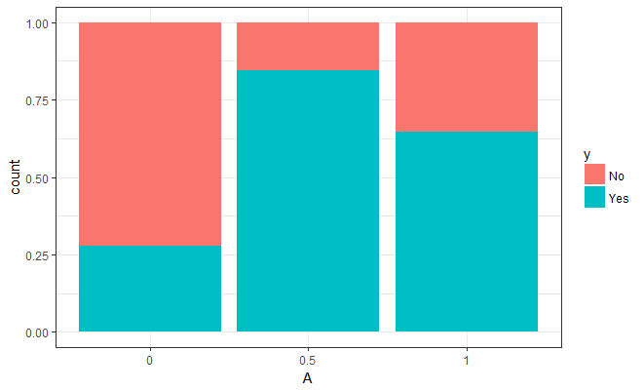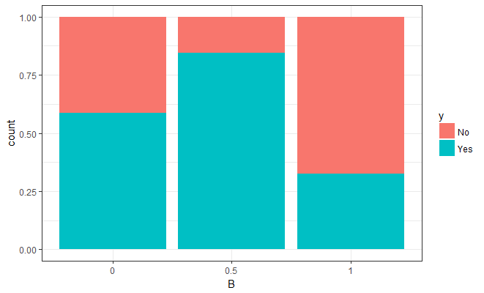

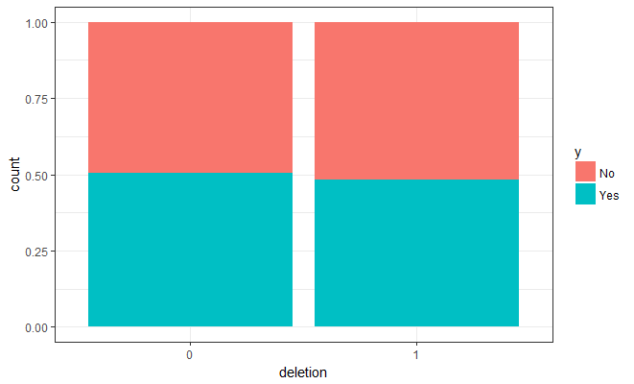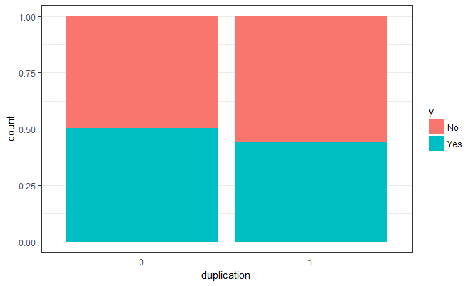

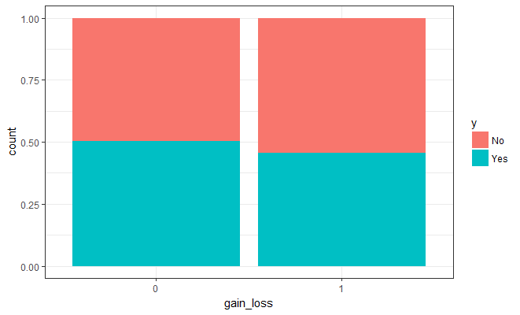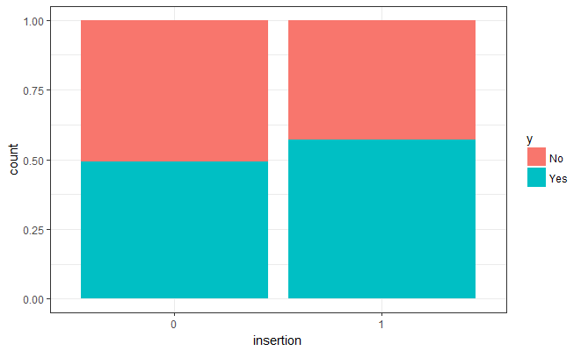

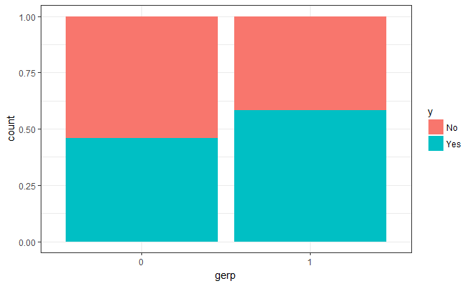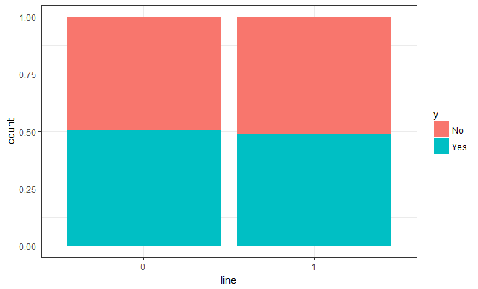

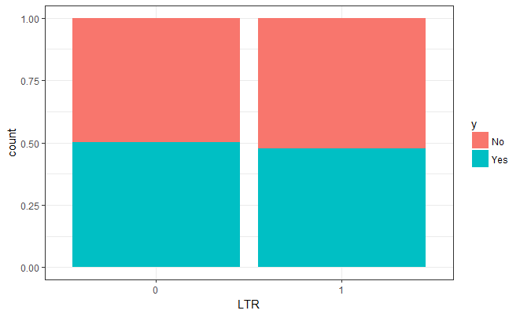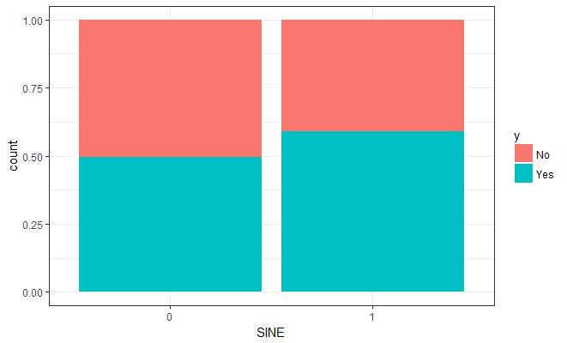

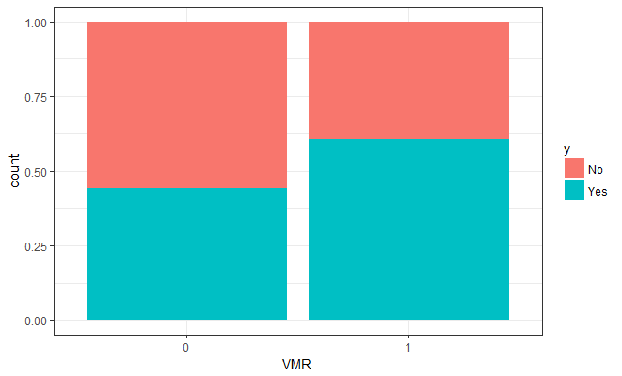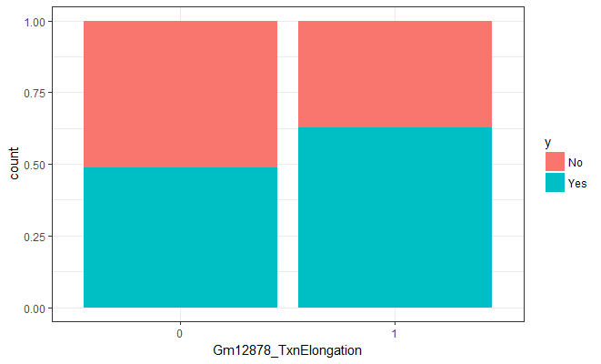

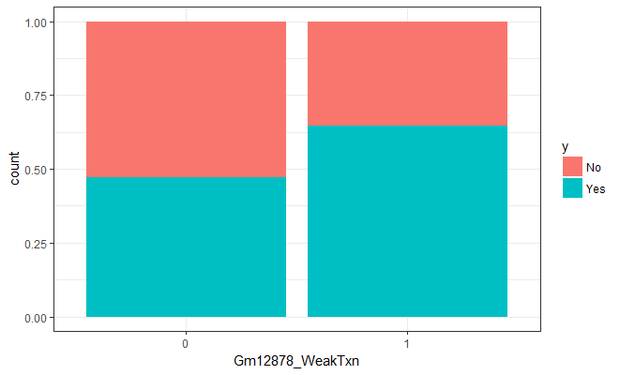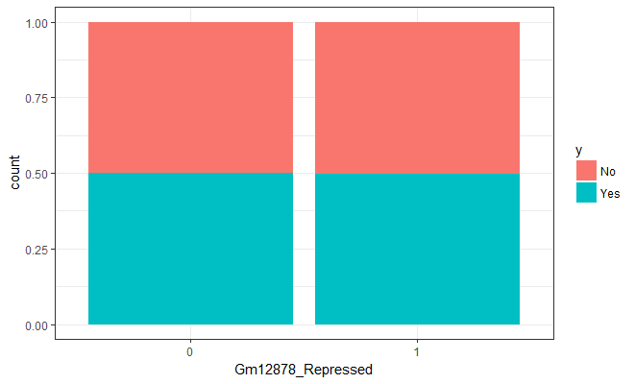

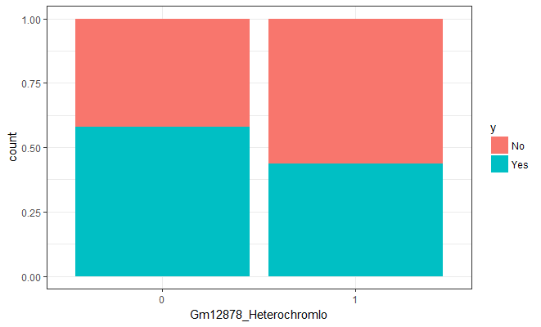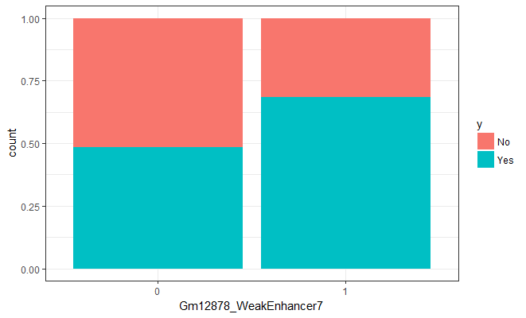

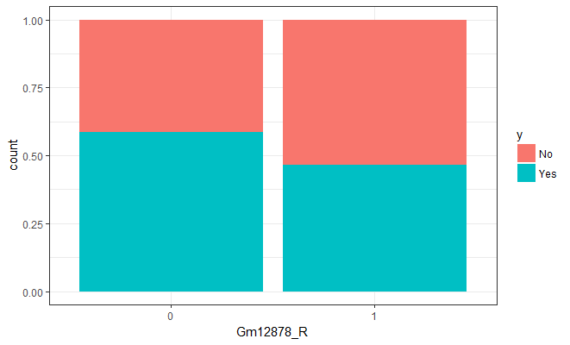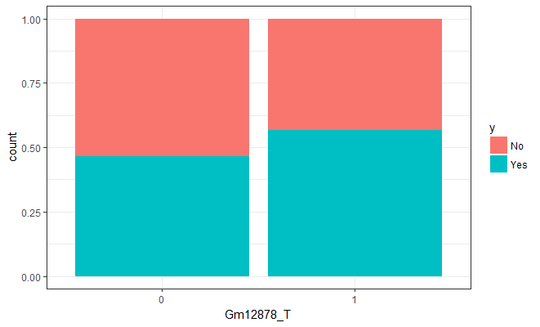

|  |  |  |  |  |
| --- | --- | --- | --- | --- |
|  |  | **TAD Boundary** | |  |
| **Feature** | **Level** | **No** | **Yes** | **P Value** |
| **A** | 0 | 58 | 22 | < 0.0001 |
|  | .5 | 00 | 01 |  |
|  | 1 | 42 | 77 |  |
| **B** | 0 | 54 | 77 | < 0.0001 |
|  | .5 | 00 | 01 |  |
|  | 1 | 46 | 22 |  |
| **VMR** | No | 72 | 58 | < 0.0001 |
|  | Yes | 28 | 42 |  |
| **Gm12878_Heterochromlo** | No | 37 | 52 | < 0.0001 |
|  | Yes | 63 | 48 |  |
| **Gm12878_WeakTxn** | No | 88 | 79 | < 0.0001 |
|  | Yes | 12 | 21 |  |
| **gerp** | No | 72 | 61 | < 0.0001 |
|  | Yes | 28 | 39 |  |
| **Gm12878_R** | No | 25 | 35 | < 0.0001 |
|  | Yes | 75 | 65 |  |
| **Gm12878_WeakEnhancer7** | No | 95 | 90 | < 0.0001 |
|  | Yes | 5 | 10 |  |
| **Gm12878_T** | No | 71 | 62 | < 0.0001 |
|  | Yes | 29 | 38 |  |
| **Gm12878_TxnElongation** | No | 93 | 88 | < 0.0001 |
|  | Yes | 7 | 12 |  |
| **insertion** | No | 92 | 89 | 0.0116 |
|  | Yes | 8 | 11 |  |
| **SINE** | No | 95 | 93 | 0.0129 |
|  | Yes | 5 | 7 |  |
| **duplication** | No | 93 | 95 | 0.0817 |
|  | Yes | 7 | 5 |  |
| **gain_loss** | No | 89 | 91 | 0.0986 |
|  | Yes | 11 | 9 |  |
| **deletion** | No | 84 | 85 | 0.3873 |
|  | Yes | 16 | 15 |  |
| **LTR** | No | 91 | 92 | 0.4568 |
|  | Yes | 9 | 8 |  |
| **line** | No | 72 | 73 | 0.5026 |
|  | Yes | 28 | 27 |  |
| **Gm12878_Repressed** | No | 93 | 93 | 1 |
|  | Yes | 7 | 7 |  |