# Lab: Design Patterns

Problems for in-class lab for the [Python OOP Course @SoftUni](https://softuni.bg/courses/python-oop).

## Abstract Factory

We are going to create an **AbstractFactory** class that will have methods for creating **chairs**, **sofas**, and **tables**:

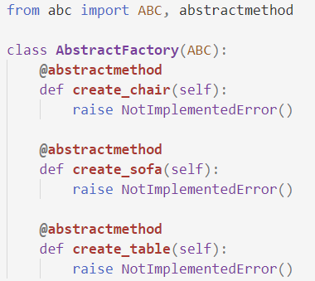

Then we are going to create the **Chair**, **Sofa** and **Table** classes:

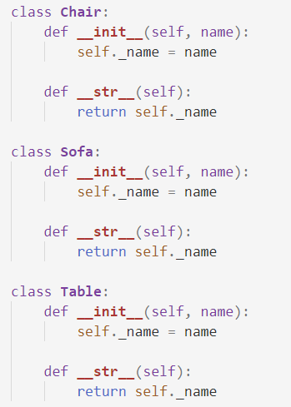

Finally, we are going to create **three** different factories that **will inherit** from the **AbstractFactiory** class: **VictorianFactory**, **ModernFactory**, **FuturisticFactory**

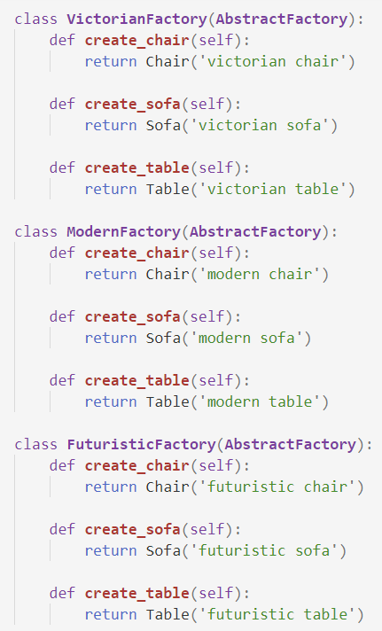

## Composite

We are going to create a class called **Component** which will have **move** and **delete** methods:

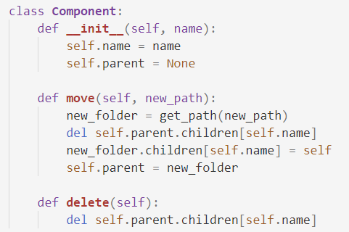

Create two more classes: **Folder** and **File**, which **inherit** from **Component**. The **Folder** class should have an **add_child** method:

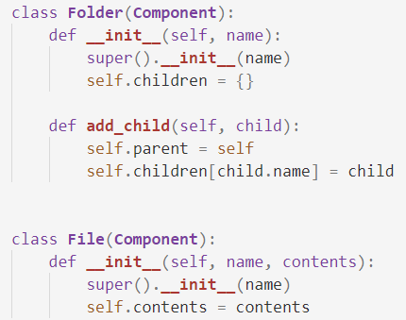

Create a **root folder** and implement the method **get_path**:

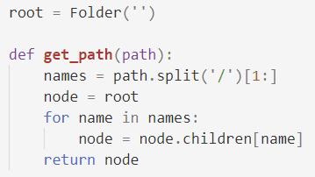

## Command

Create class **Window** and class **Document**. The Window class will have an **exit** method. The Document class will have a **save** method:

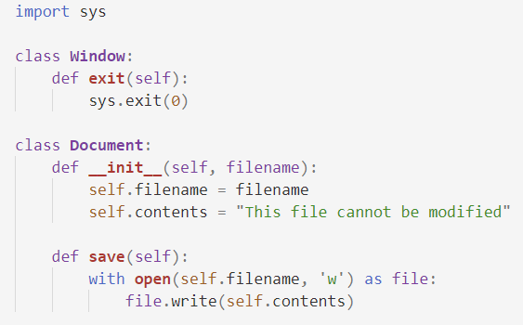

Next, we will create the classes **ToolbarDocument**, **MenuItem**, and **KeyboardShortcut**. The **ToolbarDocument** and the **MenuItem** will have a method **click**. The **KeyboardShortcut** should have a method called **keypress**.

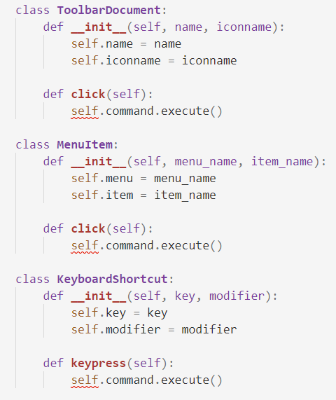

Finally, we will create two **command classes** **SaveCommand** and **ExitCommand** which will have the **execute** methods implemented in them:

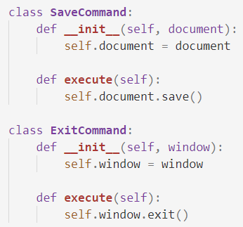

## BONUS: File Uploader

Create a simple **server** (**flask**) for file uploads of type **json** and **csv**. Render a **simple HTML form** and on **submit**:

* If the **format** of the file is **correct**, a message should be displayed in the browser: **"File uploaded successfully"**, and information about the file should be **printed on the console**
  + **CSV** Example:

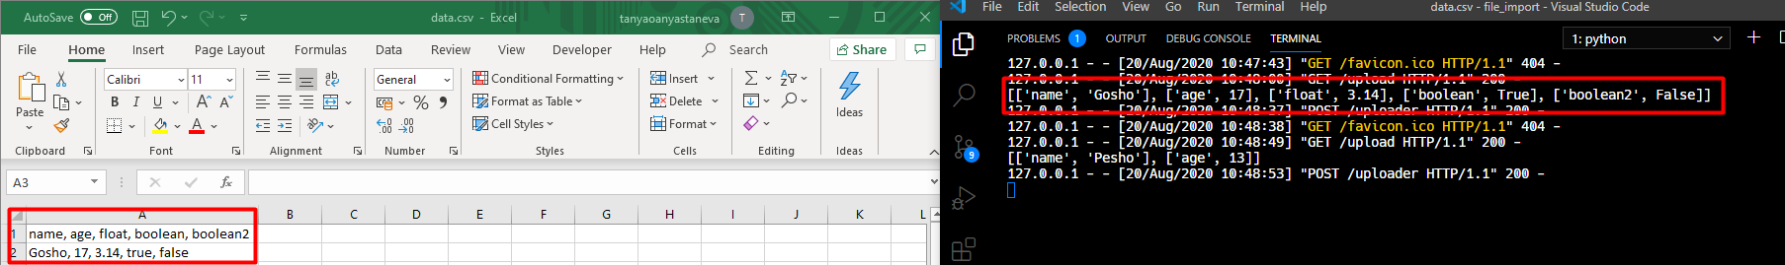

* + **JSON** Example:



* Otherwise, another message should be displayed: **"Invalid content type for import"**

***Note: Use the design patterns you have learned to build your project***

### Useful Links

* Flask **documentation**: <https://flask.palletsprojects.com/en/1.1.x/api/>
* Example **solution**: <https://github.com/Minkov/python-oop-2020-06/tree/demos/file_import>