ASSIGNMENT

WORKSHEET 2 SQL

# Q1 to Q13 have only one correct answer. Choose the correct option to answer your question.

1. Which of the following constraint requires that there should not be duplicate entries?
   1. No Duplicity B) Different

C) Null D) Unique

Answer is d) Unique

1. Which of the following constraint allows null values in a column?
   1. Primary key B) Empty Value

C) Null D) None of them

Answer is c) Null

1. Which of the following statements are true regarding Primary Key?
   1. Each entry in the primary key uniquely identifies each entry or row in the table
   2. There can be duplicate values in a primary key column
   3. There can be null values in Primary key
   4. None of the above.

Answer - A)Each entry in the primary key uniquely identifies each entry or row in the table

1. Which of the following statements are true regarding Unique Key?
   1. There should not be any duplicate entries
   2. Null values are not allowed
   3. Multiple columns can make a single unique key together
   4. All of the above

Answer is C) Multiple columns can make a single unique key together

1. Which of the following is/are example of referential constraint?

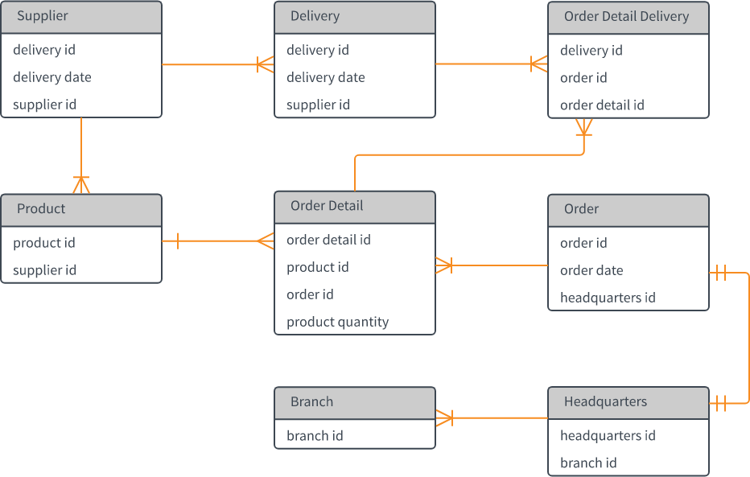

* 1. Not Null B) Foreign Key

C) Referential key D) All of them

Answer is B) Foreign Key

# For Questions 6-13 refer to the below diagram and answer the questions:

1. How many foreign keys are there in the Supplier table?
   1. 0 B) 3

C) 2 D) 1

Answer is 1 Supplier ID

1. The type of relationship between Supplier table and Product table is:
   1. one to many B) many to one

C) one to one D) many to many

Answer is - One to many

1. The type of relationship between Order table and Headquarter table is:
   1. one to many B) many to one

C) one to one D) many to many

Answer is - one to one

1. Which of the following is a foreign key in Delivery table?
   1. delivery id B) supplier id

C) delivery date D) None of them

Answer is - delivery date

1. The number of foreign keys in order details is:
   1. 0 B) 1

C) 3 D) 2

0

1. The type of relationship between Order Detail table and Product table is:
   1. one to many B) many to one

C) one to one D) many to many

1. DDL statements perform operation on which of the following database objects?
   1. Rows of table B) Columns of table

C) Table D) None of them

Answer is c) Table

1. Which of the following statement is used to enter rows in a table?
   1. Insert in to B) Update

C) Enter into D) Set Row

Answer is a) Insert in to

# Q14 and Q15 have one or more correct answer. Choose all the correct option to answer your question.

1. Which of the following is/are entity constraints in SQL?
   1. Duplicate B) Unique

C) Primary Key D) Null

Answer is Unique, Primary Key & Null

1. Which of the following statements is an example of semantic Constraint?
   1. A blood group can contain one of the following values - A, B, AB and O.
   2. A blood group can only contain characters
   3. A blood group cannot have null values
   4. Two or more donors can have same blood group

Answer is -

1. A blood group can contain one of the following values - A, B, AB and O.
2. A blood group can only contain characters