Engineering College Bikaner
Department of Computer Science & Engineering
SUMMER INTERNSHIP REPORT
WEEK 1
AI Powered Smart E-Learning Web Platform using MERN Stack for Personalized Course Recommendation, Student Progress Tracking, and Interactive Virtual Learning

Student Name | Shubham Paliwal
Application No. | AVL-26/279
Course / Branch | B.tech. Computer Science
Semester / Year | 2nd semester
Internship Organization | Aarivya Labs

Table of Contents
1. Project Overview 3
2. Problem Statement 3
3. Objectives 4
4. Scope of the Project 4
4.1 In Scope 4
4.2 Out of Scope (Current Phase) 4
5. User Roles 5
6. Functional Requirements 5
7. Non-Functional Requirements 7
8. System Architecture Diagram 8
9. Database Schema (ER Diagram) 9
10. Workflow Diagram 10
11. UI Wireframes 11
11.1 Login Page 11
11.2 Dashboard 11
11.3 Course Page 12
11.4 Progress Page 12
12. Technology Stack 13
13. Folder Structure 14
14. Future Development Plan 15
15. Conclusion 16

1. Project Overview
The project undertaken during this internship is the design and development of an “AI Powered Smart E-Learning Web Platform” built using the MERN stack (MongoDB, Express.js, React.js, and Node.js). The platform is envisioned as a comprehensive digital learning ecosystem that goes beyond traditional Learning Management Systems (LMS) by embedding Artificial Intelligence to personalize the learning journey of every student.
At its core, the platform allows instructors to create and publish structured courses consisting of video lectures, reading material, and assessments, while students can browse, enroll in, and consume this content through an interactive and responsive web interface. What differentiates this platform is its AI-driven recommendation engine, which analyzes a student's interests, learning history, and quiz performance to suggest the most relevant courses and learning paths — much like recommendation systems used by modern streaming and e-commerce platforms.
In addition to personalization, the platform places strong emphasis on student progress tracking, giving learners and instructors real-time visibility into completion rates, quiz scores, and overall learning trends through visual dashboards. An interactive virtual learning environment further supports live sessions, discussion forums, and collaborative learning tools to replicate the engagement of a physical classroom in a fully digital setting.
During Week 1 of the internship, the primary focus was on requirement gathering, problem analysis, defining the scope, identifying user roles, and preparing the foundational design artifacts — including system architecture, database schema, workflow diagrams, and UI wireframes — that will guide the development phases in the subsequent weeks.

2. Problem Statement
Traditional e-learning platforms largely follow a “one-size-fits-all” approach, delivering the same static set of courses and content to every learner regardless of their individual interests, prior knowledge, or pace of learning. This generic model often results in several challenges:
- Students struggle to discover courses that are genuinely relevant to their skill level and career goals.
- Instructors and institutions lack real-time, data-driven insight into how individual students are progressing through course material.
- Learners frequently disengage due to a lack of interactivity, monotonous content delivery, and absence of timely feedback.
- Existing systems rarely leverage learning analytics or Artificial Intelligence to adapt content or recommendations to the learner.
- Progress tracking, when available, is often limited to simple completion percentages rather than meaningful insights such as quiz trends or skill gaps.
There is, therefore, a clear need for an intelligent, adaptive, and interactive e-learning platform that personalizes course recommendations, continuously tracks and visualizes student progress, and fosters active engagement through virtual, interactive learning tools — which is precisely the gap this project aims to address.

3. Objectives
The key objectives identified for this project are as follows:
- To design and develop a full-stack e-learning web platform using the MERN stack (MongoDB, Express.js, React.js, Node.js).
- To implement an AI-based recommendation engine that suggests personalized courses based on student interests, browsing behavior, and performance history.
- To build a robust student progress tracking module that visualizes completion rates, quiz scores, and learning trends through interactive dashboards.
- To develop an interactive virtual learning environment supporting video lectures, quizzes, discussion forums, and real-time notifications.
- To design a secure, role-based access system for Students, Instructors, and Administrators.
- To create a scalable and maintainable system architecture and database schema that can support future enhancements.
- To ensure the platform is responsive, accessible, and provides a smooth user experience across devices.

4. Scope of the Project
The scope of the project defines the boundaries within which the platform will be designed, developed, and deployed during the internship period.

4.1 In Scope
- Student, Instructor, and Admin web portals with role-based dashboards.
- Course creation, management, and enrollment functionality.
- AI-driven personalized course recommendation engine.
- Student progress tracking with visual analytics (charts and reports).
- Interactive learning tools such as quizzes, video lectures, and discussion forums.
- Secure authentication and authorization using JWT-based sessions.
- RESTful API architecture connecting the React front-end with the Node/Express back-end and MongoDB database.

4.2 Out of Scope (Current Phase)
- Native mobile applications (Android/iOS) — the platform will initially be web-only and responsive.
- Live proctored examinations and advanced plagiarism detection.
- Multi-language content translation (planned for future phases).
- Payment gateway integration for paid courses (planned for a later release).

5. User Roles
The platform supports three distinct user roles, each with a dedicated dashboard and a defined set of permissions to ensure secure and organized access to system functionality.
Role | Description | Key Permissions
Student | End user who enrolls in and consumes course content | Register/Login, browse & enroll in courses, view personalized recommendations, attempt quizzes, track own progress, participate in discussion forums
Instructor | Creates and manages educational content | Create/edit/delete courses & lessons, upload videos & resources, create quizzes, view enrolled students' progress, respond in forums
Admin | Manages the overall platform and users | Manage all users & roles, approve/reject instructor content, monitor platform analytics, configure system settings, handle reported issues

6. Functional Requirements
Functional requirements describe the specific behaviors, features, and functions that the system must perform.
ID | Requirement | Description
FR-01 | User Registration & Authentication | Users can register, log in, and log out securely using JWT-based authentication with role selection (Student/Instructor).
FR-02 | Course Management | Instructors can create, update, publish, and delete courses consisting of lessons, videos, and resources.
FR-03 | Course Enrollment | Students can browse the course catalog and enroll in courses of interest.
FR-04 | AI-Based Recommendations | The system analyzes student interests and activity to generate personalized course suggestions.
FR-05 | Progress Tracking | The system tracks lesson completion, quiz scores, and displays progress visually to students and instructors.
FR-06 | Quiz & Assessment | Instructors can create quizzes; students can attempt them and receive instant scoring/feedback.
FR-07 | Interactive Learning Tools | Support for video playback, discussion forums, comments, and notifications.
FR-08 | Admin Panel | Admin can manage users, courses, and view platform-wide analytics.
FR-09 | Search & Filter | Students can search and filter courses by category, difficulty, and rating.
FR-10 | Certificate Generation | System generates a completion certificate upon successful course completion.

7. Non-Functional Requirements
Non-functional requirements define the quality attributes and constraints that govern how the system performs its functions.
Category | Requirement
Performance | Pages should load within 2–3 seconds under normal network conditions; APIs should respond within 500ms for standard queries.
Scalability | The system architecture should support horizontal scaling to accommodate a growing number of concurrent users and courses.
Security | All sensitive data (passwords, tokens) must be encrypted; role-based access control must prevent unauthorized data access.
Usability | The interface should be intuitive, responsive, and accessible across desktop, tablet, and mobile devices.
Reliability | The system should maintain 99% uptime with proper error handling and graceful degradation.
Maintainability | Code should follow modular, component-based architecture with clear documentation for future enhancement.
Compatibility | The platform must function correctly across major browsers (Chrome, Firefox, Edge, Safari).
Data Backup | Regular automated backups of the MongoDB database to prevent data loss.

8. System Architecture Diagram
The platform follows a three-tier architecture consisting of a presentation layer (React.js), an application layer (Node.js/Express.js REST APIs), and a data layer (MongoDB), supported by an AI recommendation microservice and cloud storage for media content.
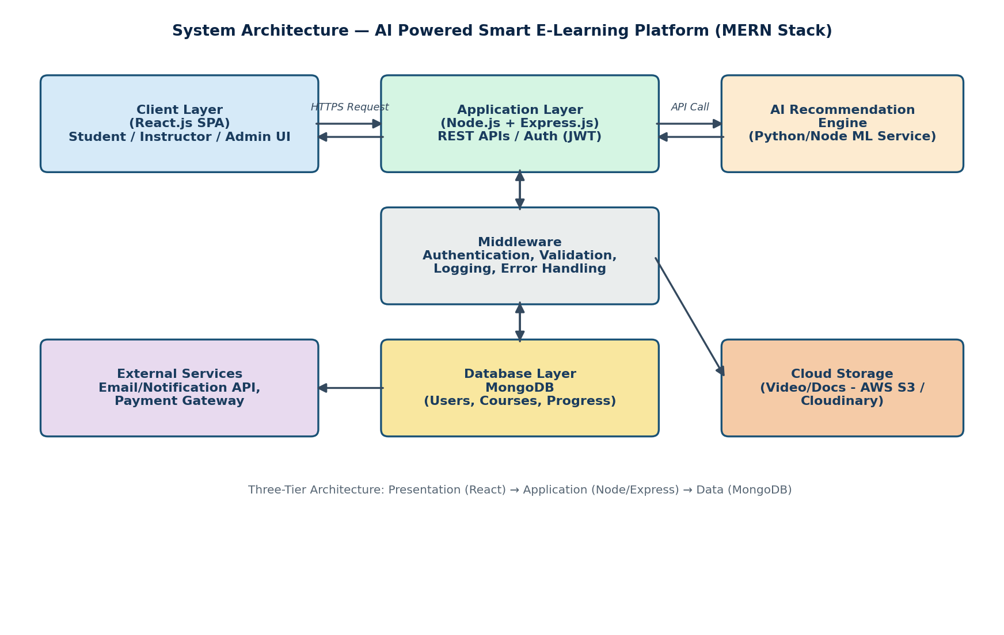
Figure 1: High-Level System Architecture of the E-Learning Platform

9. Database Schema (ER Diagram)
The database is designed using MongoDB's document-oriented model. The diagram below represents the primary collections and their relationships, which will be implemented using Mongoose schemas with reference-based (ObjectId) relationships.
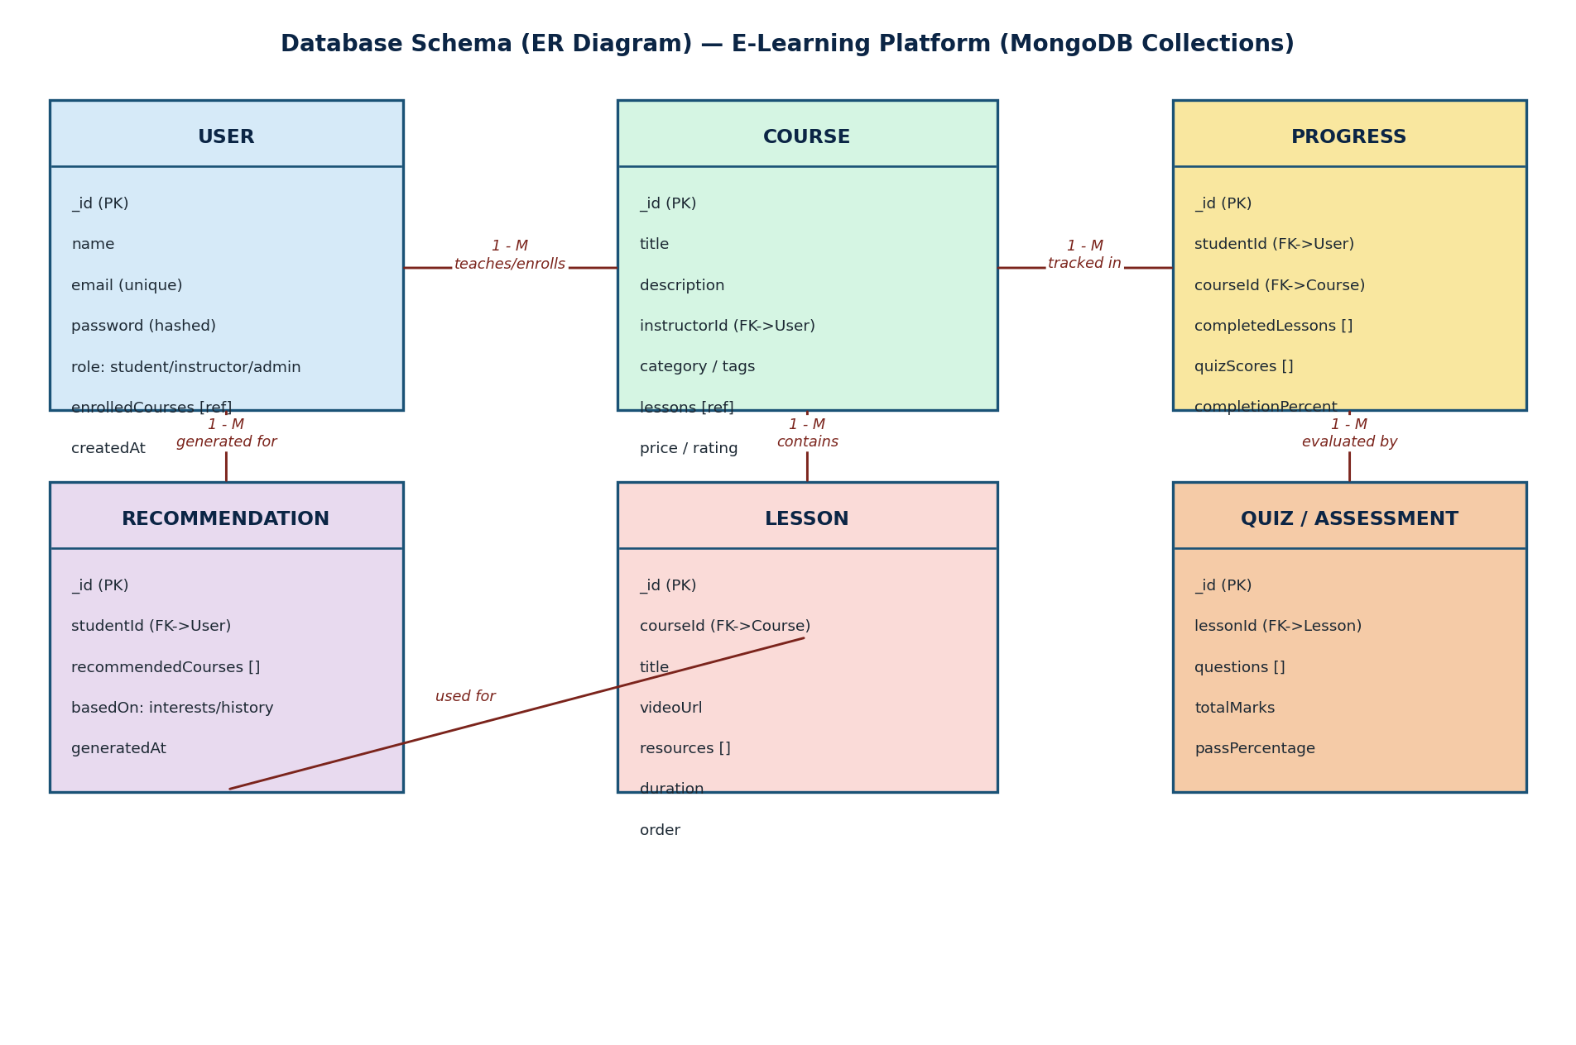
Figure 2: Entity Relationship Diagram of Core Database Collections

10. Workflow Diagram
The following diagram illustrates the typical journey of a student on the platform — from registration and onboarding, through receiving AI-based recommendations, enrolling in a course, completing lessons and quizzes, up to progress updates and certificate issuance.
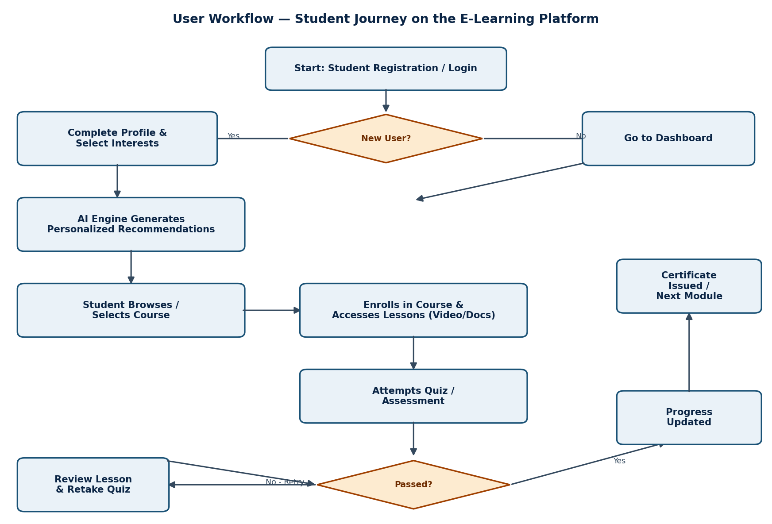
Figure 3: Student Workflow on the E-Learning Platform

11. UI Wireframes
Low-fidelity wireframes were prepared during Week 1 to visualize the layout and core components of the four most critical screens of the platform, prior to detailed UI/UX design and front-end implementation.

11.1 Login Page
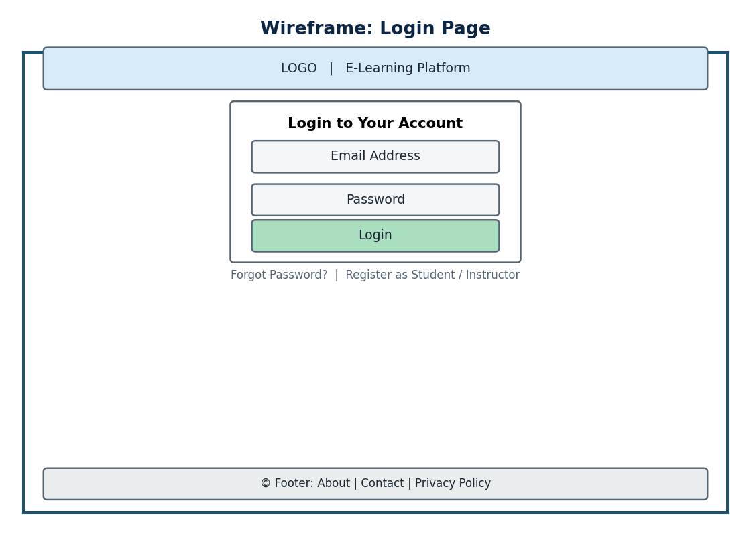
Figure 4: Login Page Wireframe

11.2 Dashboard
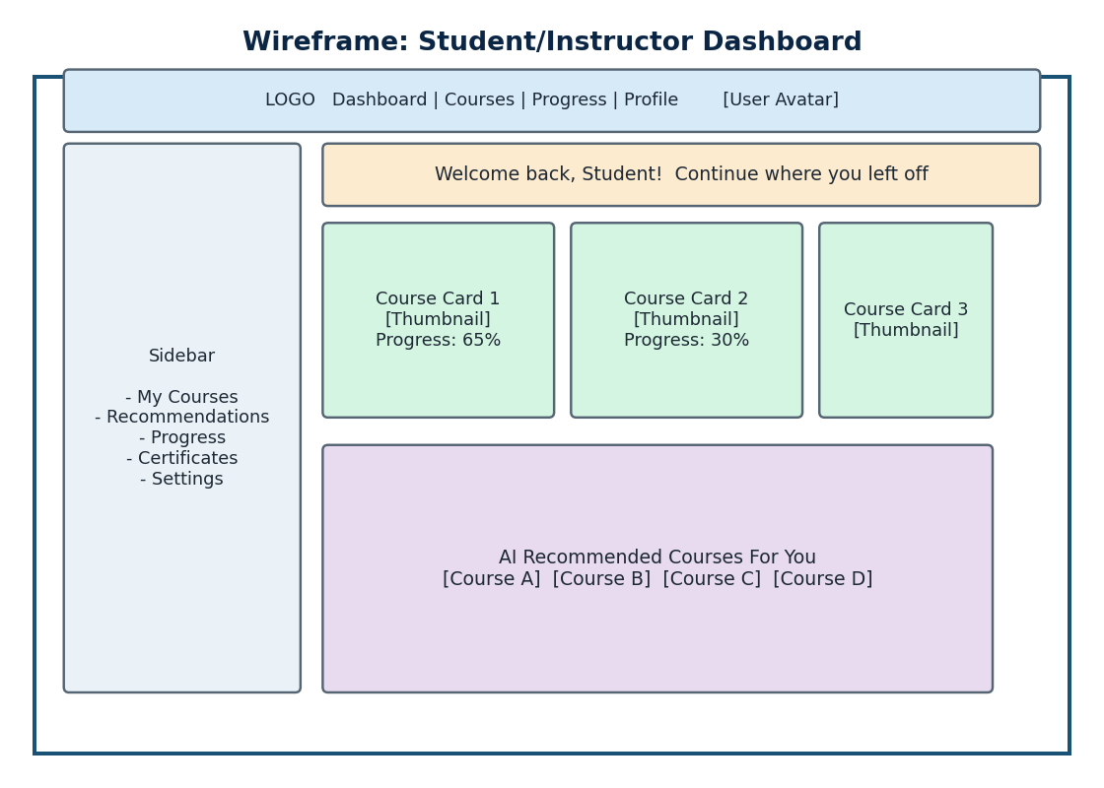
Figure 5: Student/Instructor Dashboard Wireframe

11.3 Course Page
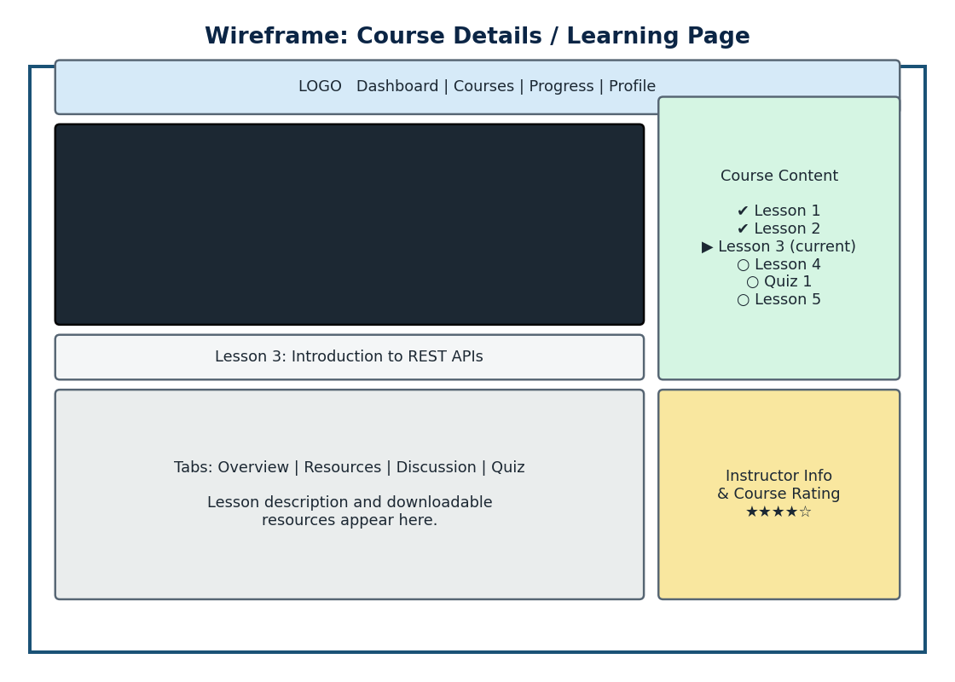
Figure 6: Course Details / Learning Page Wireframe

11.4 Progress Page
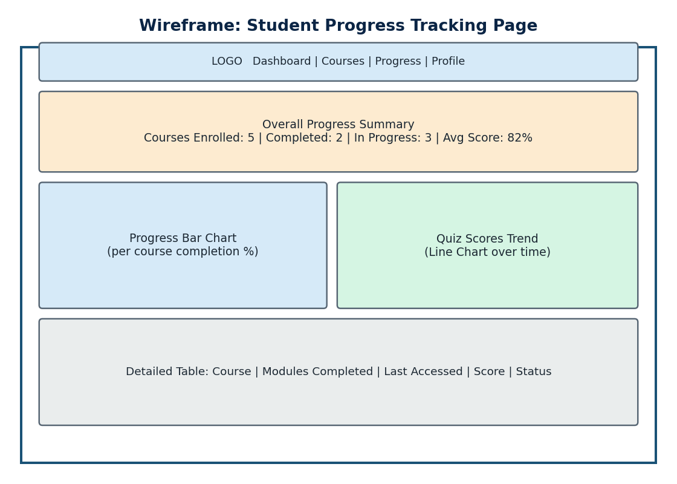
Figure 7: Student Progress Tracking Page Wireframe

12. Technology Stack
The project is built entirely on the MERN stack, supplemented with additional tools and services for AI-based recommendations, cloud storage, and real-time interactivity.
Layer | Technology | Purpose
Front-End | React.js, Redux/Context API, Axios, Tailwind CSS / Material UI | Building responsive, component-based user interfaces and state management
Back-End | Node.js, Express.js | Building RESTful APIs, handling business logic and server-side operations
Database | MongoDB, Mongoose ODM | Storing user, course, progress, and quiz data as flexible documents
AI/ML Engine | Python (scikit-learn) or Node-based recommendation service | Generating personalized course recommendations using collaborative/content-based filtering
Authentication | JSON Web Tokens (JWT), bcrypt.js | Secure user authentication and password hashing
Cloud/Storage | AWS S3 / Cloudinary | Storage and delivery of video lectures, documents, and images
Real-time Features | Socket.IO | Enabling live notifications and discussion forum updates
Version Control | Git & GitHub | Source code management and team collaboration
Deployment | Vercel/Netlify (Front-end), Render/AWS EC2 (Back-end) | Hosting and deployment of the application
Testing | Postman, Jest | API testing and unit/integration testing

13. Folder Structure
The project follows a modular folder structure separating the client (React) and server (Node/Express) codebases, as is standard practice for MERN stack applications.
e-learning-platform/
├── client/ # React front-end
│ ├── public/
│ ├── src/
│ │ ├── components/ # Reusable UI components (Navbar, Card, Chart..)
│ │ ├── pages/ # Login, Dashboard, CoursePage, ProgressPage
│ │ ├── context/ # Auth & global state (Context API/Redux)
│ │ ├── services/ # Axios API service calls
│ │ ├── utils/
│ │ ├── App.js
│ │ └── index.js
│ └── package.json
├── server/ # Node.js + Express back-end
│ ├── config/ # DB connection, environment config
│ ├── controllers/ # Route logic (auth, course, progress..)
│ ├── models/ # Mongoose schemas (User, Course, Progress..)
│ ├── routes/ # API route definitions
│ ├── middleware/ # Auth, error handling, validation
│ ├── ai-engine/ # Recommendation logic/service
│ ├── utils/
│ ├── server.js
│ └── package.json
├── docs/ # Diagrams, wireframes, documentation
├── .env
├── .gitignore
└── README.md

14. Future Development Plan
Having completed the requirement analysis and design phase in Week 1, the following roadmap has been outlined for the subsequent weeks of the internship:
Week | Planned Activities
Week 2 | Set up project repositories, initialize React & Node/Express boilerplate, configure MongoDB Atlas, implement authentication (JWT)
Week 3 | Develop course management module (CRUD operations), instructor dashboard, and course enrollment functionality
Week 4 | Build the AI recommendation engine and integrate it with the student dashboard
Week 5 | Implement progress tracking module with charts/analytics and quiz/assessment functionality
Week 6 | Add interactive features — discussion forums, notifications, and real-time updates using Socket.IO
Week 7 | Conduct integration testing, UI/UX refinement, and performance optimization
Week 8 | Deployment, final documentation, and project presentation

15. Conclusion
Week 1 of the internship has been dedicated to laying a strong conceptual and architectural foundation for the AI Powered Smart E-Learning Web Platform. Through detailed requirement analysis, the problem statement, objectives, and scope of the project were clearly defined, ensuring alignment with the goal of delivering a personalized, engaging, and data-driven learning experience.
Key design artifacts — including the system architecture diagram, database schema (ER diagram), workflow diagram, and UI wireframes for the Login, Dashboard, Course, and Progress pages — were prepared to guide the upcoming development phases. Additionally, the technology stack and folder structure were finalized, ensuring the team has a clear and consistent development approach going forward.
Overall, this initial phase has provided valuable exposure to real-world project planning, system design, and full-stack architecture decisions that are essential before diving into implementation. The groundwork laid this week sets a clear, structured path for building the platform's core features — course management, AI-based recommendations, progress tracking, and interactive learning tools — in the weeks ahead.

