1. **UNIT TESTING**

For the HelloWorld-web project, we have done 3 separate unit tests as follows:

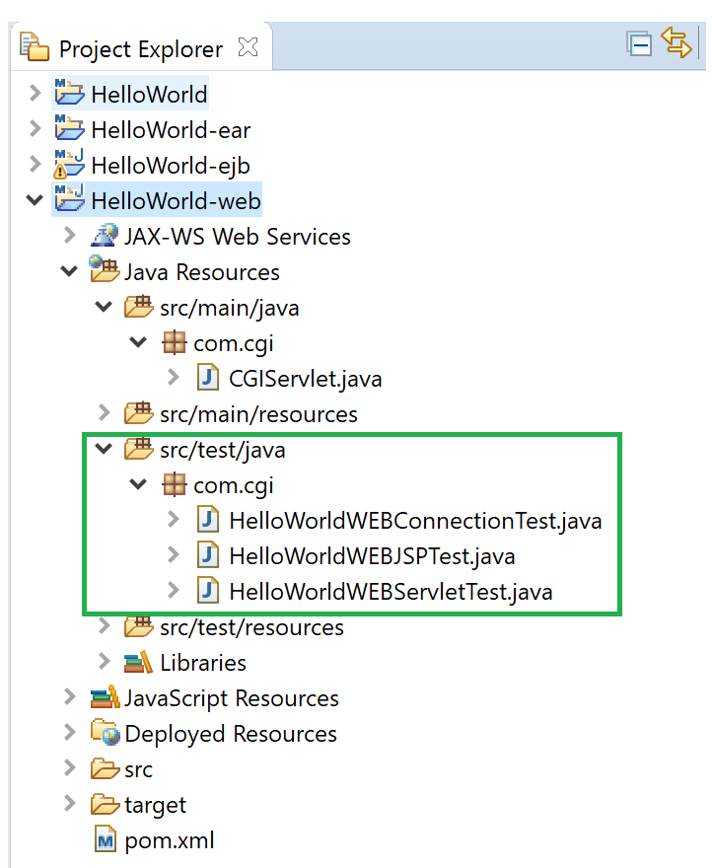

**HelloWorldWEBConnectionTest**, tests to see if there is a connection by checking the status code 200 is returned on connection. This test uses commons-httpclient dependency.

**HelloWorldWebJSPTest**, test the index.jsp page. This uses net.sourceforge.jwebunit dependency.

**HelloWorldWEBServletTest**, test to see if HelloServlet is correctly called. It uses commons-httpclient dependency.

For the HelloWorld-ejb project, we have the following unit test:

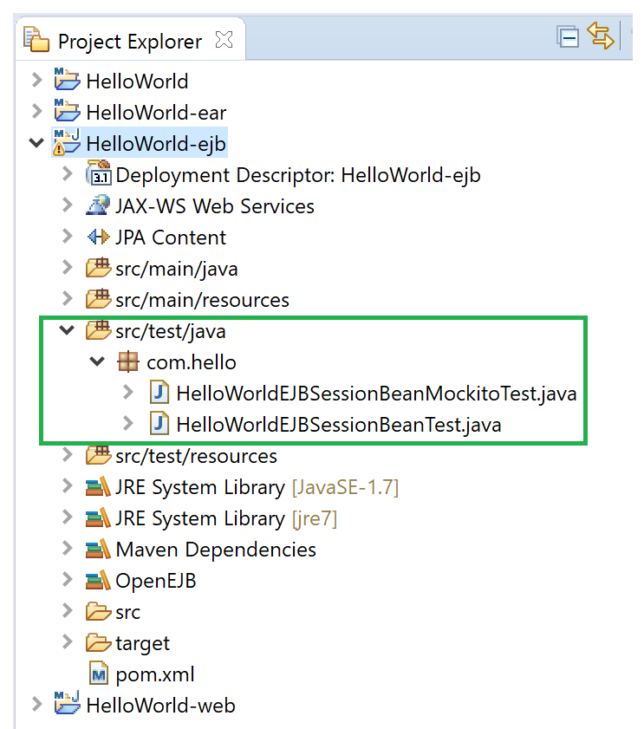

**HelloWorldEJBSessionBeanTest**, tests to see if the Session Bean is correctly executed. This uses OpenEJB container. This has been commented out as it works on Eclipse *(as shown in the first image below)* but when building on Maven, we get the error shown in the second and third images below:

Works on Eclipse:

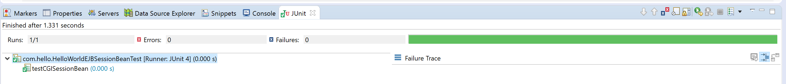

Maven Build Error:

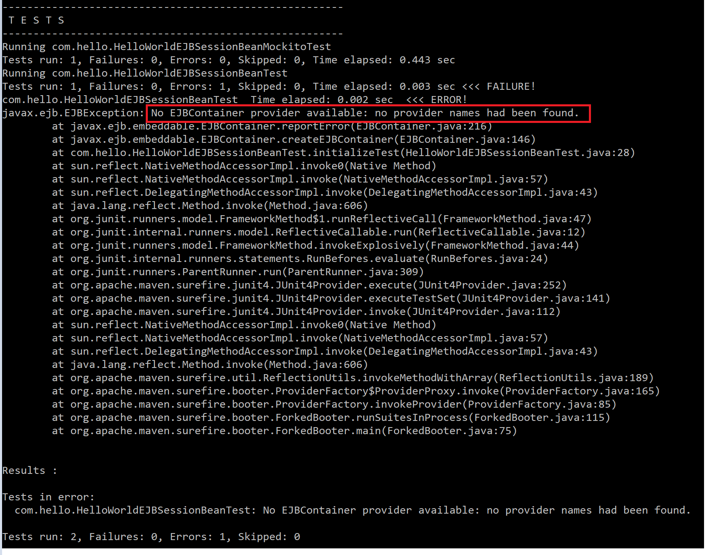

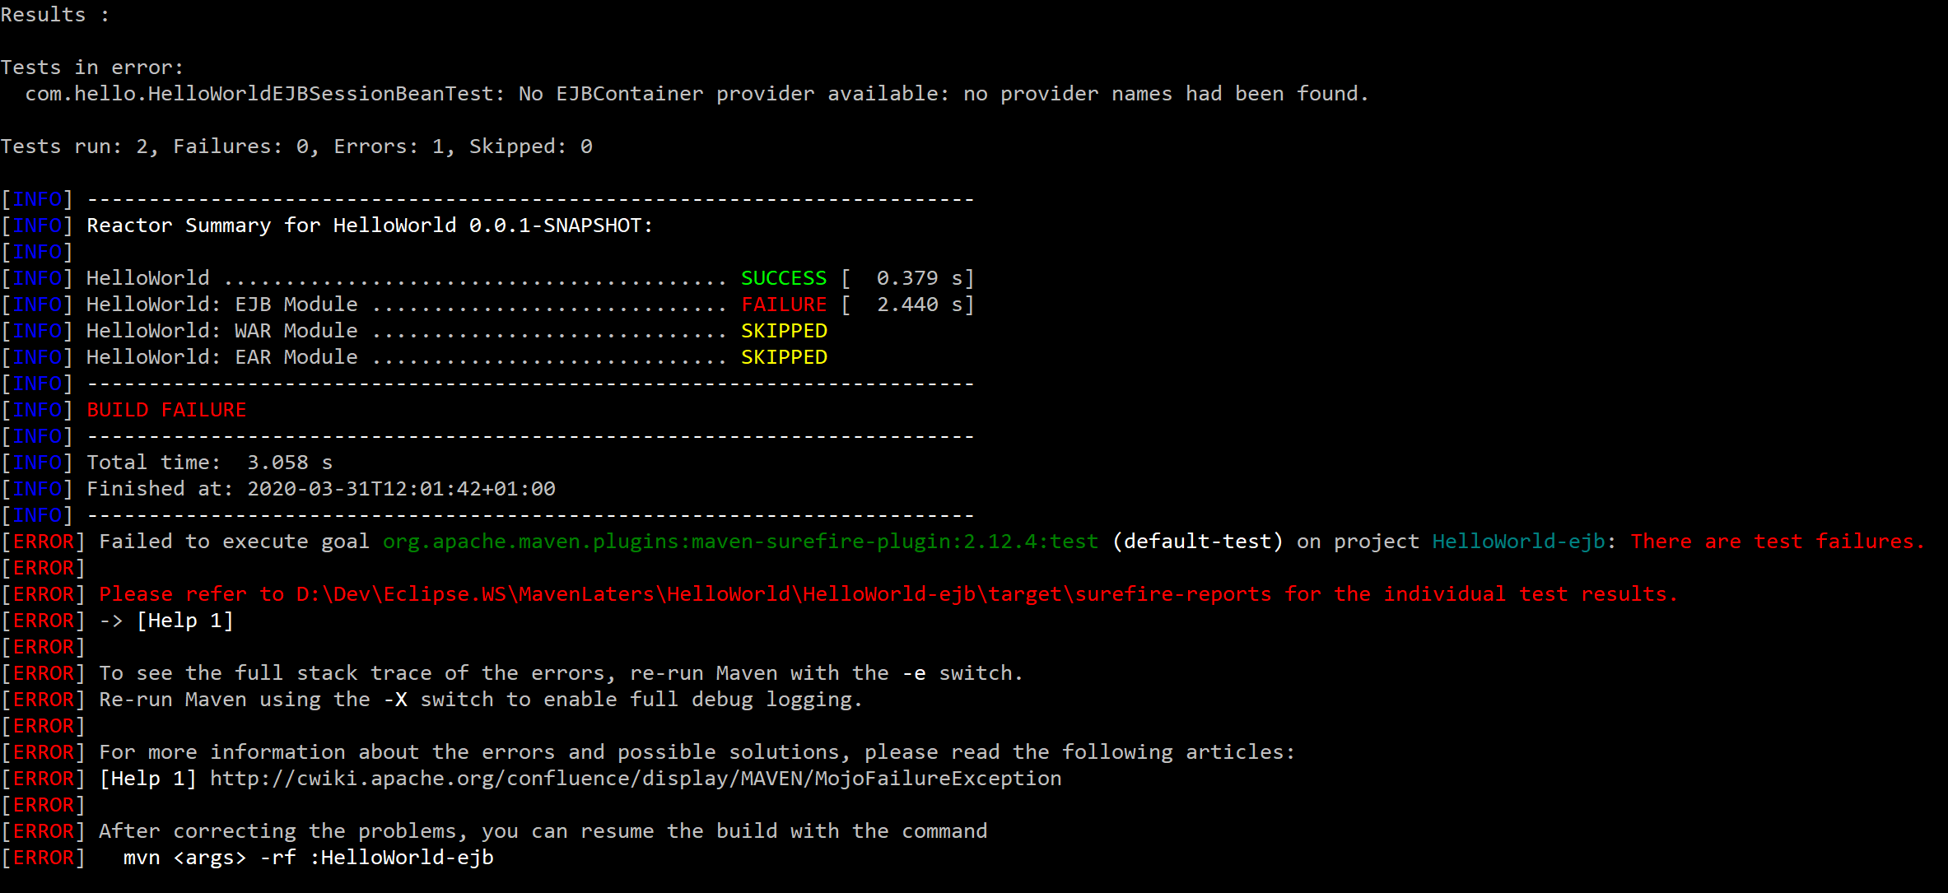

**HelloWorldEJBSessionBeanMockitoTest**, tests to see if the Session Bean is correctly executed using the Mockito framework.

1. WHEN YOU HAVE DEPLOYED THE EAR, THIS IS WHAT YOU SHOULD BE SEEING

Executing the Session Bean from a JSP

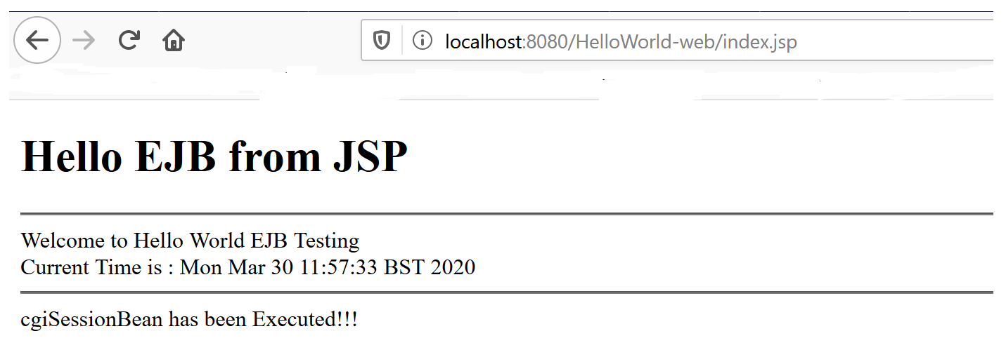

Executing the Session Bean from a Servlet

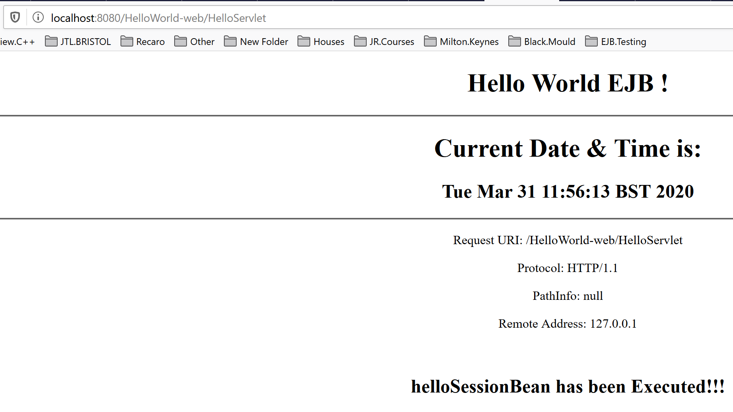

Where the Application Server is Running *(command window)*, you should see the following:

