Dear Williams-Sonoma:

Here is documentation on my solution to your Java Zipcode challenge. The problem to solve is: Given a collection of 5-digit ZIP code ranges (each range includes both their upper and lower bounds), provide an algorithm that produces the minimum number of ranges required to represent the same restrictions as the input.

I’ve written two Java classes in the package “challenge.” The first is ZipRestrictions.java. which is the main class. The other is Range.java, which holds a pair of zip codes, indicating a range from one to the other.

I chose a very large array of Boolean values, representing each possible zip code. I consider this a more elegant solution than other solutions I was considering. I “flatten” each range into the Boolean array, and then it’s easy to iterate once through it to build a StringBuilder to return. That way, I don’t have to worry about creating Comparators between objects.

I’ve included a lot of comments and documentation in the code. Here you can see the execution passing the test cases given:

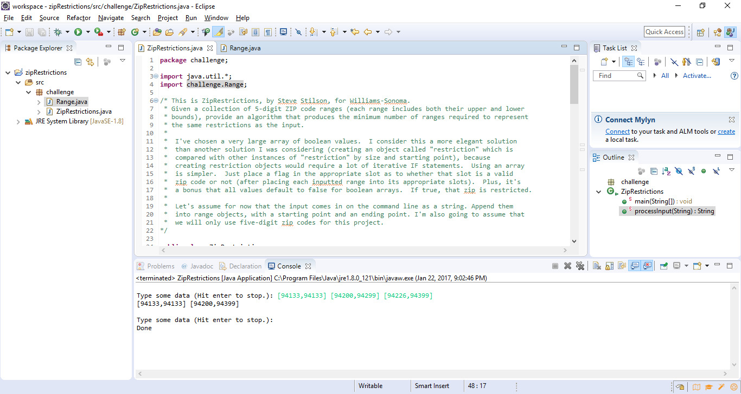

Here you can see how it handles error inputs, such as text, ranges that go from a higher number to a lower number, whitespace, ranges that are lower than the previous range, numbers above 999999, etc. If one range is invalid, it is still able to handle all the other ranges in that same input.

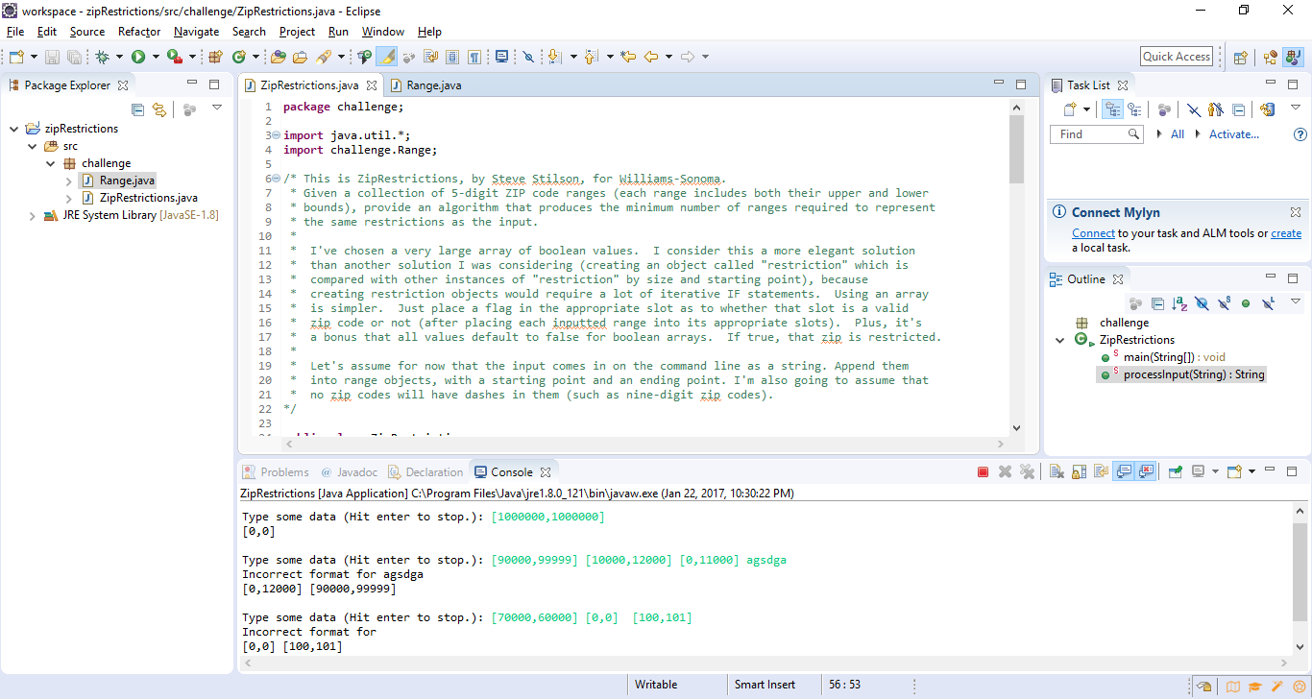

Thank you!

Steve Stilson
stilsons@gmail.com

