Dear Williams-Sonoma:

Here is my submission. It’s not the most elegant coding, but all the links work (including the picture at the top and the footer at the bottom).

When you choose a different color thumbnail at the bottom, the right color big picture shows up. And also, the word “pink” appears at the end of the title and the breadcrumbs, as you can see from this picture:

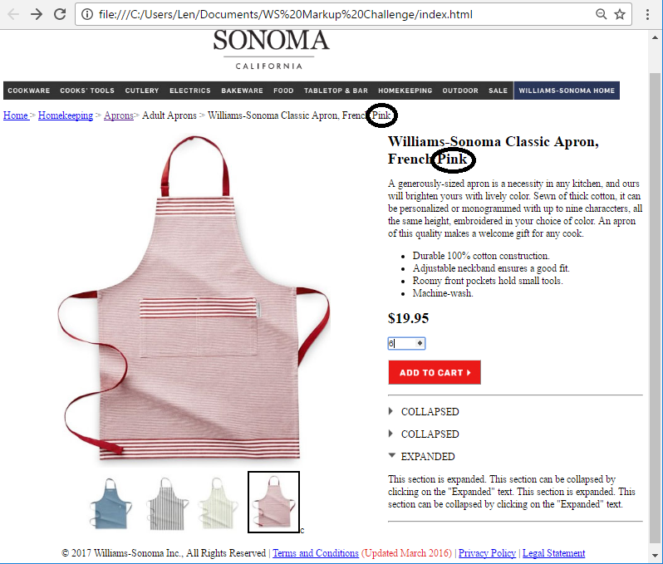

Then, when you click the “Add to cart” button, the page sends the quantity and color chosen to the next page (via a form and a hidden field), and it shows up there. Here, I chose a quantity of six and a pink apron on the first page, and both show up on the second. And the subtotal is calculated as quantity * $19.95:

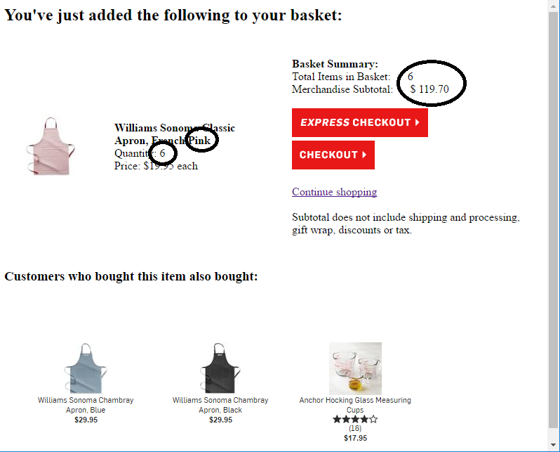

In addition, the collapsed and expanded sections in the lower right of the first page work.

Also, I have made submenus for each of the menu items across the top. Each of the submenus appears in front of the web page, just like on the actual Williams-Sonoma site. And all those links work too.

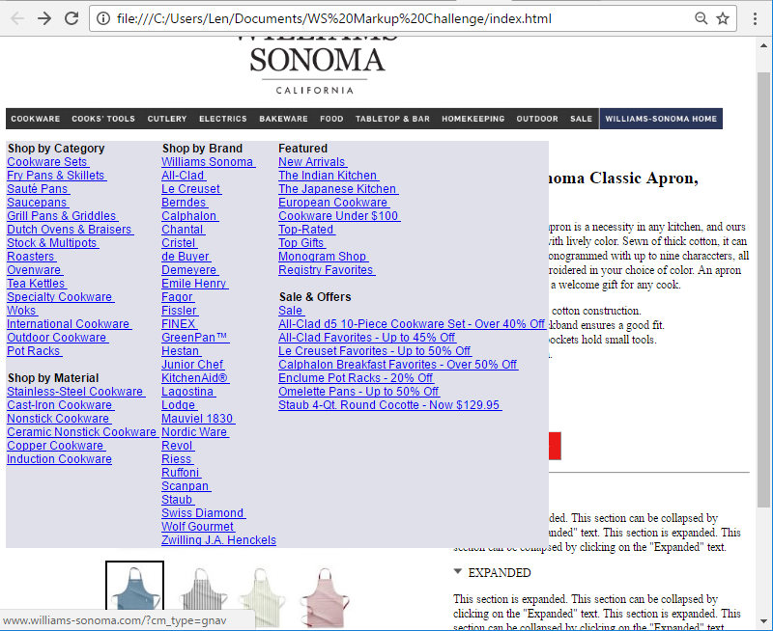

I was going to add the photo of the featured sale on the right side of the submenu (like on the real Williams-Sonoma site), but I ran out of time.

Thank you!

Steve Stilson
Software Engineer
510-610-7267

