PERSONAL INFORMATION | Stilyana Miroslavova Petrova
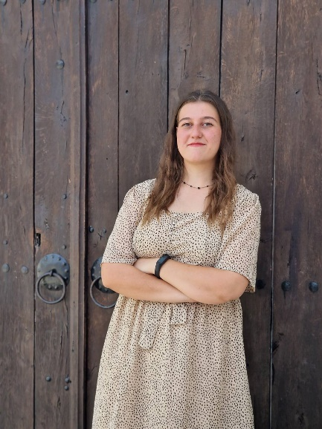 | Bulgaria, Pernik, 2300
 | 0899988546
 | stilyanapetrova1@gmail.com
github.com/stilyana-petrova
https://www.linkedin.com/in/stilyana-petrova/
 | Sex Female | Date of birth 06/03/2004 | Nationality Bulgaria

WORK EXPERIENCE

September 2023 – August 2025 | Teacher
 | High School of Natural Sciences and Mathematics “Hristo Smirnenski”, Pernik
- Teacher of Informatics and IT; Profile subjects for the Applied Programming and System Programming specialties.
- Development and adaptation of lesson topics with practical examples.
- Teaching specialized subjects contributed significantly to my development in the field of programming, particularly with the C# language, as well as in building database-driven applications. Through working with operating systems, I gained hands-on experience with command-line tools and scripting in environments such as Linux (CLI – Bash, Zsh) and Windows (PowerShell, Batch).

EDUCATION AND TRAINING

September 2023 – September 2027 | Plovdiv University “Paisii Hilendarski” - Bachelor’s Degree
 | Major: Software Engineering
 | - Replace with a list of principal subjects covered or skills acquired
February 2025 – October 2025 | Software University (SoftUni)
Courses:
Introduction to Cyber Security
Reconnaissance Fundamentals
System and Network Compromising
Compromising Platforms
September 2018 – July 2023 | Secondary education with professional qualification
 | High School of Natural Sciences and Mathematics “Hristo Smirnenski”, Pernik
 | - Specialty: Applied Programming
September 2011 – July 2018 | Primary education
 | 7th Primary School “Geogi Sava Rakovski”, Pernik

Technical Skills | C#, HTML/CSS, JavaScript, ASP.NET Core MVC/Web API, Java, MSSQL, MySQL, Batch, Bash, Linux, GitHub

PERSONAL SKILLS

Mother tongue | Bulgarian
English | UNDERSTANDING |  | SPEAKING | WRITING
 | Listening | Reading | B2 | C1
 | C2 | C1

Skills | - Communication and teamwork  - Responsibility  - Loyalty  - Honesty  - Reliability  - Adaptability  - Dedication  - Hard-working  - Presentation skills  - Fast-learner  - Creativity

ADDITIONAL INFORMATION

Projects  Platforms used for self-education | - https://github.com/stilyana-petrova  - Try Hack Me (https://tryhackme.com/p/Stilly)  - Hack The Box  - VulnHub  - PortSwigger  Cybersecurity is my passion, and I am highly motivated and excited to continue learning in this field.  I am familiar with some of the techniques and tools for pentesting.

ANNEXES

▪ Copy of completed primary education
▪ Copy of completed secondary education
- Certificate of completion for a Cybersecurity course

