PRODUCT BRIEF | VERSION 1.1.1

SqlWorkflowMonitor
Operational visibility for backend processes that should never fail silently.
Version
On-premises product | Windows x64 | Offline licensing

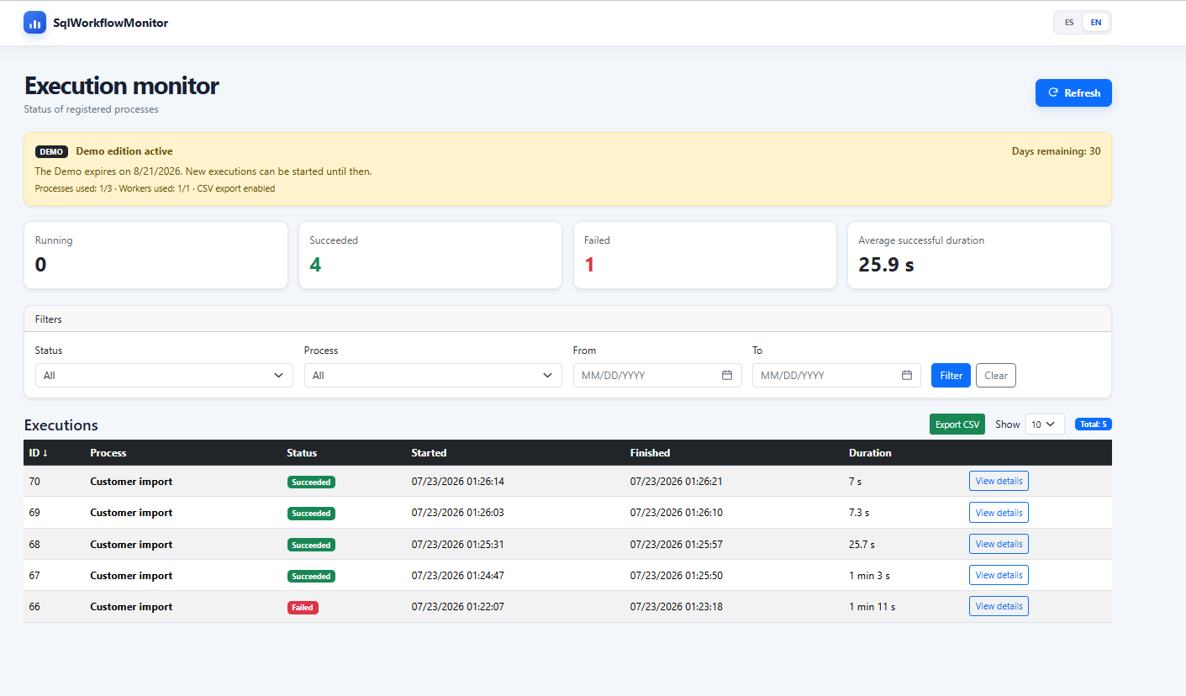
Dashboard operativo de SqlWorkflowMonitor.

.NET 10 | SQL Server | REST API | Windows Services | Offline licensing

Executive overview
SqlWorkflowMonitor is a .NET 10 and SQL Server application for recording, monitoring, and analyzing backend process executions. It centralizes information that is commonly scattered across logs, SQL queries, and manual checks: status, start, completion, duration, processed volume, and error details.
Value proposition
Enables support, development, and operations teams to detect overdue executions, diagnose incidents with evidence, and review operational history without relying on multiple sources.

The problem it solves
- Batch processes, imports, stored procedures, and Workers without a central view.
- Incidents that require reviewing several logs or querying SQL Server directly.
- Executions that remain Running and are discovered too late.
- Lack of evidence about duration, volume, and final outcome.
- Dependence on individual technical knowledge to understand what happened.

Who it is for
Audience | Primary need | Value delivered
L2/L3 support | Diagnose incidents | Status, duration, metrics, and errors in one view.
Backend teams | Instrument processes | Simple API and consistent execution model.
Operations | Monitor activity | Filterable history, overdue runs, and export.
Technical leads | Reduce blind spots | Centralized and traceable operational evidence.

PRODUCT

Current capabilities

- Bilingual dashboard in English and Spanish.
- Running, Succeeded, Failed, and Cancelled states.
- Filters, sorting, pagination, and protected CSV export.
- Details with duration, metrics, affected rows, and errors.
- Documented REST API, public health check, and API key for the Worker and integrations.
- Detection of overdue Running executions.
- Sample CSV Worker with file-age, size, row-count, and Processed/Error movement controls.
- Consistency rules in .NET and SQL Server.
- Self-contained Windows x64 publishing.
- Web and Worker installable as Windows services.
- Offline licensing signed with RSA-PSS/SHA-256.
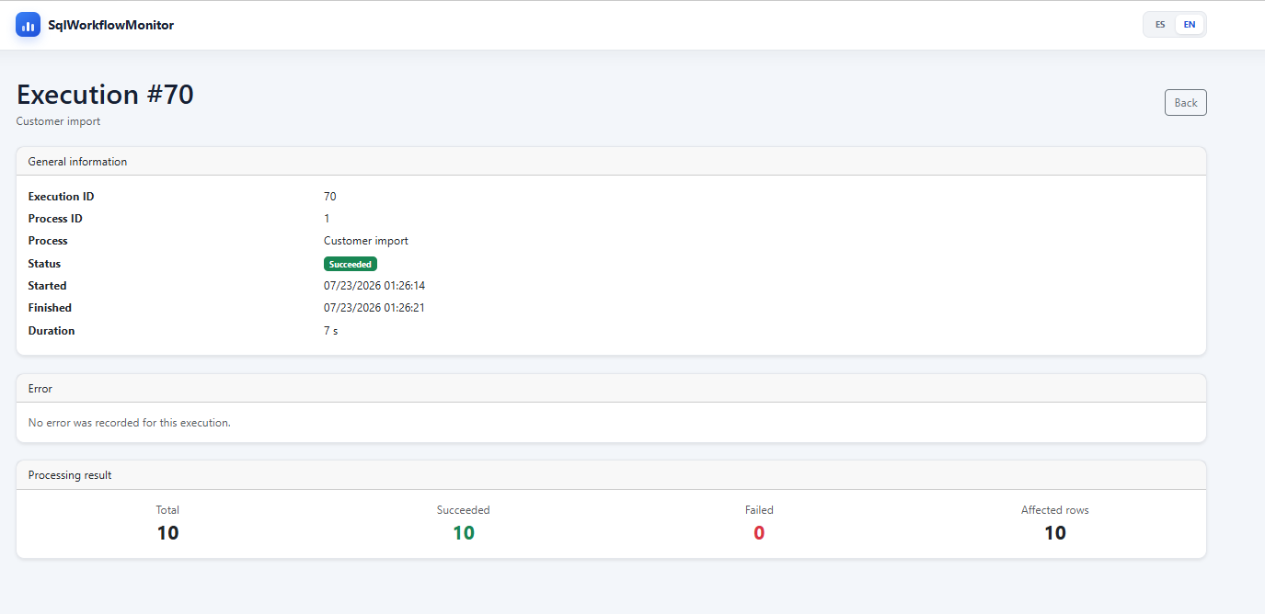
Operational execution details with processing metrics.

How it works
1. A Worker or integration tells the API that a process started.
2. SqlWorkflowMonitor records the execution as Running.
3. The process performs its work and gathers metrics.
4. The integration reports Succeeded, Failed, or Cancelled.
5. The dashboard displays history, indicators, overdue runs, and details.

Editions
All editions share the same code and binaries. The license file defines capacity, expiration, InstallationId, and enabled features.
Edition | Capacity | Behavior
Demo | 30 days, 3 processes, 1 Worker, 1 installation | Read-only mode after expiration.
Professional | 25 processes, 5 Workers, 1 production + 1 test | Annual license by installation and capacity.
Enterprise | Configurable capacity and installations | Agreed support, onboarding, and customization.

Commercial model
Limited Demo + annual license by installation and capacity + customized Enterprise. There is no per-user or per-execution charge.

IMPLEMENTATION

Distribution and operations

Characteristic | Detail
Deployment model | On-premises, Windows x64.
Runtime | .NET 10 self-contained; no installed SDK or runtime required.
Database | SQL Server; consolidated installation through Install.sql.
Services | Web and Worker with automatic startup and failure recovery.
License | Offline signed file; renewal without reinstallation.
Integrity | Package published as a Release asset with a SHA-256 checksum; the ZIP is not tracked in source control.
Languages | English and Spanish dashboard and documentation.

Current security profile
Version 1.1.1 validates security configuration at startup, protects the dashboard with a local administrator account and the API with an API key, and applies rate limiting, CSP, and safe errors. The health endpoint remains public. Kestrel binds to loopback by default; remote access requires a trusted TLS reverse proxy and network controls.

Use cases
Use case | Example
Imports | Daily customer, order, or transaction loads from files.
Batch processes | Closings, reconciliations, calculations, and reports.
Stored procedures | Long-running procedures with operational outcomes.
Integrations | Synchronizations between APIs, internal systems, or vendors.
Scheduled Workers | Services that process queues, files, or recurring tasks.

What makes it different
SqlWorkflowMonitor is not intended to replace a general-purpose observability platform. Its focus is to turn the lifecycle of a business or data process into a clear operational record that can be adopted incrementally.
- Explicit start, finish, status, and metrics model.
- Interface useful to both support and development teams.
- Direct fit with .NET and SQL Server.
- Gradual adoption: begin with one real process.
PRODUCT SUMMARY

Product description

Short description
Text
SqlWorkflowMonitor centralizes the status, duration, metrics, and errors of backend processes, batch jobs, and integrations. It helps teams detect overdue executions and diagnose incidents with evidence.

Medium description
SqlWorkflowMonitor is an on-premises .NET 10 and SQL Server application for monitoring batch processes, Workers, stored procedures, and integrations. It records execution start and completion, duration, outcome, metrics, and errors. It is distributed self-contained for Windows x64, runs as Windows services, and uses signed offline licensing.

Availability status
Version 1.1.1 consolidates the technical and commercial baseline: it aligns the installable package, SQL scripts 001–011, secure configuration, offline licensing, CI, legal material, and bilingual manuals. Version 1.1.1 is technically closed and validated for distribution under the applicable license terms.
Federico Stimpfl | www.federicostimpfl.com.ar | SqlWorkflowMonitor 1.1.1

