INSTALLATION AND OPERATIONS GUIDE

SqlWorkflowMonitor
How to install, license, configure, and operate version 1.1.1
Version
Documentation 1.1.1 | Windows x64 | August 2026

Important security notice
Important security notice: the dashboard is protected by a local administrator account, and protected API endpoints require an API key for the Worker and external integrations. Do not expose the application directly to the Internet. Keep access on localhost or a controlled private network, restrict the firewall, protect credentials, and apply infrastructure access controls.

.NET 10 | SQL Server | REST API | Windows Services | Offline licensing

1. Scope and architecture
SqlWorkflowMonitor records and displays the lifecycle of backend processes: start, completion, status, duration, metrics, and errors. The 1.1.1 distribution includes a Web application, a sample Worker, a SQL Server database, offline licensing, and scripts that install both executables as Windows services.
- Bilingual dashboard for execution history, indicators, overdue runs, and details.
- REST API to start, finish, and query executions.
- Sample Worker that processes customer CSV files.
- SQL Server storage with consistency enforcement.
- Offline Demo, Professional, and Enterprise licensing.

2. Basic concepts
Concept | Meaning
Process | A monitored type of work, such as an import or batch close.
Execution | One individual run of a process.
Worker | A service or integration that starts and finishes executions through the API.
Running | The execution started and has not been completed.
Succeeded | The execution completed successfully.
Failed | The execution ended with an error and must include a message.
Cancelled | The execution was cancelled before completion.
Overdue | A Running execution that exceeded the configured threshold.
InstallationId | A stable identifier used to bind a commercial license to an installation.

3. Requirements
- Windows x64 with Windows service support.
- SQL Server LocalDB, Developer, Standard, Enterprise, or another compatible edition.
- SSMS or another SQL client to run Database\Install.sql.
- Local administrator rights to register services.
- A service identity with access to the SqlWorkflowMonitor database.
- Visual Studio, the .NET SDK, and the .NET runtime are not required: Web and Worker are self-contained.

PART I

Preparation and installation

4. Package structure
SqlWorkflowMonitor-1.1.1-<Edition>-win-x64
├── Web
├── Worker
├── Database
│ └── Install.sql
├── Configuration
│ ├── web-appsettings.example.json
│ └── worker-appsettings.example.json
├── License
│ └── README.txt
├── Scripts
│ ├── Install-Services.ps1
│ └── Uninstall-Services.ps1
├── Legal
│ ├── EULA-ES.txt
│ ├── EULA-EN.txt
│ └── THIRD-PARTY-NOTICES.txt
├── Documentation
├── RELEASE-NOTES.md
└── VERSION.txt

Important
Do not deliver development folders such as .git, .vs, bin, obj, private keys, LicenseGenerator, or appsettings.Development.json files to a customer.

5. Verify the checksum
Before extracting the ZIP, verify that its SHA-256 matches the accompanying .sha256.txt file.
$zip = ".\SqlWorkflowMonitor-1.1.1-Demo-win-x64.zip"
$actual = (Get-FileHash $zip -Algorithm SHA256).Hash.ToLowerInvariant()
$expected = ((Get-Content "$zip.sha256.txt" -Raw).Trim() -split "\s+")[0]
$actual -eq $expected

Expected result: True.

6. Extract and locate the product
1. Extract the ZIP to a stable location, for example C:\SqlWorkflowMonitor\App.
2. Do not run services from a temporary folder or the Downloads directory.
3. Keep a copy of the ZIP and checksum for recovery.
4. Create a backup before replacing an existing installation.

7. Create the database
1. Open SSMS with an authorized account.
2. Open Database\Install.sql.
3. Review the target server and execute the entire script.
4. Confirm that SqlWorkflowMonitor was created with tables, indexes, constraints, seed data, and stored procedures.
USE SqlWorkflowMonitor;
GO
SELECT name FROM sys.tables ORDER BY name;
SELECT name FROM sys.procedures ORDER BY name;

Development installations
The development solution uses SqlWorkflowMonitor_Dev. The commercial package normalizes the installer and example configurations to use SqlWorkflowMonitor.

PART II

Configuration and licensing

8. Configure the Web application
Edit Web\appsettings.json. Configuration\web-appsettings.example.json can be used as a starting point.
"ConnectionStrings": {
"WorkflowMonitor": "Server=YOUR_SQL_SERVER;Database=SqlWorkflowMonitor;Integrated Security=True;Encrypt=True;TrustServerCertificate=False;"
},
"Licensing": {
"LicenseFilePath": "License/sqlworkflowmonitor.lic",
"PublicKeyFilePath": "Licensing/Keys/sqlworkflowmonitor-public.pem"
},
"Kestrel": {
"Endpoints": { "Http": { "Url": "http://127.0.0.1:5080" } }
}

- Server: replace YOUR_SQL_SERVER with the actual SQL Server instance.
- Integrated Security: the Web service identity must be authorized in SQL Server.
- Port 5080: the default configuration uses http://127.0.0.1:5080 and does not listen on remote interfaces. For remote access, keep Kestrel on loopback and publish through a TLS reverse proxy with network controls.
- Security: configure Security:Admin:Username, Security:Admin:PasswordHash, and Security:Admin:PasswordSalt for the dashboard. Configure Security:ApiKey and use the same key in Worker WorkflowMonitorApi:ApiKey. Enable Security:RequireHttps only when Kestrel has a valid HTTPS endpoint or the proxy correctly forwards the original scheme. The application refuses to start with empty or malformed credentials. Protect appsettings.json and do not commit secrets.

9. Configure the Worker
Edit Worker\appsettings.json. Configuration\worker-appsettings.example.json can be used as a starting point.
"WorkflowMonitorApi": { "BaseUrl": "http://localhost:5080" },
"Worker": { "Id": "CustomerCsvWorker" },
"CsvImport": {
"ProcessId": 1,
"FileName": "customers.csv",
"InputFolder": "C:\\SqlWorkflowMonitor\\Data\\Input",
"ProcessedFolder": "C:\\SqlWorkflowMonitor\\Data\\Processed",
"ErrorFolder": "C:\\SqlWorkflowMonitor\\Data\\Error",
"IntervalSeconds": 60
}

- Keep Worker:Id stable. Capacity is calculated by distinct WorkerId values.
- ProcessId must exist and be active in dbo.Processes.
- The Worker must point to the actual Web service URL and send the same API key. HTTP is accepted only for loopback addresses; use HTTPS for a remote host. Also configure the timeout, maximum CSV size, maximum rows, and minimum file age.
- Input, Processed, and Error folders are created by the installation script.

10. Editions and license file
Edition | Initial capacity | License
Demo | 30 days, 3 processes, 1 Worker, 1 installation | No commercial file required; then read-only mode.
Professional | Up to 25 processes, 5 Workers, 1 production + 1 test | Annual signed file bound to the installation.
Enterprise | Configurable processes, Workers, and installations | Signed file based on the commercial agreement.

Commercial licenses are located at Web\License\sqlworkflowmonitor.lic. To renew, replace that file and restart the Web service; the product does not need to be reinstalled.
- Signatures use RSA-PSS and SHA-256.
- The distributed application contains only the public key.
- A modified license, incorrect InstallationId, or invalid signature is rejected.
- The product displays expiration warnings.
- A 14-day grace period follows expiration; read-only mode begins afterward.
InstallationId
The installation generates an InstallationId. Send that code to the license issuer to obtain a Professional or Enterprise license. Do not send databases, passwords, or private keys.

PART III

Windows services and startup

11. Install the services
1. Configure Web\appsettings.json and Worker\appsettings.json.
2. Execute Database\Install.sql.
3. Open PowerShell as Administrator in the package root.
4. Run Scripts\Install-Services.ps1.
5. Confirm that SqlWorkflowMonitor Web and SqlWorkflowMonitor Worker are Running and configured for automatic startup.
powershell -ExecutionPolicy Bypass -File ".\Scripts\Install-Services.ps1"
Get-Service "SqlWorkflowMonitor Web", "SqlWorkflowMonitor Worker"

The Worker depends on the Web service. Both are configured to restart automatically after a failure.
Service account
The script creates services using the default Windows identity. Verify that this identity can connect to SQL Server and access configured folders. In corporate environments, use a managed service account that complies with customer policy.

12. Verify startup
Resource | Default address
Dashboard | http://localhost:5080/executions
Swagger | http://localhost:5080/swagger (only when enabled)
Health check | http://localhost:5080/api/health

The health endpoint should return HTTP 200, Healthy status, and Connected database. HTTP 503 indicates a SQL Server connectivity problem.

13. Uninstall services
The uninstall script stops and removes the services, but it does not delete the database or data folders.
powershell -ExecutionPolicy Bypass -File ".\Scripts\Uninstall-Services.ps1"

- Back up the database before updating or uninstalling.
- Keep Web\License\sqlworkflowmonitor.lic and appsettings files when appropriate.
- Data deletion must be an explicit administrator decision.

PART IV

Daily operation

14. Dashboard and indicators
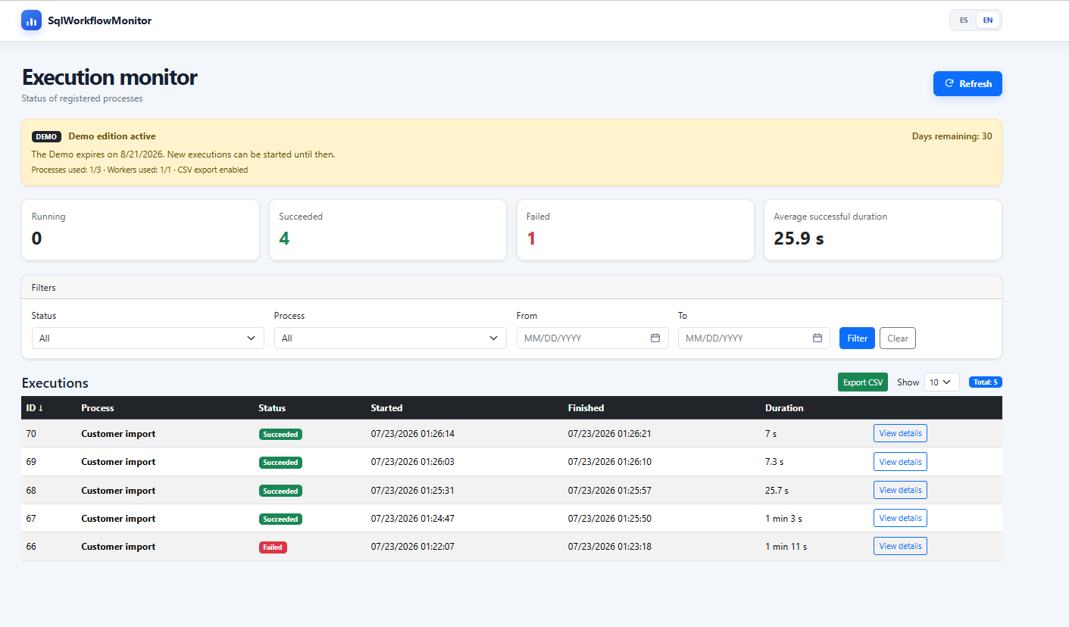
Main view with edition status, indicators, filters, and executions.
Indicator | Interpretation
Running | Executions that remain open.
Succeeded | Executions completed successfully.
Failed | Executions completed with an error.
Average successful duration | Average duration of successful executions in the current filter.
Processes / Workers used | Distinct capacity consumed by the active edition.

15. Filter, sort, paginate, and export
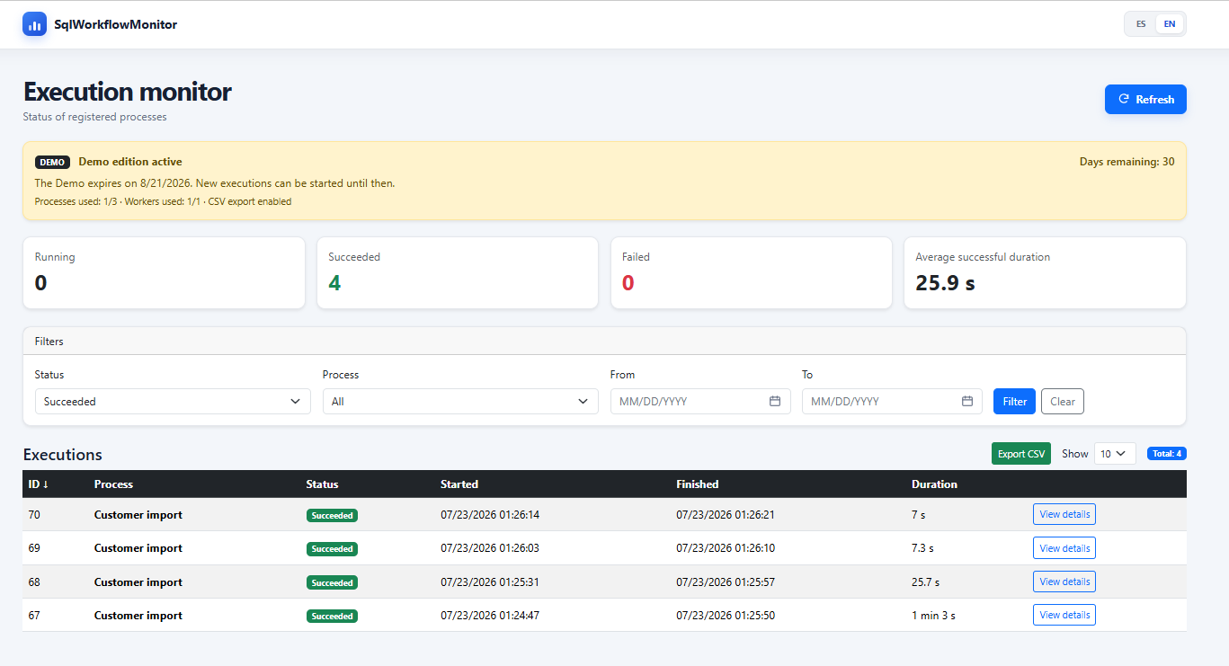
Example of execution history filtered by successful status.
- Filter by status, process, and date range.
- Sort by enabled columns and navigate with pagination.
- GET /api/executions returns 100 records by default and accepts a maximum of 500 per request.
- CSV export preserves filters and sorting, applies formula-injection protection, and respects the active license.
- The ES/EN selector changes text and visible date formatting.

16. View execution details
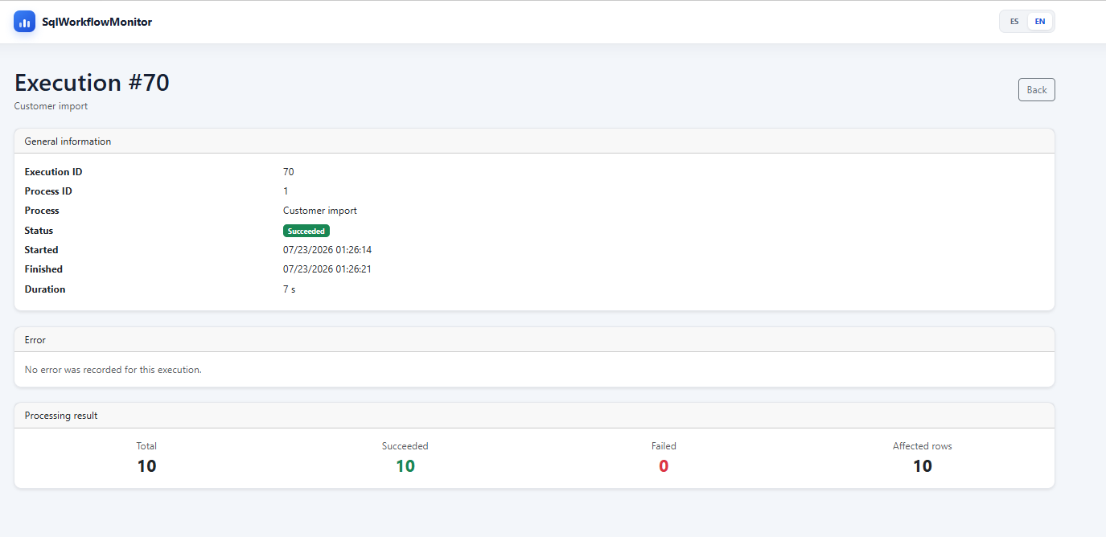
Successful execution details with processing metrics.
Field | Meaning
Total | Total number of items evaluated.
Succeeded | Items processed successfully.
Failed | Invalid items or items not processed successfully.
Affected rows | Rows modified or inserted by the process.
Error | Message reported when the execution finishes with Failed status.

PART V

CSV Worker and API integration

17. Prepare and process customers.csv
Name,Email
Ana Perez,ana@example.com
Luis Gomez,luis@example.com

- The header must be Name,Email.
- Name and Email are required; the file must contain at least one record.
- The sample implementation splits on commas and is not a full parser for complex values with embedded commas.
- After execution completion is confirmed, a valid file moves to Processed; an error moves it to Error.
- When licensing prevents a start, the file remains in Input and SqlWorkflowMonitor does not stop the customer process.

18. Available endpoints
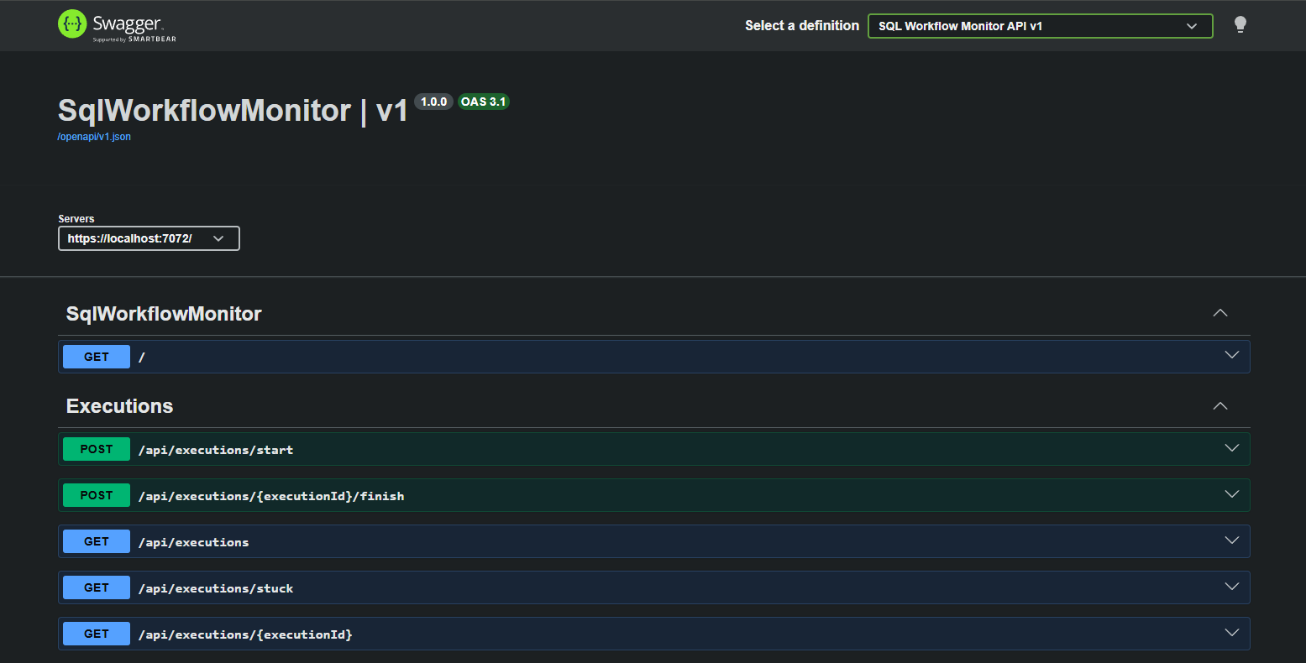
SqlWorkflowMonitor endpoints in Swagger in a controlled environment.
Method | Route | Purpose
GET | /api/health | Check API and database availability.
GET | /api/executions?limit=100 | List executions; maximum 500.
GET | /api/executions/{id} | Retrieve one execution.
GET | /api/executions/stuck?olderThanMinutes=30 | Detect overdue executions.
POST | /api/executions/start | Start an execution.
POST | /api/executions/{id}/finish | Complete an execution.

19. Start and finish executions
Protected API requests must include the configured API key.
POST /api/executions/start
{ "processId": 1, "workerId": "CustomerCsvWorker" }

A Failed execution must include errorMessage. Metrics cannot be negative, and SucceededItems + FailedItems cannot exceed TotalItems.

PART VI

Secure operation, incidents, and closure

20. Minimum deployment security
Do not expose directly to the Internet
SqlWorkflowMonitor 1.1.1 validates credentials at startup, protects the dashboard with an administrator account and the API with a key of at least 32 characters, and applies rate limiting, CSP, no-store, and safe errors. Health remains public. Kestrel listens on 127.0.0.1:5080; for remote access use a TLS reverse proxy, firewall/VPN/segmentation, and explicit AllowedHosts. Swagger is enabled only in Development.

- Use least-privilege service accounts and, where possible, separate installation/migration permissions from normal runtime permissions.
- Protect appsettings.json and the license file.
- Do not write passwords, tokens, or sensitive personal data in ErrorMessage.
- Use appropriate SQL Server backup, encryption, and access policies. The production template uses Encrypt=True and TrustServerCertificate=False; install a trusted SQL Server certificate or document any controlled exception.
- Review logs and service status after every update.

21. Common problems
Problem | Recommended check
Dashboard does not open | SqlWorkflowMonitor Web status, port 5080, and firewall.
Health returns 503 | SQL Server, database name, and ConnectionStrings:WorkflowMonitor.
Worker does not process | Worker service, customers.csv, folders, BaseUrl, and polling interval.
Start returns 403 | License status, expiration, processes, and WorkerId.
Invalid license | InstallationId, signature, dates, location, and sqlworkflowmonitor.lic filename.
Execution remains Running | Logs and finish endpoint response; close using the actual status.

22. Backup, update, and recovery
1. Stop the Worker to prevent new file processing during the update.
2. Back up the SqlWorkflowMonitor database.
3. Back up appsettings.json and the license.
4. Apply the version-specific upgrade script when one is provided.
5. Replace binaries and restart services.
6. Validate health, dashboard, API, license, and CSV processing.

23. Final checklist
- ☐ The ZIP checksum matches.
- ☐ Database\Install.sql finishes without errors.
- ☐ Web and Worker use the same database and URL.
- ☐ Services are Running and configured for automatic startup.
- ☐ Health returns Healthy / Connected.
- ☐ The displayed edition and capacity are correct.
- ☐ A valid CSV ends in Processed with metrics.
- ☐ A modified or incorrect license is rejected.
- ☐ Filters, details, API, and export work.
- ☐ Firewall and network access are restricted.
Legal documentation
Product use is subject to the applicable EULA. THIRD-PARTY-NOTICES.txt contains third-party notices. Legal, privacy, support, and commercial terms should be reviewed professionally before actual sales.

SqlWorkflowMonitor 1.1.1 | Federico Stimpfl | www.federicostimpfl.com.ar

