1. Booking System – Design (1)XML design: ERD

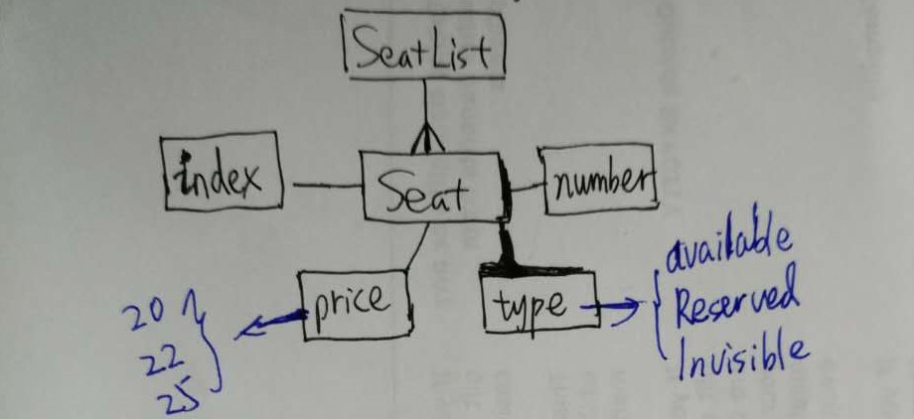

1. Booking System – Design (2)Cinema Prototype

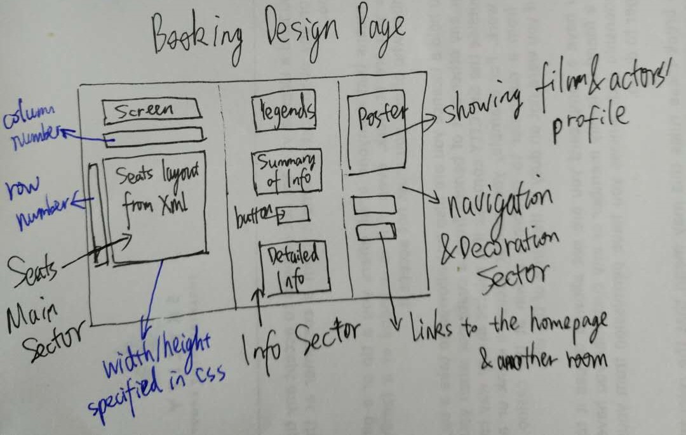

1. Game – Design –(1)Storyboard

Step1

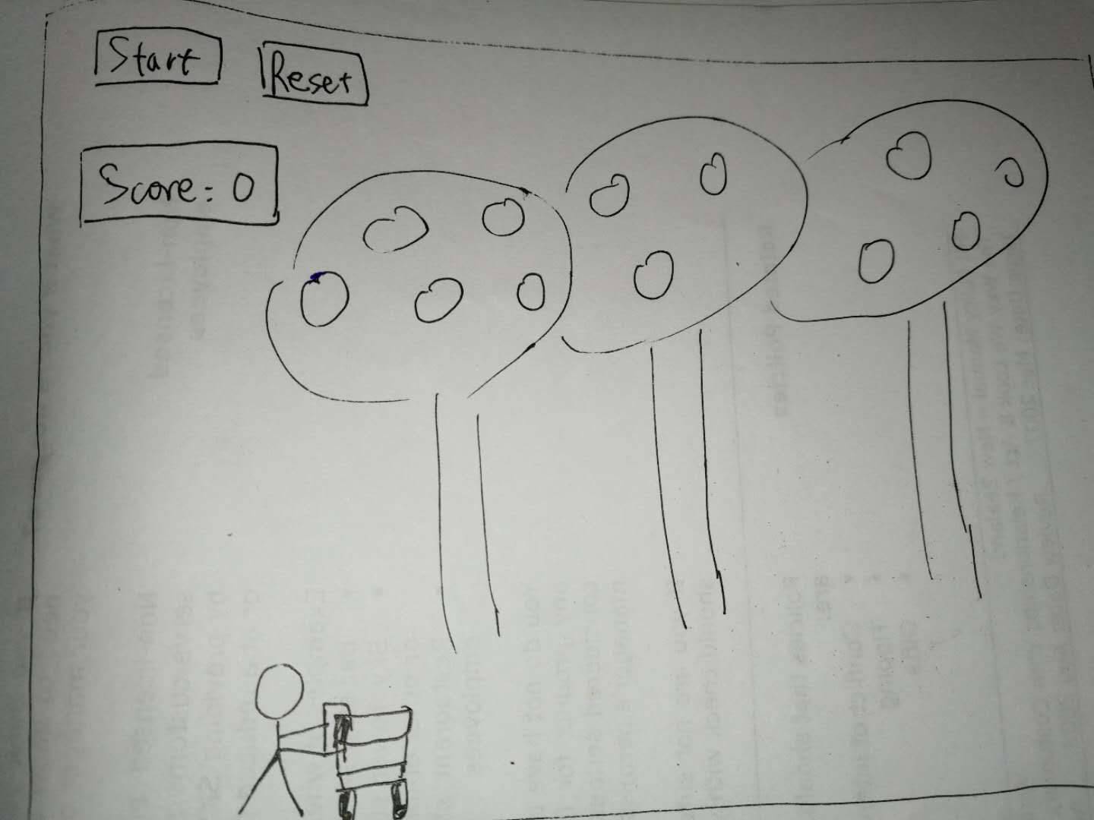

Step2

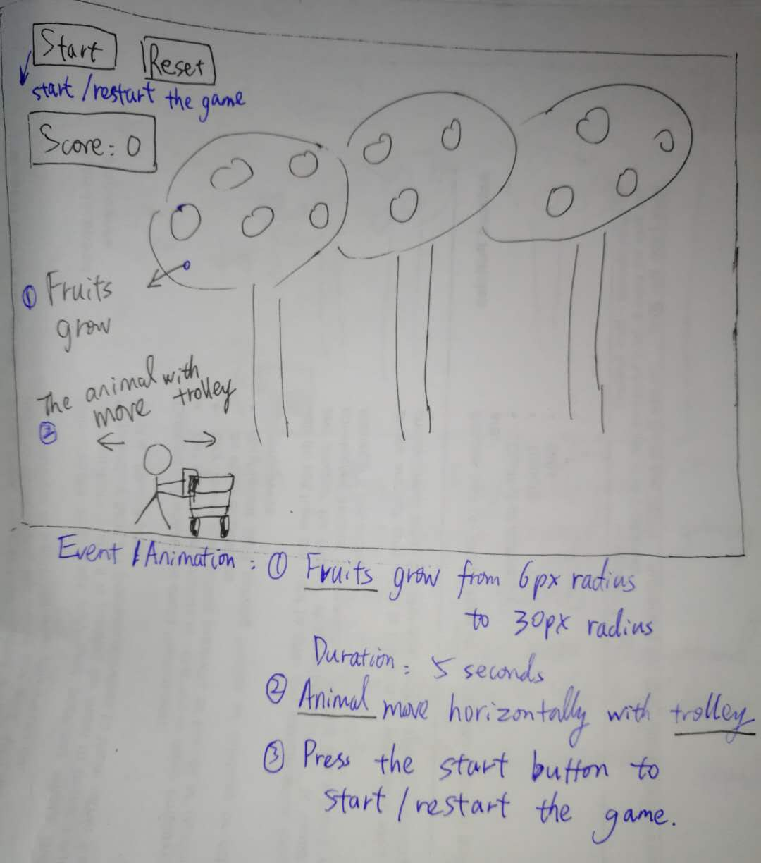

Step3:

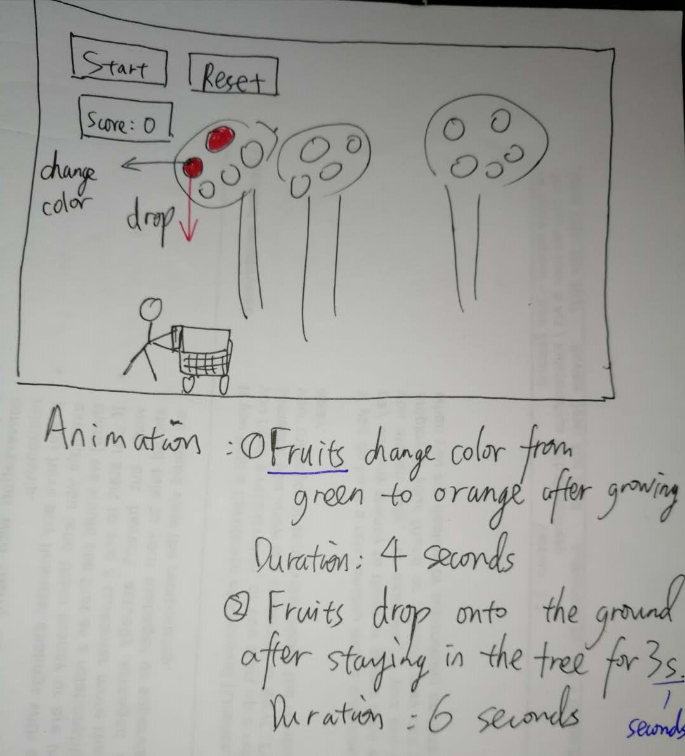

Step4

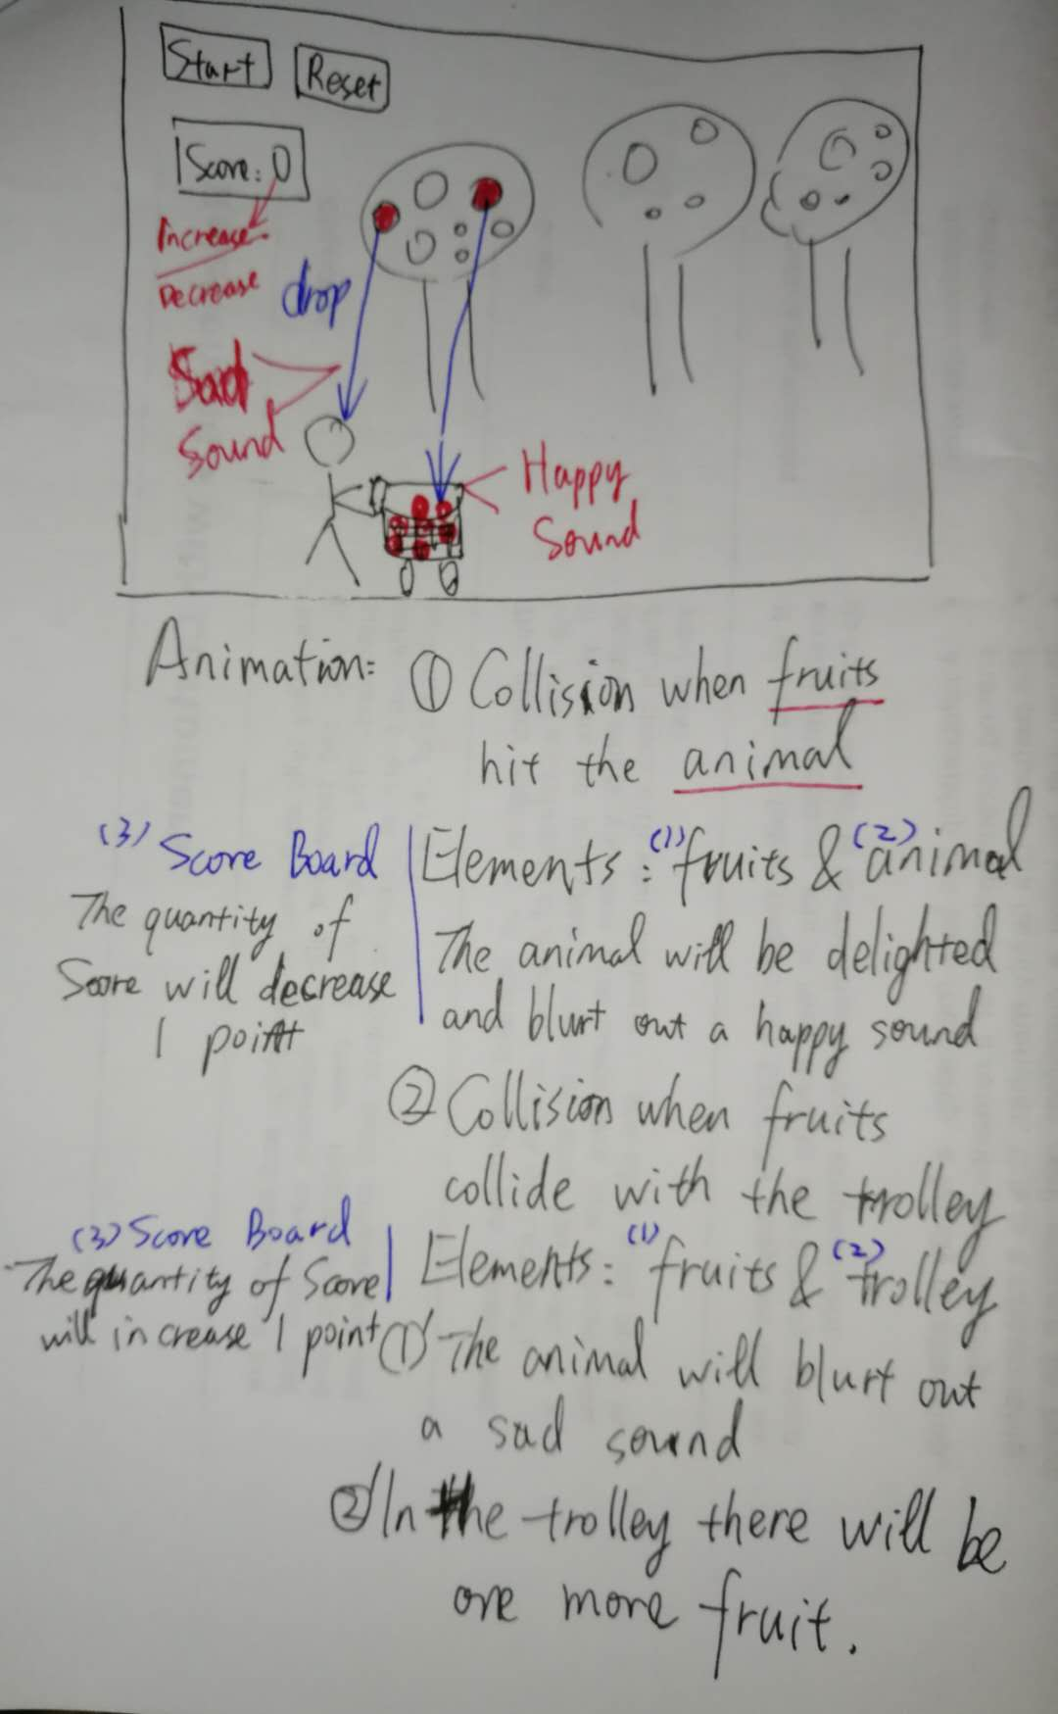

Step5:

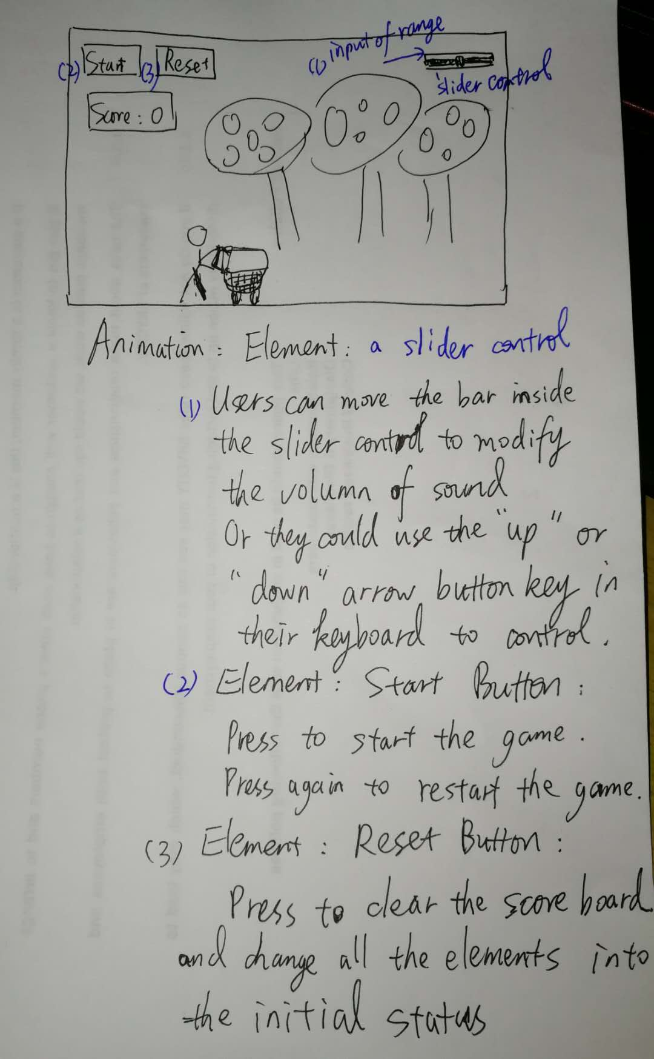

4. Booking System –Test Plan-- (1) Florence

|  |  |  |  |
| --- | --- | --- | --- |
| 1.1.Choose available seats of different rows | Click seat A2, C2, F5 | In the detailed information region there are 3 lines displayed  F5 $25  C2 $22  A2 $20  In the summary information region  Quantity changes from 0 to 3  Total Booking Fees changes from 0 to $67. | In the detailed information region there are 3 lines displayed  F5 $25  C2 $22  A2 $20  In the summary information region  Quantity changes from 0 to 3  Total Booking Fees changes from 0 to $67. |
| 2.1.Make a booking for available seats | Click seat A2, C2, F5  Click the Confirm button.  Click “OK” in the pop-up window  Click “OK” in the second pop-up window | In the detailed information region there are 3 lines displayed  F5 $25  C2 $22  A2 $20  In the summary information region  Quantity changes from 0 to 3  Total Booking Fees changes from 0 to $67.  “Are you sure you want to make this booking and pay for it?” Displayed  “Payment received. You have booked tickets successfully. Thank you.” Displayed  seat A2, C2, F5 change color from pink to grey  The detailed and summary information regions change back to the initial status. | In the detailed information region there are 3 lines displayed  F5 $25  C2 $22  A2 $20  In the summary information region  Quantity changes from 0 to 3  Total Booking Fees changes from 0 to $67.  “Are you sure you want to make this booking and pay for it?” Displayed  “Payment received. You have booked tickets successfully. Thank you.” Displayed  seat A2, C2, F5 change color from pink to grey  The detailed and summary information regions change back to the initial status. |
| 2.2.Attempt to choose one of the previously reserved seat after booking | Click on seat A2 | “This seat has been reserved! Please choose another one” Displayed | “This seat has been reserved! Please choose another one” Displayed |
| 2.3.Make another booking for available seats after the previous booking | Click seat A6, C3, F2  Click the Confirm button.  Click “OK” in the pop-up window  Click “OK” in the second pop-up window | In the detailed information region there are 3 lines displayed  F2 $25  C3 $22  A6 $20  In the summary information region  Quantity changes from 0 to 3  Total Booking Fees changes from 0 to $67.  “Are you sure you want to make this booking and pay for it?” Displayed  “Payment received. You have booked tickets successfully. Thank you.” Displayed  seat A6, C3, F2 change color from pink to grey  The detailed and summary information regions change back to the initial status. | In the detailed information region there are 3 lines displayed  F2 $25  C3 $22  A6 $20  In the summary information region  Quantity changes from 0 to 3  Total Booking Fees changes from 0 to $67.  “Are you sure you want to make this booking and pay for it?” Displayed  “Payment received. You have booked tickets successfully. Thank you.” Displayed  seat A6, C3, F2 change color from pink to grey  The detailed and summary information regions change back to the initial status. |
| 3.1. Attempt to choose one reserved seat. | Click on seat B6 | “This seat has been reserved! Please choose another one” Displayed | “This seat has been reserved! Please choose another one” Displayed |
| 3.2. Attempt to make a booking without choosing any seat. | Click the Confirm button. | “You haven't chosen any seat yet.” Displayed | “You haven't chosen any seat yet.” Displayed |
| 4.1 Go to another room. | Click the link “Go to view the room Ronald” in the right bottom region. | The webpage change into the room of film Ronald. | The webpage change into the room of film Ronald. |
| 4.2 Go back to the homepage. | Click the link “Back to the Homepage” in the right bottom region. | The webpage change into the homepage. | The webpage change into the homepage. |
| 5.1.Change the layout of the room | In the 30th line of xml file, delete “available”  In the same position, enter “Reserved” | Seat A5 change color into grey. | Seat A5 change color into grey. |
| 5.2 Attempt to book the seat whose data has changed | Click on seat A5 | “This seat has been reserved! Please choose another one” Displayed | “This seat has been reserved! Please choose another one” Displayed |

6. Booking System –Test Plan-- (2) Ronald

|  |  |  |  |
| --- | --- | --- | --- |
| 1.1.Choose available seats of different rows | Click seat A2, C2, F9 | In the detailed information region there are 3 lines displayed  F9 $25  C2 $22  A2 $20  In the summary information region  Quantity changes from 0 to 3  Total Booking Fees changes from 0 to $67. | In the detailed information region there are 3 lines displayed  F9 $25  C2 $22  A2 $20  In the summary information region  Quantity changes from 0 to 3  Total Booking Fees changes from 0 to $67. |
| 2.1.Make a booking for available seats | Click seat A2, C2, F9  Click the Confirm button.  Click “OK” in the pop-up window  Click “OK” in the second pop-up window | In the detailed information region there are 3 lines displayed  F9 $25  C2 $22  A2 $20  In the summary information region  Quantity changes from 0 to 3  Total Booking Fees changes from 0 to $67.  “Are you sure you want to make this booking and pay for it?” Displayed  “Payment received. You have booked tickets successfully. Thank you.” Displayed  seat A2, C2, F9 change color from pink to grey  The detailed and summary information regions change back to the initial status. | In the detailed information region there are 3 lines displayed  F9 $25  C2 $22  A2 $20  In the summary information region  Quantity changes from 0 to 3  Total Booking Fees changes from 0 to $67.  “Are you sure you want to make this booking and pay for it?” Displayed  “Payment received. You have booked tickets successfully. Thank you.” Displayed  seat A2, C2, F9 change color from pink to grey  The detailed and summary information regions change back to the initial status. |
| 2.2.Attempt to choose one of the previously reserved seat after booking | Click on seat A2 | “This seat has been reserved! Please choose another one” Displayed | “This seat has been reserved! Please choose another one” Displayed |
| 2.3.Make another booking for available seats after the previous booking | Click seat A6, C3, F2  Click the Confirm button.  Click “OK” in the pop-up window  Click “OK” in the second pop-up window | In the detailed information region there are 3 lines displayed  F2 $25  C3 $22  A6 $20  In the summary information region  Quantity changes from 0 to 3  Total Booking Fees changes from 0 to $67.  “Are you sure you want to make this booking and pay for it?” Displayed  “Payment received. You have booked tickets successfully. Thank you.” Displayed  seat A6, C3, F2 change color from pink to grey  The detailed and summary information regions change back to the initial status. | In the detailed information region there are 3 lines displayed  F2 $25  C3 $22  A6 $20  In the summary information region  Quantity changes from 0 to 3  Total Booking Fees changes from 0 to $67.  “Are you sure you want to make this booking and pay for it?” Displayed  “Payment received. You have booked tickets successfully. Thank you.” Displayed  seat A6, C3, F2 change color from pink to grey  The detailed and summary information regions change back to the initial status. |
| 3.1. Attempt to choose one reserved seat. | Click on seat B5 | “This seat has been reserved! Please choose another one” Displayed | “This seat has been reserved! Please choose another one” Displayed |
| 3.2. Attempt to make a booking without choosing any seat. | Click the Confirm button. | “You haven't chosen any seat yet.” Displayed | “You haven't chosen any seat yet.” Displayed |
| 4.1 Go to another room. | Click the link “Go to view the room Florence” in the right bottom region. | The webpage change into the room of film Florence. | The webpage change into the room of film Florence. |
| 4.2 Go back to the homepage. | Click the link “Back to the Homepage” in the right bottom region. | The webpage change into the homepage. | The webpage change into the homepage. |
| 5.1.Change the layout of the room | In the 30th line of xml file, delete “available”  In the same position, enter “Reserved” | Seat A5 change color into grey. | Seat A5 change color into grey. |
| 5.2 Attempt to book the seat whose data has changed | Click on seat A5 | “This seat has been reserved! Please choose another one” Displayed | “This seat has been reserved! Please choose another one” Displayed |

7. Game –Test Plan

|  |  |  |  |
| --- | --- | --- | --- |
| 1.1 Start the game | Click the Start button | The oranges are growing.  The oranges are maturing(changing colors)  The. oranges are dropping  The background music is playing  The time is counting down. | The oranges are growing.  The oranges are maturing(changing colors)  The .oranges are dropping  The background music is playing |
| 1.2 Move the animal | Press the Arrow left key  Press the Arrow right key | The animal moves from left to right  The animal moves from right to left  . | The animal moves from left to right  The animal moves from right to left  . |
| 1.3 Modify the volume. | Press the Arrow up key  Press the Arrow down key | The volume is increasing  The volume is decreasing | The volume is increasing  The volume is decreasing |
| 2.1 Catch the oranges | Press the Arrow left key  Press the Arrow right key | The animal moves from left to right  The animal moves from right to left  When the oranges dropping into the trolley, the animal blunt out a happy sound;  One point adds into the score.  When the oranges hit the animal, the animal blunt out a sad sound  One point deducted in the score | The animal moves from left to right  The animal moves from right to left  When the oranges dropping into the trolley, the animal blunt out a happy sound;  One point adds into the score.  When the oranges hit the animal, the animal blunt out a sad sound  One point deducted in the score |
| 2.2 Reset the game | Click the Reset button | Time changes back to the zero point.  Score changes back to zero.  The animal back to the original point.  Background music stops. | Time changes back to the zero point.  Score changes back to zero.  The animal back to the original point.  Background music stops. |
| 3.1 Test the running time of the game | Click the Start button.  Wait for 7 minutes | The oranges are growing.  The oranges are maturing(changing colors)  The. oranges are dropping  The background music is playing  The time is counting down.  The game stops when the time is 0. | The oranges are growing.  The oranges are maturing(changing colors)  The. oranges are dropping  The background music is playing  The time is counting down.  The game stops when the time is 0. |