College Logo Sheet
Shortlist of 27 institutions — paste each official logo into the box beside its entry.
Logos are the registered trademarks of their respective institutions and are not reproduced here. Download each mark from the institution’s own website (usually under About, Media, Press or Downloads), then click the grey box and use Insert › Pictures. Sizing the image to roughly 1.2 in wide keeps the rows even.
S. No. | Logo | Institution
1 |  | Manipal Tata Medical College  Jamshedpur, Jharkhand  Constituent of MAHE (Deemed), Manipal  mtmc.manipal.edu
2 |  | Santosh Medical College & Hospital  Ghaziabad, Uttar Pradesh  Santosh Deemed to be University  santosh.ac.in
3 |  | M. S. Ramaiah Medical College  Bengaluru, Karnataka  Affiliated to RGUHS  msrmc.ac.in
4 |  | Kasturba Medical College (KMC), Manipal  Manipal, Karnataka  Constituent of MAHE (Deemed)  manipal.edu/kmc-manipal
5 |  | Lady Shri Ram College for Women (LSR)  New Delhi  Constituent college, University of Delhi  lsr.edu.in
6 | 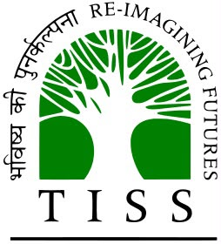 | Tata Institute of Social Sciences (TISS)  Mumbai, Maharashtra  Deemed to be University  tiss.edu
7 |  | Christ University (CHRIST)  Bengaluru, Karnataka  Deemed to be University  christuniversity.in
8 |  | GITAM Institute of Medical Sciences & Research  Visakhapatnam, Andhra Pradesh  GITAM Deemed to be University  gitam.edu
9 |  | SRM Dental College  Ramapuram, Chennai, Tamil Nadu  SRM Institute of Science & Technology  srmdentalcollege.com
10 | 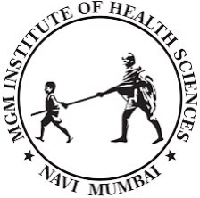 | MGM Medical College, Navi Mumbai  Kamothe, Navi Mumbai, Maharashtra  MGM Institute of Health Sciences (Deemed)  mgmuhs.com
11 | 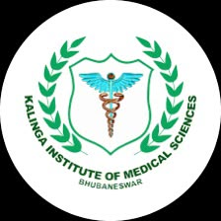 | Kalinga Institute of Medical Sciences (KIMS)  Bhubaneswar, Odisha  KIIT Deemed to be University  kims.kiit.ac.in
12 | 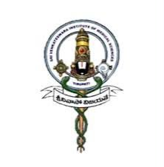 | Sri Venkateswara Institute of Medical Sciences (SVIMS)  Tirupati, Andhra Pradesh  State University (SVIMS, Tirupati)  svimstpt.ap.nic.in
13 | 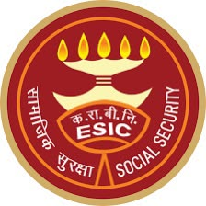 | ESIC Medical College & Hospital, Chennai  K.K. Nagar, Chennai, Tamil Nadu  ESIC, Ministry of Labour & Employment  esic.gov.in
14 |  | ESIC Medical College & Hospital, Hyderabad  Sanathnagar, Hyderabad, Telangana  ESIC, Ministry of Labour & Employment  esic.gov.in
15 |  | Bharati Vidyapeeth Dental College & Hospital  Pune, Maharashtra  Bharati Vidyapeeth Deemed University  bvuniversity.edu.in
16 |  | Adesh Medical College & Hospital  Shahabad, Kurukshetra, Haryana  Affiliated to Kurukshetra University  adeshmch.com
17 |  | Indira Gandhi Medical College & Research Institute  Puducherry  Govt. of Puducherry / Pondicherry University  igmcri.puducherry.gov.in
18 | 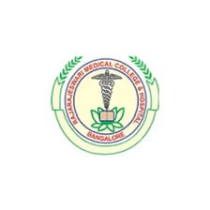 | Rajarajeswari Medical College & Hospital  Bengaluru, Karnataka  Affiliated to RGUHS  rrmch.org
19 |  | Bhaskar Medical College  Moinabad, Ranga Reddy, Telangana  Affiliated to KNRUHS  bhaskarmedicalcollege.in
20 |  | ASRAM Medical College  Eluru, Andhra Pradesh  Affiliated to Dr. NTR University of Health Sciences  asram.in
21 |  | KLE’s JGMM Medical College  Hubballi, Karnataka  KLE Academy of Higher Education & Research  kledeemeduniversity.edu.in
22 |  | SSPM Medical College & Lifetime Hospital  Padve, Sindhudurg, Maharashtra  Affiliated to MUHS, Nashik  sspmmedicalcollege.org
23 | 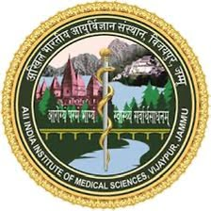 | AIIMS Jammu  Vijaypur, Samba, Jammu & Kashmir  Institute of National Importance  aiimsjammu.edu.in
24 | 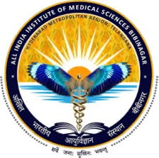 | AIIMS Hyderabad (Bibinagar)  Bibinagar, Yadadri Bhuvanagiri, Telangana  Institute of National Importance  aiimsbibinagar.edu.in
25 | 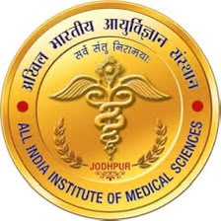 | AIIMS Jodhpur  Jodhpur, Rajasthan  Institute of National Importance  aiimsjodhpur.edu.in
26 | 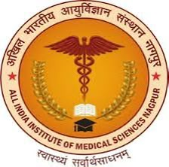 | AIIMS Nagpur  Mihan, Nagpur, Maharashtra  Institute of National Importance  aiimsnagpur.edu.in
27 | 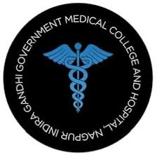 | Indira Gandhi Govt. Medical College (IGGMC)  Nagpur, Maharashtra  Govt. of Maharashtra, affiliated to MUHS  iggmcnagpur.com

