# Create an account on infinityfree

* **Email**: hanshosting@outlook.com
* **Password**: P012&*212pasx

## Select free account

## Register a domain:

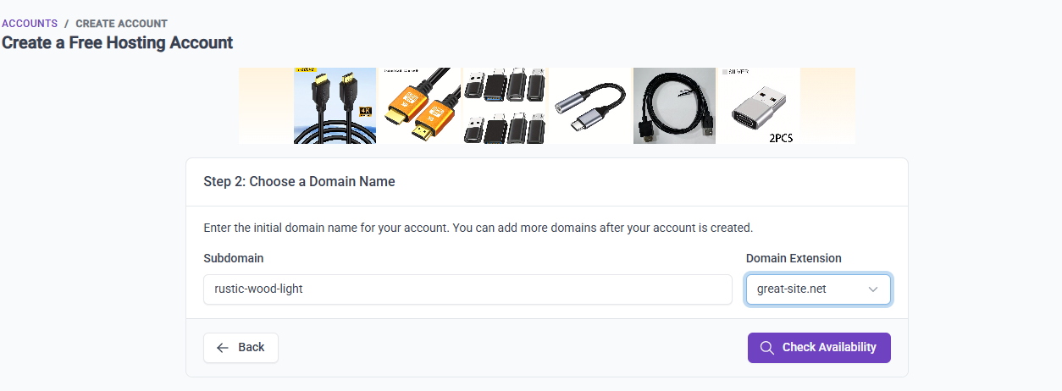

Account created:

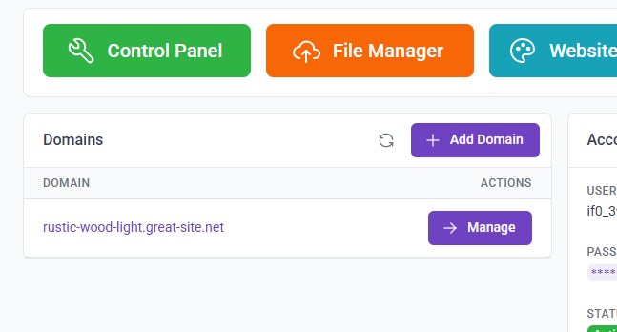

# How to create database :

## Go on Control panel

## Select Mysql Databases

## Create a db :

## Db created.

Access database by clicking on admin:

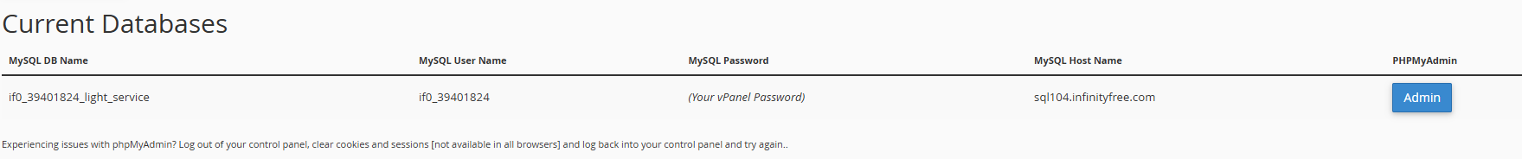

## Database view

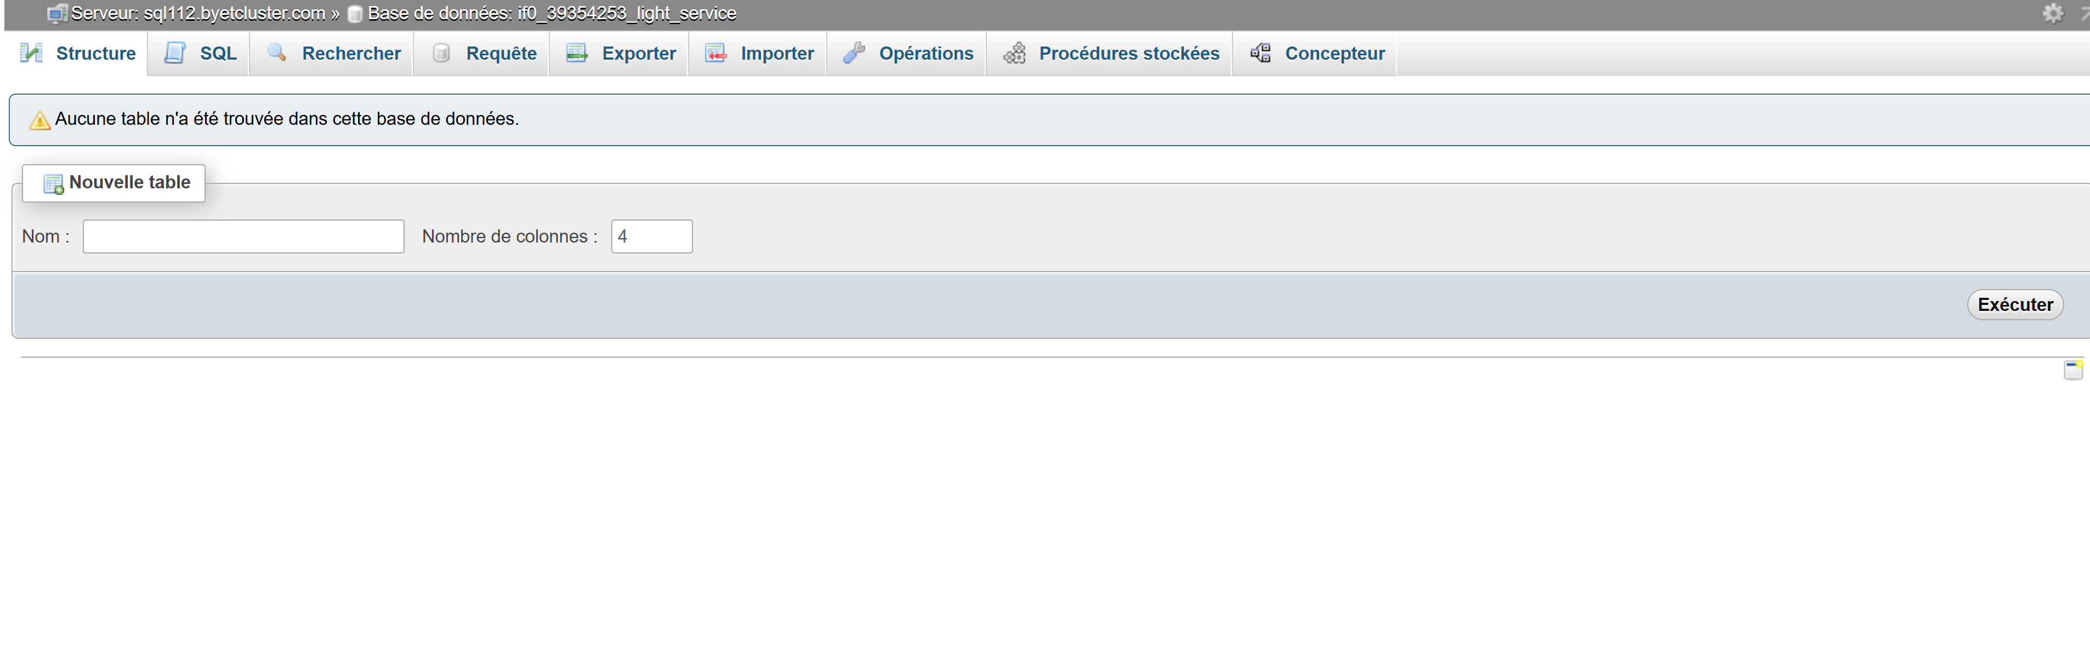

## Create tables and insert rows:

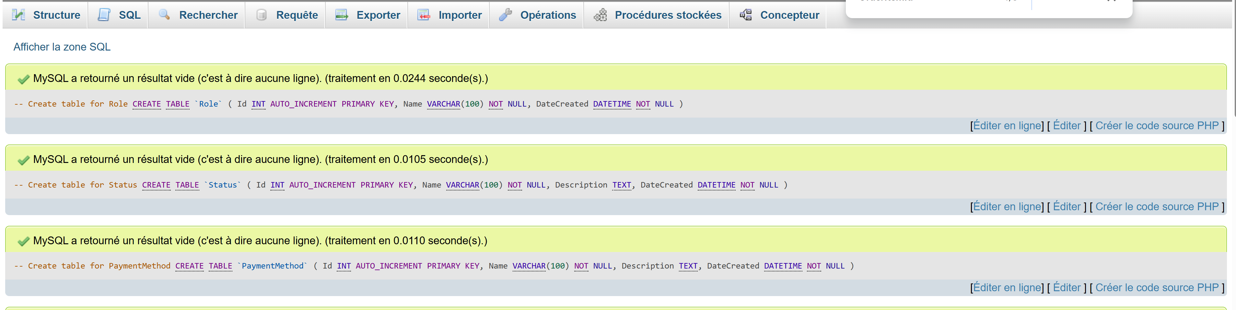

# Error when using paypal mur :

# Language and Libraries used:

Php

Javascript

Leaftletjs (Map)

Fpdf (Create pdf for receipt)

Bootstrap 5.2

Mysql database