

Wille Tuovinen, Jaakko Kauranen

SpugeQuest GDD

Sisällys

[1 Game Overview 1](#_Toc480989568)

[2 Mechanics of the game 1](#_Toc480989569)

[2.1 Gameplay 1](#_Toc480989570)

[2.2 Commands that the parser understands 2](#_Toc480989571)

[2.2.1 Action Commands 2](#_Toc480989572)

[2.2.2 Directions 3](#_Toc480989573)

[2.2.3 Other commands 3](#_Toc480989574)

[2.3 Items 3](#_Toc480989575)

[2.4 Enemies 3](#_Toc480989576)

[2.5 Events 4](#_Toc480989577)

[2.5.1 Common events 4](#_Toc480989578)

[2.5.2 Uncommon events 4](#_Toc480989579)

[2.5.3 Rare events 5](#_Toc480989580)

[3 Maps and descriptions of the squares 6](#_Toc480989581)

[3.1 Special squares 6](#_Toc480989582)

[3.1.1 Kamppi Metrostation 6](#_Toc480989583)

[3.1.2 Ruttopuisto 7](#_Toc480989584)

[3.1.3 Stockmann 7](#_Toc480989585)

[4 Walkthrough 7](#_Toc480989586)

[5 ER diagram and Relational schema 8](#_Toc480989587)

# Game Overview

SpugeQuest is a text adventure game based in modern Helsinki. The player experiences wintertime in Helsinki through the eyes of a homeless person, with a task to stay alive. The player must look for sources of heat, alcohol and small amounts of cash to keep himself alive through the winter.

The game is a survival simulator based on the real world, there are no fantasy creatures to encounter or battles to fight. Instead, the player must fight the deadly environment that will slowly kill him, if he doesn't actively look for warmth and helpful items.

# Mechanics of the game

## Gameplay

Basic gameplay consists of the player moving between different parts of the city. When he enters an area, a random event may happen. Possible events are listed later in the document.

Player has three resources/elements to monitor and play with. **Warmth**, **Blood Alcohol Level** and **Cash**. Warmth and Blood Alcohol Level are resources that are in constant state of change. Whenever the player is not warming himself or drinking alcohol the meters go down. If the warmth meter drops too low, the player freezes. If the blood alcohol level gets too low, the player goes into delirium tremens. In both cases the result is an instant game over. The third resource, cash, is a valuable and rare resource that the player may use in an emergency. Cash can get the player a metro ticket (for risk free and quick warming in the metro), or a bottle of booze from a certain state-run alcohol store. Cash, however, is hard and slow to obtain, as the player must first collect bottles from all over the city to get it.

Majority of the time the player tries to spot places that are warm and find half-empty bottles of alcohol to drink. If he enters a warm place (for example a metro station or an unlocked

stairway), he may rest and recover his warmth meter. Entering the metro without a ticket may result in the player getting kicked out of the station. After getting kicked out, the player cannot enter the same metro station again.

The warmth and blood alcohol level values are between 0 and 100. 0 is game over, 100 is full. Different items and locations affect these values in various ways.

## Commands that the parser understands

### Action Commands

* **Move [Direction]**
  + - * Attempts to move the player to the direction defined after the Move-command. Is used to move between different parts of the city. If that direction is not available to move to, produces an error message for the player.
* **Inspect [Item]**
  + - * Inspects an item, person or event that is currently happening near the player.
* **Use [Item]**
  + - * Attempts to use an item defined after the Use-command.
* **Talk [Person]**
  + - * Starts a conversation with an NPC.
* **Enter [Location]**
  + - * Used to enter a location such as metro station, stairway or a store that the player sees. Doors are sometimes locked in which case Enter produces an error message informing the player about a locked door.
* **Buy [Item]**
  + - * Used to buy an item from a store or black market. If the player doesn't have enough cash, tells the player to bugger off to get some more.
* **Rest [Location]**
  + - * Can be used when the player finds a spot to warm himself. Resting on the street is not possible.

### Directions

The player can move to north, east, south and west.

### Other commands

* **Restart game**
  + - * Restarts the game from the beginning

## Items

* **Bottle of vodka**
  + - * Refills the blood alcohol level by 50.
      * The best item for filling up blood alcohol level.
* **Bottle of kilju**
  + - * Refills the blood alcohol level by 30.
* **Bottle of beer**
  + - * Refills the blood alcohol level by 10.
* **Coin(s)**
  + - * Used to buy alcohol or metro tickets
* **Bottle(s)**
  + - * Can be collected and then returned to a store for cash

## Enemies

The game involves a very limited set of enemies, as the main goal is not to beat monsters or bosses. The NPC that could be considered an enemy would be the guards in the metro stations that may cause the player to be kicked out.

## Events

Events can happen when the player moves to a new square in the game. There are many kinds of events, some very common and some that are very rare. Each square where the player enters can only trigger one event at a time. Squares can trigger different events multiple times if the player enters the square again, though.

### Common events

Common events are some very simple things that may happen. These events do not have a big impact on the game but might help the player a little bit. Common events have a 60% chance of happening.

* Found a coin on the ground
  + - * Adds 0.5 euro for the player
* Found a bottle
  + - * Adds a bottle to the player’s inventory
* Found an opened bottle of beer
  + - * Has half the effect of the bottle of beer item, adds a bottle to the inventory.
* Political party tent offering coffee
  + - * Increases the warmth level by 10.

### Uncommon events

Uncommon events offer valuable help for the player. These have a 30% chance of happening.

* Found an unopened beer bottle
  + - * Adds a bottle of beer into the inventory
* Met a kilju merchant
  + - * Meet a guy who has a fresh batch of kilju to sell. The price of one bottle is 3 euros.
* Found a metro ticket
  + - * Metro ticket with some time left (or not!). Time left varies between 0 and 30 minutes. If still valid, offers as much warmth as there are minutes left on the ticket. Must be used instantly.

### Rare events

These events offer huge bonuses for the player but are very hard to get. Each of them has only 1% chance of happening.

* Found a full bottle of vodka
  + - * A vodka bottle is added to the inventory.
* Found a wallet
  + - * A wallet with 20 euros inside. The player’s morals are nonexistent so he keeps the money.
* Kilju merchant mistakes you for his old friend and gives you 3 bottles of kilju for free
  + - * Adds 3 bottles of kilju to the inventory.

# Maps and descriptions of the squares

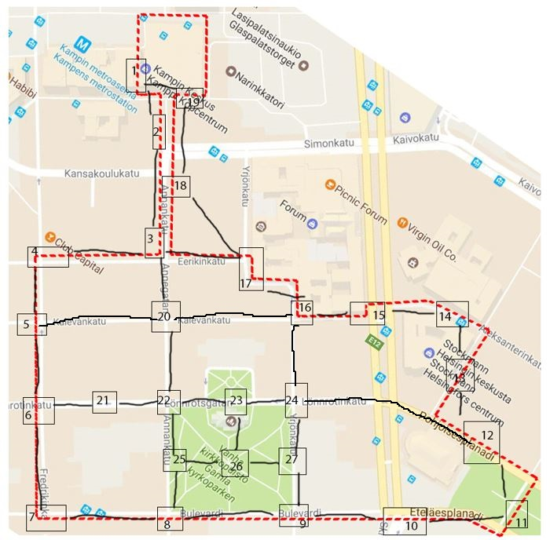

The basic map consists of small areas around Helsinki center. The squares are small parts of bigger streets. Each square has a chance of triggering random events. There are a couple special squares that have a specialty things.

## Special squares

### Kamppi Metrostation

Offers warmth, can be accessed at any time

### Ruttopuisto

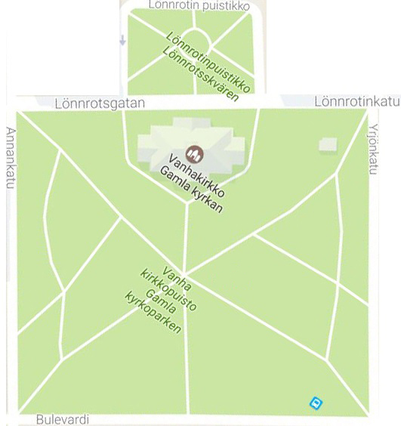The black market merchant “Masa” lives near Ruttopuisto (in square 24, see picture above). You can buy Estonian vodka from him. He accepts bottles as payment. One bottle of vodka costs 5 euros or 20 bottles.

### Stockmann

Offers warmth. 50% chance of getting kicked out right away. If you get kicked out you can’t enter again.

# Walkthrough

As the game doesn’t have a clear path to complete, writing a walkthrough is not that easy. However, there are tips for enhanced chance of survival.

1. Use money only for metro tickets or other ways to stay warm. Alcohol is much easier to find so you should mainly spend money only on increasing your warmth stats.
2. Trying to rest in the metro station is always worth it, as you won’t really lose anything by getting kicked out.

# ER diagram and Relational schema

## C:\Users\wille\AppData\Local\Microsoft\Windows\INetCache\Content.Word\ER Diagram.pngC:\Users\wille\AppData\Local\Microsoft\Windows\INetCache\Content.Word\ERD_SpugeQuest.pngC:\Users\wille\AppData\Local\Microsoft\Windows\INetCache\Content.Word\relaitonal_schema.pngC:\Users\wille\AppData\Local\Microsoft\Windows\INetCache\Content.Word\ERD_diag_SpugeQuest2.png