Overview
The goal of the project is the development of a classifier able to identify the gender from features representing face images. The dataset consists of low-dimensional records obtained by mapping face images to a common, low-dimensional manifold. For tractability and privacy reasons the data is synthetic, containing a much lower dimensionality with respect to real case scenarios. Each record is 12-dimensional belonging to either the male (label 0) or the female (label 1) class.
The datasets are imbalanced, with the training set having significantly more female samples, whereas the test set has significantly more male samples. The target application considers a balanced use-case, with a working point defined by the triplet (πT = 0.5,Cfn = 1,Cfp = 1).

Features Analysis
The following pictures show the distributions of all the features for both classes.

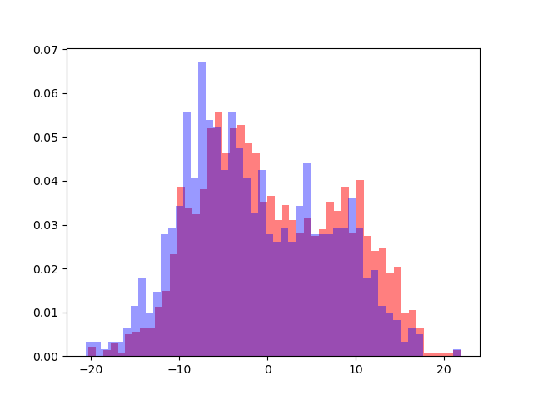 | 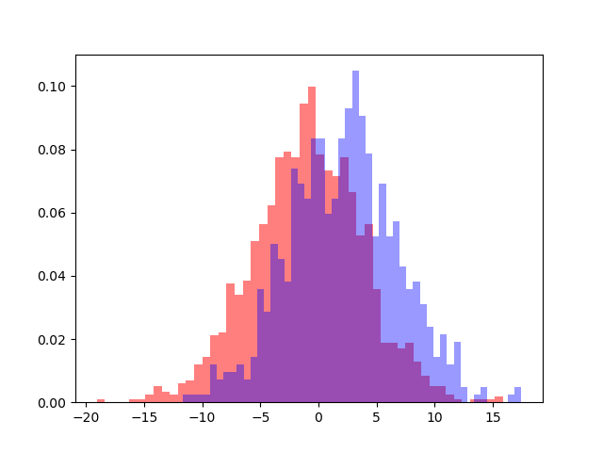 | 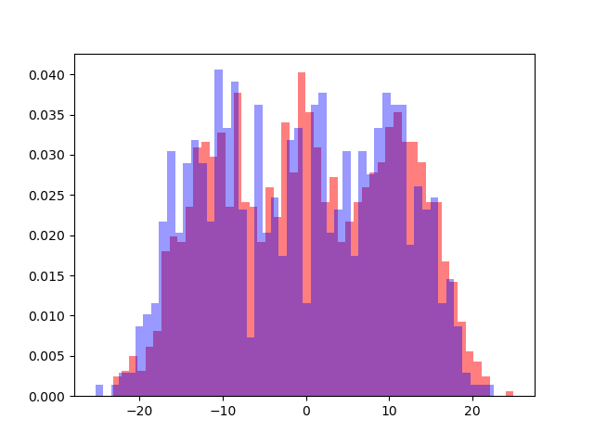
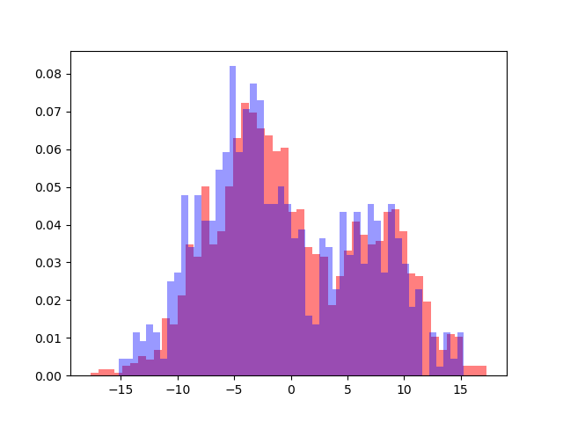 | 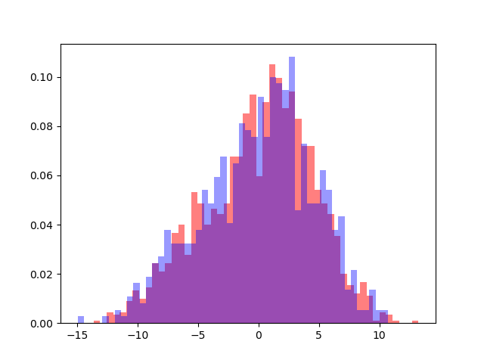 | 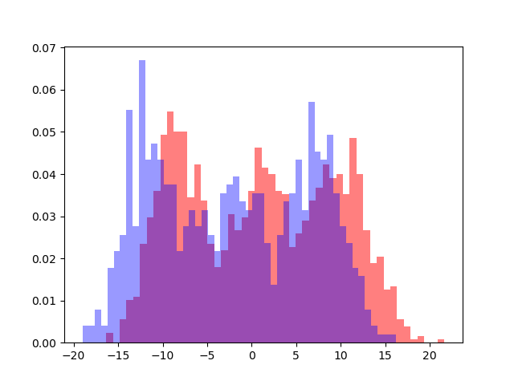
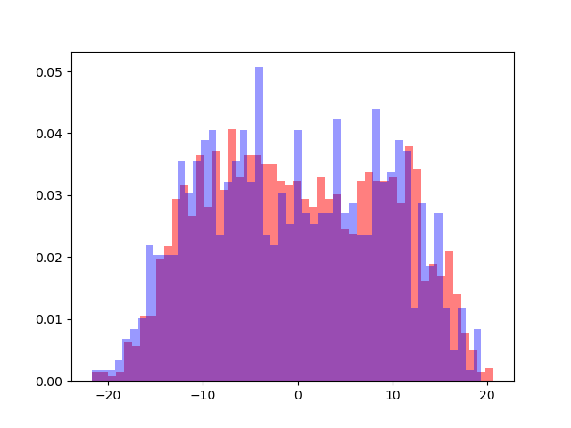 | 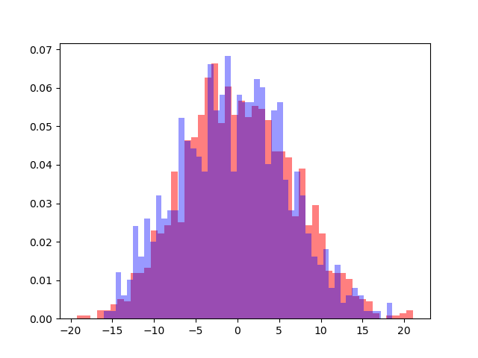 | 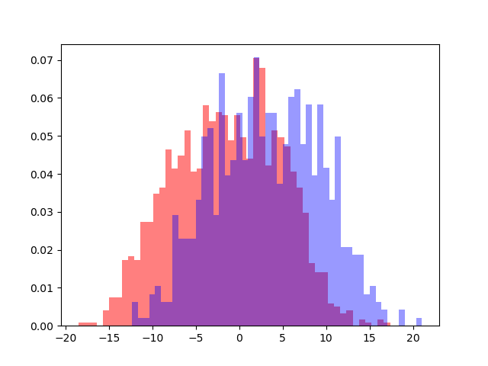
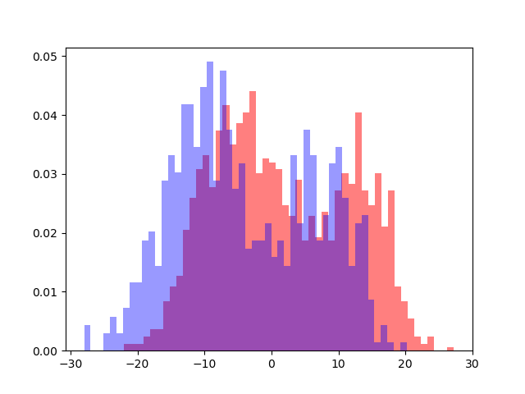 | 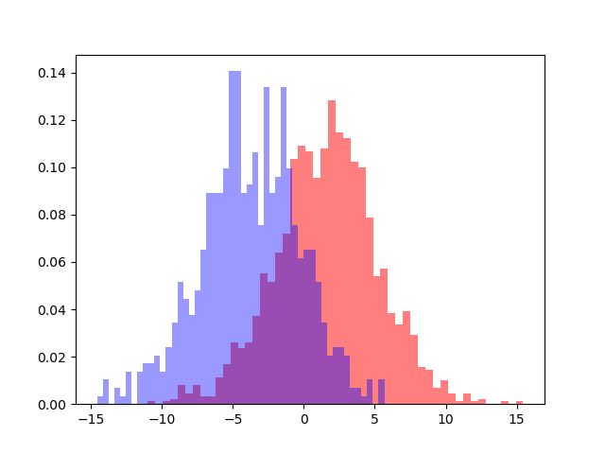 | 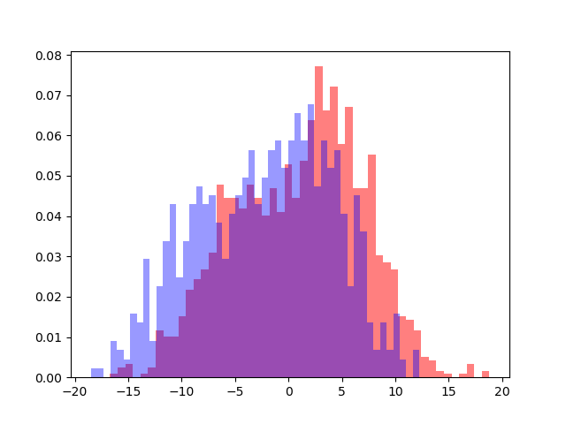

If we try to apply LDA transformation we can see that the 2 classes are linearly separable, even though we can spot a little overlapping area that could lead to errors.
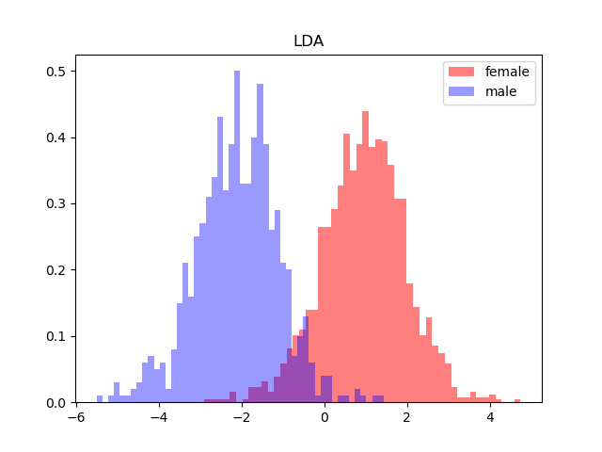
In the following are reported the heatmaps showing the correlation between features for the whole dataset and for both classes separately. We can see multiple squares with “strong” color that indicate a high correlation between features. We can suppose that models that assume independence among features will perform poorly.
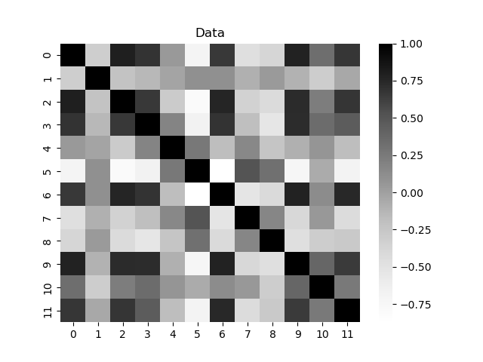 | 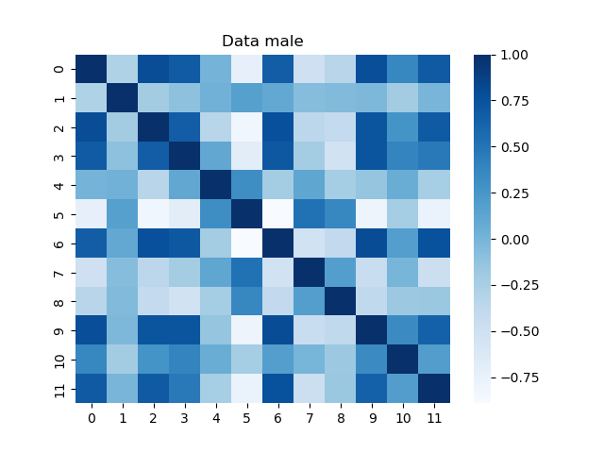 | 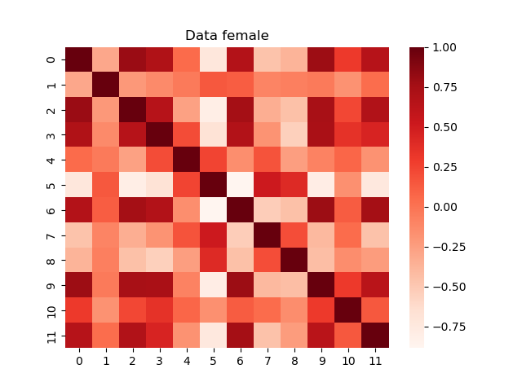

Looking at the following graph we can see that if wee reduce the dimensionality of the dataset to 8 we still retain at least 90% of the variance. Given this result I will consider applying PCA up to 8.
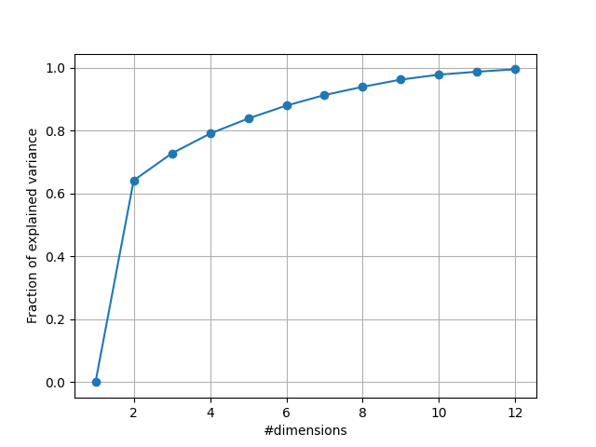
Explained variance

Validation strategy

Gaussian Models

Model | PCA | π = 0.1 | π = 0.5 | π = 0.9
Full covariance | RAW | 0.303 | 0.114 | 0.354
Full covariance | 11 | 0.298 | 0.119 | 0.356
Full covariance | 10 | 0.423 | 0.168 | 0.488
Full covariance | 9 | 0.418 | 0.187 | 0.554
Full covariance | 8 | 0.437 | 0.192 | 0.560
Naive-Bayes | RAW | 0.772 | 0.464 | 0.778
Naive-Bayes | 11 | 0.305 | 0.131 | 0.362
Naive-Bayes | 10 | 0.446 | 0.171 | 0.48
Naive-Bayes | 9 | 0.453 | 0.191 | 0.546
Naive-Bayes | 8 | 0.460 | 0.195 | 0.551
Tied | RAW | 0.292 | 0.112 | 0.338
Tied | 11 | 0.293 | 0.120 | 0.345
Tied | 10 | 0.395 | 0.166 | 0.469
Tied | 9 | 0.395 | 0.180 | 0.539
Tied | 8 | 0.405 | 0.187 | 0.557

Let’s analyze the result of each model.
The full covariance one performs better when keeping the dimensionality close to 12, but 11 does not worsen the performance very much and the computations will be faster since we exclude some information.
In the Naïve-Bayes model the model performs poorly unless we lower the dimensions. The best performance is reached when the dimensionality is brough to 11. It performs slightly worse than the previous model, probably because there could be dependencies between the features.
In the tied case the best performance is reached with the raw data, but we can follow the same reasoning that we have done for the Full Covariance case: lowering the dimensions to 11 doesn’t worsen the performance too much and we end up dealing with less information. This model performs slightly better than the other 2, probably because the distribution of the samples for each class is actually similar.

Logistic Regression
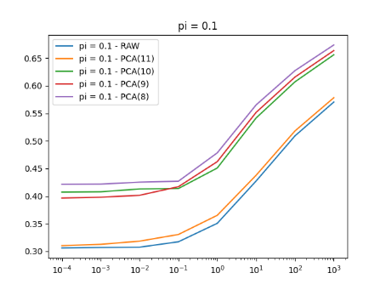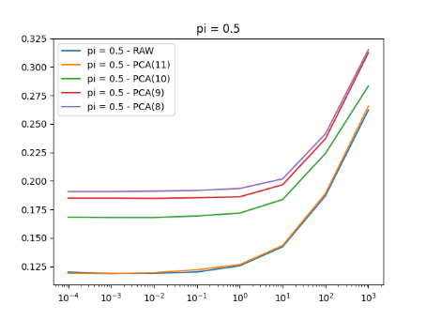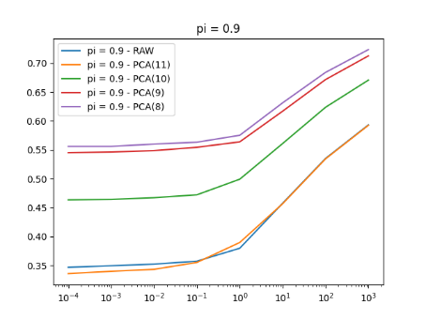
Here we show how the MIN DCF varies with respect to lambda in the 3 different cases. Raw data and PCA(11) are the most performant cases where PCA(11) overcomes Raw only when the prior is 0.9. Further decreasing the dimensionality of the dataset worsens the results. When adopting Logistic Regression it often helps to adopt some preprocessing strategies. In this case I tried to standardize the deviations and apply whitening on both Raw data and PCA(11). These are the results:
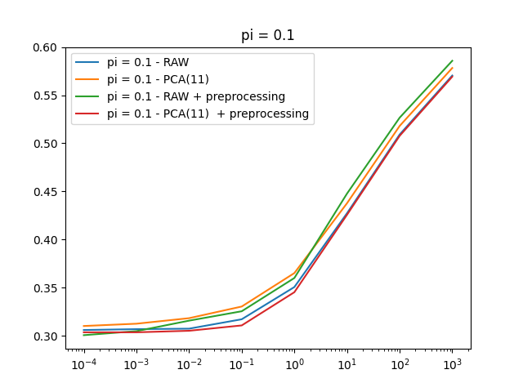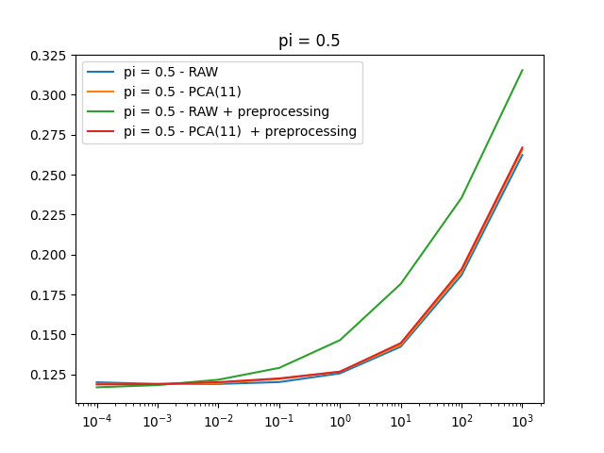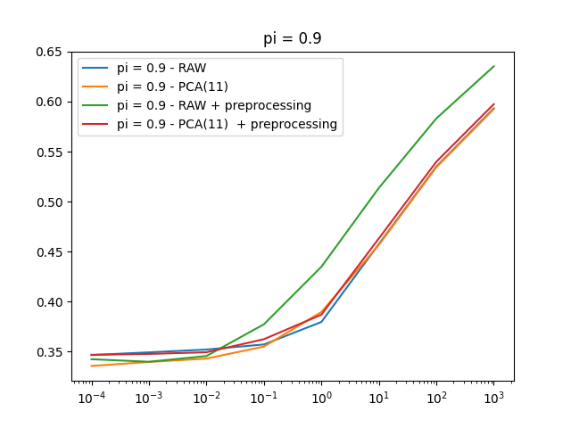
Here we can see that this preprocessing technique actually improves the performance of the model when using Raw data and when using PCA(11) we have always an improvement except for the case where the prior is 0.9.
Overall the model is more performant on RAW data, but if PCA(11) introduces a considerable improvement in computation time it can still be adopted.
Here’s the table that summarizes the results:

Model | Data | π = 0.1 | π = 0.5 | π = 0.9
Logistic Regression  𝜆 = 10-4 | RAW | 0.306 | 0.120 | 0.347
Logistic Regression  𝜆 = 10-4 | RAW* | 0.301 | 0.117 | 0.342
Logistic Regression  𝜆 = 10-4 | 11 | 0.310 | 0.119 | 0.336
Logistic Regression  𝜆 = 10-4 | 11* | 0.304 | 0.119 | 0.347
Logistic Regression  𝜆 = 10-4 | 10 | 0.407 | 0.168 | 0.463
Logistic Regression  𝜆 = 10-4 | 9 | 0.396 | 0.185 | 0.546
Logistic Regression  𝜆 = 10-4 | 8 | 0.421 | 0.190 | 0.556

SVM
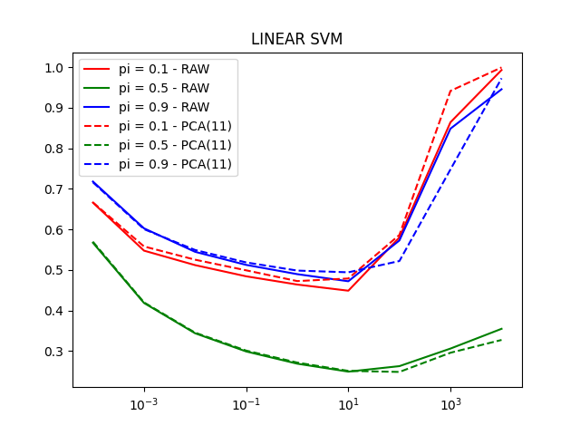
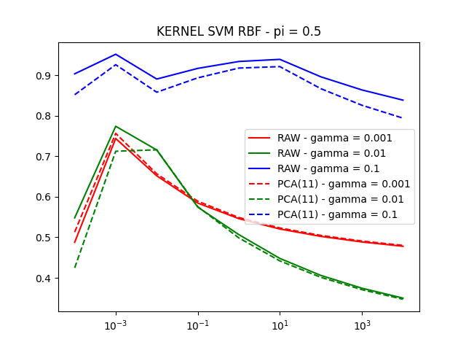
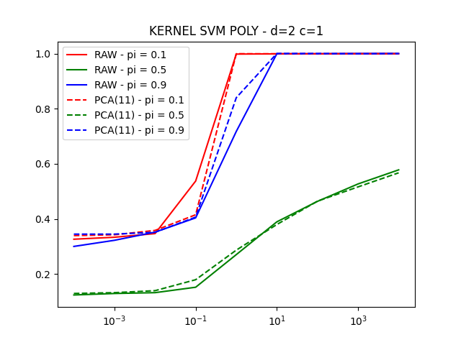
Model | PCA | π = 0.1 | π = 0.5 | π = 0.9
Linear SVM | RAW  c=10 | 0.449 | 0.249 | 0.490
Linear SVM | 11  c=10 | 0.479 | 0.250 | 0.494
Kernel SVM RBF | RAW  γ=0.001  c=104 | 0.864 | 0.478 | 0.821
Kernel SVM RBF | RAW  γ=0.01  c=104 | 0.710 | 0.350 | 0.699
Kernel SVM RBF | RAW  γ=0.1  c=104 | 0.995 | 0.838 | 0.995
Kernel SVM RBF | 11  γ=0.001  c=104 | 0.864 | 0.480 | 0.828
Kernel SVM RBF | 11  γ=0.01  c=104 | 0.703 | 0.347 | 0.694
Kernel SVM RBF | 11  γ=0.1  c=104 | 0.996 | 0.794 | 0.993
Kernel SVM POLY | RAW  c=10-4 | 0.326 | 0.124 | 0.300
Kernel SVM POLY | 11  c=10-4 | 0.339 | 0.129 | 0.344

GMM
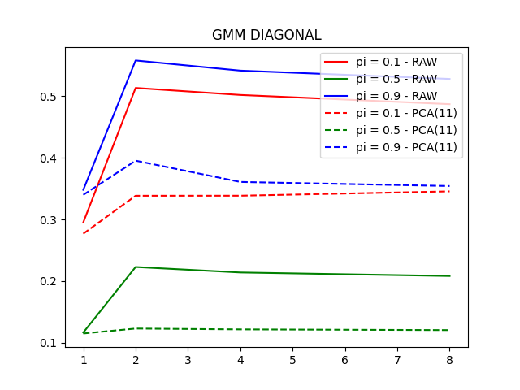
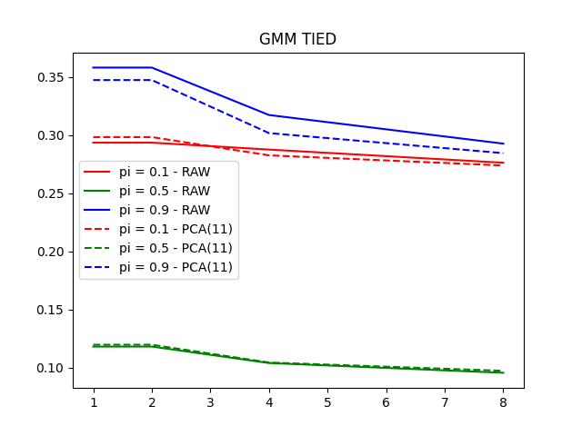
Model | PCA | π = 0.1 | π = 0.5 | π = 0.9
GMM FULL | RAW  d=4 | 0.253 | 0.090 | 0.254
GMM FULL | 11  d=4 | 0.253 | 0.090 | 0.254
GMM TIED | RAW  d=8 | 0.276 | 0.096 | 0.292
GMM TIED | 11  d=8 | 0.273 | 0.097 | 0.284
GMM DIAGONAL | RAW  d=8 | 0.487 | 0.208 | 0.528
GMM DIAGONAL | 11  d=8 | 0.346 | 0.120 | 0.354

Models comparison
Here are reported the results of the models (the best one for each family) that have better performed:

# | Model | PCA | π = 0.1 | π = 0.5 | π = 0.9
1 | GMM FULL  d = 4 | 11 | 0.253 | 0.090 | 0.254
2 | MVG Tied | RAW | 0.292 | 0.112 | 0.338
3 | Logistic Regression  𝜆 = 10-4 | RAW* | 0.301 | 0.117 | 0.342
4 | Kernel SVM POLY  c=10-4 | RAW | 0.326 | 0.124 | 0.300

Since the gap from GMM Full covariance and all the others is considerable it will be chosen for the evaluation part.

Evaluation
