Unit Excel 01

Read the task carefully first. This will answer many questions!!!

# Before we start …

Each of you will receive this task. In addition, you must download YOUR Excel file from Ilias. The Excel files are individualised so that everyone has different data to edit. To find your file, go to the ‘Data’ folder in Ilias and download the file with your matriculation number (e.g. 1234567.xlsx).

Important: The tasks are corrected automatically. You must therefore follow the instructions exactly. Under no circumstances may you change the name of the file or the worksheet. You may not move the cells with the data or add any rows or columns. Unless you are explicitly asked to do so. If a specific formula or function is specified for the solution, you must use it. If another formula or function could possibly produce the same solution, you will not receive any points for this.

# Prerequisites for Excel 01

To solve this task, you should be able to handle the following features from Excel:

* Format cells, rows, and columns
  + Fill color, font color, alignment, cut, border, ...
* Number formats (decimal places, percentage, currency, special format...)
* Simple Excel functions (SUM(), ...)
* Specify simple formulas by yourself (= A1 * A2)

# Exercise

Your Excel file will look similar to the following image:

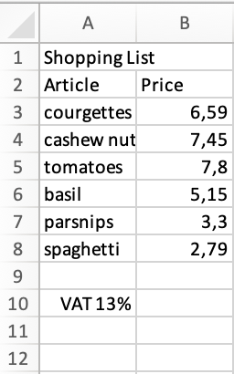

Your shopping list looks different in detail. Your task:

* Set column A column width to 20
* Join the two cells A1 and B1 into one cell
* The range of cells A1:B2 is formatted as follows:
  + Background color: FH-Mint (RGB: 0, 177, 172 or hex 00B1AC)
  + Font color: white
  + Font style: Bold (non-italics)
  + Orientation: centered (horizontal)
* For cells A1:B1, the following applies in addition: Font size 16
* In column B there are the prices of the products. However, there is no number-format applied (no €-sign. …). Select the cells with the prices and assign either the number-format "Currency" or "Accounting". As in the three cells below the last price you have to calculate some more prices (cf. below), assign the same number-format to these cells as well.
* Under the prices (cell B9 in the above figure), insert the sum of all prices.
* Calculate the VAT in the following cell (in the example, cell B10). It is possible that the stated tax rate does not correspond to reality. Mutliply "the two cells". (the value in B10 must change, if the tax rate is changed!)
* Add the total and taxes to the following cell (cell B11 in the example).
* Insert a "Thick Border Line" above the first sum or below the unit prices and above the second sum or below the tax.

# Submission

Upload the solution file to Ilias in the submission folder. Do not change the name of the file under any circumstances. Latest submission: **Sun, Oct 6, 23:55h**