Exercise Excel 02

Read the task carefully first. This will answer many questions!!!

# Before we start …

Each of you will receive this task. In addition, you must download YOUR Excel file from Ilias. The Excel files are individualised so that everyone has different data to edit. To find your file, go to the ‘Data’ folder in Ilias and download the file with your matriculation number (e.g. 1234567.xlsx).

Important: The tasks are corrected automatically. You must therefore follow the instructions exactly. Under no circumstances may you change the name of the file or the worksheet. You may not move the cells with the data or add any rows or columns. Unless you are explicitly asked to do so. If a specific formula or function is specified for the solution, you must use it. If another formula or function could possibly produce the same solution, you will not receive any points for this.

# Prerequisites for Excel 02

To solve this task, you should be able to handle the following features from Excel:

* Formats and especially number-formats
* Formulas
* Most important topic today: References (i.e. how to place the $ correctly)
  + Relative references
  + Absolute references
  + Mixed references
  + Names

Only if the references are specified correctly, you will be able to autofill the cells. If all cells are filled manually (which takes a lot of time), your solution will **not be accepted.**

# Exercises

## Formula with two variables

Open the worksheet "1) Formula". It should look similar to the following figure:

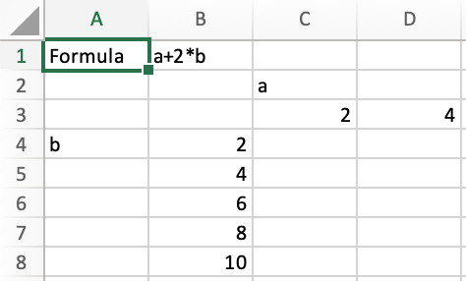

In B1 there is a formula. Your task:

* Format the cells containing the numbers in column B and row 3 as follows:
  + Fill color: FH-Mint (RGB 0, 177, 172)
  + Font color: White (RGB 255, 255, 255)
* In the range of cells spanned by the numbers, calculate the formula stated in B1 with the given values for a and b. Enter the formula (references!!) in such a way that you can automatically fill the cells down and to the right. Adjust the number format in the cells to display one decimal place.

## Exam consisting of three Parts

Öffnen Sie das Arbeitsblatt (Worksheet) "2) Prüfung". Das sollte so ähnlich wie die folgende Abbildung aussehen:

Open the worksheet "2) Exam". It should look similar to the following figure: There are three parts of the exam: Workshop, Exam 1 and Exam 2. These parts are weighted differently (see figure). The workshop grade is given (cell E1). The grade of the workshop and the weights are different for you! In the cell from C6 and B7 onwards, the possible grades for the two exams are displayed according to the grade intervals at FH Aachen.

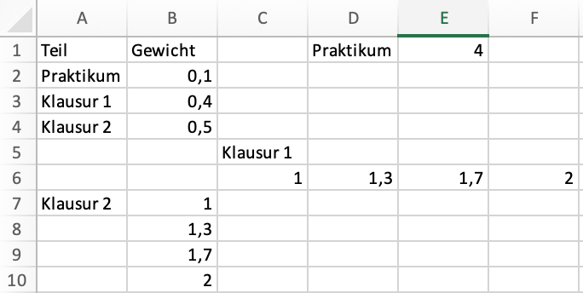

Your task:

* Format the cells with the grades in column B and row 6 as follows:
  + Fill color: FH-Mint (RGB 0, 177, 172)
  + Font color: WNoeiß (RGB 255, 255, 255)
  + Number format: One digit after the decimal place (i.e. 1.0 instead of 1)
* Format cell E1 so that one decimal place is always given.
* Assign the name "Grade_Workshop" to cell E1. Calculate the final grade in the cell range spanned by the partial grades for the two exams. Multiply the grades of the three parts (workshop, exam 1, exam 2) by the corresponding weights. Do not use numbers in the formula, but refer to the corresponding cells with the weights. If the weights in cells B2:B4 or the grades are changed, then the calculated grade must also change! Enter the formula in a way, that you can automatically fill the cell down and right (i.e. use references!)
* Instead of cell E1, specify the above name of the cell in the formula. Adjust the number format for the calculated grades so that two decimal places are displayed in every cell.

# Submission

Upload the solution file to Ilias in the submission folder. Do not change the name of the file under any circumstances. Latest submission: **Sun, Oct 13, 23:55h**