Exercise Excel 03

Read the task carefully first. This will answer many questions!!!

# Before we start …

Each of you will receive this task. In addition, you must download YOUR Excel file from Ilias. The Excel files are individualised so that everyone has different data to edit. To find your file, go to the ‘Data’ folder in Ilias and download the file with your matriculation number (e.g. 1234567.xlsx).

Important: The tasks are corrected automatically. You must therefore follow the instructions exactly. Under no circumstances may you change the name of the file or the worksheet. You may not move the cells with the data or add any rows or columns. Unless you are explicitly asked to do so. If a specific formula or function is specified for the solution, you must use it. If another formula or function could possibly produce the same solution, you will not receive any points for this.

# Prerequisites for Excel 03

To solve this task, you should be able to handle the following features from Excel:

* All prerequisites from the past weeks:
  + Formats and especially number-formats
  + References (correct placement of the $), auto-fill of constants and formulas
  + Entering formulas and functions
* Sorting of several columns
* The functions VLOOKUP(), COUNTIF(), SUMIF()
* Percentage calculation

Only if the references are specified correctly, you will be able to autofill the cells. If all cells are filled manually (which takes a lot of time), your solution will **not be accepted.**

# Exercises

## ABC-Analysis

Open the worksheet "1) ABC-Analysis". The worksheet should look similar to the following image.

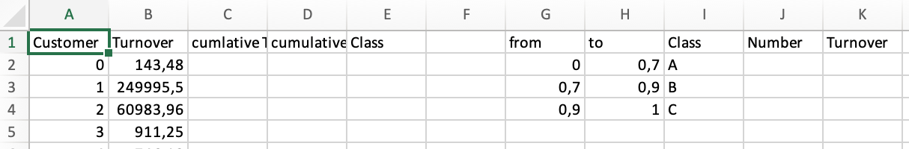

Task: Perform an [ABC Analysis](https://en.wikipedia.org/wiki/ABC_analysis) (cf. Wikipedia), i.e. perform the following steps.

* In column A are customer numbers. Adjust the number format so that instead of "0" in cell A2, "Customer-0000" is displayed. (Important: There is a "0" in the cell, only the number format changes the layout to "Customer-0000".) When the cell is activated, you will only see the "0" in the formula bar.
* Assign the number format "Accounting" or "Currency" to column B (stating from B2).
* In cells G2:H4, the border values of the classes A, B, C are listed as numbers. Assign the number format Percent (without decimal places) here.
* Set the column width of column B and C to 20. If other columns are too narrow, adjust these column widths accordingly.
* Sort columns A:D based on the turnover in column B in **descending** order, i.e. the largest turnover is at the top, the smallest turnover is at the bottom. (The customer-IDs in column A are sorted accordingly).
* Calculate the cumulative turnover in column C. The cumulative turnover is the sum of all sales up to the respective row.
  + Thus, in C2 is the sum from B2 to B2 (sum of one value), in C3 is the sum of all sales from B2 to B3, in C4 is the sum from B2 to B4 ...
  + Alternatively: C2 is the same as B2. In C3 there is the sum of C2 and B3, in C4 there is the sum of C3 and B4.
  + Important: The column must be auto-fillable (from cell C3 at the latest).
* In column D calculate the cumulative sales as a percentage. The last cumulative value in column C is the sum of all sales. If you divide C2 by this last value, you get the cumulative share. Select the number format % with one digit behind the comma (point).
  + The percentage in D should get bigger and bigger, in the last cell there must be 100.0%.
  + The cells in D must be auto-fillable.
* In column E "Class", use the formula VLOOKUP() to enter the class to which the customer belongs. In the example of the figure:
  + All customers from 0% – 75% belong to class A.
  + All customers from 75% - 95% belong to class B.
  + All customers from 95% - 100% are Class C (your class borders might be different).
* Use the COUNTIF() or SUMIF() functions to calculate the number of customers in a class, and the total turnover of the class in columns J and K.
* Use the following format in row 1:
  + Fill color: FH-Mint (RGB 0, 177, 172)
  + Font color: White (RGB 255, 255, 255)
  + bold, centered
* The classes in columns E and I are also centered.

## Exam

Open the worksheet "2) Exam" (see figure below). Further to the right of the worksheet you can see partial grades from two parts of the exam and workshop respectively. Grades are given for different students. In all three tables, the same students are listed.

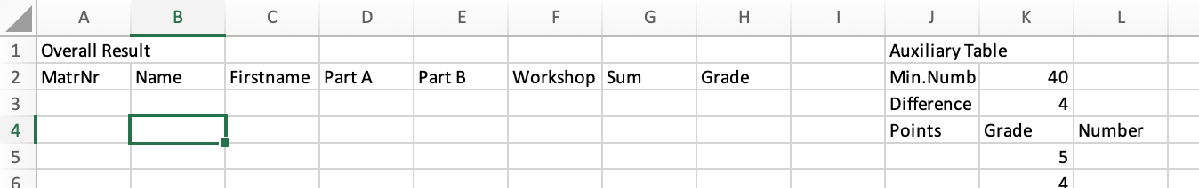

Your task:

* Copy all matriculation numbers from one of the tables into column A (starting from row 3).
* Sort the matriculation numbers from small to large.
* Use the VLOOKUP() function to transfer the respective values to columns B:F.
* Sum up the values from columns D:F into column G. Now you have the total points for each student. The grade is derived from the auxiliary table in columns J:L. This has yet to be filled out.
* In cells K2:K3 there are two constants: the minimum number of points to pass the exam, as well as the point difference between two grades. In cells J5:J15, enter the following values:
  + J5 a 0 (from 0 points you get a 5.0)
  + J6 a reference to the minimum score in K2 (from this point you get a 4.0)
  + J7 = J6 + point difference in K3 (from there you get a 3.7)
  + Cells J8 to J15 are auto-filled accordingly. For at least K3 points more, you get a better partial grade.
  + Attention: From J7 onwards, the whole thing must be auto-fillable downwards.
* Now you can calculate the grade in column H using a VLOOKUP().
* Important: All formulas in columns B:H or J and L must be automatically fillable!
* Finally, use the COUNTIF() function to determine the number of students with a certain grade (cells L5:L15).
* Adjust the formats as follows:
  + Cells A1, J1, N1, V1, AE1: Bold, font size 16
  + Cells A2:H2, J2:J4, J4:L4, N2:T2, V2:AC2, AE2:AH2
    - Fill color: FH-Mint (RGB 0, 177, 172)
    - Font color: White (RGB 255, 255, 255)
    - bold, centered
  + Cells K5:K15: Number format: "0,0"
  + Column H from H3 onwards: Number format: "0.0"
* Change the entries with the minimum number of points and and the point difference in K2:K3. The distribution of grades should adapt. Reset the two cells back to their original values.

# Submission

Upload the solution file to Ilias in the submission folder. Do not change the name of the file under any circumstances. Latest submission: **Sun, Oct 20, 23:55h**