Exercise Excel 04

Read the task carefully first. This will answer many questions!!!

# Before we start …

Each of you will receive this task. In addition, you must download YOUR Excel file from Ilias. The Excel files are individualised so that everyone has different data to edit. To find your file, go to the ‘Data’ folder in Ilias and download the file with your matriculation number (e.g. 1234567.xlsx).

Important: The tasks are corrected automatically. You must therefore follow the instructions exactly. Under no circumstances may you change the name of the file or the worksheet. You may not move the cells with the data or add any rows or columns. Unless you are explicitly asked to do so. If a specific formula or function is specified for the solution, you must use it. If another formula or function could possibly produce the same solution, you will not receive any points for this.

# Prerequisites for Excel 04

To solve this task, you should be able to handle the following features from Excel:

* All prerequisites from the past weeks:
  + Formats and especially number-formats
  + References (correct placement of the $), auto-fill of constants and formulas
  + Entering formulas and functions
* Sorting of several columns
* The functions COUNTIFS(), SUMIFS(), SUMPRODUCT()
* Percentage calculation

Only if the references are specified correctly, you will be able to autofill the cells. If all cells are filled manually (which takes a lot of time), your solution will **not be accepted.**

# Exercises

## Purchase Orders

Open the worksheet "1) Orders". The worksheet should look similar to the following figure:

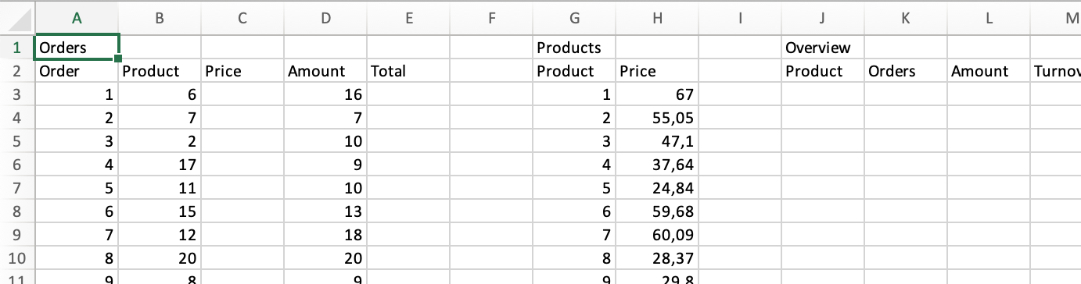

Task: Perform the following steps.

* -Line 1 contains headings. Adjust the format so that the headings have a size of 16 and are bold.
* Column A contains order numbers. Adjust the number format so that "Ord-001" is displayed in cell A2 instead of "1". (Important: There is a "1" in the cell, only the number format changes the layout to "Ord-001". If the cell is clicked, you will only see the "1" in the formula bar).
* In the same way, adjust the format in column B so that it shows "Prod-01" instead of 1. The same applies to columns G and J.
* Assign the number format "Currency" or "Accounting" to all cells containing prices or sales.
* In the cells A2:E2, G2:H2, J2:M2 and O2:O4, please use the following format:
  + Fill color: FH-Mint (RGB 0, 177, 172)
  + Font color: White (RGB 255, 255, 255)
  + Bold, centred
* If necessary, adjust the column width so that the values are visible. Possibly also later if you have entered formulas there.
* - The "Products-table" contains the prices for each product. Use a formula to enter the appropriate price for the given product in column C.
* -Calculate the turnover per order (quantity * unit price) in column E
* - In the "Overview-table", the following should be entered for each product:
  + Column J: All Products (Prod-01 to …)
  + Column K: In how many orders the product is ordered
  + Column L: How many units of the product were ordered in total
  + Column M: The total sales made with each product.
* - To do this, use the functions COUNTIF() and SUMIF()
* In cells P2:P4, calculate the total turnover in three different ways:
  + P2: Add all sales from column E
  + P3: Add all sales from column M
  + P4: Use the function SUMPRODUCT() in a suitable way.
* - The same result should appear in all three cells at the end.

## Sales

Open the worksheet "2) Sales". (see following illustration).

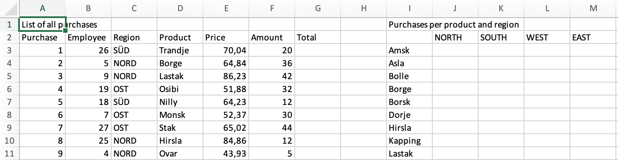

Your Task:

* Line 1 contains headings. Adjust the format so that the headings have a size of 16 and are bold.
* In the cell areas A2:G2, I2:M2, O2:S2, U2 and W2:AA2, please use the following format:
  + Fill color: FH-Mint (RGB 0, 177, 172)
  + Font color: White (RGB 255, 255, 255)
  + Bold, centred
* In column A from A3, adjust the number format so that it reads "Purc-0001".
* In column B **and** in cell V2, use the number-format "Empl-000".
* Adjust the number format to "Accounting" or "Currency" wherever sales or prices are shown.
* Calculate the turnover per sale (price * number) in column G
* Enter an employee number in cell V2. (e.g. 3, but same number-format as in column B.)
* In the three tables "Purchases per product and region", "Turnover per product and region" and "Turnover per product and region and employee", use the formulae SUMIFS() or COUNTIFS() to determine the desired values. Adjust cell V2 and check whether the values in the third table change.
* When submitting, make sure that cell V2 contains a meaningful value. Otherwise the correction will result in 0 points.

# Submission

Upload the solution file to Ilias in the submission folder. Do not change the name of the file under any circumstances. Latest submission: **Sun, Oct 27, 23:55h**