Exercise Excel 05

Read the task carefully first. This will answer many questions!!!

# Before we start …

Each of you will receive this task. In addition, you must download YOUR Excel file from Ilias. The Excel files are individualised so that everyone has different data to edit. To find your file, go to the ‘Data’ folder in Ilias and download the file with your matriculation number (e.g. 1234567.xlsx).

Important: The tasks are corrected automatically. You must therefore follow the instructions exactly. Under no circumstances may you change the name of the file or the worksheet. You may not move the cells with the data or add any rows or columns. Unless you are explicitly asked to do so. If a specific formula or function is specified for the solution, you must use it. If another formula or function could possibly produce the same solution, you will not receive any points for this.

# Prerequisites for Excel 04

To solve this task, you should be able to handle the following features from Excel:

* All prerequisites from the past weeks:
  + Formats and especially number-formats
  + References (correct placement of the $), auto-fill of constants and formulas
  + Entering formulas and functions
* Percentage calculation
* Excel functions to handle financial issues. Especially interests and depreciation.

Only if the references are specified correctly, you will be able to autofill the cells. If all cells are filled manually (which takes a lot of time), your solution will **not be accepted.**

You can construct the formulas from financial mathematics yourself. However, the corresponding Excel functions are expected in the following tasks. Self-constructed solutions will **not be accepted.**

# Tasks

For all tasks, all cells which represent costs, instalments, values, ... i.e. the content is money, have to be formatted as follows:

* €-sign
* Two decimal places after the decimal point
* If the value of the number is negative, the number should be displayed in red.

In some cases, there are very large numbers or entries. Adjust the column width so that the numbers can be read.

Note: When it comes to financial figures, the signs are important. Whenever you have to pay something or the number represents a debt, a negative number should be used. When you receive or when you own some money, the number is positive. For example, the instalments you pay in the first task should be negative.

## Task 1: Monthly Instalment

You want to take out a loan and want to compare different options (interest rate, duration). Calculate the monthly instalment and the total amount you have to repay for each of these options. The following applies to the task: The installments are paid on a monthly base at the end of each month, the loan is to be repaid in full. Further conditions can be found in the worksheet. Your task will look similar to the image below:

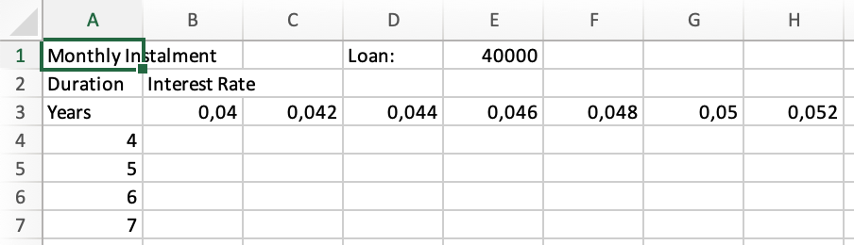

Open the "1) Monthly Installment" worksheet. Proceed as follows:

* Formatting
  + Line 1: Font size 16, bold
  + Cells A2:B2, A3:I3, K2:L2, K3:S3: background color FH-Mint (RGB 0, 177, 172), font color white
  + Format the cells representing the years in columns A and K in the same way.
  + The years in columns A and K use the following number format: 0" Y"
  + The interest rates in line 3 are formatted as a percentage with two decimal places.
* In cell B4, calculate the amount of the monthly installment. Use the $ in such a way that you can autofill the function to the right and down.
* In cell L4, calculate how much you have to pay in total for the loan. (As far as I know, there is no Excel formula for this). Think for yourself how you can calculate this sum.

## Task 2: Interest and repayment

You have taken out a loan. You have negotiated that you will pay an instalment once a year (not once a month) and always at the end of the year. Further conditions can be found on the second worksheet "2) Interest and Repayment". Although you pay the same instalment every year, the proportion of interest or repayment varies from instalment to instalment. On the following worksheet, calculate the respective amount of interest and repayment or your remaining debt for each year.

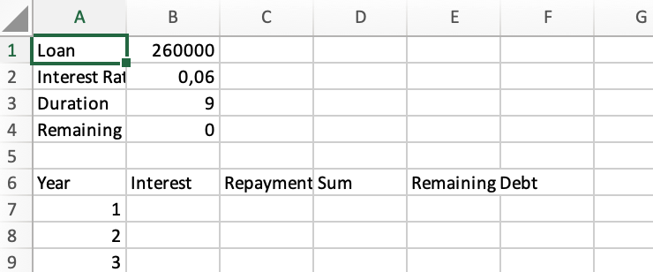

Open the worksheet and do the following:

* Add the numbers in column A from row 7 onwards so that the numbers match the term in B3.
* Format cells A1:A4 and A6:E6 as follows: background color: FH-Mint, font color: white.
* In the same way, format the cells with the years in column A.
* For cell B3 and for the years in cells A7 and following, use the number format 0" J"
* The interest rate in cell B2 is represented by a percentage and one decimal place.
* Use the appropriate formulas to calculate the interest and repayment in the respective year. Interest and repayment must be negative because you have to pay something. The amount of interest is getting smaller from year to year, and that of repayment is correspondingly increasing.
* In column D, form the sum of the two values. These sums in column D must all be the same. Calculate the remaining debt. This results as follows:
  + In cell E7: - Credit - repayment (Credit is a positive value, you will receive money. The debt is a negative value, you have to pay money back. The repayment is a negative value, you have to pay.)
  + In cell E8 and following: Residual debt from previous line – current repayment.
* Finally, there should be a 0 in the lowest residual debt cell. You have repaid the loan in full.

## Task 3: Depreciation

The last task deals with three different methods of depreciating a machine. In each process, the machine has the same acquisition value, the same salvage value and the same service life. With the help of the corresponding formulas, calculate the amount of depreciation, the book value and the salvage value of the machine for each year.

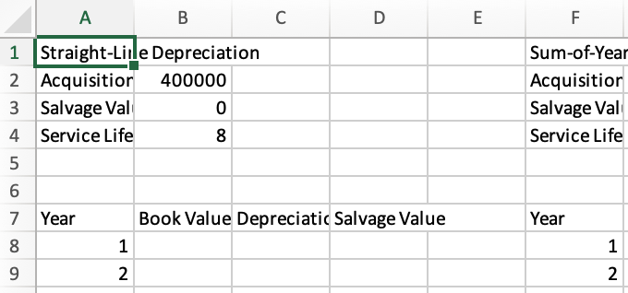

Open the worksheet "3) Depreciation" and proceed as follows:

* Formatting:
  + Line 1 has a font of 16 and is bold.
  + The cells with content in columns A, F, and K (except row 1) have FH-Mint as the background color and white as the font color. The same applies to line 7.
  + The years in columns A, F and K use the number format 0" Y"
  + The total power in cell L5 and the power specifications in cells L8 and following have the number format 0" h"
  + Adjust the width of the columns appropriately. If necessary, even later.
* The following applies to all three tables with the depreciation:
  + The book value in the first year is equal to the acquistion value.
  + The book value in the following years is always equal to the salvage value from the previous year.
  + The salvage value is the difference between the book value and the depreciation of the respective year.
  + The depreciation in the first two tables is calculated using the corresponding Excel formula.
  + There is no Excel formula for depreciation in Units-of-Production depreciation. Every year, depreciation is made in proportion of the yearly performance (in hours) in relation to the total performance (in hours).
* To check: The following applies to all three types of depreciation: At the end of the service life, the salvage value in the lower right cell of the table must correspond to the salvage value specified in row 3.

# Submission

Upload the solution file to Ilias in the submission folder. Do not change the name of the file under any circumstances. Latest submission: **Sun, Nov 3, 23:55h**