Exercise Excel 06

Read the task carefully first. This will answer many questions!!!

# Before you start

Each of you will receive this task. In addition, you must download YOUR Excel file from Ilias. The Excel files are individualised so that everyone has different data to edit. To find your file, go to the ‘Data’ folder in Ilias and download the file with your matriculation number (e.g. 1234567.xlsx).

Important: The tasks are corrected automatically. You must therefore follow the instructions exactly. Under no circumstances may you change the name of the file or the worksheet. You may not move the cells with the data or add any rows or columns. Unless you are explicitly asked to do so. If a specific formula or function is specified for the solution, you must use it. If another formula or function could possibly produce the same solution, you will not receive any points for this.

# Prerequisites for Excel 03

To solve this task, you should be able to do the following things from Excel:

* All requirements of the previous weeks:
  + Formats, Number Formats
  + Build simple functions yourself
  + Sort multiple columns based on one column
  + VLOOKUP(), ...
  + Setting refrences with $ correctly, i.e. absolute and relative references
* New: Logic functions: IF(), AND(), ... IFERROR()
* Only if the references are specified correctly, you will be able to autofill the cells. If all cells are filled manually (which takes a lot of time), your solution will **not be accepted.**

# Tasks

## Exam

Similar task as in the third week! But now with additional logic functions.

Open the worksheet "1) Exam". The worksheet should look similar to the following image.

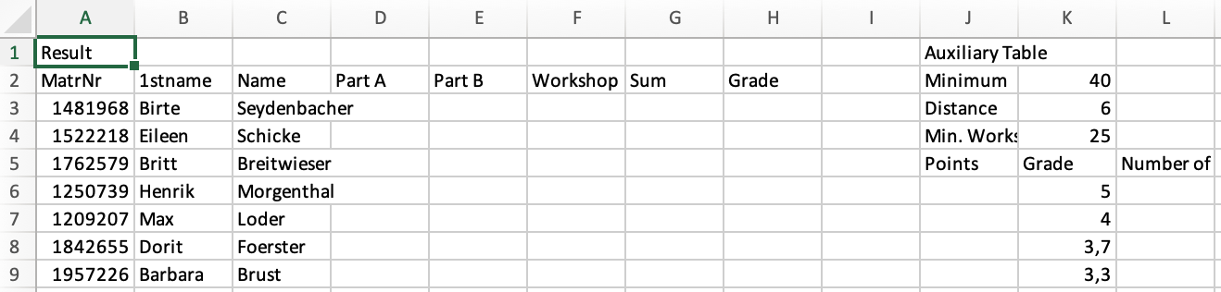Your task:

* Sort the students in columns A:C based on the matriculation number in ascending order.
* Calculate the sums in columns T and AC
* Use the VLOOKUP() function to get the corresponding to columns D:F. Attention: Not all students have participated in all parts. There are some fields where there is an error message (#NV). Use the IFERROR() function to replace the errors with nothing (an empty string "" (quotes with nothing in between)).
* Calculate the sum of columns D:F in column G.
* Now you have the total score for each student. The grade is derived from the auxiliary table in columns J:L. This has yet to be filled out.
* There are three constants in cells K2:K4:
  + the minimum score to pass the exam,
  + the point gap between two grades.
  + **NEW**: The minimum number of points that must be achieved in the workshop in order to pass the exam
* In cells J6:J16, enter the following values:
  + J6 a 0 (from 0 points you get a 5.0)
  + J7 a reference to the minimum score K2 (from this point you get a 4.0)
  + J8 = J7 + distance in K3 (from there you get a 3.7)
  + Cells J9 to J16 are filled accordingly. For at least K3 points more, you get a better partial grade. Attention: From J7 onwards, the whole thing must be autofilled down.
* Now you can calculate the grade in column H.
  + First, use IF() to check whether the minimum score has been achieved in the workshop.
  + If this is the case, then calculate the grade with a VLOOKUP().
  + Otherwise, there is a 5.0.
* Finally, use the COUNTIF() function to determine the number of students with a certain grade (cells L5:L15).
* Adjust the formats as follows:
  + Line 1: Bold, font size 16
  + Zellen A2:H2, J2:J5, J5:L5, N2:T2, V2:AC2, AE2:AH2
    - Fill color: FH-Mint (RGB 0, 177, 172)
    - Font color: White (RGB 255, 255, 255)
    - bold, centered
  + Cells K6:K16: Number format: "0,0"
  + Column H from H3 down: Number format: "0.0"
* Play with the minimum score and distance. The distribution of grades should adapt. Reset the two cells back to their original values.

## Christmas Allowance

Christmas is coming soon and there are three working groups in company XYZ that have made proposals for the amount of the Christmas allowance.

Open the worksheet "2) Christmas Allowance". The worksheet should look similar to the following image.

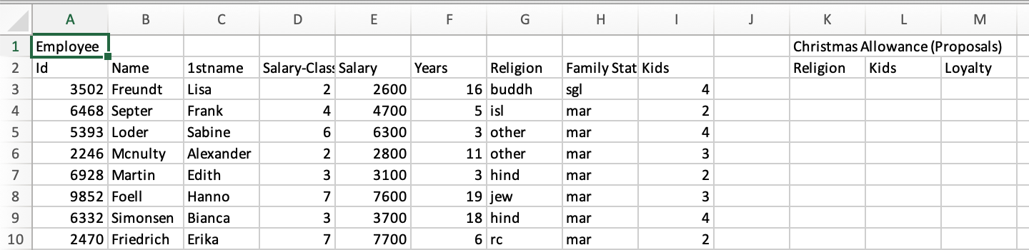

Create the following formats:

* Line 1: Font size 16, bold
* A2:I2, K2:M2: FH-Mint background color (RGB 0, 177, 172), white font color
* The following number formats starting from line 3:
  + A: Number-format "M-"0000
  + E, K, L, M: Currency with the € symbol and two decimal places
* If necessary, adjust the width of the columns.

The three working groups have developed different proposals for the calculation of the Christmas allowance.

* Group 1 (column K): Christmas has a religious background. Members of a religion (column G) receive 50% of their salary as a Christmas bonus. If someone is non-denominational (column G "none"), he/she receives only 20% of the salary as a Christmas bonus.
* Group 2 (column L): Christmas is the feast of children. There is a 100€ Christmas bonus for each child. Single people (column H: sgl) receive an additional €500 if they have at least one child.
* Group 3 (column M): Loyalty must be rewarded: All employees who have been with the company for more than 10 years receive 50% of their salary as a Christmas bonus. Employees who have been with the company for at least 5 years receive 30%. All others 10%.

In columns K:M, calculate the amount of the Christmas bonus for each employee according to the three suggestions.

## ISBN13

In the lecture, it was discussed how the correctness of an ISBN13 can be checked. In the following, you will implement an ISBN13 checker.

Open the worksheet "3) ISBN13". The worksheet should look similar to the following image.

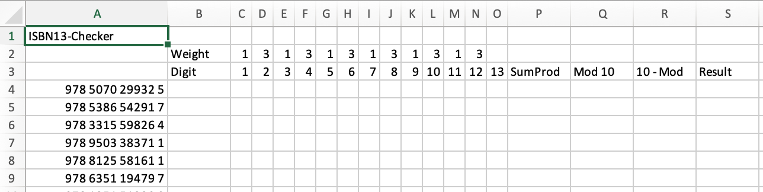

Create the following formats:

* Line 1: Font size 16, bold
* Cells B2:B3, P3:S3 : FH-Mint background color, white font color

Perform the following calculations:

* C4: Use the MID() function. This function is actually a text function (will be discussed later). The function cuts out a given number (3rd parameter) of characters from a text (1st parameter) from a position (2nd parameter). In this case, the first parameter is the ISBN (cell A4), the second parameter is the digit (cell C3). The third parameter is a 1, we want to have exactly one digit. The result should now be a 9 (first digit of the ISBN)
* Caution: This 9 is not a number, but a sign. Therefore, the 9 is also aligned to the left. Add   
  " * 1" behind the function in C4. This multiplication converts the text back into a number.
* Now insert $ so that you can autofill the cells to the right up to column O. Now the individual digits of the ISBN should be in cells C4 to O4.
* Add more $ so that you can autofill cells C4 to O4 downwards as well.
* P4: Calculate the sum of the products of the digits C4:N4 (not O4 !!) with the weights in C2:N2
* Q4: Calculate modulo 10 using the MOD() function
* R4: Subtract the result in Q4 from the number 10.
* R4: Attention: If there is a 0 in Q4, then there is now a 10 in R4. That must not be the case. There should be a 0. Think about how to adjust the function in R4 so that in this case there is a 0 in the cell.
* S4: Compare your result from R4 with the result from O4. If both results are the same, then the text "ISBN correct" should be given as output in S4. Otherwise, the text "Wrong".
* Autofill down P4:S4 automatically.
* There is one wrong ISBN in the list. Copy this wrong ISBN to cell T4

# Submission

Upload your solution to Ilias into the submission folder. Do not change the name of the file under any circumstances. Latest submission: **Sun, Nov. 10, 23:55h**