Exercise Excel 07

Read the task carefully first. Many questions are answered by this!!

# Before you start

Each of you will receive this task. In addition, you must download YOUR Excel file from Ilias. The Excel files are individualised so that everyone has different data to edit. To find your file, go to the ‘Data’ folder in Ilias and download the file with your matriculation number (e.g. 1234567.xlsx).

Important: The tasks are corrected automatically. You must therefore follow the instructions exactly. Under no circumstances may you change the name of the file or the worksheet. You may not move the cells with the data or add any rows or columns. Unless you are explicitly asked to do so. If a specific formula or function is specified for the solution, you must use it. If another formula or function could possibly produce the same solution, you will not receive any points for this.

# Prerequisites for Excel 07

To solve this task, you should be able to do the following things with Excel:

* All requirements of the previous weeks:
  + Formats, Number Formats
  + Build simple functions yourself
  + The most important text functions: SMALL(), LEFT(), RIGHT(), LENGTH(), FIND (), REPLACE(), ...

Only if you set references correctly are you able to fill in cells automatically. If you enter all the formulas manually, you will need a lot, a lot of time. And the solution is **not recognized as correct**!

# Tasks

Especially in tasks 2 and 3, the functions become complex, several functions have to be used together. This can be achieved by nesting functions. However, the formulas sometimes become confusing. You are also welcome to use additional columns for intermediate results, then you don't have to do everything in one cell. If you want to use additional columns, use columns to the RIGHT of the columns that are already filled in or to the right of the columns where the solutions are expected.

Adjust the column width so that the content is reasonably readable for you.

## E-mail for students

You work for the Studierendensekretariat of FH Aachen. You will receive a list of new students (first name, surname, address, ...) (see figure below).

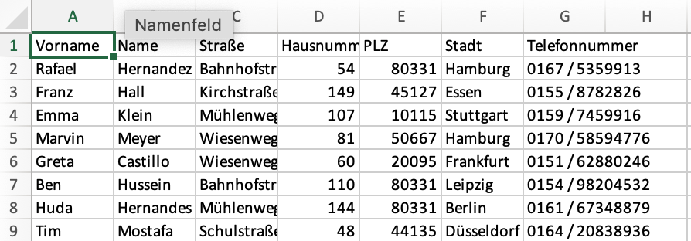

Your task:

* Open the worksheet "1) Students"
* In column H, create the e-mail address of the students according to the scheme of the FH Aachen, i.e. [firstname.lastname@alumni.fh-aachen.de](mailto:firstname.lastname@alumni.fh-aachen.de) (Example: The student in line 2 would have to receive the e-mail address [rafael.hernandez@alumni.fh-aachen.de](mailto:rafael.hernandez@alumni.fh-aachen.de) ).
* Use suitable Excel functions for editing texts. Make sure that the first letters of first names and surnames in the email address are lowercase.
* Email addresses must be unique. An e-mail has been assigned twice because two people have identical first and last names. Find the duplicate email. Use the functions of the past weeks in an appropriate way. Copy the duplicate email to cell J2.
* Format:
  + In cell H1, add the heading "Email".
  + Cells A1:H1: FH-Mint background color (RGB 0, 177, 172), white font color

## Name from E-mail address

Open the "2) E-Mail" worksheet. The worksheet looks similar to the following image:

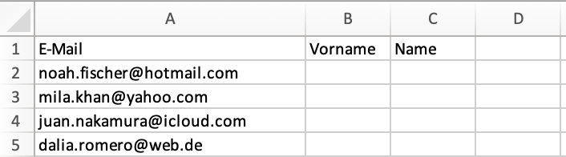

You have received e-mails from various people who may want to enrol for your studies. The email addresses (column A) come from different domains (hotmail.com, yahoo.com, ...), but always have the structure [firstname.lastname@domain](mailto:firstname.lastname@domaine). Your task:

In columns B and C, use text functions to extract the first name and lastname from the e-mail addresses. The first letter must be displayed in capital letters (example: B2: Noah, C2: Fischer)

The format in cells A1:C1 is the same as in the previous task.

## Phone numbers

Finally, you will get an address list with phone numbers like in the following figure:

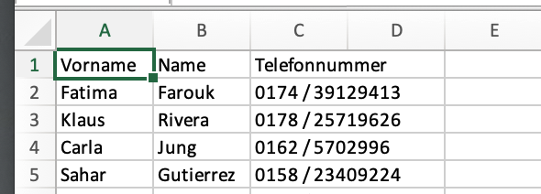

The telephone numbers are in the format "Area Code / Number" (see figure). In column D, create the same phone number with the following format:

* First "+49"
* Empty space
* Then in brackets the area code without 0 (e.g. (174) )
* Empty space
* The number

Example: The number 0174 / 39129413 (see Figure C2), should become +49 (174) is 39129413 in D2

You can't solve this problem with number formats, instead you have to use suitable text functions.

# Submission

Upload the solution file to Ilias in the submission folder. Do not change the name of the file under any circumstances. Latest drop-off: **Sun, Nov. 17, 23:55h**