Exercise Excel 08

Read the assignment carefully. Many questions are answered by this!!

# Before you start

Each of you will receive this task. In addition, you must download YOUR Excel file from Ilias. The Excel files are individualised so that everyone has different data to edit. To find your file, go to the ‘Data’ folder in Ilias and download the file with your matriculation number (e.g. 1234567.xlsx).

Important: The tasks are corrected automatically. You must therefore follow the instructions exactly. Under no circumstances may you change the name of the file or the worksheet. You may not move the cells with the data or add any rows or columns. Unless you are explicitly asked to do so. If a specific formula or function is specified for the solution, you must use it. If another formula or function could possibly produce the same solution, you will not receive any points for this.

# Prerequisites for Excel 08

To solve this task, you should be able to do the following things from Excel:

* Because of Reading Week, there is no new content. You should repeat the material of the first weeks:
  + Formats, Number Formats
  + Build simple functions yourself
  + Functions from the fields of mathematics, text, logic, finance, ...

Only if references are set correctly you are able to fill in cells automatically. If you enter all the formulas manually, you will need a lot of time. And the solution is **not recognized as correct**!

# Tasks

In some tasks, you need to nest functions. If you prefer to do this step by step and want to save intermediate values, you can do so. However, the intermediate values must be to the RIGHT of the cells that have already been filled in or that you are to fill in. When correcting, the solutions are expected, e.g. in cell G5, your solution should not slip to e.g. H5 due to an intermediate value.

Adjust the column width so that the content is reasonably readable for you.

## Automatically generated invoice

You work at OGIA GmbH and are supposed to (partially) automate invoicing there. For this purpose, a customer database and a product database are available. In this case, these are simply parts of the Excel spreadsheet (see image below).

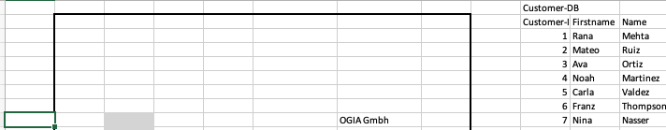

Your task:

* Open the "1) Invoice" worksheet
* In columns B:H there is a black frame, where the invoice is to be created automatically. In each of the gray fields, there must be a formula. In the orange fields, constants have to be filled in.
* The automation is as follows:
  + If a customer number is inserted in H14, the values for C9:C11 (name, address) are automatically fetched from the customer database.
  + If a product number is retrieved in the fields C20:C29, the values in columns B, D, F, G are automatically added. Only the number in column E has to be filled in manually.
* **Important:** The following applies to all formulas: Nothing must be displayed (no error, no 0, ...) if the referenced cells are empty.
  + If there is no customer number in H14, the C9:C11 fields remain empty.
  + If there is no product number in C23, the fields in B23, D23, F23, remain empty. The same is true for all other cells C20:C29 and their corresponding cells in B, D, F.
  + If there is no value in G20, the numbers in G30:G34 remain empty.
  + You must use IFERROR() or IF() accordingly.

What to do:

* Format:
  + The number format for the customer number (columns J and H14) is: "Cust-"0000
  + The number format for the product number (column R, C20:C29) is: "Prod-"000
  + The discount in column P and in F31 is a percentage without a comma (e.g. 15%)
  + The number format for all prices (column T, F20:F29, G20:G34) is currency with €.
* Formulas and values:
  + In H14 enter a customer number
  + In H15, add a fantasy invoice number.
  + In H16 you use the formula =TODAY(), the current date is displayed.
  + Depending on the customer number in H14, the cells C9:C11 are filled:
    - C9: First name, space, last name (e.g. Peter Müller)
    - C10: Street and house number
    - C11: Zip Code and City
  + Cells C20:C29 can contain up to 10 product numbers. These are always entered from top to bottom.
  + Cells B20:B29 contain the numbers 1 to 10. Only if there is a value in column C in the respective cell, the item number is displayed. The formulas must be automatically filled down from B21 at the latest.
  + The product name is automatically entered in cells D20:D29.
  + In cells E20:E29, the number of products is manually added.
  + In cells F20:F29, the unit price of the product is inserted by formula.
  + In the cells, the total price (number * unit price) is calculated.
  + In cell G30, the sum of G20:G29 is calculated.
  + Cell F31 will enter the discount depending on the customer number.
  + In cell G31, the discount is calculated (F31*G30)
  + In cell G32, the discount (G31) is subtracted from the sum (G30).
  + In cell F33 enter 19% (if there is nothing there yet)
  + In cell G33, calculate VAT (F33*G32)
  + In cell G34, add the values from G32 and G33
  + In cell D39, calculate when the invoice should be paid at the latest: =H16 + 14 (14 days later than the invoice date)
* Format again: Delete the gray and orange in the background. Repair border lines that were deleted during autofill.

## Project plan

Open the "2) Project Plan" worksheet. The worksheet looks similar to the following image:

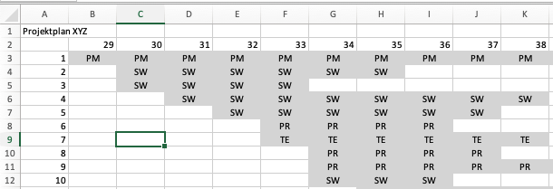

Line 2 contains the calendar weeks, column A contains the work packages of the project. The placement of the greyed cells shows which work package extends over which weeks. The abbreviations in the work package (e.g. PM) indicate who is responsible for the work package.

To the right of the plan is a helper table, where the costs for the individual roles are listed. Below the project plan, it should be calculated how many people of which role (PM, SW, ...) are needed per week, anf what this costs per week and per week accumulated.

Your task:

* Format:
  + Cells A1 and cell containing "Cost per …": bold, font 16
  + Number format for the calendar weeks in line 2: "KW-"00
  + Number format for the work packages in column A: "AP-"000
  + Number format for all costs: Currency with € sign
  + Background color for the calendar weeks, work packages and for the cell in row 2 to 5 under the cell "Cost per …": FH-Mint and white font
* Calculations:
  + In the cells below the project plan, to the right of the entries PM, SW, ...: Calculate the demand per roll (SW, SW, TE; PR) per week. Enter a formula only in the cell to the right of PM (column B, row depends on the project plan) and autofill it from there to the bottom and to the right.
  + Calculate the cost per week. Multiply the cost from the helper table with the number of the roles you need.
  + Calculate the accumulated costs per week.
* Format: If necessary, adjust the column width.

## Emails

You have received emails from various customers and want to do an analysis of these customers. Which country do the customers come from? What domain are they using. Open the "3) E-Mails" worksheet, which looks something like this:

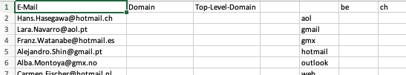

In column A, you can see the email addresses. In columns B and C, you should determine the respective domains or the top-level domains. Then you do a quantitative analysis in the cross table E1:S9.

* Format:
  + Cells A1:C1, E1:S1, E2:E9: FH-Mint background color, white font
* Calculation:
  + In column B, you use text functions to determine the domain. Example from [Sami.Zayed@web.pt](mailto:Sami.Zayed@web.pt) the web is extracted.
  + In column C, you determine the top-level domain. Example from [Sami.Zayed@web.pt](mailto:Sami.Zayed@web.pt) becomes pt
  + In cells F2:R8, you determine how many emails the corresponding domain or top-level domain has. The function should be auto-fillable from F2 down and right.
  + Finally, find the totals of the rows and columns.

## Logic

In this task, you will have to do some puzzles. Open the worksheet "4) Logic Brain Teaser. It should look like this (German Version of the sheet: Replace "FALSCH" by "FALSE" and "WAHR" by "TRUE")

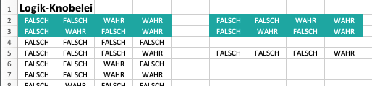

In the FH-mint-colored cells in rows 2 and 3 are the input values for a logic function. Depending on the input, this function is supposed to deliver the outputs in lines 4 – 19. In the table on the left, you can see the values as constants that are to be achieved by the logic function. In the table on the right, the same values are supposed to be achieved by functions. Four lines are already filled in as an example.

* Row 5 is the function AND() related to the inputs in rows 2 and 3 of the respective column.
* Line 9 st a copy of line 3
* Line 11 is the OR() related to lines 2 and 3
* Line 19 is OR(F2; NOT(F2)).

There are other solutions for these lines as well.

Your task:

* Fill in the open rows in the table on the right.
* You may only use the AND(), OR() and NOT() functions.
* You may only make a reference to rows 2 and 3 of the respective column.
* The function within a line must be the same. So just fill in column F and autofill to the right.
* The values in the right table must look the same as the values in the left table.

Have fun puzzling

# Tax

Upload the solution file to Ilias in the submission folder. Do not change the name of the file under any circumstances. Latest drop-off: **Sun, Nov. 24, 11.55 p.m.**