Exercise Excel 09

Read the assignment carefully. Many questions are answered by this!!

# Before you start

Each of you will receive this task. In addition, you must download YOUR Excel file from Ilias. The Excel files are individualised so that everyone has different data to edit. To find your file, go to the ‘Data’ folder in Ilias and download the file with your matriculation number (e.g. 1234567.xlsx).

Important: The tasks are corrected automatically. You must therefore follow the instructions exactly. Under no circumstances may you change the name of the file or the worksheet. You may not move the cells with the data or add any rows or columns. Unless you are explicitly asked to do so. If a specific formula or function is specified for the solution, you must use it. If another formula or function could possibly produce the same solution, you will not receive any points for this.

# Prerequisites for Excel 09

To solve this task, you should master the following things of Excel:

* All content of the previous weeks. In addition:
  + Function to calculate time and date
  + Number formats for time and date

Only if you set references correctly are you able to fill in cells automatically. If you enter all the formulas manually, you will need a lot, a lot of time. And the solution is **not recognized as correct**!

# Tasks

In some tasks, you need to nest functions. If you prefer to do this step by step and want to save intermediate values, you can do so. However, the intermediate values must be TO the RIGHT of the cells that have already been filled in or that you are to fill in. If a solution is e.g. expected in cell G5, your solution should not slip to e.g. H5 due to an intermediate column.

Adjust the column width so that the content is reasonably readable for you.

## Date and time with functions and with number format

In the following task, the same – at least outwardly visible – results are to be achieved with the help of functions or number formats. Cells B2 and F2 contain a date and a time respectively (see the following figure):

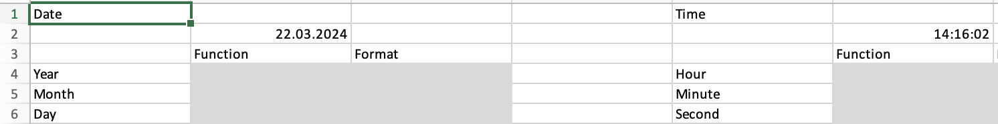

Open the "1) Time" worksheet. In the gray fields, you must specify functions and/or number formats. Your tasks are as follows:

Formats:

* Cells A1, E1: bold, font size 16
* Cells B3:C3, F3:G3, A4:A9, A11, E4:E6: FH-Mint background color, white font color.

Functions:

* Cells B4:B9 all refer to cell B2. With the help of Excel functions and self-created formulas, calculate the year, month, ... of the date.
* In cell B8, the format should be as follows: "Wk-05".
* In cell B9 the format should be as follows "Q1".
* The WEEKDAY() function returns a number as a result. Create a helper table that represents the day as a name. The helper table should be to the right of the cells that are already in use. With the help of VLOOKUP() you can then convert the result of WEEKDAY() into the name of the day. Side condition: Monday = 1, Sunday = 7.
* In cells C4:C7, year, month, ... can be determined. However, there is only a reference to cell B2 (=B2) in the cell. Adjust the number format so that year, month, ... are displayed.
* The cells F4:G6 all refer to the time in F2. In cells F4:F6 you again use formulas to calculate hours, minutes, ... of F2.
* In cells G4:G6, you use number formats.
* In cell B11 make a reference to B2. The result should be e.g.(depending on the date): "Version from Friday, 22. November 2024"

**Note:** In some versions of Excel, the number format, that specifies minutes, is implemented incorrectly. When you enter the format, everything is usually fine. When you save the file and reopen it again, the month is displayed instead of minutes. If this is the case for you, simply leave the format as you have entered it for the minutes.

## Price depends on age

A visit to the cinema is organised for the final classes of the XY School. Ticket prices are broken down by age (see figure):

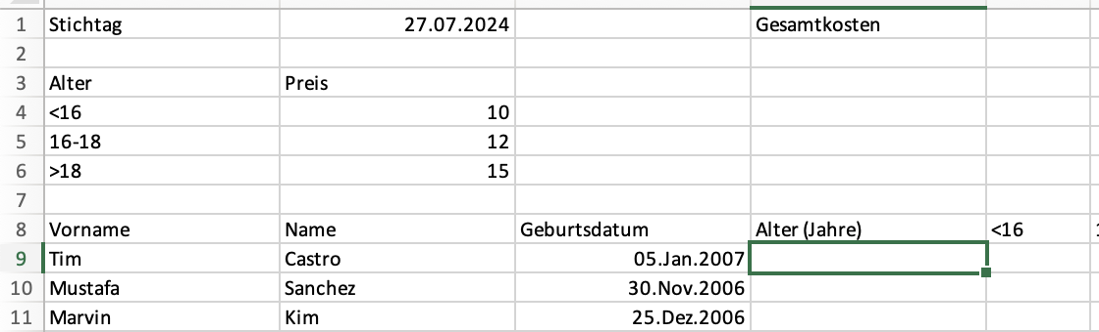

Open the "2) Cinema" worksheet and make the following adjustments:

Sizes:

* Cells A1, D1, A3:B3, A4:A6, A8:H8: FH-Mint background color, white font color
* Number formats: E1, B4:B6, column H from H9: currency, two decimal places, € sign

Functions:

* Calculate the age of each person in relation with respect to the date in B2.
* In columns E, F, G there is an "X" if the person is in the relevant age group (younger than 16, 16-18, older than 18. Note: If the result in column D is 18, the person in question is older than 18)
* In column H, indicate how expensive the ticket is for the person in question.
* In cell E1, calculate the total cost for all tickets.

## Interest

Since calculating with times and dates is complicated, the financial industry usually works with the 360-day year. Each of the 12 months contains 30 days. The differences to the actual duration are "rounded away". In the following task, you will receive interests on a given amount that you have invested. Calculate the interest once on the basis of the 360-day year, once on the basis of the correct duration.

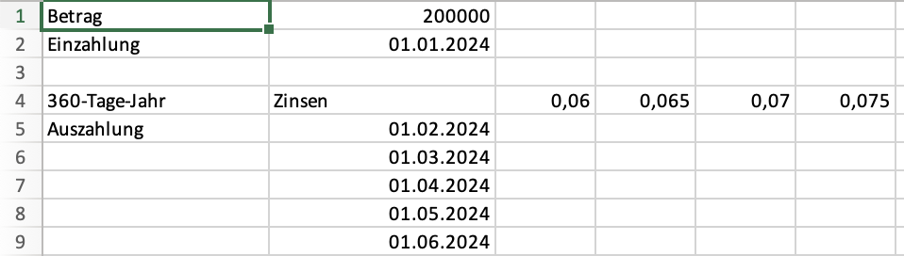

Open the worksheet "3) Interest" and follow these steps:

Formats:

* Cells A1:A2, A4:L4, A5, A18:L18, A19: FH-Mint background color, white font color
* Cells C4:L4, C18:L18: Number format percent with one decimal place
* Cells B1, C5:L16, C19:L30: Number format: currency, two decimal places, € sign, if negative then red.
* If your values end before or after column L, adjust the formats accordingly.

Functions:

* You invest the amount from cell B1. There are different interest rates (columns C-L) and different points in time when you get the payment back (rows 5-16, or 19-30).
* In the table above, calculate the interest received on the basis of a 360-day year.
* Based on the "normal" year, calculate the interest received in the table below.

As a check: After one year, both methods should lead to the same result!

# Submission

Upload the solution file to Ilias in the submission folder. Do not change the name of the file under any circumstances. Latest drop-off: **Sun, Dec. 1, 11.55 p.m.**