Exercise Excel 10

Read the assignment carefully. Many questions are answered by this!!

# Before you start

Each of you will receive this exercise. In addition, you must download YOUR Excel file from Ilias. The Excel files are individualised so that everyone has different data to edit. To find your file, go to the ‘Data’ folder in Ilias and download the file with your matriculation number (e.g. 1234567.xlsx).

Important: The tasks are corrected automatically. You must therefore follow the instructions exactly. Under no circumstances you must change the name of the file or the worksheet. You must not move the cells with the data or add any rows or columns. Unless you are explicitly asked to do so. If a specific formula or function is specified for the solution, you must use it. If another formula or function could possibly produce the same solution, you will not receive any points for this.

# Prerequisites for Excel 10

To solve this task, you should master the following things of Excel:

* All content of the previous weeks. In addition:
  + Creation of charts (line chart, scatter chart, ...)
  + Chart customization
    - Line color and thickness
    - Adding Data Series
    - Adjustment of x- and y-axis
    - Linking chart elements to cells
    - …

Only if you set references correctly are you able to fill in cells automatically. If you enter all the formulas manually, you will need a lot, a lot of time. And the solution is **not recognized as correct**!

# Tasks

For some of the tasks, first the data has to be prepared. Partly, this requires nested functions. If you prefer to do this step by step, you are welcome to use additional cells. However, the cells in which I expect values or cells that are needed for the charts must not be moved.

Adjust the column width so that the content is reasonably readable for you.

## Turnover

To start, you'll create a line chart and a pie chart. The sales figures of various sales employees over several months up to November are given. There is no data for December yet (see figure):

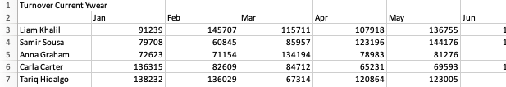

First, sum the sum of the monthly sales of the individual employees in the corresponding column. Then create the charts:

* Line chart for all employees throughout the year (including December)
* Pie chart about the sum
* Add a chart title (if you don't already have one) and connect it to cells A1 (line chart) and N2 (pie chart). (If you change the text in cell A1, the line chart title should change as well.)

The results can look something like this:

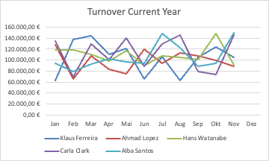 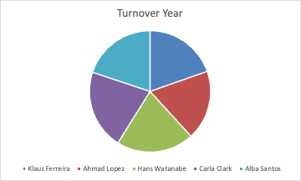

## Stock exchange

You will receive stock market data from two companies from the years 2013 – 2023. Since trading on the stock exchange is not carried out every day, the data is not complete. Individual data is missing, while no value is entered for some given dates. They are supposed to create line charts for the companies for a given year. To do this, the data must first be prepared.

In cell G3 there is a date (e.g. 2.12.2018). In this case, you need to create charts for the coming year (i.e. 2019). In particular, you are supposed to draw a 30-day (60-day, 90-day) curve, which is why G3 does not show 1.1.2019 but a lead time of 30 (60, 90) days.

Your task:

* Starting from the date in G3, you fill in column G so that ALL the dates are there until the end of the coming year. In the example, column G contains the data from 2.12.2018 to 31.12.2019.
* Then determine the price for all the data in column H. If there is no value for a date, take the price from the previous day. The functions IFERROR(), IF() or VLOOKUP() are helpful. If there is no value for the first day (in the example 2.12.2018), you can simply extend column G upwards. I.e., insert a cell, move the old values down one line and enter the new date 1.12.2018 in G3 now.
* In the column "30-days" (60-days, 90-days) you now calculate the average value of the last 30 days (including the current one). Start to do this not in row 3 but in the row with the 1st of January. To do the calculation, use the AVERAGE() function. (That's why the lead time of 30 (60, 90) days had to be added.
* In the column "Normalized" you calculate a normalized price. Imagine, you would have invested €100 in the company, how would the money have developed? The calculation can be done with a simple formula: Assuming January 1st, 2019 is in cell G35, then cell H35 is the current price. In J35, you can use this formula: =H35/$H$35 * 100. You can automatically fill in this formula downwards.
* For the second company, fill in the columns K,L,M in the same way. You can reuse the data from column G.

Now the line charts:

* The first chart shows the current prices for both companies as well as the smoothed 30-day (60-day, 90-day) values.
* In cells I1 and L1, you have entered a color including the color code (in hex) for each of the two companies. Assign the respective color to the lines of the companies. The smoothed 30-day (60-day, 90-day) line has a thickness of 2.5 pt and the line with the current price has a thickness of 1 pt.
* In the x-axis is the timeline. Adjust the axis options so that a date axis is chosen, that the beginning is on 1st Jan of the year and the end is on 31st Dec, that the main and tick marks are in the month and that the chosen number format is dd.mm.yyyy
* The second line chart shows the two normalized prices. Again, use the colors for the two companies. Both lines must start at 100 and then develop differently.
* For the x-axis, the same applies as above.
* Add a suitable chart title.
* Legends should be shown.

The charts could look like this:

 

## GDP and population

In worksheet "3) GDP" you get the GDP (in million €) and the population for two countries. Create a line chart for each country that shows the evolution of GDP and population. Use the default colors for GDP (G1) and population (H1).

* First, adjust the number format of columns B and D so that the unit "M€" (mega euro, million euro) is shown there.
* Create a line chart for each country with two lines (GDP and population)
* The x-axis is the years.
* Important: Since population and GDP have two different units, you need to add a second y-axis. In the end, GDP should be displayed in the left y-axis, the population in the right y-axis.
* Add a chart title and a legend. The chart titles are linked to cells B2 and D2, and the legends are linked to cells B3:E3.

The result could look like this:

 

## Scatter Chart

Open the "4) Scattered-Diagram" worksheet. There you will find a table with the data of 100+ people. The data is as follows: height, weight, sex. Your task: Create a scatter chart in which each person is represented by a dot according to their height and weight. The sex is to be represented with the help of the colors (cell D1, E1).

* Adjust the number formats to indicate "cm" in column A and "kg" in column B. Column A without one decimal place, column B with exactly one decimal place.
* Sort the data by sex.
* Create an scattered chart and insert the male and female data as different data series.
* The size is shown on the y-axis, the weight on the x-axis.
* Adjust the axes as follows:
  + x-axis goes from 40kg to 120kg
  + y-axis goes from 150cm to 210cm
* Assign the colors to the rows: Male 🡪 D1, Female 🡪 E1
* Add chart title and legend. The following applies:
  + Chart title refers to cell A1
  + Legend refers to two cells in column C so that "m" or "w" is represented.

The result could look like this:



# Submission

Upload the solution file to Ilias in the submission folder. Do not change the name of the file under any circumstances. Latest drop-off: **Sun, Dec. 8, 23:55h**