Exercise Excel 11

Read the assignment carefully. Many questions are answered by this!!

# Before you start

Each of you will be given this task. In addition, you need to download **YOUR** Excel file from Ilias. The Excel files are individualized, so that everyone has different data to process. To find your file, go to the "Individual Excel File" folder in Ilias and download the file with your matriculation number (e.g. 1234567.xlsx).

Important: The tasks are corrected automatically. Therefore, you must follow the task exactly. You must not change the name of the file or worksheets under any circumstances. You must not move the cells with the data, add rows or columns. Unless this is explicitly requested of you. If a certain formula or function is given for the solution, you must use it. If a different formula or function might yield the same solution, you won't get any points for it.

# Prerequisites for Excel 11

To solve this task, you should master the following things of Excel:

* All content of the previous weeks. Additionally:
  + Import of csv files
  + "Text to Columns"-transformation
  + Use of filters
  + Conditional formatting

Only if you set references correctly are you able to fill in cells automatically. If you enter all the formulas manually, you will need a lot, a lot of time. And the solution is **not recognized as correct**!

# Tasks

This week, raw data must be converted into data that can be processed by Excel. There are various ways to do this. Two alternatives are proposed as part of the task.

Adjust the column width so that the content is reasonably readable for you.

## Corona

For the first task, you must first obtain data from the RKI. Go to the following address <https://robert-koch-institut.github.io/COVID-19_7-Tage-Inzidenz_in_Deutschland/> and download the csv file with the 7-day incidence of Covid-19 cases for the federal states (Bundesländer) in Germany and save it so that you can access it later.

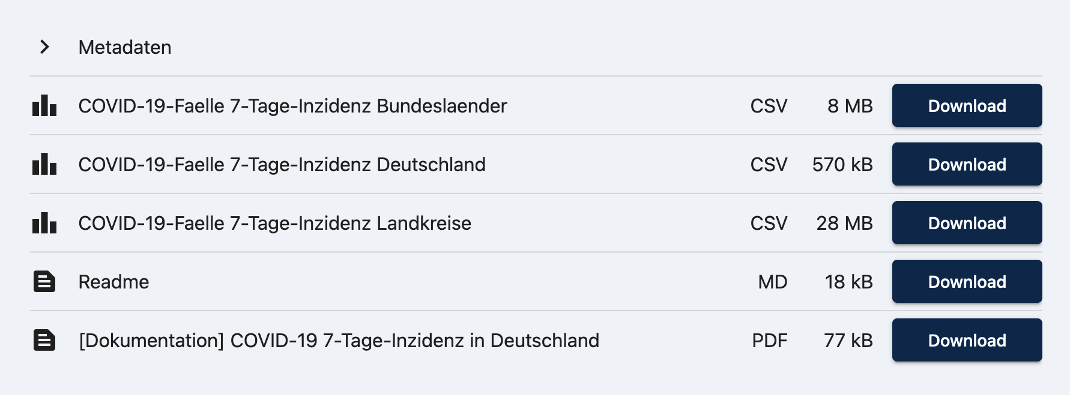



Open your Excel file and go to the worksheet "1) Corona". There is no data there yet. In cells J1:J2, a federal state (Bundesstaat) is given for one year. For these two parameters, you should create a line chart with the 7-day incidence at the end. First, the data must be imported. There are several options to do this. Two alternatives are described in the following:

Option 1:

1. From the "Data" menu, "Get & Transform Data" group, select "From Text"
2. Navigate to your csv file and select it for import.
3. The advantage of this alternative is that you can now select the "File origin". Behind this are various codes that indicate how 0s and 1s are converted into a character. Especially with special characters such as ä, ö, ü there are sometimes problems. Check the preview to see if everything looks as expected. If special characters are not displayed correctly, select a different format for the file origin. If everything is okay, click "Next".  
   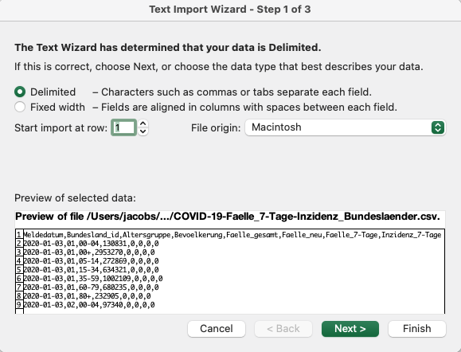



1. In the second step in the dialog box, you have to select which separator separates the individual values. Preview again and select the appropriate separator. If the correct separator has been selected, the individual entries are displayed in columns. Click "Next".
2. Click through each column and select the appropriate number format. Different formats are offered for the date (e.g. "DMY", "YMD", ...), select the appropriate one. If there are real numbers (numbers with a dot) in a column, click on "Advanced". There you have the option to choose whether a comma or a dot is used for real numbers. Many data sets generated by programs use the dot here. Select "Finish".
3. Select the appropriate field to import ($A$1 of the current spreadsheet).
4. Check the data carefully. If the data is not formatted as desired, go back and repeat the previous steps!
5. There is too much data available, you are only interested in data for one federal state, one year and for all age groups. Therefore, the data must now be filtered. Go to the "Start" menu, "Edit" group and select "Filter" under "Sort and Filter". Filter buttons should appear in the first line (see figure).  
   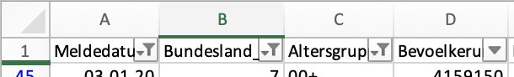



1. In column A, select the default year (cell J2). In column B, select the state (cell J1, number after the name). In the age group, select "00+" (all ages).
2. Finally, select columns A ("Meldedatum") and H ("Incidence 7 days") and create a line chart.

Option 2:

1. Navigate to the csv file and open it with a double-click. Typically, the operating system is set to open csv files with Excel. The file should look something like this:  
   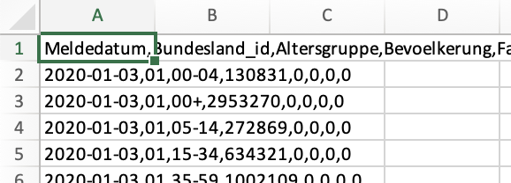

A data set is always in one cell, the data is NOT in different cells.

1. Highlight column A and go to the "Data" menu, "Data Tools" group, "Text to Columns" function.
2. Go through steps 4 through 9 of Option 1. Possible problem: If some data is not displayed correctly, you will not be able to select a different codex because step 3 is not offered in this procedure. In this case, select option 1.
3. You've imported and filtered the data. Copy the spreadsheet and go to the "1) Corona" worksheet of your Excel file. Copy the data from cell A1.
4. Follow step 10 of option 1.

## Conditional formatting

In the data sheet "2) Data" there is random data. The data has already been inserted as text. Similar to Task 1, Option 2, they must first be distributed to different cells using the "Text in Columns" function. Then follow these steps:

1. Cell A1:R1 is given the following format: Background color: FH-Mint, Font color: White, centered
2. Select the cells from row 2 in columns B:P and assign the colour scale specified in cell U1 to the cells (Conditional Formatting)
3. Select the cells in column Q starting from row 2 and assign the icon set specified in U2.
4. In column R from row 2 onwards, highlight the character specified in U3 by showing it **in bold**.

The result could look like this:



# Submission

Upload the solution file to Ilias in the submission folder. Do not change the name of the file under any circumstances. Latest drop-off: **Sun, Dec. 15, 23:55h**