Exercise Excel 12

Read the assignment carefully. Many questions are answered by this!!

Just like the task during the Reading Week, this task is voluntary. You can make up points. If you don't submit anything, you don't lose anything.

# Before you start

Each of you will be given this task. In addition, you need to download **YOUR** Excel file from Ilias. The Excel files are individualized, so that everyone has different data to process. To find your file, go to the "Data" folder in Ilias and download the file with your matriculation number (e.g. 1234567.xlsx).

Important: The tasks are corrected automatically. Therefore, you must follow the task exactly. You must not change the name of the file or worksheets under any circumstances. You must not move the cells with the data, add rows or columns. Unless this is explicitly requested of you. If a certain formula or function is given for the solution, you must use it. If a different formula or function might yield the same solution, you won't get any points for it.

# Prerequisites for Excel 12

To solve this task, you should master the following things of Excel:

* All content of the previous weeks:

Only if you set references correctly are you able to fill in cells automatically. If you enter all the formulas manually, you will need a lot, a lot of time. And the solution is **not recognized as correct**!

# Tasks

Adjust the column width so that the content is reasonably readable for you.

## Salutation

Week 7 was already about text functions. You need them today, too. However, in combination with logic formulas (e.g. IF()). You may be able to simplify the situation by remembering last week's "Text to Columns" feature.

In worksheet "1) Salutation" you have the data of a number of people in column A.

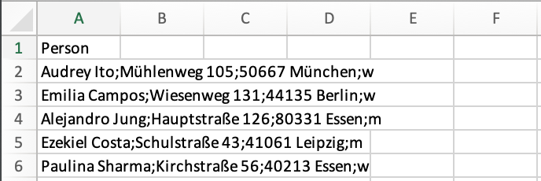

At the beginning, before the first separator, is the name of the person. More exactly, the first name and the last name separated by a space. At the end, after the last separator, there is a letter: m, f, d. These stand for male, female, diverse. In column J, you should insert the appropriate salutation (e.g. for an envelope) depending on gender. The following applies:

* If gender = m: The salutation is "Mr. <first name> <last name>"
* If gender = w: The salutation is "Mrs. <first name> <last name>"
* If gender = d: The salutation is "<first name> <last name>"

Note: there is exactly one space between first and last name. If Mrs./Mr. appears at the front, there is exactly one space between Mrs./Mr. and the first name.

Examples:

* Row 2: "Mrs. Audrey Ito"
* Row 4: "Mr. Aljandro Jung"

## World Data

The data in the worksheet "2) Countries" comes from the webpage https://ourworldindata.org. For the years 1990, 2000, 2010 and 2020, there are values for GDP per capita, population and life expectancy for every country in the world. Your task:

* Transfer the data into individual columns.
* Sort by continent.
* Create filters and filter by year = 2020
* Create a bubble chart. Each continent represents a (data) series.
  + X-values: GDP per capita
  + Y-value: Life Expectancy
  + Sizes: Population
* I.e. the more inhabitants a country has, the bigger the bubble. The higher the GDP per capita, the further to the right the bubble moves, the higher the life expectancy, the higher the bubble moves up.
* Use the filters to show and hide individual continents.
* Filter out an individual country and look at the values for all years.
* Finally, set the filters to Year = 2020, Continent = Asia, Europe

## Math is beautiful

Even if you may not agree with the headline, I will try to convince you. Open the corresponding worksheet. There you will see some x- and y-values.

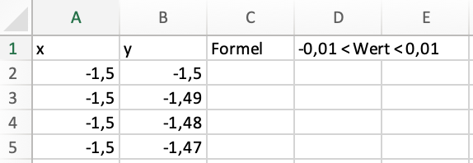

(More precisely, the x-y combinations cover all points between -1.5/-1.5 and 1.5/1.5 in increments of 1/100.

The equation x² + y² - 1 – |x|y = 0 has a solution for many combinations of x and y that result in an image. (By the way, |x| stands for the absolute value of x, i.e. the number x without a sign. Thus |7| = 7, |-7| = 7. In Excel, there is the formula ABS()) to compute this absolute value.)

Your task:

* Use the above formula in column C to calculate the respective value of the formula for the values for x and y in columns A and B.
* Since the exact combinations for x and y leading to a zero are not exactly at our points x/y, we now have to trick something in column D. If the value from column C is between -0.01 and 0.01, we write a 0 in column D, otherwise a 1.
* Now set automatic filters and filter out the rows that have a 0 in column D.
* Finally, create a point chart from the x and y values of the filtered rows.

# Submission

Upload the solution file to Ilias in the submission folder. Do not change the name of the file under any circumstances. Latest drop-off: **Sun, Jan. 5, 2025, 23:55h**