**/*Government wish to know the number of colleges in each state to allocate budget**

**Write a query to find Number of Universities in each state in Decreasing Order*/**

Select "State", count(*) as No_of_Colleges

From "University","Address_zip"

Where "University"."Zipcode" = "Address_zip"."Zipcode"

group by "State"

order by no_of_colleges Desc;

**/* Govenment wish to keep a check on the number of Public Universities**

**in the country. Query the requirement*/**

**select count(*) as Public_Universities From "University"**

**/*Government wish to know the total aid going to each ethnic group to**

**see if there is bias towards any specific ethnic group.**

**Write a query to find the same*/**

**Select "Ethnicity",Sum("Aid_Value") as Total_aid**

**from "Ethnicity" inner Join "StudentDetails"**

**on "Ethnicity"."Ethnic_id" = "StudentDetails"."Ethnic_id"**

**group by "Ethnicity"."Ethnic_id" order by SUM("Aid_Value") Desc**

**/*Government wish to know the student details who**

**score above average in sat to analyse the trend in their degree completion.**

**Therefore query Students who have sat score greater than 1500 and less than 1600 (before indexing)*/**

**Select \***

**from "StudentDetails"**

**where "Sat_Score" >1500 and "Sat_Score" < 1600**

**/*Government wish to know the student details who**

**score above average in sat to analyse the trend in their degree completion.**

**Therefore query Students who have sat score greater than 1500 and less than 1600 (After indexing)*/**

**Select \***

**from "StudentDetails"**

**where "Sat_Score" >1500 and "Sat_Score" < 1600**

**/*Government wish to send inputs to Universities doing poorly in terms of**

**degree completion time. Write query to find the Universities that have**

**average degree completion time greater mean degree completion time**

**of all the students*/**

**select "Name", Avg("Degree_Completion_time") as Avg_Degree_Comp_Time**

**from "StudentDetails", "University"**

**where "StudentDetails"."University_id" = "University"."University_id"**

**group by "University"."University_id"**

**having Avg("Degree_Completion_time") > (Select avg("Degree_Completion_time") from "StudentDetails")**

**order by Avg("Degree_Completion_time") desc**

**We can see in explain too that aggregating degree completion time and sorting on average degree completion time is taking the most time in the query. This can be optimized by creating an index for degree completion time.**

**AFTER INDEXING,**

**/*Government wants to know the Ethnic representation of Faculty**

**for each University to see if guidelines are followed. Write a**

**query for the same*/**

**Select "University"."Name", "Ethnicity", count(*) as Number**

**from "University" inner join "FacultyDetails"**

**on "University"."University_id" = "FacultyDetails"."University_id"**

**inner join "Ethnicity" on "FacultyDetails"."Ethnic_id" = "Ethnicity"."Ethnic_id"**

**group by "University"."University_id", "Ethnicity"**

**order by "University"."Name"**

**/* Government wish to analyze the students who recive aid**

**greater than 18000$ and less than 20000$ and degree completion is**

**greater than 4 years but less than 6 years to see if the aid is really helping them*/**

**select * from "StudentDetails"**

**where ("Aid_Value" >= 18000 and "Aid_Value" <=20000) and**

**("Degree_Completion_time" >=4 and "Degree_Completion_time" <=6)**

**After Indexing**

**/*New college is established at Englewood. Insert the college in University Table */**

**Insert into "University"**

**values (3706,'SUNY Englewood','Public','www.sunyengle.edu',14214)**

**/* Faculty Cindy Smith has retired, remove her entry from Faculty Details */**

**Delete from "FacultyDetails" where "Name" = 'Cindy Smith'**

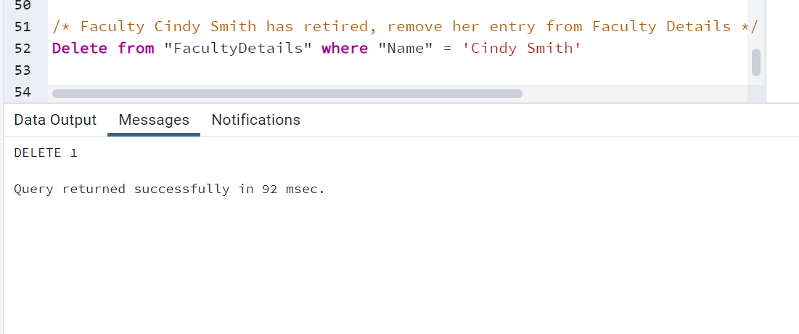

**/*Jenifer Carr, student id =1 received a federal aid of 12000$,**

**update the aid_value in the StudentDetails*/**

**update "StudentDetails"**

**set "Aid_Value" = 12000**

**where "Student_id" = 1**

**and "Student_Name" = 'Jenifer Carr'**

**/*Government need to know the number of colleges present in buffalo**

**to make it educational corridor if number of colleges is greater than 5**

**Write a query to find the same*/**

**Select count(*) as NoOfCollgesatBuffalo**

**from "University"**

**join "Address_zip"**

**on "University"."Zipcode" = "Address_zip"."Zipcode"**

**where "City" = 'Buffalo';**

**/* Government wants to know the male to female ratio of faculty for**

**Amridge Univeristy univeristy id = 3 after complaints of poor gender ratio*/**

**select Concat(sum(case when "Gender" = 'Male' then 1 end),':',**

**sum(case when "Gender"= 'Female' then 1 end)) as Male_to_Female**

**from "FacultyDetails"**

**where "University_id" = 3**

