CS550 Programming Assignment 3

A20427181

Haiyouer Aiyilaiti

Design Document

Class:

MainEntrance: main entrance of the program. User choose to use PULL or PUSH approach according to the configuration file before running the program.

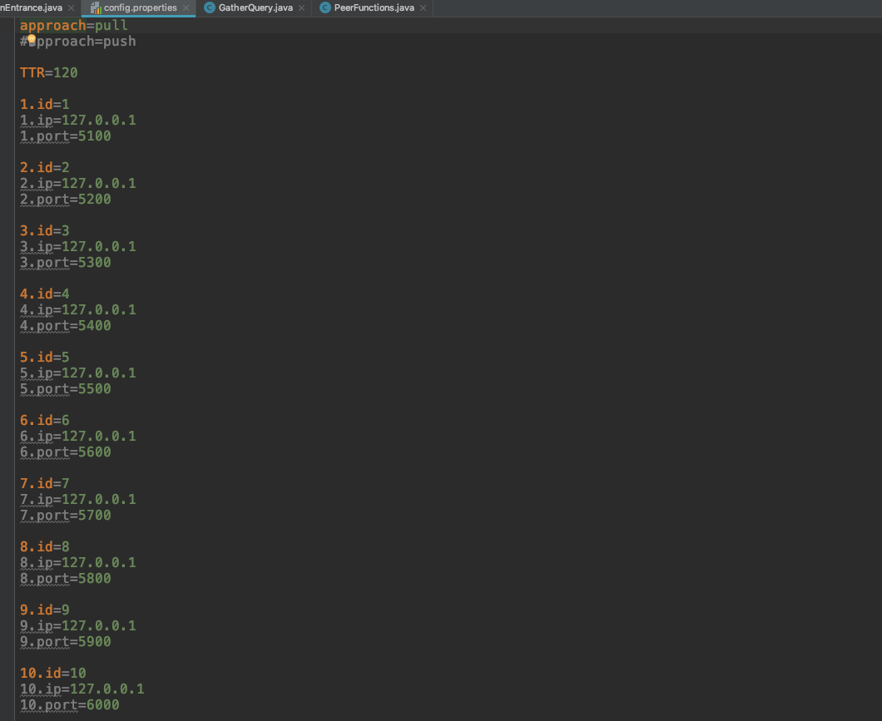

Main menu is shown here for user to choose from.

ConnectNeighborThread: a subclass of thread where the connection between neighbors are setup.

FileProperties: A simple class to maintain the status of the files.

GatherQuery: two arraylists to store query related info

MainInterface: declared methods for file related operations

MainInterfaceImpl: implementation of the methods in the interface

PeerFunctions: main methods of peers are implemented

PeerProperties: simple class to store basic information of peers

Watcher: a watcher to monitor modification on files

For each peer, there are two directories.

downloadedFiles: for storing files from other peers.

sharedDir: for storing its own files.

