CS550 Programming Assignment 3

Manuals and Outputs

1. Run MainEntrance.class in terminal. (Here I just use IntelliJ IDEA console.)
2. Enter peer ID one by one. (1 to 10) to run 10 peers.

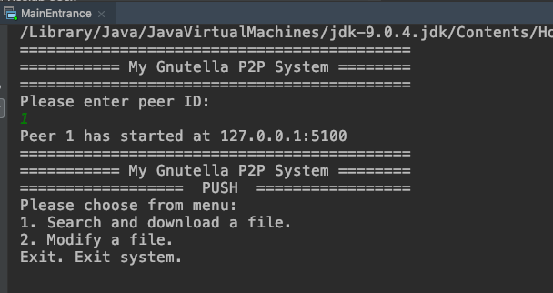

1. In one of the peers, enter 1 to search for file.

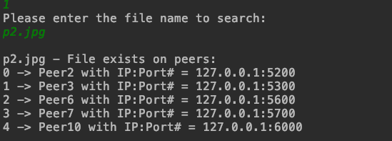

1. Select a peer to download from.

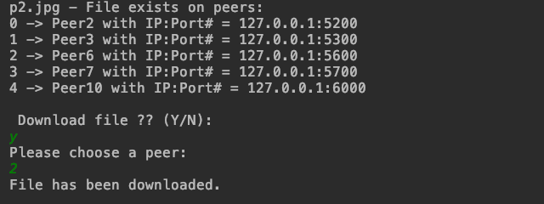

1. From main menu, select 2 to make modification to a file.

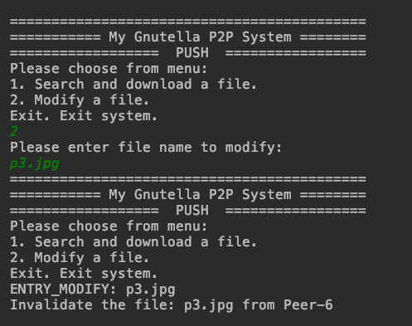

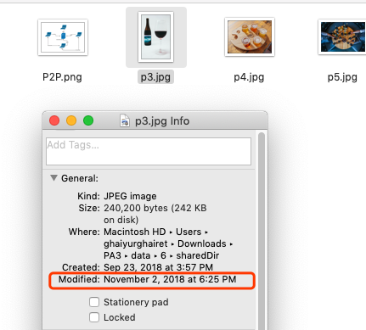

File is modified and invalidate message is sent out.

1. Similar steps for PULL approach after changing the config file. There would be one more option in the menu.

