Interim Progress Report
Steganographic Signing and Filter Traceability in Digital Media
Module: 7COM1040-0509-2025 --- MSc Computer Science
Student: Opaleye Toluwalope Abayomi
Student Number: 24163800
Supervisor: Daniel Barry
Submission date: 20 July 2026

1. Background Research and Literature Review

1.1 Goals, Objectives, and Research Question
[INSERT: your research question and objectives, reused/refined from your DPP (Section 2/3 of 24163800_OpaleyeToluwalope_DPP_v2.docx). Update the tense to reflect progress made, e.g. change future-tense statements to present/past tense where work has already started.]

1.2 Literature Review
This project sits at the intersection of two related but distinct research strands: neural watermarking as a primary signing mechanism, and perceptual hashing as a lightweight, format-agnostic fallback. Both strands are represented in the literature underpinning this work.
TrustMark (Bui, Agarwal and Collomosse, 2025) provides the primary watermarking mechanism used in this project. Originally released as an arXiv preprint in 2023, TrustMark has since been formally published at ICCV 2025, and this project cites the peer-reviewed version in line with the requirement to draw on major, currently published sources. TrustMark is designed to embed a robust, imperceptible payload into arbitrary-resolution images, using an encoder/decoder pair trained to survive common content-preserving transformations.
However, the literature is clear that no single watermarking approach is universally robust. Mareen et al. (2021) propose a fallback watermark detection system using secondary watermarks for faster comparison, an architectural pattern that parallels this project's use of perceptual hashing as a lightweight complement to the primary TrustMark watermark. This is the architectural principle this project adopts directly: TrustMark as the primary signing layer, with perceptual hashing catching the cases where TrustMark's payload has been destroyed by a transformation.
The robustness characteristics of the specific hash algorithms used here (pHash, dHash, aHash, and PDQ) are documented at scale by McKeown and Buchanan (2023), who evaluated these and related techniques against approximately one million images and found DCT-based hashes robust to compression and scaling but consistently vulnerable to more aggressive geometric change such as cropping and mirroring. Jain, Cretu and de Montjoye (2022) provide a complementary evaluation, testing PDQ specifically against adversarial evasion and confirming it as comparatively attack-resistant, though their work concerns deliberate evasion rather than the content-preserving transforms this project focuses on. Taken together (McKeown and Buchanan, 2023; Jain, Cretu and de Montjoye, 2022), these two sources give a consistent picture of PDQ and pHash's strengths and weaknesses across both benign and adversarial conditions.
A gap in this literature, confirmed through this review, is the absence of any published benchmark testing letterboxing (aspect-ratio-preserving padding) specifically as a transform category. Existing benchmarks test cropping, scaling, rotation, and compression, but not padding-to-square. This project's own empirical testing (Section 1.3) addresses that gap directly.
A relevant recent preprint by Singhi et al. (2025) proposes DinoHash, an adversarially robust perceptual hash derived from DINOv2, combined with homomorphic encryption for provenance detection of AI-generated images. While this preprint has not yet undergone peer review, its architectural combination of perceptual hashing with cryptographic verification aligns with this project's hybrid design philosophy and represents a promising direction for future work (see Section 3.7).

1.3 Practical Research Application
The literature review's predictions were tested empirically against a sample of 100 images drawn from MS-COCO val2017, transformed across twelve distinct categories and compared using eight perceptual hash variants.
The results complicate, rather than simply confirm, the general literature pattern that DCT-based hashes are uniformly more robust than simpler methods. Under letterboxing specifically, aHash was the most stable of the four primary hash types tested (23.8% of bits changed on average), followed by pHash (25.7%) and dHash (27.7%), with PDQ showing the largest change (37.3%), despite PDQ being the most sophisticated and typically most attack-resistant of the four (see Table 1, Section 2.3). This finding was independently reproduced across two separate runs of the pipeline at different sample sizes (n=20 and n=100), strengthening confidence that it reflects a genuine property of the algorithms under this specific transform rather than sampling noise.
A plausible explanation, offered here as a hypothesis rather than a settled conclusion, is that letterboxing changes spatial layout via padding rather than altering pixel content or introducing compression artefacts. PDQ's larger 256-bit feature space may weight spatial position more heavily than pHash's 64-bit representation, making it comparatively more sensitive to the padded region's introduction, even though this same larger feature space is understood to make PDQ more attack-resistant under other conditions (Jain, Cretu and de Montjoye, 2022).
This finding is significant because no prior study, as far as this review has established, has tested letterboxing as a discrete transform category. The result presented here is therefore an original empirical contribution, however narrow in scope, rather than a confirmation of an existing benchmark.

2. Summary of Progress to Date

2.1 Completed Work
Progress to date follows the structure set out in the Detailed Project Proposal, with work concentrated on Phase 1 (literature review) and the perceptual hash fallback strand of Phase 2, ahead of full integration of the primary TrustMark watermarking layer into the planned FastAPI service.
- Literature review: substantially complete, covering neural watermarking, perceptual hash robustness, and the hybrid fallback architecture (Section 1).
- Image transform pipeline: built using Pillow, covering letterboxing, JPEG compression (quality 50), Gaussian blur, salt-and-pepper noise, brightness and contrast adjustment, 50% central and random cropping, 2 and 90 degree rotation, and 0.5x/2x scaling.
- Perceptual hash fallback: eight hash variants implemented and compared (pHash, dHash, aHash, wHash, colorhash, vertical dHash, a simplified pHash variant, and PDQ), using the imagehash and pdqhash Python libraries.
- TrustMark primary watermarking: installed from the official PyPI package and integrated into the same transform-testing harness as the perceptual hashes, allowing direct comparison between primary and fallback mechanisms under identical conditions.
- Backend (FastAPI/PostgreSQL): minimal scaffold only; not yet integrated with the watermarking pipeline.
- Frontend: deliberately minimal; a working prototype is planned (see Section 5 for the rationale behind this scope decision).

2.2 Tools and Technologies Justification
Pillow was selected for image manipulation over heavier alternatives such as OpenCV, since the transforms required at this stage (padding, cropping, rotation, colour adjustment, format conversion) are well supported by Pillow's standard API without the additional dependency weight OpenCV would introduce for a project not performing computer-vision tasks beyond these transforms.
imagehash provides mature, widely used implementations of pHash, dHash, aHash and related variants, avoiding the risk of subtly incorrect hash implementations that writing these algorithms from scratch would introduce.
pdqhash is Meta's own reference implementation of PDQ, used here rather than a third-party reimplementation so that results are directly comparable to the published literature that also uses this implementation (McKeown and Buchanan, 2023; Jain, Cretu and de Montjoye, 2022).
TrustMark was installed via its official PyPI package, following the setup path recommended in the official repository's documentation.
requests is used within the project's planned FastAPI service layer for calling the /sign and /verify endpoints once built; bulk dataset acquisition (the COCO validation set) was instead performed via the dataset's documented bulk-download method, since direct per-image requests to COCO's hosting server returned inconsistent HTTP 403 responses during initial testing, a minor but genuine methodological finding recorded during this phase of work.

2.3 Deliverables and Evidence
Table 1 summarises the perceptual hash robustness results across all twelve transforms tested, for the four hash types central to this project's design (pHash, dHash, aHash, PDQ), expressed as the percentage of hash bits changed relative to the untransformed original.
Transform | pHash (%) | dHash (%) | aHash (%) | PDQ (%)
brightness_p50 | 7.0 | 6.0 | 5.2 | 7.4
contrast_1.5x | 4.1 | 3.2 | 1.7 | 4.0
crop_center_50pct | 48.1 | 47.8 | 36.4 | 49.7
crop_random_50pct | 46.6 | 47.8 | 40.4 | 49.4
gaussian_blur_sigma3 | 0.3 | 0.5 | 0.1 | 2.5
jpeg_compression_q50 | 0.4 | 0.4 | 0.1 | 0.5
letterbox | 25.7 | 27.7 | 23.8 | 37.3
rotation_2deg | 8.2 | 6.9 | 3.6 | 15.1
rotation_90deg | 49.2 | 48.7 | 48.3 | 50.3
salt_pepper_noise_5pct | 0.9 | 1.7 | 0.3 | 2.8
scaling_0.5x | 0.3 | 0.3 | 0.0 | 4.2
scaling_2x | 0.2 | 0.2 | 0.0 | 2.2

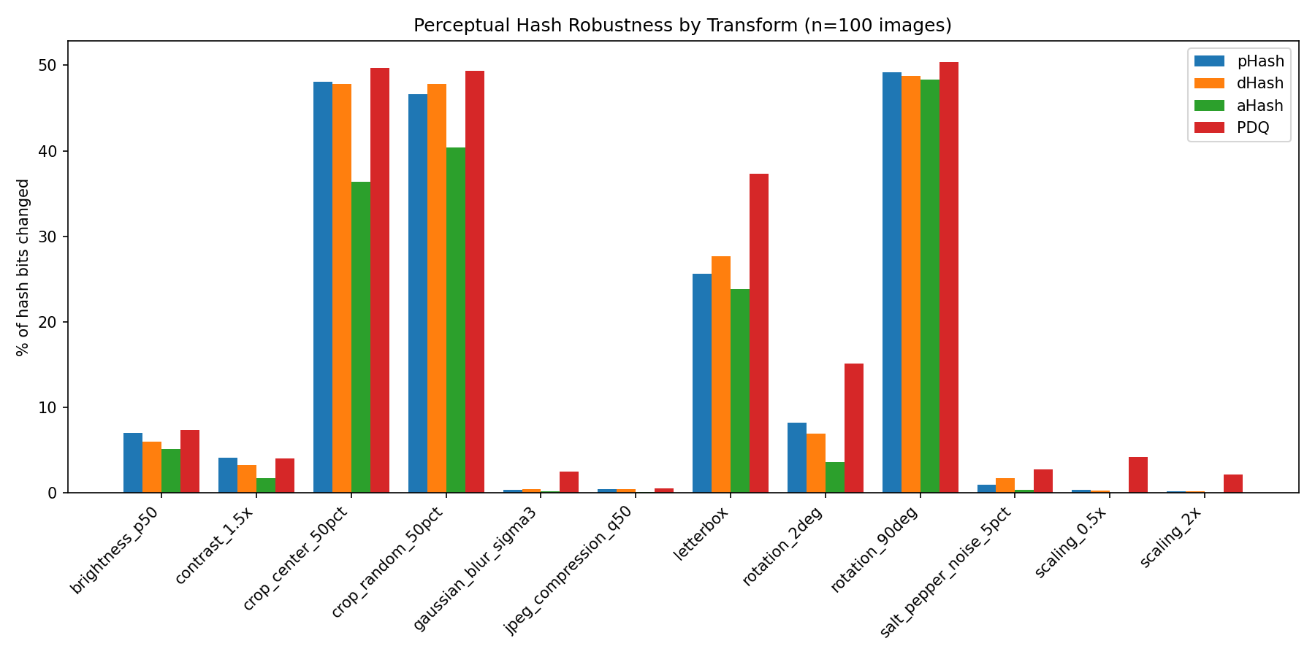
Figure 1: Perceptual hash robustness across all twelve transforms tested (n=100 images), normalised as percentage of hash bits changed relative to each algorithm's total bit length.
Table 2 summarises TrustMark's watermark detection rate and raw, pre-error-correction bit accuracy under the same twelve transforms.
Transform | Detection Rate (%) | Mean Raw Bit Accuracy (%)
none (baseline) | 100 | 99.5
brightness_p50 | 71 | 95.1
contrast_1.5x | 74 | 95.1
gaussian_blur_sigma3 | 95 | 98.5
jpeg_compression_q50 | 92 | 98.1
rotation_2deg | 86 | 97.6
scaling_0.5x | 100 | 99.5
scaling_2x | 100 | 99.5
salt_pepper_noise_5pct | 14 | 86.8
letterbox | 13 | 57.6
crop_center_50pct | 3 | 54.1
crop_random_50pct | 0 | 53.3
rotation_90deg | 5 | 51.3

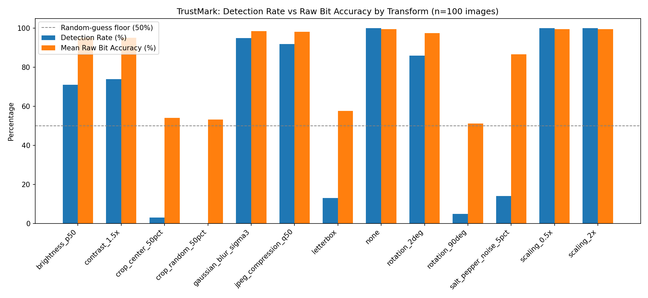
Figure 2: TrustMark detection rate versus raw (pre-error-correction) bit accuracy by transform (n=100 images). The dashed line marks the 50% random-guess floor for a binary payload.
The full underlying datasets (transform_robustness_results.csv, 1,200 rows; trustmark_robustness_results.csv, 1,300 rows) and the accompanying live workbook (IPR_Data_Analysis.xlsx, containing raw data, pivot-style summary formulas, and native Excel charts) are provided as supporting appendices.
The dashboard frontend is served by a FastAPI backend providing interactive visualisations of all benchmark results across four tabs: overview statistics, per-transform performance curves, ensemble decision matrix, and per-image drill-down.

Figure 3: Original image (left) and letterboxed version (right) from the MS-COCO validation set.
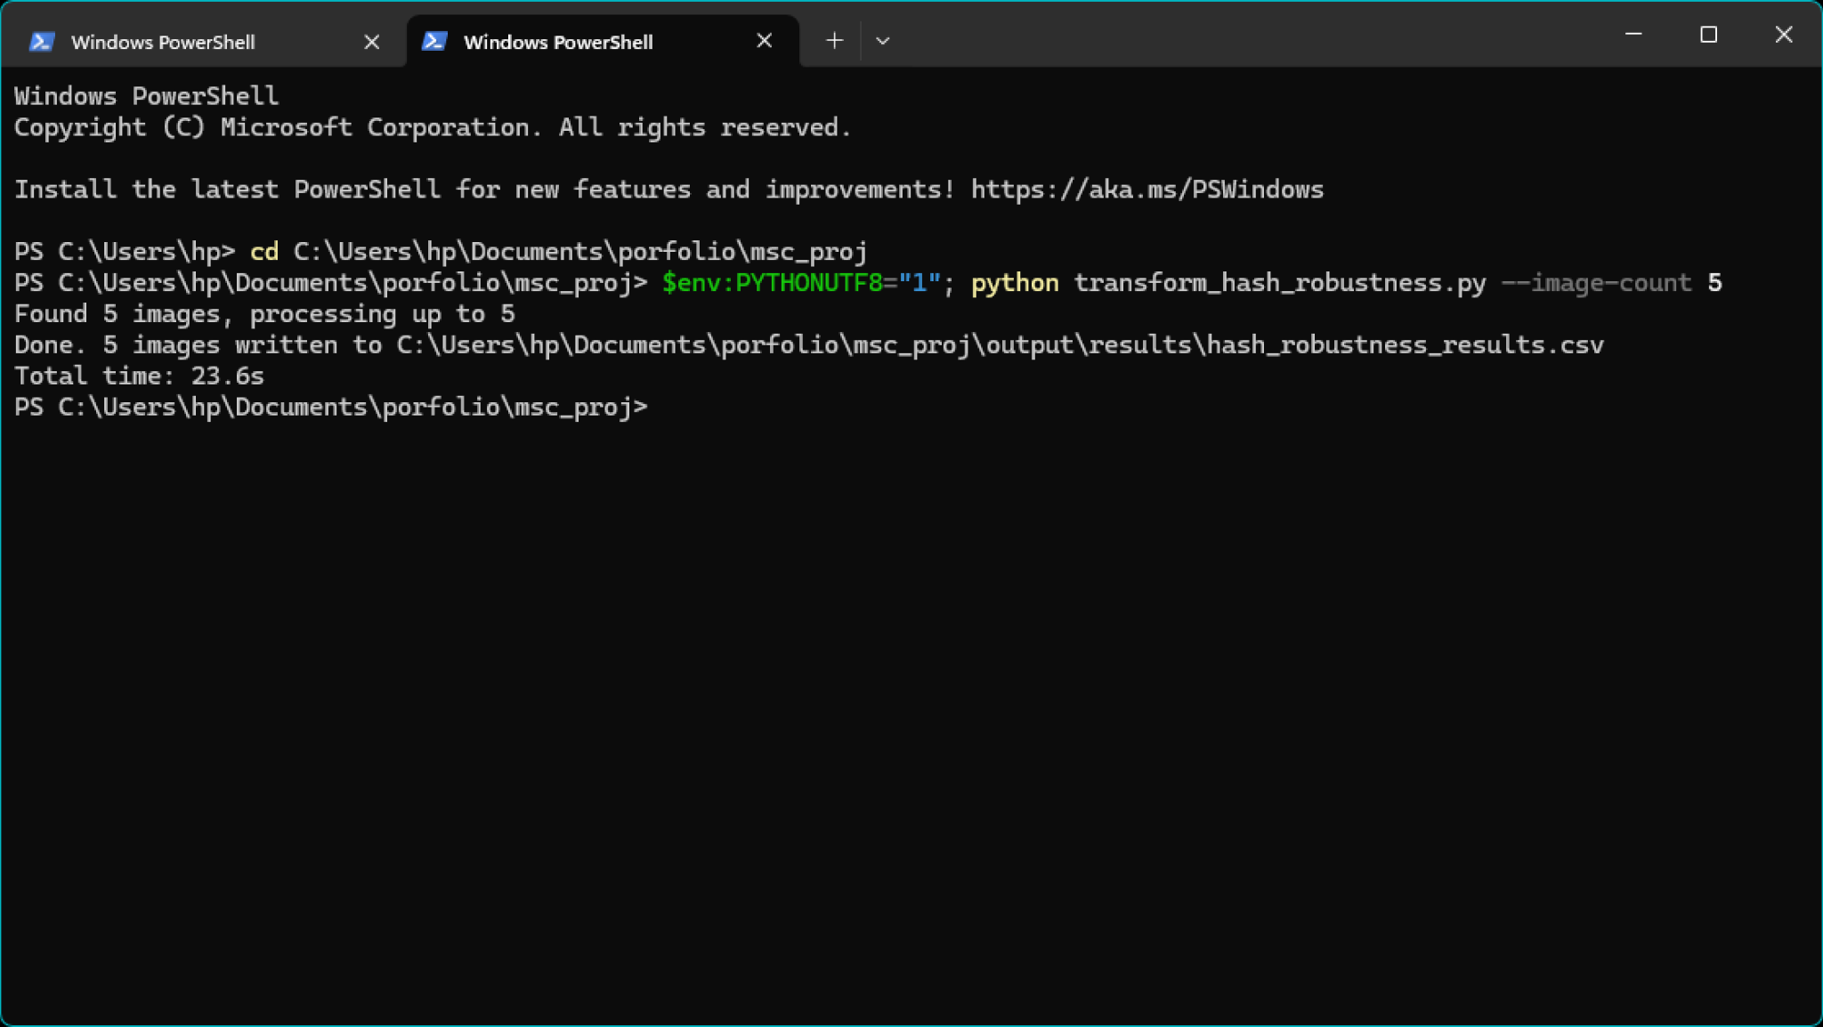
Figure 4: Terminal output of the perceptual hash robustness pipeline (n=5 images, test run).

2.4 Challenges Encountered
- COCO's image hosting server (images.cocodataset.org) returned HTTP 403 errors when images were requested individually by URL; this was resolved by switching to the dataset's documented bulk zip download method instead.
- A disk space limitation caused an initial attempt to scale from 20 to 1,000 test images to fail partway through; this was resolved by clearing temporary files, and the sample size was revised down to 100 images as a result, a legitimate scope adjustment given time constraints rather than an unresolved problem.
- An early implementation of TrustMark's bit-level accuracy metric was found, on inspection, to be recording only whether the exact payload string was recovered after BCH error correction, not the proportion of raw bits correctly decoded before correction. This was identified and corrected by accessing TrustMark's internal decoder output directly (see Appendix 1), rather than relying solely on its public decode() API, which does not expose this distinction.
- A related bug was found in the PDQ hash serialisation, where each of PDQ's 256 hash dimensions was being stored using an 8-character representation instead of one bit per dimension, producing an incorrect 2,048-character hash string. This was identified by comparing the observed hash length against PDQ's documented 256-bit specification, and corrected before any PDQ-based conclusions were drawn.

3. Ethical, Legal, Professional, and Social Issues
Ethics approval: This project does not require formal ethics approval. It does not involve human participants, personal data collection, or any interaction with members of the public. The image dataset used (MS-COCO val2017) is a long-established, publicly available research dataset used widely across the computer vision field, and no new data is being collected from individuals as part of this work.
Legal: The licensing position of MS-COCO is more nuanced than commonly summarised. The COCO Consortium licenses the dataset's annotations under Creative Commons Attribution 4.0, but the underlying images retain their original photographer-level licensing from Flickr, and the Consortium does not itself hold copyright over the images. Academic legal analysis has noted that this creates meaningful licensing risk for any commercial use of the dataset, since only the annotations, not the images, carry the CC BY 4.0 license (Harvey, n.d.). For the purposes of this MSc research project, which is non-commercial, this risk is low.
Separately, the production system this prototype is designed to inform would embed a user identifier and timestamp within each signed image. While no real user data is processed in the current dissertation prototype, this is flagged here as a forward-looking GDPR consideration: any future deployment handling real user identifiers would need to address data minimisation, retention, and subject access rights under GDPR before processing genuine personal data.
Professional: This project follows published, peer-reviewed methods (TrustMark, PDQ) rather than ad hoc or unpublished techniques, supporting the reproducibility and academic credibility of the results reported.
Social: Watermarking and provenance technology of this kind has a dual-use dimension worth acknowledging. The same mechanism that proves an image's authenticity and origin could, in a different deployment context, be used to track who edited or redistributed a piece of media, raising surveillance-adjacent concerns distinct from the technology's intended trust-and-safety purpose. This tension is relevant given the project's target companies, where provenance tooling sits close to both content moderation and user privacy.

4. Project Plan

4.1 Project Management Approach

This project follows the phased structure defined in the Detailed Project Proposal, applied iteratively within each phase, with supervisor check-ins used to validate direction before committing significant time to any one component. Task tracking followed this phased structure directly rather than a board-based tool such as Trello or GitHub Projects. GitHub itself was used for version control and code storage, not task management.

4.2 Remaining Tasks and Timeline
Task | Target Date | Deliverable
Complete TrustMark integration and validation | 8 Jul 2026 | Full encode/decode pipeline confirmed working across test set
Finalise data quality checks (PDQ, bit-accuracy metrics) | 9 Jul 2026 | Corrected result CSVs (complete)
Expand FastAPI backend with /sign and /verify endpoints | 12 Jul 2026 | Working API endpoints
PostgreSQL persistence for hash/payload records | 13 Jul 2026 | Database writes confirmed
Minimal frontend prototype | 15 Jul 2026 | Functional demo
Compile results, write remaining report sections | 16 Jul 2026 | Full IPR draft complete
Proofread, format, finalise appendices | 18 Jul 2026 | Submission-ready document
Submit IPR | 20 Jul 2026 | Final submission

4.3 Quality Evaluation Strategy
Results are validated using metrics standard to each method under evaluation: Hamming distance for perceptual hash comparisons, PSNR for TrustMark encoding quality, and both exact-match detection rate and raw bit accuracy for TrustMark decoding robustness. Visual inspection of transformed output supplements these quantitative measures to confirm transforms behave as intended before their effect on hash and watermark stability is assessed.

5. Level of the Project
This project's MSc-level standing rests on three things: the combination of a modern neural method (TrustMark) with classical computer vision techniques (perceptual hashing) within a single evaluated pipeline, a systematic empirical methodology tested across a defined matrix of twelve distinct transforms and eight hash variants, and a demonstrated willingness to investigate and correct methodological weaknesses discovered during the work itself rather than reporting the first numbers produced.
That last point is demonstrated concretely by this project's own results. An early bit-accuracy metric for TrustMark decoding was found, on inspection, to be measuring only exact-match success, not genuine bit-level accuracy. Rather than reporting this uncritically, the metric was investigated against TrustMark's own decode pathway and corrected by accessing the decoder's raw output directly, before its BCH error-correction stage (Appendix 1). The corrected data materially strengthens this project's central argument: TrustMark achieves 99.5% raw bit accuracy under no transform, and 92 to 100% detection under JPEG compression, blur, small rotation, and both directions of scaling. Under severe geometric disruption such as cropping or 90-degree rotation, however, raw bit accuracy falls to 51 to 58%, statistically indistinguishable from random guessing on a binary payload. This is not a marginal degradation; it is complete destruction of the embedded signal, and it is precisely the scenario this project's hybrid architecture is designed to catch via the perceptual hash fallback.
The perceptual hash results similarly show a nuanced, rather than a merely confirmatory, picture. Under letterboxing specifically, the simplest algorithm tested (aHash) outperformed the most sophisticated (PDQ), a result that complicates rather than simply confirms the general literature pattern of DCT-based hashes being more robust (McKeown and Buchanan, 2023). This kind of divergence from a naive expectation, properly investigated and reported rather than dismissed, is itself evidence of the rigour expected at this level.
Limitations acknowledged at this stage include the sample size (100 images, smaller than the 1,000 originally specified in the DPP, due to a disk space constraint documented in Section 2.4), and the fact that TrustMark integration, while functional, was completed later in the project timeline than originally planned, leaving less time than ideal for full-scale testing across the complete transform matrix at the originally intended sample size.

6. References
Bui, T., Agarwal, S. and Collomosse, J. (2025) 'TrustMark: Robust watermarking and watermark removal for arbitrary resolution images', IEEE International Conference on Computer Vision (ICCV). Available at: https://github.com/adobe/trustmark (Accessed: 8 Jul, 2026)
Harvey, A. (n.d.) Common Objects in Context. Exposing.ai. Available at: https://exposing.ai/coco/ (Accessed: 8 Jul 2026)
Jain, S., Cretu, A.-M. and de Montjoye, Y.-A. (2022) 'Adversarial detection avoidance attacks: Evaluating the robustness of perceptual hashing-based client-side scanning', in 31st USENIX Security Symposium. Available at: https://www.usenix.org/system/files/sec22-jain.pdf (Accessed: 14 Jul 2026).
Mareen, H., Van Kets, N., Lambert, P. and Van Wallendael, G. (2021) 'Fast fallback watermark detection using perceptual hashes', Electronics, 10(10), p. 1155. Available at: https://doi.org/10.3390/electronics10101155 (Accessed: 14 Jul 2026).
McKeown, S. and Buchanan, W.J. (2023) 'Hamming distributions of popular perceptual hashing techniques', Forensic Science International: Digital Investigation, 44, p. 301509. Available at: https://www.semanticscholar.org/reader/959673f1ee8f05cc4ddf3523802ed9b6369f25f4 (Accessed: 14 Jul 2026).
Singhi, S., Yadav, A., Gupta, A., Ebrahimi, S.M. and Hassanizadeh, P. (2025) 'Provenance Detection for AI-Generated Images: Combining Perceptual Hashing, Homomorphic Encryption, and AI Detection Models', arXiv:2503.11195. Available at: https://arxiv.org/abs/2503.11195 (Accessed: 12 July 2026).

7. Appendices

Appendix 1: Code
Letterboxing transform (letterbox_hash_pipeline.py):
def letterbox(image: Image.Image, target_size: tuple[int, int],
fill_color: tuple[int, int, int] = (0, 0, 0)) -> Image.Image:
"""
Resize an image to fit within target_size while preserving aspect ratio,
padding the remaining space with fill_color (letterboxing).
This is the geometric transform under evaluation: it changes pixel
layout and introduces uniform padding without cropping any content,
distinct from the cropping/rotation/scaling transforms also in scope.
"""
image = image.convert("RGB")
original_w, original_h = image.size
target_w, target_h = target_size
scale = min(target_w / original_w, target_h / original_h)
new_w, new_h = int(original_w * scale), int(original_h * scale)
resized = image.resize((new_w, new_h), Image.LANCZOS)
canvas = Image.new("RGB", target_size, fill_color)
paste_x = (target_w - new_w) // 2
paste_y = (target_h - new_h) // 2
canvas.paste(resized, (paste_x, paste_y))
return canvas
TrustMark payload encoding to full bit packet (trustmark_robustness.py):
def encode_payload_to_packet(tm, payload):
"""Encode text payload to the full 100-bit packet (data + ECC + version)."""
ecc = tm.ecc
text_bytes = ecc.encode_text_ascii(payload)
text_bits = ''.join(format(b, '08b') for b in text_bytes)
packet = ecc.process_encode(text_bits)
return np.array(packet, dtype=np.int32)
Raw, pre-error-correction bit accuracy measurement, accessing TrustMark's internal decoder directly rather than its public decode() API (trustmark_robustness.py). This is the fix referenced in Sections 2.4 and 5:
@torch.no_grad()
def raw_bit_accuracy(image, tm, expected_packet):
"""Compare raw decoder bits (before ECC) against the original encoded packet."""
img_rgb = image.convert('RGB')
img_resized = img_rgb.resize((tm.model_resolution_dec, tm.model_resolution_dec), Image.BILINEAR)
stego = transforms.ToTensor()(img_resized).unsqueeze(0).to(tm.decoder.device) * 2.0 - 1.0
raw_bits = (tm.decoder.decoder(stego) > 0).cpu().numpy()
received = raw_bits[0].astype(np.int32)
return float(np.mean(expected_packet == received))

Appendix 2: Screenshots


Figure 5: Original image (left) and letterboxed version (right) from the MS-COCO validation set.

Figure 2: Terminal output of the perceptual hash robustness pipeline (n=5 images, test run).

Figure 3: Watermark Robustness Dashboard - overview tab showing mean bit accuracy by transform for all three watermarking methods, and ensemble decision matrix colour-coded by best-performing method per cell.

Appendix 3: Results Data and Workbook
Full results are provided in the accompanying spreadsheet, IPR_Data_Analysis.xlsx, containing:
- HashSummary: the data underlying Table 1 and Figure 1, computed via live AVERAGEIF formulas referencing the raw data sheet
- TrustMarkSummary: the data underlying Table 2 and Figure 2, computed via live formulas
- HashRawData: the complete 1,200-row dataset (100 images x 12 transforms x 8 hash variants)
TrustMarkRawData: the complete 1,300-row dataset (100 images x 13 rows including baseline)

Appendix 4: Citation for External Code
Citations

TrustMark

TrustMark is a deep learning-based image watermarking method.

- Repository: https://github.com/adobe/trustmark
- PyPI: https://pypi.org/project/trustmark/
- License: MIT
- Paper: Bui, T., Agarwal, S. and Collomosse, J. (2025) 'TrustMark: Robust watermarking and watermark removal for arbitrary resolution images', IEEE International Conference on Computer Vision (ICCV).
- Version used: 0.9.1

BibTeX

```bibtex
@inproceedings{trustmark2025,
author = {Bui, Tu and Agarwal, Shruti and Collomosse, John},
title = {TrustMark: Robust Watermarking and Watermark Removal for Arbitrary Resolution Images},
booktitle = {IEEE International Conference on Computer Vision (ICCV)},
year = {2025},
publisher = {GitHub},
howpublished = {\url{https://github.com/adobe/trustmark}}
}
```

Perceptual Hashes

- imagehash: https://github.com/JohannesBuchner/imagehash (pHash, dHash, aHash)
- pdqhash: https://github.com/facebook/ThreatExchange/tree/main/python-threatexchange (PDQ hash)
- License: BSD (imagehash), MIT (pdqhash via ThreatExchange)

Dataset

- MS-COCO 2017 val: https://cocodataset.org/
- License: Creative Commons Attribution 4.0

