
UNIVERSITY OF HERTFORDSHIRE
School of Physics, Engineering and Computer Science
MSc Title: Computer Science Masters Project
Module Code and Title: 7COM1040-0509-2025 - Computer Science Masters Project
Date: 20 August, 2026
Project Title: Steganographic Signing and Filter Traceability in Digital Media
Scope note: this title reflects the proposed project scope. The implemented prototype is a transformation-aware watermarking and perceptual-hashing screening benchmark: it embeds and verifies watermark payloads (TrustMark, LSB, DCT and a two-layer hybrid) and compares perceptual hashes under a graded still-image transform matrix. It does not implement cryptographic signing, key management, C2PA provenance manifests, a trust chain, or an authenticity verdict.

Name: Opaleye Toluwalope Abayomi
Student ID: 24163800
Supervisor: Daniel Barry

Proofreading confirmation
I confirm that this report has been proofread for spelling, grammar, structure, terminology, figure and table numbering, cross-references, accessibility, and consistency between the report and its artefacts.
Proofreader: Opaleye Toluwalope Abayomi
Date: 20/08/2026
Confirmation/signature: Opaleye Toluwalope Abayomi

MSc FPR Declaration
This report is submitted in partial fulfilment of the requirement for the degree of:
Master of Science in Computer Science Masters Project, at the University of Hertfordshire (UH).
I hereby declare that the work presented in this project and report is entirely my own, except where explicitly stated otherwise. All sources of information and ideas, whether quoted directly or paraphrased, have been properly referenced in accordance with academic standards. I understand that any failure to properly acknowledge the work of others could constitute plagiarism and may result in academic penalties.
I did not use human participants in my MSc Project.
I hereby give permission for the report to be made available on the university website provided the source is acknowledged.

Contents

Proofreading confirmation 2
Contents 4
List of figures 6
List of tables 6
Glossary 6
Abstract 8
1. Introduction 8
1.1 Context and problem 8
1.2 Aim 9
1.3 Objectives and success criteria 9
1.4 Research question 9
1.5 Novelty and contribution 10
1.6 Research-to-product integration 10
1.7 Feasibility and scope 10
1.8 Risks at project level 11
1.9 Report structure 11
2. Literature Review 11
2.1 From steganography to learned watermarking 11
2.2 Contextual AI-media literature and removal threats 12
2.3 Similarity, hashing, and provenance 13
2.4 Standards, governance, and professional practice 13
2.5 Literature synthesis and gap 14
3. Methodology 14
3.1 Research design 14
3.2 Dataset and evidence scales 14
3.3 Transformation matrix 15
3.4 Pipeline implementations 16
3.5 Metric definitions 17
3.6 Validation gates 17
3.7 Reproducibility and data lineage 18
3.8 Analysis protocol and decision semantics 19
3.9 Threat model 19
3.10 Ethical, legal, and social design 20
3.11 Implemented versus proposed improvements 20
4. Quality and Results 21
4.1 Quality-assurance evidence 21
4.2 Evidence matrix 21
4.3 Validated historical/baseline results 22
4.4 Results by transformation class 22
4.5 What the data cannot answer 23
4.6 Final1200 evidence 23
4.7 Payload/ECC ablation result 26
4.8 Evidence interpretation 27
4.9 Required statistical improvements 27
4.10 Uncertainty analysis (final1200) 28
5. Evaluation and Conclusion 29
5.1 Construct validity 29
5.2 Internal validity 29
5.3 External and statistical validity 29
5.4 Threats and risk matrix 29
5.5 Project management and Gantt reflection 30
5.6 BCS mapping 31
5.7 Future work 31
5.8 Conclusion 33
References 33
Appendices 37
Appendix A: Repository evidence index 37
Appendix B: Artefact and reproducibility record 37
Appendix C: Transform and payload specification 37
Appendix D: Expanded validation checklist 37
Appendix E: Proposed final statistical table 38
Appendix F: Ethics, legal, and deployment checklist 38
Appendix G: Future experiment protocol 38
Appendix H: Figure and table publication gates 38
Objective | Evidence of completion | Status
Review current research, standards, law, and professional guidance | Literature and governance synthesis | Implemented in this report
Define a shared deterministic transformation pipeline | `transforms.py`, named conditions, stable seeds | Implemented
Compare TrustMark with LSB and DCT | Historical validated CSVs and final1200 CSVs | Implemented at both scales, with evidence separated
Compare eight perceptual hashes | Historical 100-image CSV and validated final1200 compressed hash result | Implemented at both scales, with evidence separated
Measure recovery and similarity separately | Raw bit accuracy, decode presence, PSNR/MSE, Hamming distance | Implemented
Produce threshold and ensemble views | 80-condition historical matrix and analysis script | Implemented for the historical set
Run a payload/error-correction ablation | 12-config dev-scale sweep (97,200 rows) plus ensemble-aware rescoring | Implemented at dev scale; selected config validated at 1,200
Demonstrate a secure provenance system | Signed C2PA manifests, identity, key lifecycle, trust chain | Not implemented and not claimed
Establish universal robustness or authenticity | Independent replication and attack evaluation | Not achieved and explicitly out of scope
IPR/DPP promise | Status | Evidence
Payload recovery >90% across JPEG/PNG (hypothesis) | Not confirmed | JPEG two-layer 85.6%; PNG not implemented
TrustMark primary watermarking | Delivered | TM final1200 benchmark
Perceptual hash fallback | Delivered (similarity screen) | 8 hashes benchmarked
Two-layer payload-recovery hybrid | Delivered (new, Path B) | Fallback watermark channel, Section 4.11
Filter pipeline (brightness, contrast, saturation) | Delivered | transforms.py
Custom LUT filters | Not delivered | Listed as future work
JPEG/PNG/WebP re-encoding | Partial (JPEG only) | PNG/WebP future work
Geometric robustness (crop, rotation, stretch) | Delivered (no stretch) | Rotation/scaling/crops tested
PSNR imperceptibility | Delivered | PSNR reported
SSIM imperceptibility | Delivered (10-image sample) | output/remediation_ssim.csv; SSIM 0.88-0.97
Verification interface (web dashboard) | Delivered (Sign/Verify, React) | FastAPI + React frontend (dashboard-react/)
PostgreSQL persistence | Delivered (local Docker PostgreSQL 16) | migrate_to_db.py executed against a live instance; row counts verified (768,000 hash / 291,600 watermark / 97,200 fallback / 80 ensemble); dashboard serves from the database
React (JSX) frontend | Delivered | dashboard-react/ (Vite + React)
Custom payload (name/copyright) | Delivered (user-supplied) | Sign/Verify payload field; per-method capacity
Watermark detection (two images) | Delivered | /api/analyze; Detect tab
Confidence score output | Delivered | /api/verify returns confidence + definition
C2PA/manifest/authenticity | Explicitly out of scope | Not claimed
Evidence set | Images | Main artefacts | Evidence status | Permitted use
Historical/baseline | 100 | Hash CSV 64,000 rows; TrustMark, LSB, DCT 8,100 rows each; ensemble 80 rows | Validated historical result set | Historical numerical claims, clearly labelled
Final hash | 1,200 | Clean compressed hash result, 768,000 rows | Complete/clean final hash output | Hash-only final1200 reporting after coverage checks
Final LSB | 1,200 | `final1200/lsb_robustness_results.csv` | Complete final1200 output | LSB-only final1200 reporting after file reconciliation
Final DCT | 1,200 | `final1200/dct_robustness_results.csv` | Complete final1200 output | DCT-only final1200 reporting after file reconciliation
Final TrustMark | 1,200 | `final1200/trustmark_robustness_results.csv` | Complete/validated; 97,200 rows including baseline | Final1200 comparison, with transformed-condition aggregation stated
Metric | Definition | What it supports | What it does not support
Hamming distance | Number of changed representation bits | Hash representation change | Authorship or exact integrity
Bit-error fraction | Hamming distance divided by method bit length | Normalised hash comparison | Universal similarity threshold
Raw bit accuracy | Expected packet bits recovered before correction | Signal recovery quality | Exact valid-message success or provenance
Decode presence | Decoder reports a valid payload | End-to-end decode event | Correct authorship or absence of wrong payload
PSNR | Pixel-domain encode quality measure | One imperceptibility dimension | Robustness or perceptual acceptability alone
MSE | Mean squared pixel error | Encode distortion | Security
Threshold pass | Current rule: watermark mean accuracy above 0.5 or hash worst-algorithm error below 0.5 | Screening matrix | Calibrated operational decision
Gate | Check | Failure response
G1 | Manifest count, unique IDs, filenames, and checksums | Stop; do not analyse
G2 | Expected image-condition-method coverage | Mark incomplete and stop final claims
G3 | No duplicate keys or unintended baseline duplication | Repair or exclude run
G4 | Correct PDQ bit serialisation and hash lengths | Recompute affected hash output
G5 | Raw TrustMark bits are measured before error correction | Recompute TrustMark metrics
G6 | Missing values, impossible ranges, payload lengths, and dimensions | Stop and inspect pipeline
G7 | Transform names and intensities match `transforms.py` | Reject drifted output
G8 | Numerical tables and figures regenerate from the declared files | Replace stale artefacts
G9 | Analysis records image-level unit, interval method, and baseline policy | Do not present pooled values as inferential
G10 | Report, dashboard, workbook, and CSV values reconcile | Hold submission until corrected
Gate | Enforcing mechanism | Status
G1 Manifest count, IDs, checksums | experiment_manifest.py (creation); checksum re-verification manual | Partially enforced
G2 Expected coverage | validate_experiment.py | Enforced
G3 Duplicate keys | validate_experiment.py | Enforced
G4 PDQ serialisation | Corrected transform_hash_robustness.py; recompute | Enforced by correction; not runtime-checked
G5 Raw TrustMark bits before ECC | trustmark_robustness.py decode path | Enforced in code; not runtime-checked
G6 Missing values, ranges, dimensions | analyze_uncertainty.py | Partially enforced (separate script)
G7 Transform names match transforms.py | Expected counts derived from transforms.py; name drift not explicitly rejected | Partially enforced
G8 Tables and figures regenerate | generate_figures.py; generate_remediation_assets.py | Enforced by regeneration (manual invocation)
G9 Image-level unit and interval | analyze_uncertainty.py (final1200 descriptive intervals) | Enforced for descriptive summary
G10 Report, dashboard, CSV reconciliation | Manual review; this remediation pass | Manual
Claim or output | Source | Scale | Status | Allowed wording
Historical TrustMark robustness | baseline TrustMark CSV | 100 | Validated | “In the validated 100-image experiment…”
Historical LSB/DCT comparison | baseline CSVs | 100 | Validated | Historical comparison only
Historical hash comparison | baseline hash CSV | 100 | Validated | Historical comparison only
Historical ensemble | ensemble CSV | 100, 80 conditions | Validated | Thresholded screening matrix
Final hash robustness | compressed final1200 hash result | 1,200 | Complete/clean | Hash-only final1200 claim after reconciliation
Final LSB output | final1200 LSB CSV | 1,200 | Complete | LSB-only final1200 claim after validation
Final DCT output | final1200 DCT CSV | 1,200 | Complete | DCT-only final1200 claim after validation
Final TrustMark robustness | validated final1200 TrustMark CSV | 1,200; 97,200 rows | Complete/validated | Final1200 claim with baseline policy and aggregation stated
Authenticity/provenance | no signed manifest or trust chain | n/a | Not implemented | Must not be claimed
Transform | TrustMark bit accuracy | LSB bit accuracy | DCT bit accuracy | Hash mean bit-error | Hash worst-algorithm bit-error
brightness | 0.9696 | 0.4974 | 0.8694 | 0.0271 | 0.0378
contrast | 0.965 | 0.5055 | 0.8748 | 0.0202 | 0.044
saturation | 0.9923 | 0.5867 | 0.9032 | 0.0092 | 0.0362
vibrancy | 0.9687 | 0.7037 | 0.8924 | 0.0337 | 0.043
gaussian_blur | 0.9678 | 0.5845 | 0.8232 | 0.0071 | 0.0176
salt_pepper_noise | 0.8595 | 0.9685 | 0.7417 | 0.0131 | 0.0288
jpeg_compression | 0.9044 | 0.509 | 0.8328 | 0.0081 | 0.0144
rotation | 0.6438 | 0.6159 | 0.5497 | 0.1679 | 0.3736
scaling | 0.9941 | 0.513 | 0.5021 | 0.0063 | 0.0355
crop_center | 0.6549 | 0.4987 | 0.5008 | 0.2068 | 0.4712
crop_random | 0.6455 | 0.5005 | 0.5013 | 0.2127 | 0.4847
letterbox | 0.562 | 0.6452 | 0.636 | 0.1721 | 0.3867
Configuration | Rows | Corrected-exact % | Decode-present % | Clean-image exact % | Scale
bch_super_4chars | 8100 | 66.36 | 66.96 | 99.0 | dev100
bch_super_5chars | 8100 | 66.02 | 66.83 | 99.0 | dev100
bch_super_1chars | 8100 | 64.8 | 65.63 | 98.0 | dev100
bch_5_4chars | 8100 | 63.09 | 63.94 | 99.0 | dev100
bch_5_5chars | 8100 | 62.73 | 63.4 | 99.0 | dev100
bch_4_5chars | 8100 | 61.72 | 62.56 | 98.0 | dev100
bch_4_4chars | 8100 | 61.53 | 62.46 | 99.0 | dev100
bch_3_5chars | 8100 | 60.22 | 61.8 | 98.0 | dev100
bch_3_4chars | 8100 | 59.12 | 60.79 | 98.0 | dev100
bch_5_1chars | 8100 | 58.09 | 58.81 | 98.0 | dev100
bch_4_1chars | 8100 | 58.06 | 59.02 | 99.0 | dev100
bch_3_1chars | 8100 | 50.28 | 52.53 | 96.0 | dev100
bch_super_4chars (selected) | 97200 | 66.22 |  |  | final1200
Method | Metric | Conditions | Images | Mean of condition means | Max condition SD | Interval envelope | Interval method
dct | bit_accuracy | 80 | 1200 | 0.7198 | 0.1818 | [0.4691, 0.9103] | percentile_bootstrap_mean
dct | decode_present | 80 | 1200 | 0.1526 | 0.475 | [0.0, 0.3707] | wilson_binomial
hash | mean_bit_error_fraction | 80 | 1200 | 0.0737 | 0.0439 | [0.0018, 0.24] | percentile_bootstrap_mean
hash | worst_algorithm_bit_error_fraction | 80 | 1200 | 0.1735 | 0.1031 | [0.0108, 0.5031] | percentile_bootstrap_mean
lsb | bit_accuracy | 80 | 1200 | 0.5878 | 0.205 | [0.4702, 0.9955] | percentile_bootstrap_mean
lsb | decode_present | 80 | 1200 | 0.049 | 0.4981 | [0.0, 0.8832] | wilson_binomial
trustmark | bit_accuracy | 80 | 1200 | 0.8517 | 0.1433 | [0.5055, 0.9979] | percentile_bootstrap_mean
trustmark | decode_present | 80 | 1200 | 0.6073 | 0.4943 | [0.0082, 0.9955] | wilson_binomial
Transform | Two-layer | TrustMark | Fallback
brightness | 0.9207 | 0.8368 | 0.8144
contrast | 0.9121 | 0.8119 | 0.8296
saturation | 0.9951 | 0.9739 | 0.9041
vibrancy | 0.9413 | 0.8322 | 0.8632
gaussian_blur | 0.8749 | 0.8653 | 0.5387
salt_pepper_noise | 0.4576 | 0.3097 | 0.3351
jpeg_compression | 0.8560 | 0.6352 | 0.7990
rotation | 0.2562 | 0.2420 | 0.0221
scaling | 0.9865 | 0.9861 | 0.0197
crop_center | 0.2734 | 0.2607 | 0.0197
crop_random | 0.2660 | 0.2516 | 0.0187
letterbox | 0.1042 | 0.0800 | 0.0612
JPEG quality | TrustMark | Fallback | Two-layer
5 | 0.0267 | 0.6892 | 0.6967
10 | 0.0383 | 0.2942 | 0.3217
20 | 0.4233 | 0.8900 | 0.9308
35 | 0.8008 | 0.9008 | 0.9617
50 | 0.8992 | 0.9042 | 0.9708
65 | 0.9408 | 0.9042 | 0.9800
80 | 0.9683 | 0.9050 | 0.9892
95 | 0.9842 | 0.9042 | 0.9975
Channel | Payload recovery, transformed (%) | Clean-image recovery (%) | Mean raw bit accuracy (%)
Hybrid two-layer (TrustMark OR fallback) - ours | 67.28 | 99.75 | not applicable (recovery metric)
TrustMark alone | 60.73 | 98.75 | 85.17
DCT baseline | 15.26 | 34.33 | 71.98
LSB baseline (context) | 4.90 | 100.00 (definitional) | 58.78
Risk | Likelihood | Impact | Control | Residual concern
Partial run presented as complete | High | High | Evidence matrix, coverage gate, separate statuses | Future rerun still needs audit
Wrong metric or serialisation | Medium | High | PDQ and raw-bit checks; range tests | New versions may drift
False provenance confidence | Medium | High | Explicit construct distinctions; UI wording | Users may still overinterpret
Adaptive or generative removal | High | High | Threat model; future WAVES-style track | Not tested now
Wrong payload or false positive | Medium | High | Proposed negative/wrong-payload evaluation | Current data insufficient
Privacy or tracking misuse | Medium | High | Fixed non-personal payload; future DPIA-style review | Public images may contain people
Rights or licence breach | Medium | High | Terms and licence checklist | Final packaging decision pending
Dashboard exposure | Medium | Medium | Localhost scope; SSDF controls proposed | No auth, rate limiting, or audit log
Storage and reproducibility failure | Medium | Medium | Serial execution, manifest, checksums | Environment still needs capture
Work package | Planned sequence | Outcome/reflection
Requirements and ethics | Early | Established scope and public-dataset boundary
Literature and standards | Early and iterative | Expanded after threat and provenance risks became clear
Transform implementation | Early | Centralised in `transforms.py`
Hash pipeline | Early | Historical 100-image and clean final1200 output available
TrustMark integration | Middle | Historical and validated final1200 runs available
LSB and DCT baselines | Middle | Historical and complete final1200 outputs available
Validation and correction | Middle/later | Exposed PDQ and raw-bit issues; should have been earlier gates
Dashboard | Later | Functional CSV-backed research visualisation
Analysis and report | Final phase | Required sample-size correction and evidence separation
Packaging | Final gate | Declaration, proofreading, PDF, and `.txt` artefacts remain user actions
BCS responsibility | Project application
Public interest | Avoid claims that could cause unjustified censorship or trust
Competence | Recognise model, sample, and threat-model limits
Integrity | Correct PDQ and TrustMark measurement issues
Due care | Use validation gates and retain partial evidence
Privacy | Avoid real identifiers and document future payload controls
Security | State absence of authentication, key management, and attack testing
Accurate representation | Separate historical 100-image, validated final1200, and unimplemented evidence
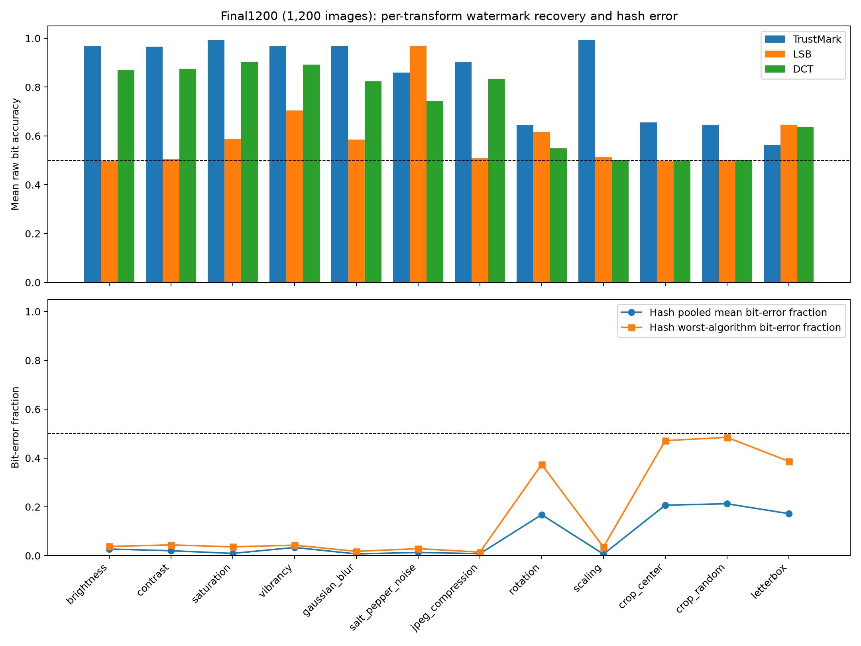
Figure 8: Final1200 method-comparison graph, generated from FPR_Method_Comparison.xlsx and the validated final1200 result files (1,200 images; 96,000 transformed observations; descriptive recovery rates).

