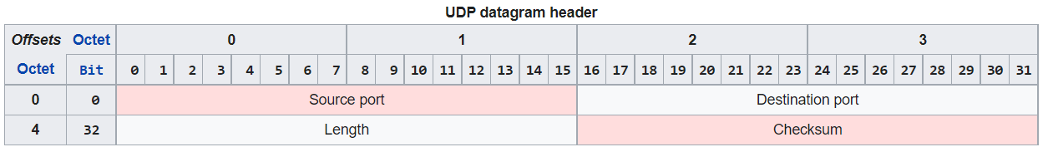

**Source port number**

This field identifies the sender's port assumed to be the port to reply to if needed.

**Destination port number**

This field identifies the receiver's port and is required. Similar to source port number, if the client is the destination host then the port number will likely be an ephemeral port number and if the destination host is the server then the port number

**Length**

This field specifies the length in bytes of the UDP header and UDP data.

The minimum length is 8 bytes, the length of the header.

The field size sets a theoretical limit of 65,535 bytes (8-byte header + 65,527 bytes of data) for a UDP datagram.

However the actual limit for the data length, which is imposed by the underlying [IPv4](https://en.wikipedia.org/wiki/IPv4) protocol, is 65,507 bytes (65,535 bytes − 8-byte UDP header − 20-byte [IP header](https://en.wikipedia.org/wiki/IPv4_header)).[[5]](https://en.wikipedia.org/wiki/User_Datagram_Protocol#cite_note-5)

Using IPv6 [jumbograms](https://en.wikipedia.org/wiki/Jumbogram" \o "Jumbogram) it is possible to have UDP datagrams of size greater than 65,535 bytes.[[6]](https://en.wikipedia.org/wiki/User_Datagram_Protocol#cite_note-6) RFC [2675](https://datatracker.ietf.org/doc/html/rfc2675) specifies that the length field is set to zero if the length of the UDP header plus UDP data is greater than 65,535.

**Checksum**

The [checksum](https://en.wikipedia.org/wiki/Checksum) field may be used for error-checking of the header and data. This field is optional in IPv4, and mandatory in IPv6.[[7]](https://en.wikipedia.org/wiki/User_Datagram_Protocol#cite_note-rfc2460-7) The field carries all-zeros if unused.[[8]](https://en.wikipedia.org/wiki/User_Datagram_Protocol#cite_note-rfc768-8)