
Steps to load the course subversion repository

- Download and install Subversion onto your machine (http://subversion.tigris.org)
- Download and install TortoiseSVN onto your machine (http://tortoisesvn.tigris.org)
- Download the repository rar file using the information in the email I sent you.
- Create a development directory on your C:\ drive.
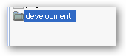
- Copy the rar file into the development folder
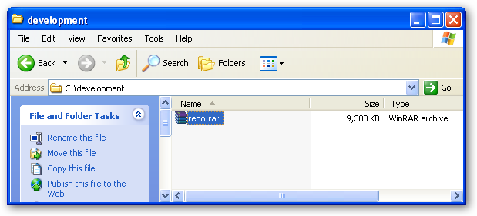
- Extract the contents of the rar file into the development folder (you can use WinRar to do this)
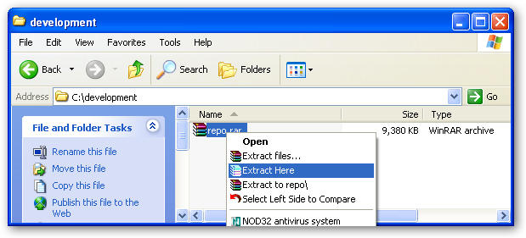
- Delete the rar file so that you are only left with the repository dump file (the size of your dump file may be different that the one in the image).
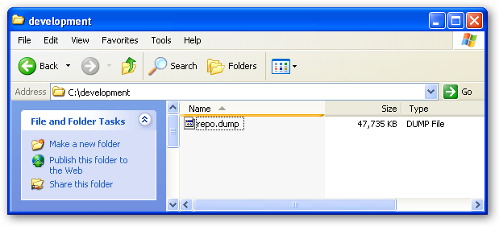
- Open a command prompt and navigate to your development folder
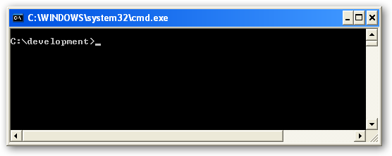
- Type the following command:
  - svnadmin create courserepo
  - hit enter
- Your development folder should now look like this:
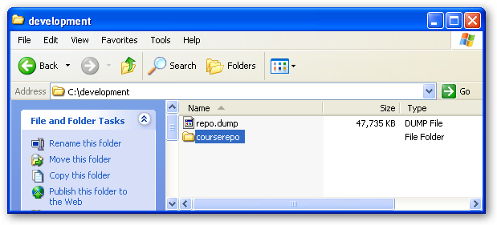

- The previous command creates an empty subversion repository. Now you need to load in the contents of the repository dump file. Execute the following command from the command prompt (the command prompt should still be pointed at your development folder)
  - svnadmin load courserepo < [nameofdumpfile] *make sure you replace the [name of dumpfile] with the name of the file that was extracted from the rar file, and omit the square brackets.
- After a little while the full contents of the repository should be loaded into a repository on your local machine.
- Exit the command window.
- Go back into your development folder (in Windows Explorer) and get ready to do a checkout of the code.
- Right click in the folder window and choose SVN Checkout:
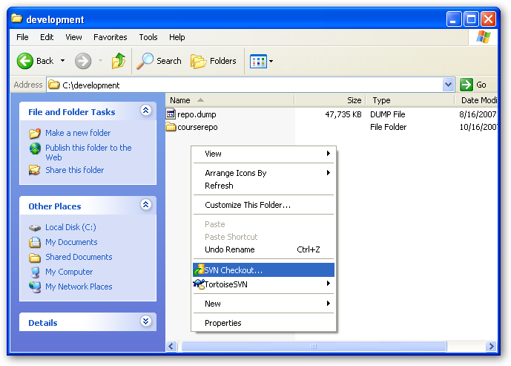
- Configure the checkout dialog with the following information:
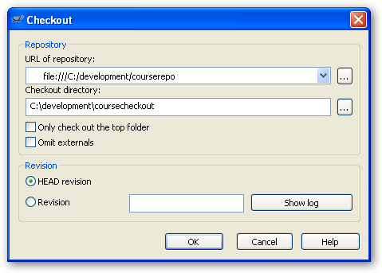

- After hitting the OK button, you should have a new folder named coursecheckout in your development folder. This folder will contain all of the sourcecode for the class.

If you have any problems extracting the code please do not hesitate to contact me.

Thanks.

