CSS学习笔记

# CSS How To...

三种方式插入CSS样式，主要为：

外部样式表：

<head>  
<link rel="stylesheet" type="text/css" href="mystyle.css">  
</head>

内部样式表

<head>  
<style>  
……  
</style>  
</head>

行内样式表

<h1 style="color:blue;margin-left:30px;">This is a heading</h1>

中间用分号隔开；

# CSS Colors

颜色的表示可以用三种方式：

* a valid color name - like "red" 目前HTML和CSS支持140个标准的颜色名字。可以在这里查询

https://www.w3schools.com/colors/colors_names.asp

* an RGB value - like "rgb(255, 0, 0)"
* a HEX value - like "#ff0000"

# CSS Backgrounds

* background-color
* background-image
* background-repeat 这里定义一张图片只在某个方向重复。

body {  
    background-image: url("gradient_bg.png");  
    background-repeat: repeat-x; 或者repeat-y/no-repeat  
}

* background-attachment fixed（固定位置，不随着滚动条滚动
* background-position 注意到这个位置，其实是相对于body里面元素的视图。而非整个页面视图。

简写模式：background: #ffffff url("img_tree.png") no-repeat right top;

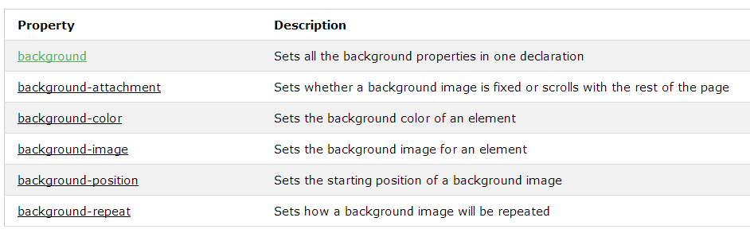

# CSS Borders

specify the style, width, and color of an element's border

border-style

四个值的情况下代表：上右下左；

三个值的情况下代表：上 右左 下；

两个值的情况下代表：上下 右左

一个值的情况下代表：四个边都一样

* dotted - Defines a dotted border
* dashed - Defines a dashed border
* solid - Defines a solid border
* double - Defines a double border
* groove - Defines a 3D grooved border. The effect depends on the border-color value
* ridge - Defines a 3D ridged border. The effect depends on the border-color value
* inset - Defines a 3D inset border. The effect depends on the border-color value
* outset - Defines a 3D outset border. The effect depends on the border-color value
* none - Defines no border
* hidden - Defines a hidden border

border-width

specific size (in px, pt, cm, em, etc) border-width: 5px;

three pre-defined values: thin, medium, or thick border-width: medium;

可以每条边都不一样 border-width: 2px 10px 4px 20px;

border-color

border-top-style: dotted;  
border-right-style: solid;  
border-bottom-style: dotted;  
border-left-style: solid;

简写模式：border: 5px solid red； 中间的样式一定要有不能省略；

border-radius 圆角

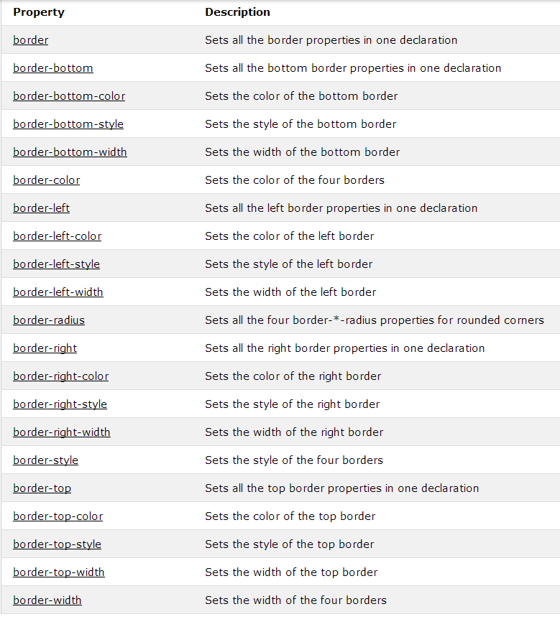

# CSS Margins

used to generate space around elements.

* margin-top
* margin-right
* margin-bottom
* margin-left

margin可以设置为auto，length，%或者inherit。

把它设置为auto可以水平居中某一个元素。设置成inherit会继承父级的设置；

margin是会collapse的。也就是两个元素不同的margin，会取大的那个值。

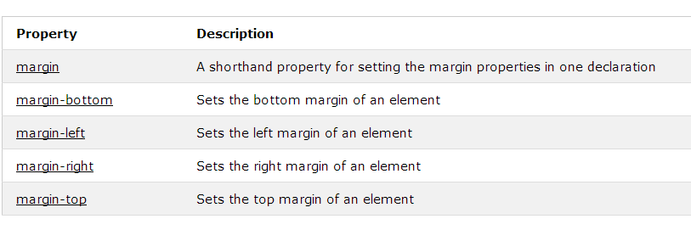

# CSS Padding

are used to generate space around content.

* padding-top
* padding-right
* padding-bottom
* padding-left

可以设置为length，%或者inherit。注意，没有auto哦！

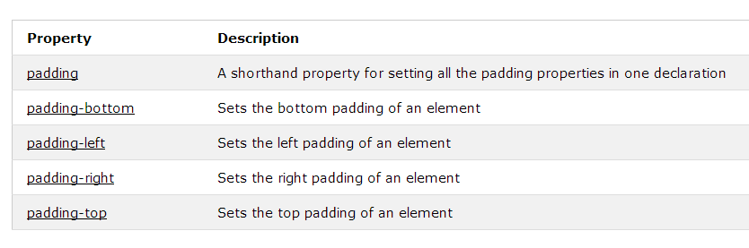

# CSS Height and Width

set the height and width of an element.

auto, or be specified in length values, like px, cm, etc., or in percent (%) of the containing block.

max-width：这个元素是设置最大长度，使得当浏览器窗口小于所设定的值时，它会自动的缩放。

**Note:** The value of the max-width property overrides width.

max-height

min-height

min-width

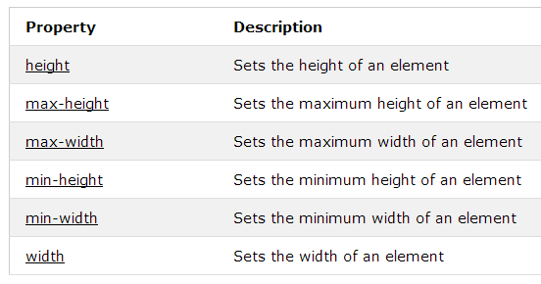

# CSS Box Model---------------------------------------非常重要

All HTML elements can be considered as boxes. In CSS, the term "box model" is used when talking about design and layout.

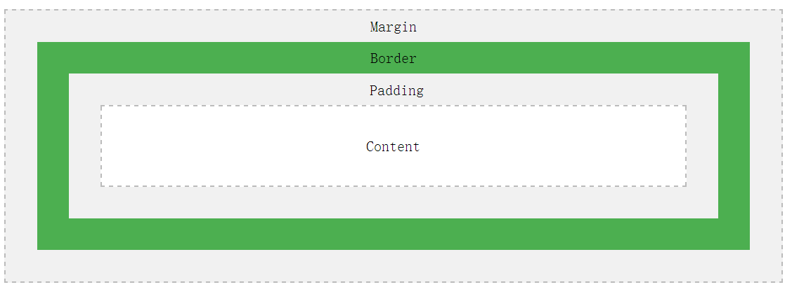

**Important:** When you set the width and height properties of an element with CSS, you just set the width and height of the **content area**. To calculate the full size of an element, you must also add padding, borders and margins.

# CSS Outline

outline-style

outline-color

outline-width

outline-offset:定义了border和outline之间的空隙。如果用margin，则是outline外的空间。outline和border本身是没有空隙的。

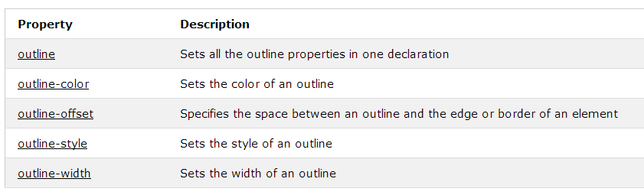

# CSS Text

Color

text-align ：center; left; right; justify;

text-decoration：used to set or remove decorations from text.

text-decoration: none; is often used to remove underlines from links: overline; line-through; underline;

text-transform：text-transform: uppercase; lowercase; capitalize;

text-indent 第一行文字的缩进

letter-spacing

line-height

direction：rtl

word-spacing

text-shadow

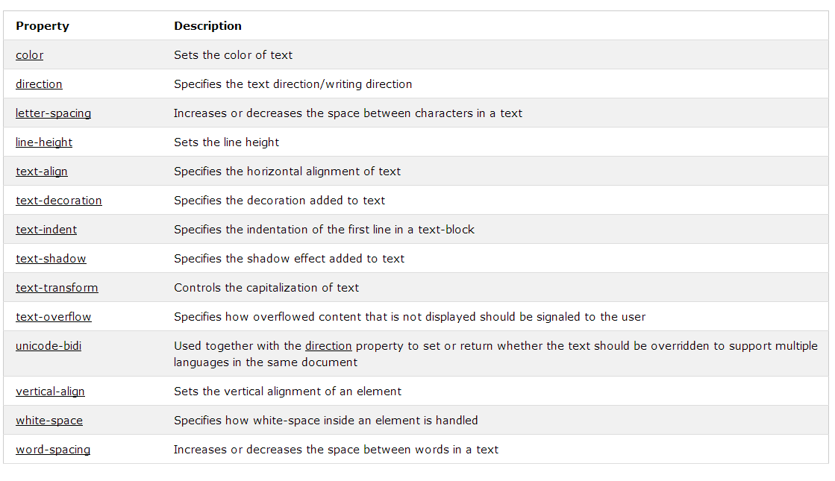

# CSS Fonts

the font family, boldness, size, and the style of a text.

In CSS, there are two types of font family names:

* **generic family** - a group of font families with a similar look (like "Serif" or "Monospace")
* **font family** - a specific font family (like "Times New Roman" or "Arial")

 font-family: "Times New Roman", Times, serif; 最要用几个。当第一个没有，会以此找下一个；

font-style：normal; italic; oblique;

font-size

Set Font Size With Em

To allow users to resize the text (in the browser menu), many developers use em instead of pixels.

1em is equal to the current font size. The default text size in browsers is 16px. So, the default size of 1em is 16px.

The size can be calculated from pixels to em using this formula: *pixels*/16=*em*

font-size: 2.5em; /* 40px/16=2.5em */

font-weight：normal; bold;

font-variant normal; small-caps;

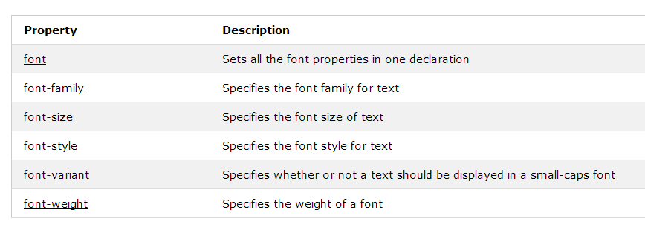

# CSS Icons

The simplest way to add an icon to your HTML page, is with an icon library, such as Font Awesome.

To use the Font Awesome icons, add the following line inside the <head> section of your HTML page:

## Font Awesome Icons

<link rel="stylesheet" href="https://cdnjs.cloudflare.com/ajax/libs/font-awesome/4.7.0/css/font-awesome.min.css">

**Note:** No downloading or installation is required!

## Bootstrap Icons

<link rel="stylesheet" href="https://maxcdn.bootstrapcdn.com/bootstrap/3.3.7/css/bootstrap.min.css">

## Google Icons

<link rel="stylesheet" href="https://fonts.googleapis.com/icon?family=Material+Icons">

# CSS Links

With CSS, links can be styled in different ways.

[Text Link](javascript:void(0)) [Text Link](javascript:void(0)) [Link Button](javascript:void(0)) [Link Button](javascript:void(0))

可以设置link的样式：颜色，字体，背景等。

link有四种状态：

* a:link - a normal, unvisited link
* a:visited - a link the user has visited
* a:hover - a link when the user mouses over it
* a:active - a link the moment it is clicked
  + a:hover MUST come after a:link and a:visited
  + a:active MUST come after a:hover

a:link, a:visited {

background-color: white;

color: black;

padding:14px 25px;

border-color: green;---错误，要定义border宽度，颜色，还有是什么style啊

border：1px solid green;

text-align: center;

text-decoration: none;

display: inline-block;

}

a:hover, a:active{

background-color:red;

}

# CSS Lists

没有顺序的用ul li

有顺序的用ol li

list-style-type：circle; square; upper-roman; lower-alpha; 还可以是none。可以把margin和padding设置为0。

简写方式：list-style: square inside url("sqpurple.gif"); 如果图片显示不出来，则会用square来显示。否则图片会取代square

list-style-image：url('sqpurple.gif');

list-style-position：inside;outside； outside是默认的；

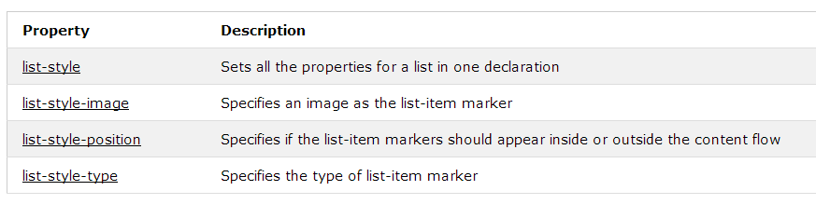

# CSS Tables

table, th, td tr：每一行

border: 1px solid black; table th td都可以有

border-collapse: collapse; table里面定义

width and height

text-align

vertical-align

padding

border-bottom

:hover 针对每一行 变颜色等；

tr:nth-child(even) {background-color: #f2f2f2}

overflow-x:auto <div style="overflow-x:auto;">

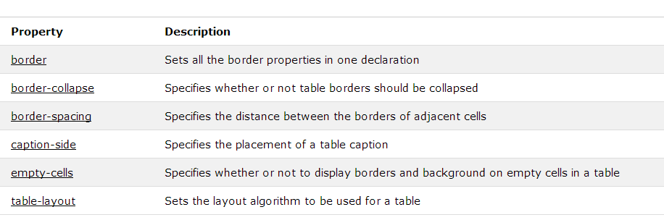

这个笔记很重要