The downstream operator qualifies, predicts and shapes the certified compression of electronic densities
Abstract
Compressed scientific fields are judged by quantities computed from the reconstruction, yet the reference analysis may not resolve the requested tolerance. QoI Stability Qualification (QSQ) qualifies the measurement contract before any codec is scored: across 254 electronic densities, a five-probe screen separated fresh Bader threshold-exceedance risks of 1.600% (135/8,437 trials) in qualified and 81.325% (5,326/6,549) in rejected materials. For linear operators, the operator symbol fixes where compression error belongs and what that gains. In pre-registered tests on 60 unused bulk crystals and 32 unused surface slabs, gains predicted before compression for five operators matched measurement (Spearman 0.978 and 0.979). For the Hartree potential, the closed-form law certified 10.2-fold (60/60) and 18.5-fold (32/32) more compression than equal-search pointwise codecs; for bulk crystals it lies within 10.5% of the operational optimum. On 48 further unused crystals, one stream certified Hartree potential and Bader charges together (48/48) at median byte overhead 1.000.
Introduction
Electronic-structure databases store electron densities on dense real-space grids, and error-bounded lossy compressors such as ZFP, SZ3 and SPERR are the standard means of reducing such floating-point fields.¹–⁴ Lossy compression is used across scientific workflows⁵ and in quantum chemistry, for two-electron integrals and atomic-orbital bases.⁶,⁷ A stored density is rarely the scientific result. The result is a quantity computed from it: a potential, a field, an atomic charge.
Downstream fidelity is therefore an accepted requirement of scientific compression. Multilevel methods control user-prescribed derived quantities through operator norms;⁸ error-control theory maps quantity-of-interest (QoI) tolerances to data-level bounds;⁹ QPET tunes pointwise bounds for differentiable QoIs;¹⁰ application pipelines preserve several QoIs at once, including by constraint satisfaction after decompression;¹¹–¹³ TOPIQ predicts QoI bias and uncertainty from compressed data;¹⁴ Compression Safeguards and FFCz correct decoded data until declared pointwise, QoI or spectral bounds hold;¹⁵,¹⁶ progressive retrieval guarantees errors on derivable QoIs;¹⁷ and topology-aware compressors preserve discrete structure that pointwise bounds miss.¹⁸,¹⁹ These methods bound, predict or enforce the error of a declared QoI.
Task-based quantization established that a quantizer should be designed for the task it serves rather than for the signal itself.²⁰ Coefficient-dependent step sizes under a weighted squared error are classical high-rate allocation,²¹,²² and step-size maps tuned to a downstream error model have long been used in image coding.²³ Here we apply that principle to stored physical fields. The task is a physical operator with an exact reciprocal-space symbol, and every decoded field is recertified under that operator.
Measurement science adds a step that compression benchmarks omit. Analytical chemistry does not report a concentration below a method's limit of quantification,²⁴ and measurement-system analysis compares gauge variation with the tolerance before the gauge accepts or rejects parts.²⁵ In a compression benchmark the reference analysis plays the gauge, and its capability under the declared contract decides whether a tolerance can be scored at all.
Here we show that the downstream operator governs certified compression at three points (Fig. 1). It qualifies: QSQ decides whether the complete measurement contract resolves the requested tolerance, and its verdict predicts fresh risk. It shapes: for linear operators, the operator symbol yields a closed-form allocation law, which we test prospectively on unused bulk crystals and surface slabs from two databases. It predicts: the gain of operator-aware over operator-blind allocation, computed from the operator symbol and the reference spectrum and committed before compression, matches the measured gain for five operators. Finally, one stream is certified for the Hartree potential and for Bader charges together. Every confirmatory result follows a protocol committed before its outcomes (Methods, Table 1).
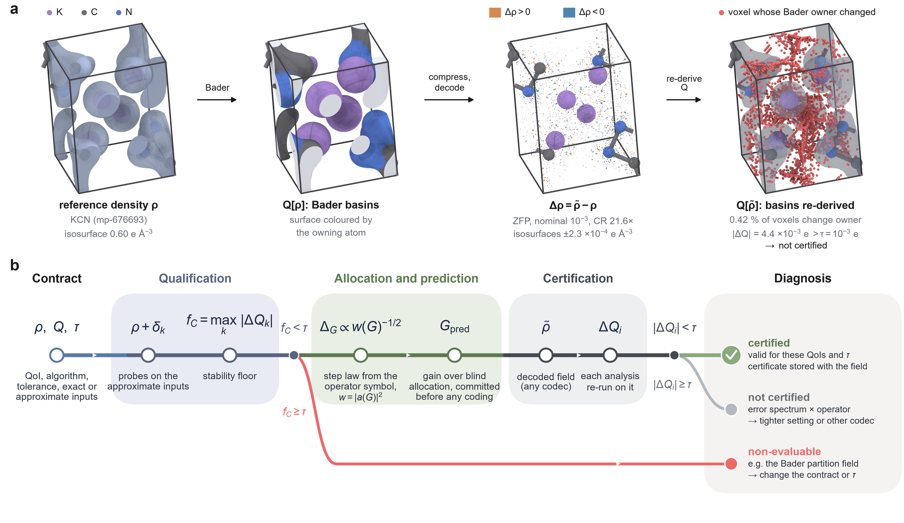
Fig. 1 | The downstream operator at each stage of certified compression. a, The objects the contract acts on for one development material and one frozen benchmark row (KCN, mp-676693; ZFP at nominal relative tolerance 10⁻³, compression ratio 21.6): reference valence density (isosurface 0.60 e AA⁻³), its Bader basins coloured by owning atom, the decoded error ρ-ρ (isosurfaces ±2.3×10⁻⁴ e AA⁻³) and the voxels whose Bader owner changes when basins are re-derived on ρ (0.42%). The charge error, 4.4×10⁻³ e, exceeds τ=10⁻³ e for a material whose stability floor (2.2×10⁻⁵ e) makes it eligible, so the row is eligible and not certified. b, The workflow as one track. The contract declares the quantity of interest Q, the downstream algorithm, the tolerance τ and which inputs are exact or approximate. Qualification applies the pre-specified probes δₖ to the approximate inputs and records the stability floor fC=maxₖ|Δ Qₖ|; a contract with fC≥τ leaves the main line as non-evaluable. Allocation and prediction read the operator symbol a(G): the step law ΔG∝ w(G)⁻¹/² with w=|a|², and the gain over operator-blind allocation, G pred, committed before any coding. Certification re-runs each analysis on the decoded field from any codec: the field is certified when every |Δ Qᵢ|<τ; an eligible contract with |Δ Qᵢ|≥τ at every evaluated setting is not certified.
Results
A tolerance is scored only after the measurement contract resolves it
A measurement contract declares the QoI, the downstream numerical algorithm, the scientific tolerance τ and the role of every input as exact or approximate. QSQ perturbs the approximate inputs five times at their own float32 precision scale, takes the maximum downstream response as the stability floor fC, and admits the contract when fC<τ (Methods). Each material–contract–tolerance decision then ends in one of three outcomes: certified, not certified, or non-evaluable (Fig. 1b). For Bader charge, atomic basins follow the topology of a partition-defining density,²⁶ and grid algorithms re-derive them for every input.²⁷–²⁹
We froze the five-probe screen and challenged it with 59 fresh perturbations for each of 254 development densities (186 Materials Project bulk crystals, 68 NOMAD slabs). All 14,986 trials produced valid Bader outcomes. At 10⁻³ e, QSQ admitted 143/254 materials. Qualified materials exceeded the threshold in 135/8,437 fresh trials (1.600%; material-cluster 95% CI 0.782–2.596%), rejected materials in 5,326/6,549 (81.325%; 75.981–86.257%), and 20/143 versus 110/111 materials showed any exceedance (Fig. 2a,d). The separation held at 10⁻⁴ e (46/254 admitted; 4.016% versus 86.938%) and at 10⁻² e (229/254; 0.148% versus 79.593%). Fresh risk rose steeply as a material's floor approached the tolerance (Fig. 2a).
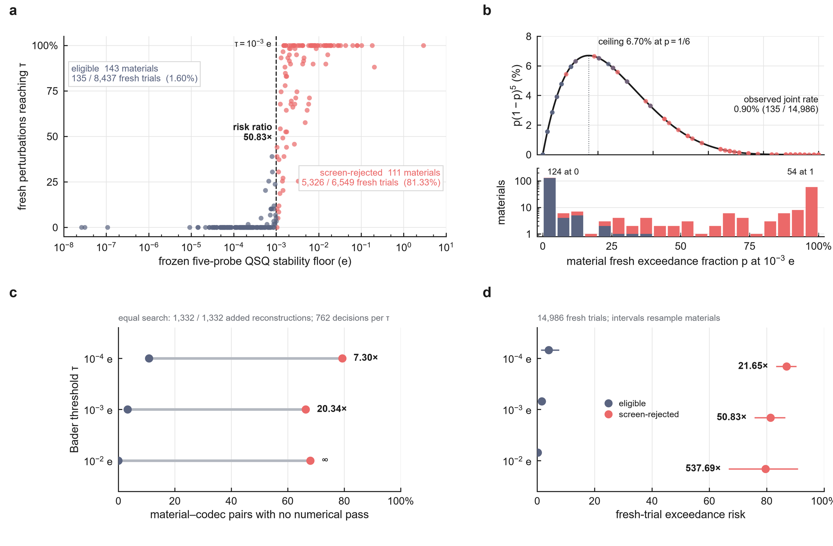
Fig. 2 | The frozen QSQ screen prospectively stratifies downstream numerical risk. a, Each of the 254 development materials at its frozen five-probe stability floor against the fraction of its 59 fresh perturbations whose re-derived Bader response reaches τ=10⁻³ e (dashed line). The 143 admitted materials (navy) exceed τ in 135 of 8,437 fresh trials (1.600%; material-cluster 95% CI 0.782–2.596%); the 111 rejected materials (red) in 5,326 of 6,549 (81.325%; 75.981–86.257%). b, Finite-panel admission bound p(1-p)⁵ (ceiling 6.70% at p=1/6) with every material placed at its fresh exceedance fraction; the observed joint rate is 0.90% (135/14,986). c, Equal-search control: after completing the same tight settings for every material (1,332/1,332 added reconstructions), no-pass risk of eligible and rejected material–codec pairs (762 decisions per threshold); 20.34-fold at 10⁻³ e (3.3% versus 66.4%). d, Fresh exceedance risk at the three pre-specified thresholds with material-cluster 95% intervals: 4.016% versus 86.938% at 10⁻⁴ e, 1.600% versus 81.325% at 10⁻³ e and 0.148% versus 79.593% at 10⁻² e.
Qualification also governs codec comparisons. When the same tight settings were completed for every material (1,332/1,332 added reconstructions), the fraction of material–codec pairs with no passing reconstruction at 10⁻³ e was 3.3% for qualified and 66.4% for rejected pairs, a 20.34-fold ratio (Fig. 2c). A finite panel carries a distribution-free guarantee: for exchangeable probes, the joint probability of admission and a later exceedance is at most nⁿ/(n+1)ⁿ⁺¹, 6.70% for n=5; the observed joint rate was 0.901% (Fig. 2b).
Evaluability belongs to the contract, not to the material. With Henkelman Bader 1.05 and an all-electron partition reference (AECCAR0 + AECCAR2), perturbing only the integrated charge field left 50/50 analyzable materials eligible at 10⁻³ e, whereas perturbing the partition reference left 3/50. Holding the partition reference exact is therefore a contract choice that makes Bader charges scorable; it defines the Bader contract used for joint certification below. Implementation transfer, a second topology-sensitive QoI and an external cohort are reported in Supplementary Note 1.
The operator symbol explains the codec effect and fixes a closed-form allocation law
At matched realized L∞ distortion, codecs still differ in Hartree-potential error. For 457 ZFP/SZ3 pairs matched within material (214 materials), the material-level Hartree-error ratio was 0.0776221, and 0.0776219 under a Nyquist-safe Poisson operator; the real-space error agreed with its Fourier expression to a relative discrepancy of 1.296×10⁻¹⁵. Writing E for the error energy over non-zero, Nyquist-safe modes and SH=WH/E for the Hartree susceptibility, with WH=ΣG|Δρ(G)|²/|G|⁴, each pair's ratio factors exactly as
RH=√((E ZFP)/(E SZ3)) √((S H,ZFP)/(S H,SZ3)).
The material-level centres were 0.375963 for the energy factor and 0.202683 for the susceptibility factor (Fig. 3c), and frequency allocation carried a material-median 62.0% of the absolute log effect (Fig. 3d). ZFP places less error energy in the long-wavelength modes that the Hartree symbol amplifies (Fig. 3a,b).
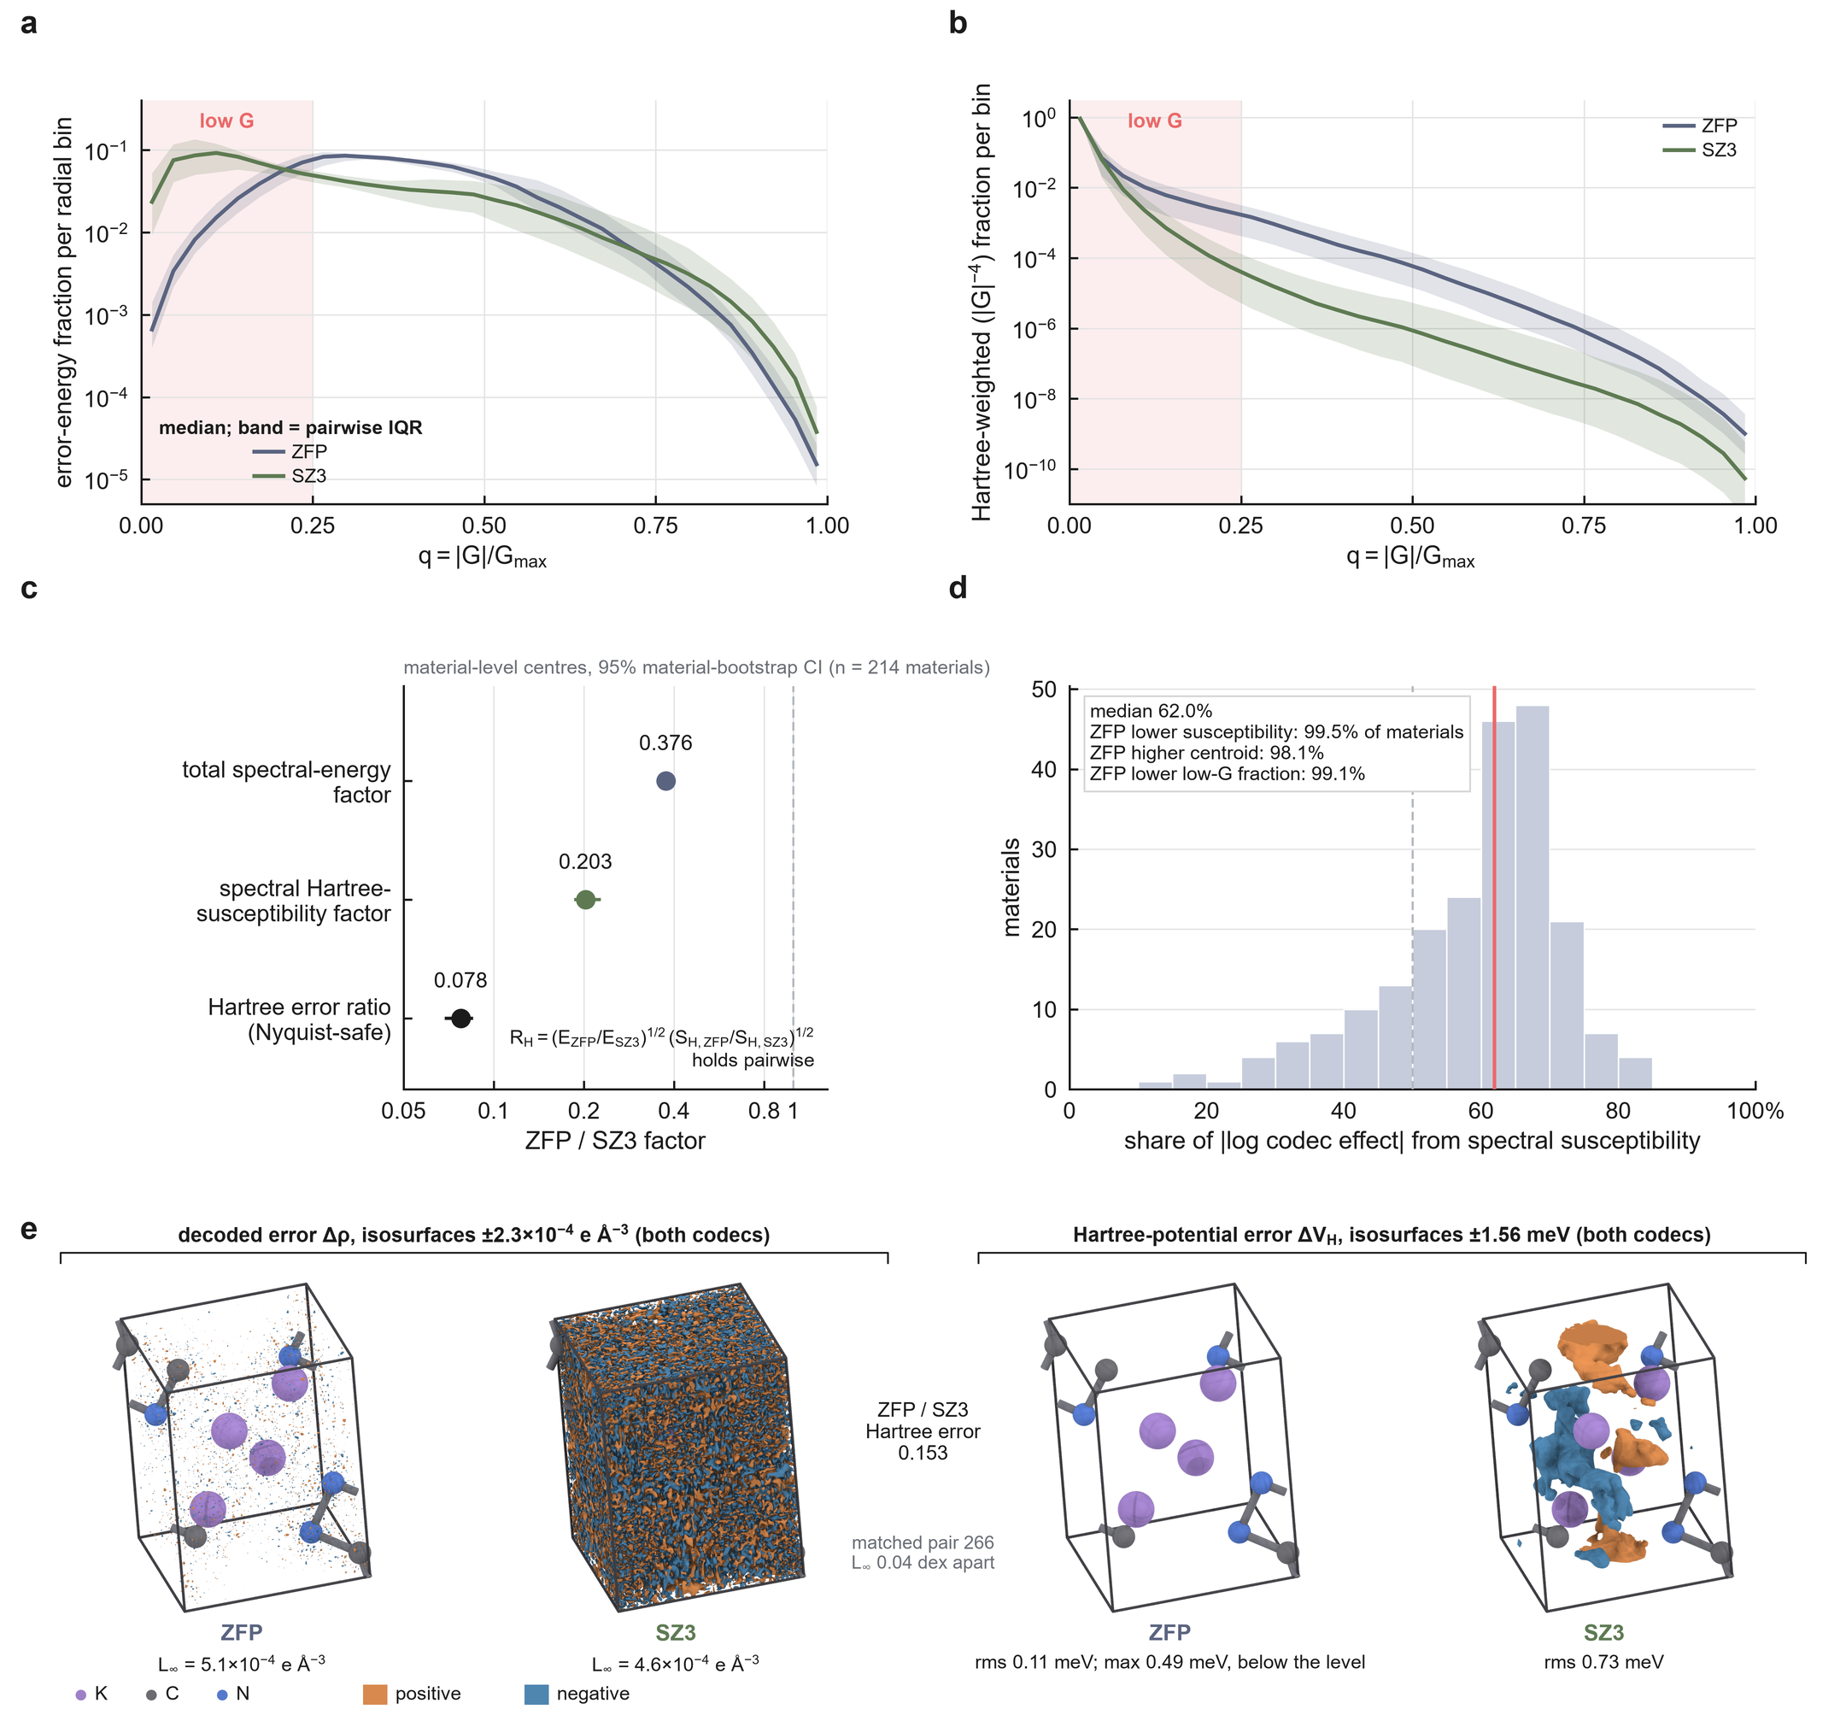
Fig. 3 | The Hartree operator's spectral weight explains the codec effect at matched distortion. a, Radial reconstruction-error spectra for the 457 within-material ZFP/SZ3 pairs matched on realized L∞ (214 materials); medians of non-zero, Nyquist-safe error-energy fractions with pairwise interquartile ribbons. b, Hartree weighting (|G|⁻⁴) emphasizes the long-wavelength modes where SZ3 places more error. c, Material-level centres and 95% bootstrap intervals of the total spectral-energy factor (0.376), the Hartree-susceptibility factor (0.203) and the Nyquist-safe Hartree-error ratio (0.07762); the multiplicative closure is exact for each pair. d, The susceptibility factor contributes a material-median 62.0% of the absolute log codec effect. e, One matched pair in three dimensions (KCN, mp-676693): at one decoded-error isolevel, ZFP error is confined to sparse voxels whereas SZ3 error fills the cell, and the Hartree-potential error forms long-wavelength SZ3 lobes that ZFP does not reach (RMS 0.11 versus 0.73 meV).
The same symbol prescribes the allocation. For a linear operator diagonal in reciprocal space with symbol a(G), the squared operator error of a density error δρ is ΣG w(G) |δρ(G)|² with weight w=|a|². Under high-rate scalar quantization, minimizing this weighted error at fixed rate gives the classical step-size law²¹,²²
ΔG∝ w(G)⁻¹/².
For the Hartree potential, a=4π/|G|², so w∝|G|⁻⁴ and ΔG∝|G|². The allocation algebra is textbook; what the operator adds is the weight, taken from physics rather than from perception or signal statistics, and the certificate: every stream is decoded and its Hartree error recomputed from the real-space field. A frozen-ladder implementation of this law was confirmed earlier on a disjoint 48-material cohort and a 254-material census (Supplementary Note 2).
On one density the law's action can be followed shell by shell (KCN, the material of Figs. 1a and 3e; Fig. 4). The step grows as |G|² from the exactly stored G=0 (Fig. 4a). Beyond q=|G|/G max≈0.26 the root-mean-square reference coefficient falls below the step and quantizes to zero (Fig. 4c), so 97.5% of the bytes sit in the 10 innermost of 32 shells (Fig. 4e). Within q≤0.25 the Hartree error per mode stayed within 10.4–13.6 times its all-mode mean, the equal-distortion signature of the law; under uniform steps the same quantity spanned 0.238 to 19,829, with the lowest shell dominating, as for ZFP, SZ3 and SPERR (Fig. 4d). At a decoded Hartree error of 10⁻⁶ the law certified a compression ratio of 133, against 60.7 for uniform steps, 115 for truncation at its best cutoff and 15.7, 13.5 and 6.6 for ZFP, SZ3 and SPERR (Fig. 4b).
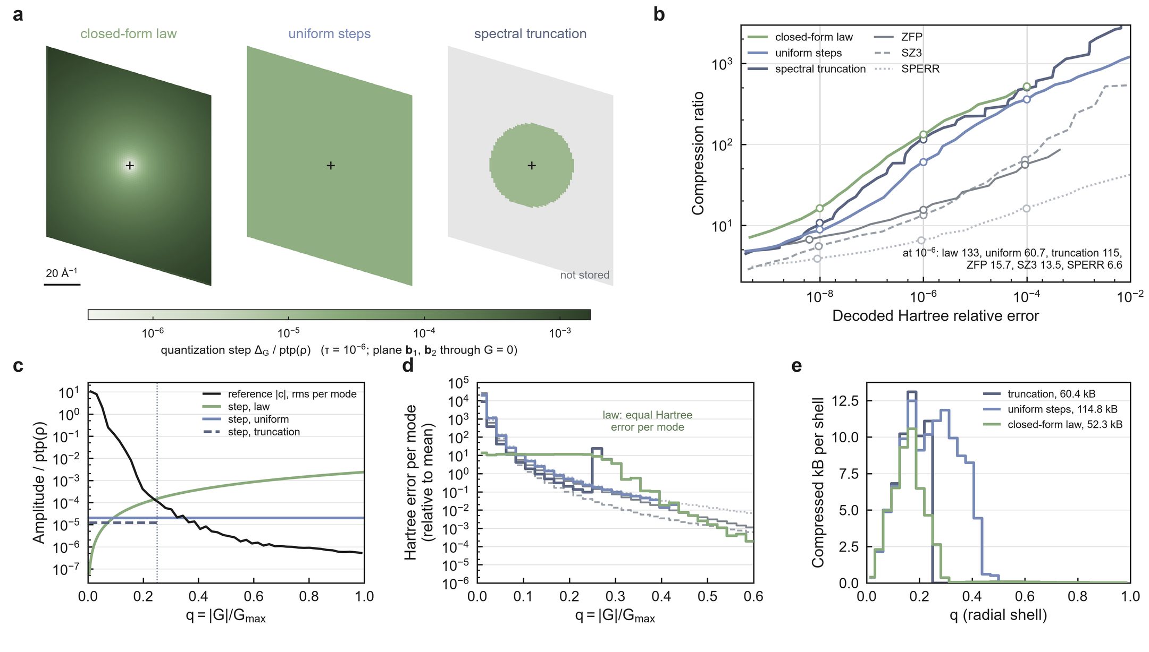
Fig. 4 | The operator symbol fixes where the step, the error and the bytes go. One development density (KCN, mp-676693) and the Hartree potential; every stream is decoded and its Hartree error recomputed. a, Quantization step ΔG on the reciprocal plane through G=0 spanned by b₁ and b₂ for the closed-form law (ΔG∝|G|²), uniform steps and spectral truncation at its best cutoff (q=0.25; outer modes not stored), each at its certified point for a Hartree tolerance of 10⁻⁶; G=0 (cross) is stored exactly. b, Compression ratio against decoded Hartree relative error; truncation is the lower envelope over 32 cutoffs; open circles, certified points at 10⁻⁴, 10⁻⁶ and 10⁻⁸ (vertical lines). c, Root-mean-square reference coefficient per radial bin, q=|G|/G max, and the step of each policy at 10⁻⁶. d, Hartree error per mode relative to its all-mode mean, per radial bin, at 10⁻⁶; colours and line styles as in b. e, Compressed bytes per radial shell at 10⁻⁶, with stream totals.
Under equal search, the law certifies an order of magnitude more than pointwise codecs on bulk crystals and surface slabs
We tested the law prospectively on 60 Materials Project bulk crystals and 32 NOMAD surface slabs that had never been used in the project (Methods). Three arms received the same continuous search with decode-verified certificates: the closed-form law (A1), spectral truncation at the best of 32 cutoffs (A2), and the best of ZFP, SZ3 and SPERR (A6). The Hartree contract is relative root-mean-square potential error below τ, with historical and Nyquist-safe evaluation. Both cohorts ran with zero pipeline failures.
At τ=10⁻⁶, the law certified a median 10.2-fold more compression than the best pointwise codec on bulk crystals (95% CI 9.13–12.09; 60/60 materials) and 18.5-fold more on slabs (15.8–23.1; 32/32) (Fig. 5a). It exceeded spectral truncation 1.32-fold (1.27–1.35; 52/60) and 1.41-fold (1.28–1.72; 27/32) (Fig. 5b). The advantage over pointwise codecs held at every tolerance: 9.10-, 10.2- and 3.30-fold on bulk crystals and 15.9-, 18.5- and 7.0-fold on slabs at 10⁻⁴, 10⁻⁶ and 10⁻⁸ (Fig. 5c; per-tolerance tables in Supplementary Note 5). In absolute terms the law certified median compression ratios of 196 on bulk crystals and 504 on slabs at 10⁻⁶, against 16.0 and 23.3 for the best pointwise codec (Fig. 5d).
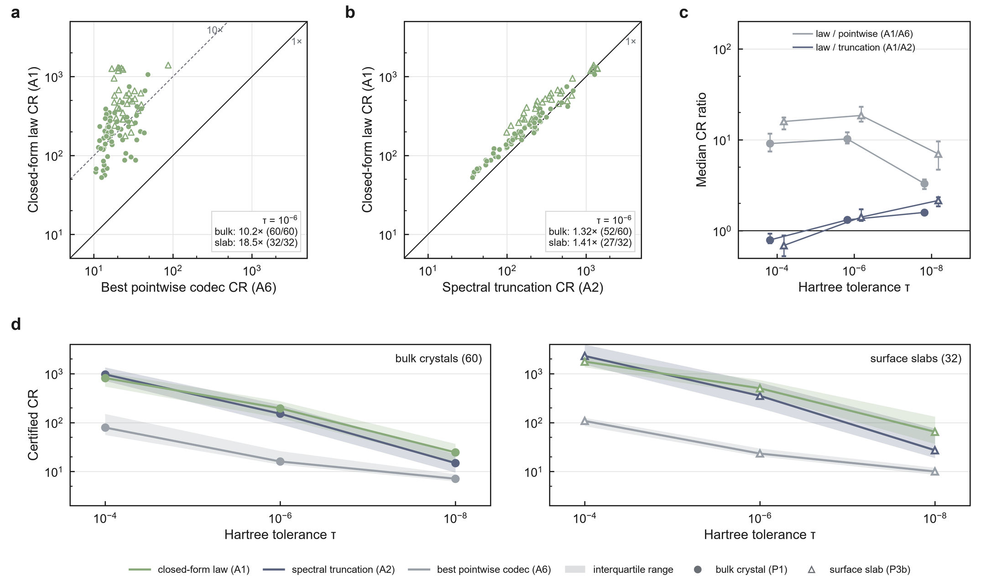
Fig. 5 | Under equal search, the closed-form law certifies an order of magnitude more than pointwise codecs and beats spectral truncation. Fresh cohorts: 60 bulk crystals (P1, circles) and 32 surface slabs (P3b, triangles); every stream decode-verified; A1, A2 and A6 receive equal continuous search. a, Certified compression ratio (CR) of the law (A1) against the best of ZFP, SZ3 and SPERR (A6) at Hartree relative error 10⁻⁶; lines mark ratios 1 and 10 (medians 10.2-fold, 60/60, and 18.5-fold, 32/32). b, A1 against spectral truncation (A2) at 10⁻⁶ (1.32-fold, 52/60; 1.41-fold, 27/32). c, Median ratios A1/A6 and A1/A2 with bootstrap 95% CIs at 10⁻⁴, 10⁻⁶ and 10⁻⁸ for each cohort. d, Certified CR against tolerance for the three arms: median (line) and interquartile range (band) over the materials of each cohort.
The advantage over truncation is a property of tight tolerances. It grows to 1.59-fold (bulk) and 2.16-fold (slabs) at 10⁻⁸, whereas at 10⁻⁴ truncation certifies more (ratios 0.79 and 0.69). At that rate most coefficients fall in the quantizer's dead zone, the regime in which low-rate transform-coding theory replaces the high-rate law.³⁰,³¹ Operational allocation, examined next, covers that regime.
The operator metric carries the gain, and the system class sets the optimizer's share
To separate the metric from the optimizer, we built the operational optimum (A3): Lagrangian selection, per radial shell, over exact pairs of compressed bytes and operator distortion,³²,³³ targeted directly at the decode-verified Hartree certificate. Its control (A5) runs the same machinery in the operator-blind L₂ metric, with the Lagrange multiplier chosen only so that the same Hartree certificate holds.
Ordering the arms as a ladder separates three factors (Fig. 6a). At τ=10⁻⁶, operator-blind rate–distortion allocation in the same Hermitian-orbit representation (A5) certified 5.6-fold more than the best pointwise codec on bulk crystals and 7.3-fold more on slabs; the closed-form operator law (A1) added 1.89- and 2.66-fold to that; and operational allocation in the operator metric (A3) a further 1.105- and 1.222-fold.
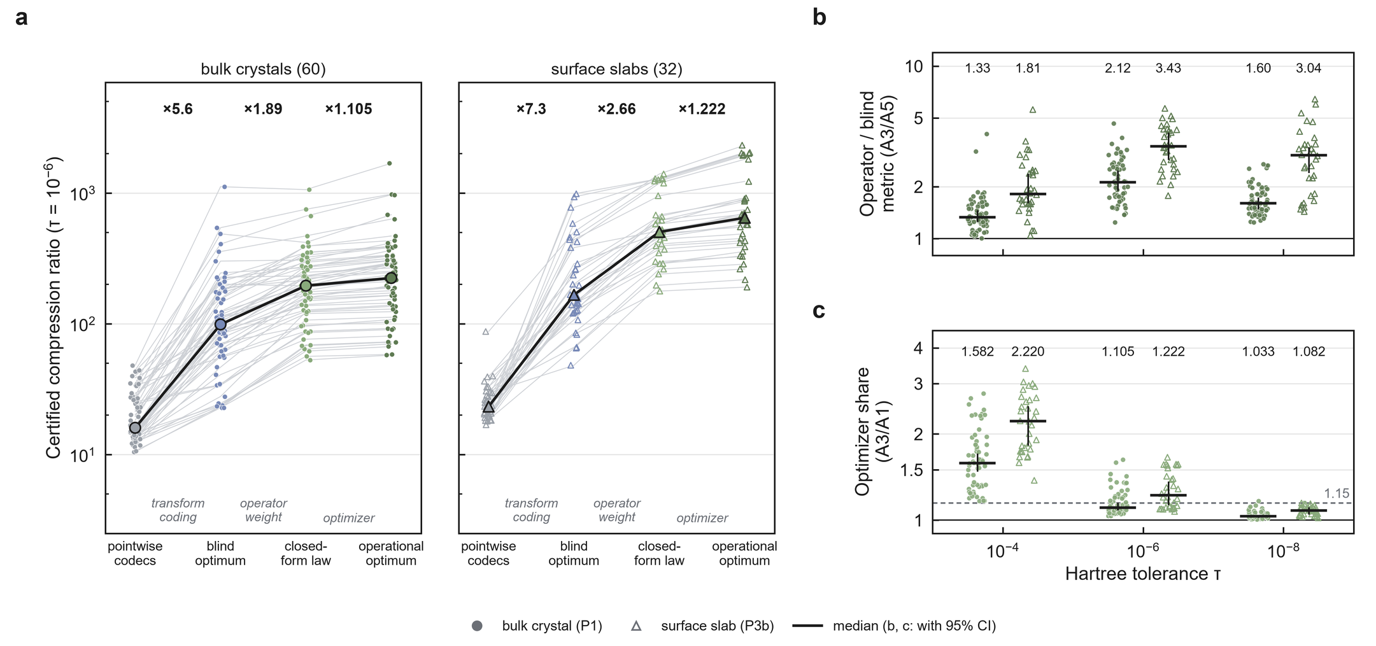
Fig. 6 | The gain ladder separates transform coding, the operator weight and the optimizer. Fresh cohorts as in Fig. 5. a, Certified CR at a Hartree tolerance of 10⁻⁶ for each material (thin lines) and the median (bold) along the arms: best pointwise codec (A6), operator-blind rate–distortion optimum (A5), closed-form law (A1) and operational optimum in the operator metric (A3); the factor between rungs is the median per-material ratio. b, A3/A5, the operator metric at equal optimization, per material at three tolerances; bar, median; whisker, bootstrap 95% CI (at 10⁻⁶: 2.12-fold, 60/60; 3.43-fold, 32/32). c, A3/A1, the optimizer's share over the law; dashed line, pre-registered threshold 1.15 (at 10⁻⁶: bulk 1.105, 95% CI 1.090–1.146; slabs 1.222, 1.138–1.359).
The metric carries the gain. At τ=10⁻⁶, the optimum under the operator metric certified 2.12-fold more than the optimum under the blind metric on bulk crystals (95% CI 1.92–2.46; 60/60) and 3.43-fold more on slabs (2.89–4.08; 32/32) (Fig. 6b). The ratio exceeded 1.3 at every tolerance (bulk 1.33, 2.12 and 1.60; slabs 1.82, 3.43 and 3.04 at 10⁻⁴, 10⁻⁶ and 10⁻⁸).
The optimizer's share depends on the system class. For bulk crystals the closed-form law is within 10.5% of the operational optimum (median ratio 1.105, 95% CI 1.090–1.146, 60 crystals); for surface slabs operational allocation adds 22% (median ratio 1.222, 95% CI 1.138–1.359, 32 slabs), at a Hartree tolerance of 10⁻⁶ (Fig. 6c). The share shrinks as the tolerance tightens (bulk 1.58, 1.10 and 1.03; slabs 2.22, 1.22 and 1.08 at 10⁻⁴, 10⁻⁶ and 10⁻⁸). The closed-form law is therefore the encoder for bulk crystals at tight tolerances, and operational allocation the encoder for surfaces, for loose tolerances and for joint contracts.
One stream certifies the Hartree potential and Bader charges together
A stored density usually serves more than one analysis. We froze a joint contract before any run (Methods): Hartree relative error below 10⁻⁶ on the final stream, and Henkelman Bader charges with an exact all-electron partition reference, maximum atomic-charge error at most τB and zero basin reassignment, for τB=10⁻³, 10⁻⁴ and 10⁻⁵ e. Four base codecs competed: the operational Hartree encoder (R3, the A3 codec), the frozen-ladder law (J), spectral truncation (T1) and the best of ZFP, SZ3 and SPERR (GF). Each base received the same post-processors, including uniform per-basin projection, which restores each basin's charge with the additive correction of smallest L₂ and L∞ norm, the Euclidean counterpart of the entropy-divergence constraint satisfaction applied to velocity moments of fusion data,¹² and certify-then-project, which projects only when the decoded stream fails the Bader contract.
On 48 fresh bulk crystals, one stream from R3, certified for the Hartree potential at 10⁻⁶, was also certified for Bader charges with zero basin reassignment at 10⁻³, 10⁻⁴ and 10⁻⁵ e in 48/48 materials. At 10⁻⁴ e its joint compression ratio equalled its Hartree-only ratio (median overhead 1.000, 95% CI 1.000–1.000; Fig. 7d) and exceeded that of the best other base codec under the same joint contract in 48/48 materials (median 1.317-fold, 95% CI 1.269–1.360; minimum 1.096; Fig. 7a). Median joint compression ratios were 298 for R3, 213 for J, 212 for T1 and 18.6 for GF (Fig. 7b). Every certified stream kept its maximum atomic-charge error at or below τB with no voxel reassigned (144/144 stream–tolerance pairs; Fig. 7c).
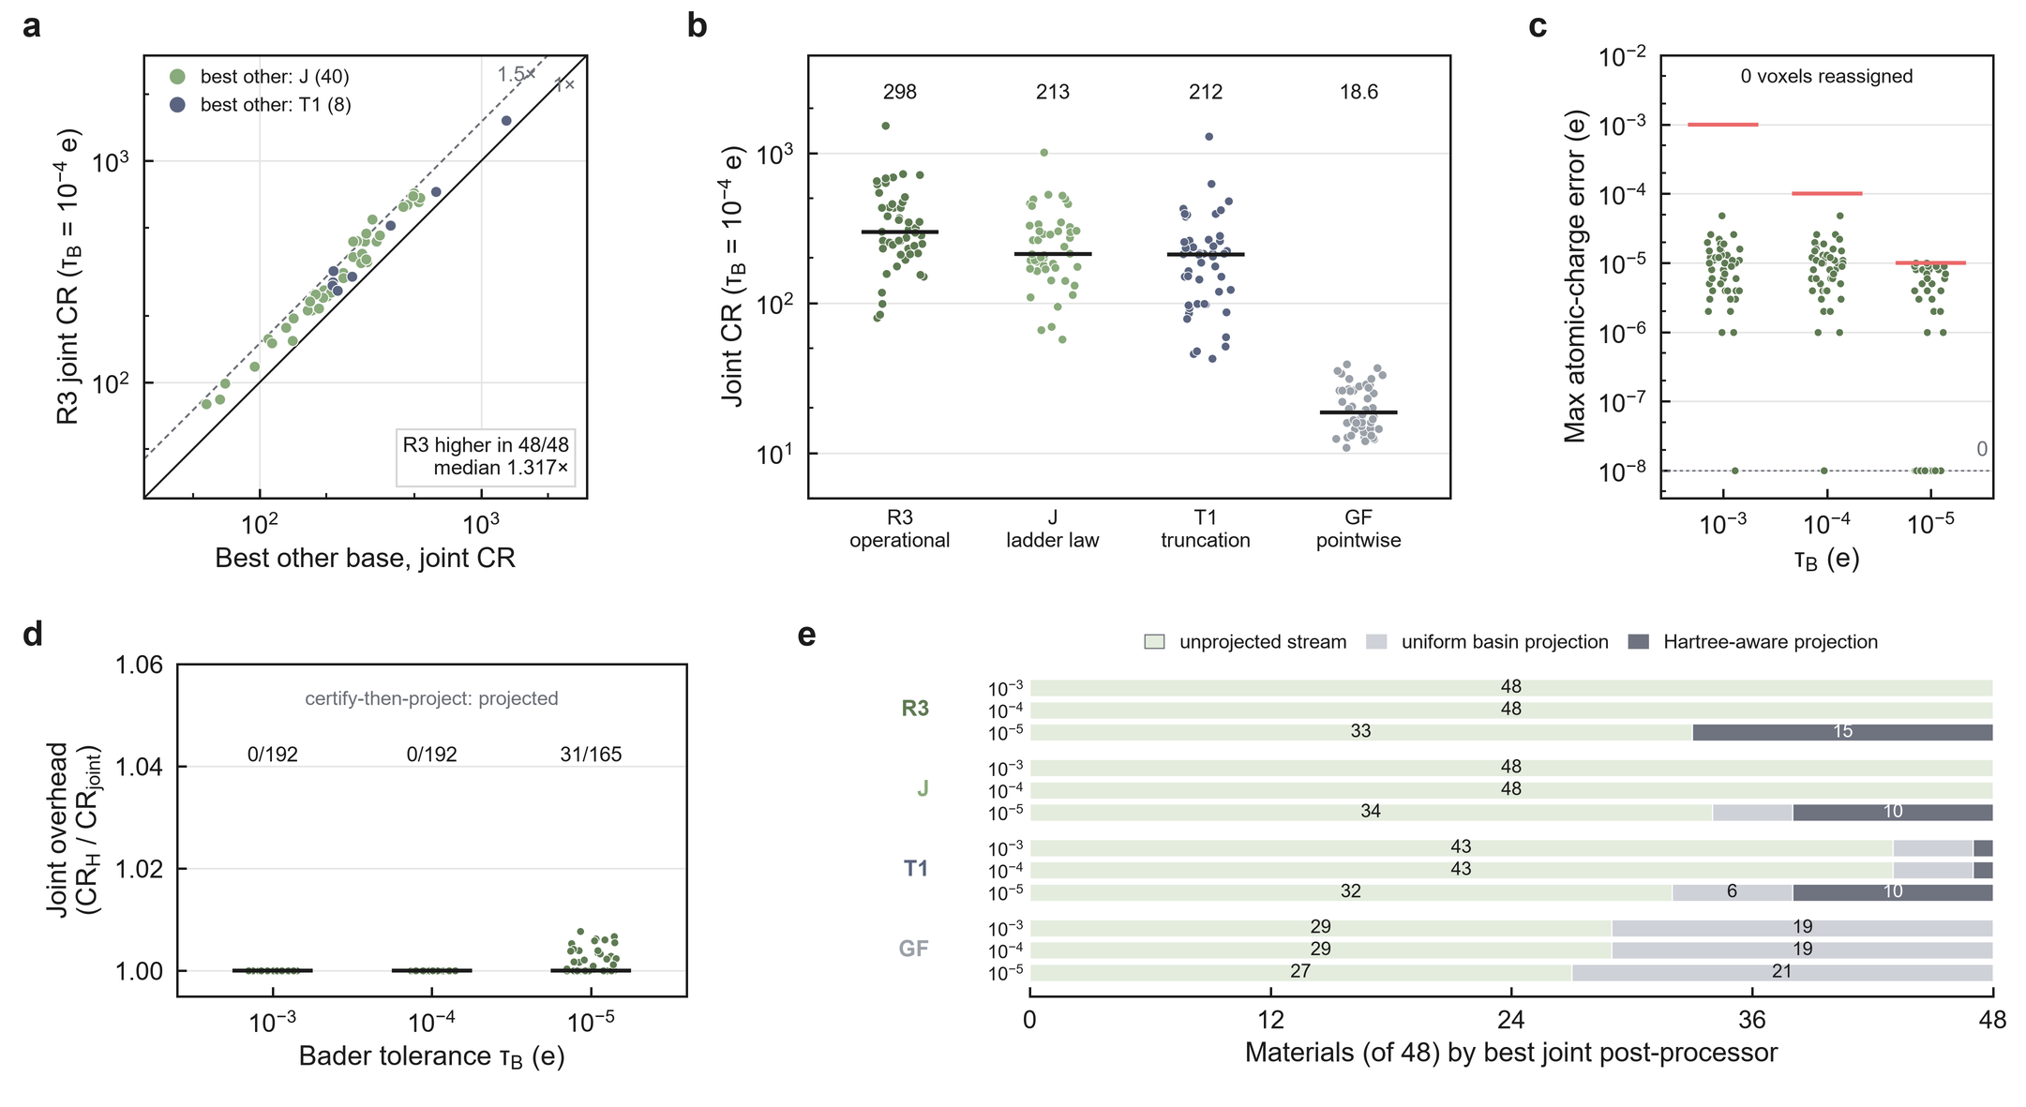
Fig. 7 | One operator-aware stream certifies the Hartree potential and Bader charges together. 48 fresh bulk crystals (P2); joint contract: Hartree relative error below 10⁻⁶ and Henkelman Bader charges with an exact all-electron partition reference, error at most τB, zero basin reassignment. a, Joint compression ratio of the operational Hartree encoder (R3) against the best other base codec for each material at τB=10⁻⁴ e, coloured by that base; R3 is higher in 48/48 (median 1.317-fold). b, Joint CR at τB=10⁻⁴ e for each base codec at its best post-processor: R3, frozen-ladder law (J), spectral truncation (T1) and pointwise codecs (GF) (medians 298, 213, 212 and 18.6). c, Maximum atomic-charge error of the certified R3 stream per material at each τB (red bars, τB); errors of exactly zero are drawn on the dashed floor; no voxel was reassigned (144/144). d, Joint overhead (Hartree-only over joint CR) of R3 at each τB (median 1.000 at each), with the number of certify-then-project decisions that applied a projection (0/192, 0/192, 31/165). e, Post-processor that gave each base its best joint stream at each τB.
The Hartree certificate already carries the Bader charges under an exact partition. The unprojected stream was the best joint choice in 48/48 materials at 10⁻³ and 10⁻⁴ e and in 33/48 at 10⁻⁵ e, where Hartree-aware projection was best for the other 15, whereas the pointwise streams needed uniform projection in 19, 19 and 21 materials (Fig. 7e); certify-then-project applied a projection in 0/192, 0/192 and 31/165 decisions at the three tolerances (Fig. 7d), and the median overhead was 1.000 at every τB. The 12-material engineering cohort that authorized this test gave the same picture (12/12; overhead 1.000; 12/12 wins, median 1.355; Supplementary Note 4). When a source must be self-contained, the partition itself can be stored losslessly as a label map or as a partition-faithful all-electron reference (Supplementary Note 3).
The gain is predicted before compression from the operator symbol and the reference spectrum
Whether operator-aware coding is worth deploying depends on the operator. For five linear operators of the density (gradient, Laplacian, Hartree field, Hartree potential and Gaussian smoothing with sigma=0.5 Å) and the density itself as control, we compared operator-weighted allocation (ΔG∝ w⁻¹/²) with operator-blind allocation (uniform steps) at equal operator error and recorded the measured gain G obs as the ratio of their compressed sizes. Before any compression, we computed the predicted gain G pred for every material and operator from the operator symbol and the material's reference spectrum alone, with a finite-rate entropy-coded quantization model (Methods), and committed the predictions to the repository.
The predictions matched. At τ=10⁻⁶, the median absolute log error was 0.024 over 300 bulk pairs and 0.029 over 160 slab pairs, with Spearman rank correlations of 0.978 and 0.979 (Fig. 8a); pooled over the 92 materials, 0.026 and 0.977, with 80% of pairs within 25% (per-operator tables in Supplementary Note 5). Every pair of operators was ordered as predicted, and the density control gave G obs=1. At τ=10⁻⁴ the errors were 0.034 and 0.040, with Spearman 0.944 and 0.914 (Fig. 8b). Within each operator that gains, the predictor also ranked the materials (pooled Spearman 0.79 for the Hartree potential, 0.84 for the Hartree field, 0.89 for Gaussian smoothing; Fig. 8d–f).
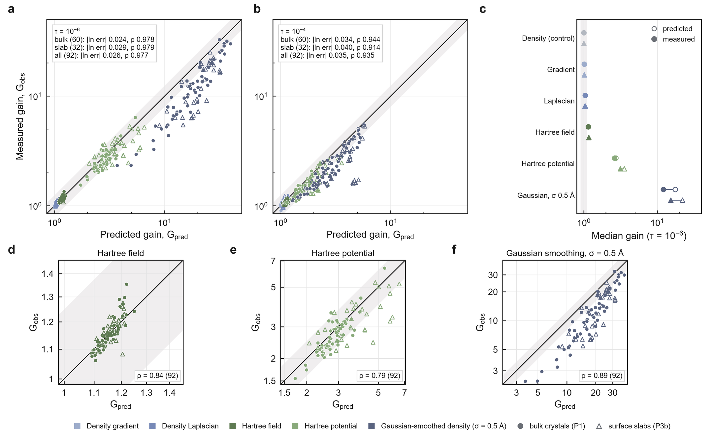
Fig. 8 | The gain of operator-aware allocation is predicted before compression. Five operators (gradient, Laplacian, Hartree field, Hartree potential, Gaussian smoothing with sigma=0.5 Å) on 60 fresh bulk crystals (circles) and 32 fresh surface slabs (triangles); predictions were committed before any compression run (P1 d5fc30b, P3b c1e6564). a, Predicted against measured gain at τ=10⁻⁶ for 300 bulk and 160 slab material–operator pairs; line, identity; band, ±25%. Median absolute log error 0.024 (bulk), 0.029 (slab), 0.026 (pooled); Spearman 0.978, 0.979 and 0.977. b, The same at τ=10⁻⁴ (0.034, 0.040, 0.035; Spearman 0.944, 0.914, 0.935). c, Per-operator medians at τ=10⁻⁶, predicted (open) and measured (filled), bulk (circles) and slab (triangles), ordered by predicted gain, with the density control and the pre-registered null-gain band [0.90, 1.11] (shaded). d–f, Within-operator ranking at τ=10⁻⁶ over the 92 materials for the three operators that gain (Spearman 0.84, 0.79 and 0.89).
The operator symbol sets which operators gain (Fig. 8c). Derivative operators gain little: predicted and measured median gains were 1.014 and 1.011 for the gradient and 1.039 and 1.042 for the Laplacian on bulk crystals (slabs: 1.012 and 1.015; 1.031 and 1.047), and the measured gain fell within [0.90, 1.11] in 100% and 98.3% of bulk crystals (100% and 96.9% of slabs), as predicted. The Hartree field gains about 15% (1.151 and 1.149; slabs 1.164 and 1.165), the Hartree potential 2.6–3.1-fold (2.72 and 2.61; slabs 3.55 and 3.14), and Gaussian smoothing an order of magnitude (17.6 and 12.1; slabs 22.0 and 15.3). The predictor is the classical coding-gain construction³⁴,³⁵ evaluated with a physical weight and a finite-rate dead-zone model; compression-ratio prediction from data statistics is established separately.³⁶
Discussion
The downstream operator enters certified compression at each stage, and each stage licenses a different decision. Qualification decides whether a tolerance can be scored at all; a non-evaluable outcome is resolved by changing the contract, not the codec, as holding the Bader partition reference exact moved eligibility from 3/50 to 50/50. Gain prediction decides, before any compression run, whether operator-aware coding is worth deploying for a given operator: about 1–5% for derivative operators, two- to three-fold for the Hartree potential, an order of magnitude for smoothing. The system class decides the encoder: the closed-form law for bulk crystals at tight tolerances, operational allocation for surfaces and loose tolerances. Certification decides whether the decoded object meets the contract, for one operator or for several.
The operator is thus the unit of design. Task-based quantization²⁰ and weighted transform coding²¹–²³ supply the principle and the algebra; QoI-preserving compressors supply bounds, corrections and predictions for declared quantities.⁸–¹⁷ The present work adds the physical instantiation and its quantified consequences: the symbol of the downstream operator, read on each material's reciprocal lattice, explains a codec effect at matched distortion, fixes a closed-form allocation, forecasts its gain, and defines the certificate under which the decoded field is accepted. The operator metric, not the optimizer, carries the gain (2.12- and 3.43-fold at equal optimization), which is why a physically correct weight matters more than a better search.
Joint certification shows how contracts compose. Several QoIs have been controlled on one stream before, in fusion data, progressive retrieval and combinable safeguards.¹¹,¹²,¹⁵,¹⁷ Here the two contracts differ in kind: a global elliptic-operator norm on the reciprocal lattice and integrals over a topologically defined real-space partition, certified by the production Bader code. Under an exact partition, the Hartree certificate already carried the Bader charges to 10⁻⁴ e at no measurable cost, and a projection was needed only at 10⁻⁵ e.
The results are defined on linear reciprocal-space operators of the valence density and on the exact-partition Bader contract; on bulk crystals from the Materials Project and surface slabs from NOMAD; and on Hartree tolerances from 10⁻⁴ to 10⁻⁸. Within that scope, every confirmatory number follows a protocol, population rule and, where applicable, prediction file committed before its outcomes, and the full register of protocols and outcomes is public. For electronic-structure data, the question shifts from whether a density can be compressed to which analyses its stored form must support, and the operator of each analysis then says how to store it.
Methods
Measurement contract and QSQ
A contract C specifies the QoI, the downstream algorithm, the tolerance τ and whether each input is exact or approximate. QSQ perturbs only approximate inputs. For an approximate density ρₘ, εₘ=‖float32(ρₘ)-ρₘ‖∞, and five fixed-seed perturbations U(-εₘ,+εₘ) (seeds 20260905, 1, 2, 3, 4) are applied. The floor is fC=maxₖ r C,k, the largest response over the five probes (for Bader charge, the maximum absolute per-atom charge change with re-derived basins), and
eligible(C,τ) ≡ fC<τ, certified(r,C,τ) ≡ eligible(C,τ) ∧ Δ Q(r)<τ .
An ineligible pair is non-evaluable; an eligible pair with no certified reconstruction is not certified. If the n qualification responses and a later response are exchangeable, P[eligible ∧ r^*≥τ]=𝔼[p(1-p)ⁿ]≤ nⁿ/(n+1)ⁿ⁺¹, the one-sided tolerance-limit argument.³⁷ The prospective test used 59 fresh seeds per material (labels 10000–10058, PCG64 streams from SHA-256 of material, family and label); the work order of 14,986 keys was hashed before execution. The all-electron-reference contract used Henkelman Bader 1.05 (-b ongrid -vac 0.001) with CHGCAR integrated over basins of ρ AE=AECCAR0+AECCAR2. Full QSQ protocols are in Supplementary Note 1 and the repository.
Hermitian-orbit representation and certificate
Densities are transformed with an orthonormal FFT. Reciprocal indices are partitioned into Hermitian orbits under k ↦ -k mod N, one canonical coefficient is stored per orbit, and G=0 is the only coefficient stored exactly. On even grids, a Nyquist coordinate is alias-equivalent to ± N/2; for every such mode the alias choices are enumerated and the minimum |G|² safe is used, so no mode receives a looser step from a sign convention. A policy assigns ΔG=α uG; for the closed-form law uG=w(G)⁻¹/² normalized at G max,safe, giving ΔG=α(|G| safe/G max,safe)² for the Hartree potential. Real and imaginary parts are rounded to integers, grouped into 32 radial shells with the smallest sufficient signed integer type, and compressed with zlib level 6. Compression ratio is 8N divided by the complete stream bytes, headers included. Every stream is decoded and certified when the Hartree relative root-mean-square error is below τ under both the historical operator (4π/|G|², G=0 set to zero) and the Nyquist-safe operator (even-grid Nyquist planes also removed), for which
RMS(Δ VH)²=((4π)²)/(N²)Σ G ∈ Gₛ(|Δρ(G)|²)/(|G|⁴).
For the spectral audit, ZFP and SZ3 reconstructions of the 254 development densities were matched within material on log₁₀ of realized L∞, without replacement, with a caliper of 0.10 dex; the 914 reconstructions of the 457 pairs were regenerated and had to reproduce their stored L∞ and Hartree error before entering the audit. Material-level centres are computed from within-material medians on the log scale; the multiplicative decomposition is exact for each pair.
Arms and the operational optimum
Arms follow the frozen protocol. A0: closed-form law, frozen 25-point ladder α/ptp(ρ) ∈ [10⁻⁷,10¹]. A1: closed-form law, continuous α bisection. A2: spectral truncation at cutoff qc ∈ k/32, bisection per cutoff, best cutoff. A3: operational optimum, Δₖ=mₛ uₖ with a per-shell multiplier from a 2¹/⁴ ladder or the shell dropped, selected by bisection on the Lagrange multiplier over each shell's exact (zlib bytes, operator distortion) curve plus a feasibility-preserving greedy polish, under both Hartree certificates with margin 0.995. A5: the same machinery with a flat prior and L₂ selection metric, multiplier chosen only so that the Hartree certificate holds. A6: best of ZFP, SZ3 and SPERR²–⁴ by absolute-tolerance bisection. Bisection arms use 60 iterations in log space and report the highest-ratio evaluated point that passes the decoded certificate; A1, A2 and A6 therefore have equal search. Tolerances were τ ∈ 10⁻⁴,10⁻⁶,10⁻⁸, primary 10⁻⁶.
Single-density diagnostics
Fig. 4 uses one development density (KCN, mp-676693, 84×96×108 grid) and the codecs of the arms: the law codec with continuous α (ΔG=α q², as A1), the same codec with uniform steps (the operator-blind arm of the gain test), the truncation codec at each of the 32 cutoffs, and ZFP, SZ3 and SPERR by absolute tolerance. Rate–distortion curves sweep α or the tolerance; the truncation curve is the lower envelope over cutoffs. Certified points use the bisection of the arms above, with decode back-off. Radial statistics use 48 equal bins in q=|G| safe/G max,safe; the decoded error energy per mode is weighted by |G|⁻⁴.
Gain predictor
Part B used six operators with squared weights w=1 (density), |G|² (gradient), |G|⁴ (Laplacian), |G|⁻² (Hartree field), |G|⁻⁴ (Hartree potential) and exp(-sigma²|G|²), sigma=0.5 Å (Gaussian smoothing). The operator-weighted arm used u=w⁻¹/² and the blind arm u=1; each used continuous α bisection on the Nyquist-safe relative error in that operator's metric (margin 0.995), every stream was decode-verified, and G obs=bytes blind/bytes opt. The predictor models each real coefficient component as a zero-mean Laplacian whose variance is the reference spectral power averaged over 256 radial |G| bins, quantized by rounding with ideal entropy coding, for which output entropy and mean squared error have exact closed forms. For each policy, α is solved for the target operator error, giving predicted payload bits R, and
G pred=(F+R blind/8)/(F+R opt/8),
where F is the geometry-only container size. The model includes the dead zone that the high-rate law ignores. Its form was fixed by a retrospective calibration on 12 engineering materials (Supplementary Note 6) and then tested only prospectively.
Populations and pre-registration chronology
Populations were drawn under rules frozen before any candidate was downloaded and excluding every identifier (833) and reduced formula (291) used anywhere in the project. P1 (12 shakedown + 60 confirmatory) and P2 (12 engineering + 48 confirmatory, with AECCAR0 and AECCAR2) are Materials Project bulk crystals drawn by hash rank within size strata from the open S3 listing³⁸; P3b is 32 NOMAD VASP surface slabs³⁹, one per reduced formula and at most six per upload. Only metadata was read before the freeze; no outcome was computed on any candidate. Table 1 lists the commit order; commits are on the public repository and timestamps are UTC. Full protocols, manifests, provenance hashes and the register of every protocol with its outcome are in the repository.
Table 1 | Pre-registration chronology.
step | commit | time (UTC)
Population selection rule and exclusion set frozen | 10e7863 | 2026-10-06 14:27
P1 and P2 manifests drawn | 708dd37 | 2026-10-06 15:09
Law protocol (Parts A and B, criteria) frozen | fe2e08a | 2026-10-06 15:26
P1 predictions committed | d5fc30b | 2026-10-06 15:32
P1 run recorded | 4164519 | 2026-10-06 15:54
P3b selection rule and protocol amendment frozen | 39ba728 | 2026-10-06 15:59
P3b cohort drawn | d1c1050 | 2026-10-06 16:03
P3b predictions committed | c1e6564 | 2026-10-06 16:08
P3b run recorded | eaa3267 | 2026-10-06 16:23
Joint-contract protocol and criteria frozen | 8a784a4 | 2026-10-06 16:25
Joint-contract engineering gates passed | e095a0c | 2026-10-06 16:42
Joint-contract confirmation recorded | e4d9d0b | 2026-10-06 18:00

Joint contract and certify-then-project
The joint contract requires Hartree relative error below 10⁻⁶ (historical and Nyquist-safe) on the final stream and, with Henkelman Bader 1.05 (-b ongrid -vac 0.001, exact AECCAR0 + AECCAR2 reference), maximum atomic-charge error at most τB and zero basin reassignment. Bases: R3 (the A3 codec), J (frozen-ladder law), T1 (truncation ladder) and GF (ZFP, SZ3 and SPERR at abstol/ptp=10⁻⁹ to 10⁻¹, 25 points). Post-processors: none; uniform projection, which adds dᵢ/Nᵢ on basin i to restore the stored basin sums; Hartree-aware projection, which minimizes ‖ Hc‖²/sH+mu‖ c‖²/sρ subject to the same sums (mu ∈ 10⁻⁴,10⁻²,1); and certify-then-project, which stores a one-byte flag, runs Bader on the unprojected stream and applies a projection only if that stream fails. Bytes include payload, side channel and flag. For each material, τB and base, the best post-processor is the one with the highest certified joint ratio, a choice every base receives. Overhead is CR Hartree-only/CR joint for R3; utility is the R3 joint ratio over the maximum joint ratio of J, T1 and GF.
Statistics
Medians and percentile 95% confidence intervals of the median come from 10,000 bootstrap resamples over materials with fixed seeds (20261006 for the law protocol, 20261007 for the joint contract). Pre-registered criteria were, for the law: near-optimality median CR A3/CR A1≤1.15 with CI upper bound ≤1.20; operator metric median CR A3/CR A5>1.5, CI lower bound >1.35, wins ≥90%; pointwise codecs median >4, wins ≥95%; truncation median >1.15, wins ≥75%; prediction median |ln(G pred/G obs)|≤ln1.25 and Spearman ≥0.85 over operator–material pairs, operator ordering preserved, and G obs ∈ [0.90,1.11] in ≥80% of materials for operators with median G pred<1.05. For the joint contract: ≥46/48 jointly certified; overhead median ≤1.10 with CI upper bound ≤1.15; utility ≥36/48 wins, median >1.10, CI lower bound >1.00. QSQ intervals are material-cluster bootstrap intervals. Spearman correlations are computed over operator–material pairs, excluding the density control.
Data availability
Source densities are public. Bulk crystals are Materials Project charge densities (CHGCAR, AECCAR0, AECCAR2) from the open S3 bucket materialsproject-parsed (listing of 2026-10-06);³⁸ surface slabs are NOMAD VASP entries retrieved through the public NOMAD API;³⁹ the external QSQ cohort also uses AFLOW densities.⁴⁰ Every manifest records identifier, URL, byte count and SHA-256. All derived tables, per-material results, prediction files, protocols and the register of every protocol with its outcome are in the public repository https://github.com/stloendays/QoI. An archival snapshot will be deposited at Zenodo (DOI: [placeholder: to be minted at submission]).
Code availability
All code (QSQ, codecs, arms, gain predictor, joint-contract runner, statistics and figure scripts) is in the public repository https://github.com/stloendays/QoI, with the continuous-integration workflows that ran each pre-registered phase. The archival snapshot is the Zenodo record above (DOI: [placeholder: to be minted at submission]).
References
- Di, S. et al. A survey on error-bounded lossy compression for scientific datasets. ACM Comput. Surv. 57, 1–38 (2025).
- Lindstrom, P. Fixed-rate compressed floating-point arrays. IEEE Trans. Vis. Comput. Graph. 20, 2674–2683 (2014).
- Liang, X. et al. SZ3: A modular framework for composing prediction-based error-bounded lossy compressors. IEEE Trans. Big Data 9, 485–498 (2023).
- Li, S., Lindstrom, P. & Clyne, J. Lossy scientific data compression with SPERR. In Proc. 2023 IEEE International Parallel and Distributed Processing Symposium (IPDPS) 1007–1017 (IEEE, 2023).
- Cappello, F. et al. Use cases of lossy compression for floating-point data in scientific data sets. Int. J. High Perform. Comput. Appl. 33, 1201–1220 (2019).
- Gok, A. M. et al. PaSTRI: Error-bounded lossy compression for two-electron integrals in quantum chemistry. In Proc. 2018 IEEE International Conference on Cluster Computing (CLUSTER) 1–11 (IEEE, 2018).
- Lara, A. O., Talbot, J. J., Wang, Z. & Head-Gordon, M. An algorithm for atom-centered lossy compression of the atomic orbital basis in density functional theory calculations. J. Chem. Theory Comput. 22, 3327–3340 (2026).
- Ainsworth, M., Tugluk, O., Whitney, B. & Klasky, S. Multilevel techniques for compression and reduction of scientific data—quantitative control of accuracy in derived quantities. SIAM J. Sci. Comput. 41, A2146–A2171 (2019).
- Jiao, P. et al. Toward quantity-of-interest preserving lossy compression for scientific data. Proc. VLDB Endow. 16, 697–710 (2022).
- Liu, J. et al. QPET: A versatile and portable quantity-of-interest-preservation framework for error-bounded lossy compression. Proc. VLDB Endow. 18, 2440–2453 (2025).
- Gong, Q. et al. Maintaining trust in reduction: Preserving the accuracy of quantities of interest for lossy compression. In Driving Scientific and Engineering Discoveries Through the Integration of Experiment, Big Data, and Modeling and Simulation 22–39 (Springer, 2022).
- Lee, J. et al. Error-bounded learned scientific data compression with preservation of derived quantities. Appl. Sci. 12, 6718 (2022).
- Banerjee, T. et al. Online and scalable data compression pipeline with guarantees on quantities of interest. In Proc. 2023 IEEE 19th International Conference on e-Science (e-Science) 1–10 (IEEE, 2023).
- Liu, Y. et al. TOPIQ: Statistical error propagation for quantity-of-interest prediction under lossy compression. Preprint at https://arxiv.org/abs/2608.26912 (2026).
- Tyree, J. et al. Compression Safeguards: Building trust into lossy data compression. EGUsphere https://doi.org/10.5194/egusphere-2026-4266 (2026).
- Ren, C. et al. FFCz: Fast Fourier correction for spectrum-preserving lossy compression of scientific data. Preprint at https://arxiv.org/abs/2601.01596 (2026).
- Wu, X. et al. Error-controlled progressive retrieval of scientific data under derivable quantities of interest. In Proc. International Conference for High Performance Computing, Networking, Storage and Analysis (SC24) 1–16 (IEEE, 2024).
- Yan, L., Liang, X., Guo, H. & Wang, B. TopoSZ: Preserving topology in error-bounded lossy compression. IEEE Trans. Vis. Comput. Graph. 30, 1302–1312 (2024).
- Gorski, N., Liang, X., Guo, H., Yan, L. & Wang, B. A general framework for augmenting lossy compressors with topological guarantees. IEEE Trans. Vis. Comput. Graph. 31, 3693–3705 (2025).
- Shlezinger, N., Eldar, Y. C. & Rodrigues, M. R. D. Hardware-limited task-based quantization. IEEE Trans. Signal Process. 67, 5223–5238 (2019).
- Gersho, A. & Gray, R. M. Vector Quantization and Signal Compression (Springer, 1992).
- Goyal, V. K. Theoretical foundations of transform coding. IEEE Signal Process. Mag. 18, 9–21 (2001).
- Watson, A. B. DCT quantization matrices visually optimized for individual images. In Proc. SPIE 1913, 202–216 (1993).
- Currie, L. A. Nomenclature in evaluation of analytical methods including detection and quantification capabilities (IUPAC Recommendations 1995). Pure Appl. Chem. 67, 1699–1723 (1995).
- Automotive Industry Action Group. Measurement Systems Analysis Reference Manual, 4th edn (AIAG, 2010).
- Bader, R. F. W. Atoms in Molecules: A Quantum Theory (Oxford Univ. Press, 1990).
- Henkelman, G., Arnaldsson, A. & Jónsson, H. A fast and robust algorithm for Bader decomposition of charge density. Comput. Mater. Sci. 36, 354–360 (2006).
- Tang, W., Sanville, E. & Henkelman, G. A grid-based Bader analysis algorithm without lattice bias. J. Phys.: Condens. Matter 21, 084204 (2009).
- Yu, M. & Trinkle, D. R. Accurate and efficient algorithm for Bader charge integration. J. Chem. Phys. 134, 064111 (2011).
- Mallat, S. & Falzon, F. Analysis of low bit rate image transform coding. IEEE Trans. Signal Process. 46, 1027–1042 (1998).
- Sullivan, G. J. Efficient scalar quantization of exponential and Laplacian random variables. IEEE Trans. Inf. Theory 42, 1365–1374 (1996).
- Shoham, Y. & Gersho, A. Efficient bit allocation for an arbitrary set of quantizers. IEEE Trans. Acoust. Speech Signal Process. 36, 1445–1453 (1988).
- Ortega, A. & Ramchandran, K. Rate-distortion methods for image and video compression. IEEE Signal Process. Mag. 15, 23–50 (1998).
- Huang, J. J. Y. & Schultheiss, P. M. Block quantization of correlated Gaussian random variables. IEEE Trans. Commun. Syst. 11, 289–296 (1963).
- Jayant, N. S. & Noll, P. Digital Coding of Waveforms (Prentice-Hall, 1984).
- Underwood, R. et al. Black-box statistical prediction of lossy compression ratios for scientific data. Int. J. High Perform. Comput. Appl. 37, 412–433 (2023).
- Wilks, S. S. Determination of sample sizes for setting tolerance limits. Ann. Math. Stat. 12, 91–96 (1941).
- Jain, A. et al. Commentary: The Materials Project: a materials genome approach to accelerating materials innovation. APL Mater. 1, 011002 (2013).
- Draxl, C. & Scheffler, M. The NOMAD laboratory: from data sharing to artificial intelligence. J. Phys. Mater. 2, 036001 (2019).
- Curtarolo, S. et al. AFLOW: an automatic framework for high-throughput materials discovery. Comput. Mater. Sci. 58, 218–226 (2012).

